FINANCIAL TYRANNY: Defeating the Greatest Cover-Up of All Time
Posted by David Wilcock | Jan 13, 2012 | David's Blog | Jump to Comments (1356)
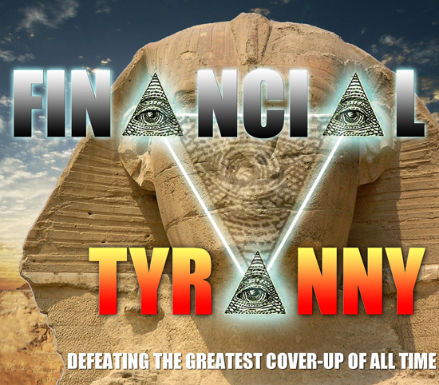
- Part One: FINANCIAL TYRANNY: Defeating the Greatest Cover-Up of All Time
- Section Two: The History
- Section Three: The Real World
- Section Four: The Occult Economy
- Section Five: Bretton Woods and the BIS
- Section Six: The Ultimate Ponzi Scheme
- Comments
- All Pages

FINAL VERSION 2/9! A 122-nation alliance is backing a lawsuit that could free the Earth from financial tyranny. This investigation reveals who the perpetrators are and what we can do to solve the problem.

[Note: The most recent updates to these first six sections were posted on Sunday, January 29th. The remaining four sections had to be published separately, due to size constraints on our database.

Please Note: You may quote excerpts from this investigation and republish them in your blog, but please do not re-post the entire investigation, as additional updates and ‘tweaks’ may be necessary. Instead, please link your readers back to the original. Thanks!]

JUST IN THE NICK OF TIME

2012 has begun as a year of rampant paranoia and hopelessness on the Internet and throughout mainstream media.

The economy appears to be in a dire predicament — ready to go over a cliff into an abyss few can even allow themselves to consider.

The Euro has been teetering on the brink of total collapse. A frantic bailout of the entire European Union, proposed by the Federal Reserve, has done very little to relieve the fears of the public.

On December 19th, 2011, Britain announced they will refuse to participate in this bailout — showing how tense and uncertain the situation really is.

Simultaneously, very aggressive and blatant moves are being made to start World War III in the Middle East — with imminent, ever-increasing threats from Israel and the United States to attack Iran.

Since 9/11, Americans and much of the Western world have been led to believe that the biggest enemy they face is terrorism from Islamic extremists. Nonetheless, there is now overwhelming, undeniable evidence that the true enemy… is within.

You are about to read a comprehensive investigation summarizing all the best information I have gathered about the true nature of this crisis since I became directly aware of it, twenty years ago — in 1992.

Very few people are aware that a massive 122-nation coalition has formed to solve the problem — just in the nick of time – and they are backing a legal, public solution to end Financial Tyranny.

A TRILLION DOLLAR LAWSUIT

A trillion-dollar lawsuit was filed as of November 23, 2011 — and the resulting investigation will provide a rock-solid legal framework to reveal the full nature of the problems we face… and arrest those responsible:

https://divinecosmos.com/media/Keenan_complaint_11-23-2011_SDNY.pdf

Bear in mind that the evidence backing this lawsuit, if made public, will completely expose what has been going on at the highest levels — by the people themselves, speaking in their own words.

This would be the most dramatic public expose’ of the group responsible for this Financial Tyranny since the early 1800s — as you will see.

Our initial announcement and confirmation of this lawsuit has already received over 650,000 hits, 34,000 Facebook Likes and 1000 written comments as we publish this final, completed investigation.

LETHAL CONSEQUENCES

This initial announcement also earned me a very serious warning — from two different insiders working at high levels of government — that I needed to publish the entire investigation as quickly as possible, or my life could be in imminent danger.

The conspirators are desperate to stop the bleeding and save themselves from prosecution. Threats, bribery, blackmail, torture and murder are their standard tools of the trade.

As you will see, on December 31st, David Hutzler publicly conveyed vital information to me for this case, acting directly on behalf of Benjamin Fulford — the former Asia-Pacific bureau chief for Forbes Magazine, and a leading representative of this international alliance.

Ben had David direct me to the “Unwanted Publicity Intelligence” website, which contains extremely sensitive documents. I was astonished when I reviewed this website, considering that I was told it is lethally dangerous to publish pictures of the Federal Reserve bonds we will be discussing.

A week later, on January 6th, David and his eight-year-old son Mackie burned to death in their home. Hardly anything recognizable was left. Accelerants were found outside and arson has not been ruled out.



UPDATE 2/7: THEY WERE SHOT TO DEATH, THEN BURNED

Just as we were preparing to publish the final version of this investigation, we discovered startling new news.

Autopsies revealed that David Hutzler and his son both died of gunshot wounds — not fire.

http://www.journal-news.net/page/content.detail/id/574757/Police–Fire-victims-had-been-shot.html?nav=5006
MARTINSBURG – The bodies of a father and son discovered after a fire in Glengary last month were found to have gunshot wounds, and an investigation has determined that the blaze was intentionally set, officials confirmed for the first time Monday.

The bodies of 56-year-old David Cole Hutzler and his son, 9-year-old James Hutzler, were discovered Jan. 6 after a fire at 436 Apple Harvest Drive in Berkeley County near the Virginia state line. Both victims were found in the mobile home’s rear bedroom.

“I can confirm for you that the fire was intentionally set,” Assistant West Virginia State Fire Marshal Patrick Barker, who investigated the fire, said Monday.

Meanwhile, West Virginia State Trooper J.D. Brand, who is one of the officers leading the investigation into the deaths, confirmed reports that both victims had gunshot wounds. He told a reporter Monday that the incident is now being considered a homicide investigation.
OUTRAGEOUS ASSERTION THAT THIS WAS DONE DELIBERATELY
We all knew and loved “Hutz” on Benjamin Fulford’s forum. He participated frequently and really wanted to make a difference in this world. His comments were funny and insightful. He loved my work and believed in what I’m doing.

He was one of those people who had “the burden of wisdom” — the knowledge of the degree of harm that is being done in this world by Financial Tyranny.

Friends of his have spoken to me personally and said how dearly he loved his son. He would have done anything for Mackie.

Hutz knew from Fulford that we were very close to some major changes in the world — which were extremely positive. That’s why he forwarded me the links to this damning evidence on Ben’s behalf.

All that being said, the police are literally expecting us to believe that he shot Mackie, lit his own home on fire with gasoline well enough to burn it beyond all recognition, and then went back and shot himself — in the same room where Mackie was.

http://your4state.com/fulltext?nxd_id=235772

“We believe he took the life of his son and then set the fires and then took his own life,” says Trooper Brand.
From the investigation and talking to people close to the victims the lead investigator, Trooper Brand says the father had a history of making remarks that seemed questionable and unstable.
“Spoke to a number of people that knew the victims quite well. Received several accounts of the victim making suicidal comments and also several indicators that over the past couple years he had become mentally unstable,” says Trooper Brand.
Trooper Brand says unless any new information is found, their investigation is complete.

WHAT DO YOU THINK?

If you start learning the truth about Financial Tyranny, you will naturally be branded as making “questionable remarks” that seem “mentally unstable” by people who are unaware of the things you are about to read.

Given the fact that this one legal case could single-handedly destroy a conspiracy for global financial tyranny that goes back at least 300 years, do you really think this cover story is true?

If you’re suicidal enough to kill your own son and kill yourself, why would you be so concerned about trying to destroy all the evidence?
Out of fear, skeptics will insist there is no connection between this bizarre double murder and the damning information Hutz passed along to me. I disagree.

Even in light of this blatant threat, I will not be intimidated. This tragic event only inspired me to do an even better job with the investigation.

You deserve to know the truth.

Our future depends on it.

THIS IS NOT YOUR TYPICAL NEWS STORY

Up until now, the only mainstream media outlet that has dared to report on this intriguingly vast and mysterious case is the Courthouse News Service:

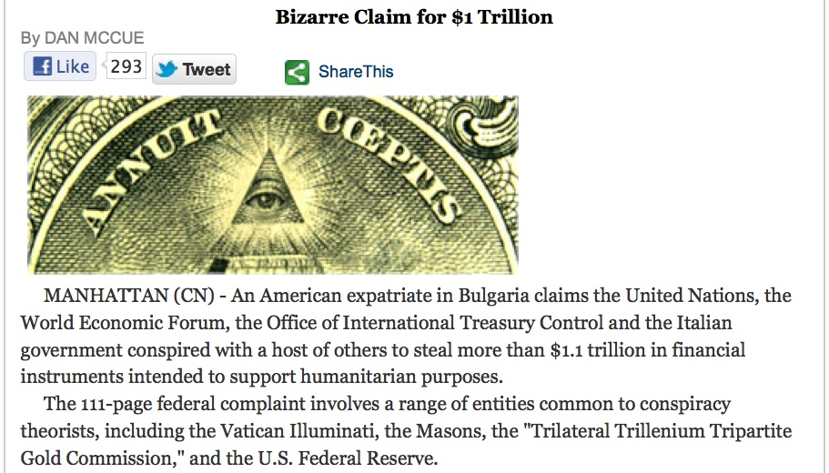

The “back story” behind this lawsuit is extremely complex. Since November 23rd, 2011, I have worked an average of 14 or more hours a day to produce this report.

Furthermore, the core information pertaining to the case itself is cloaked in the deepest secrecy. Much of it must be obtained firsthand — from people who have to risk their lives to tell the truth.

Wherever possible, I have drawn off of provable information. When this was unavailable, I relied as much as possible on “leaked” insider testimony that is already well-established on public record to reveal the story. The works of David Guyatt — at http://www.deepblacklies.co.uk — have been uniquely beneficial in this regard.

In addition to the above investigative methods, you will also read the world’s first exclusive, detailed interview with the two main plaintiffs responsible for filing this lawsuit — explaining what they are doing and why it is so urgently needed.

First, however, we need to break down the lies and reveal the full scope of the problem – relying upon provable facts, documented in the public domain, as much as possible.

THE FEDERAL RESERVE SYSTEM

Since 1913, the currency of the United States has been owned and managed by a private corporation of international bankers known as the “Federal Reserve System.”

This group prints “Federal Reserve Notes” and loans them out to the United States Treasury. American taxpayers then pay interest to the Federal Reserve banking families for the rights to use their money.

The Federal Reserve banking families can therefore print as much money as they want — and give it to whomever they want, secretly, with no oversight or input from the United States government.

In this clip, former Federal Reserve chairman Alan Greenspan admits that the Federal Reserve is an independent agency whose decisions cannot be overruled by any element of the legitimate United States government.

“REPORTER: What is the proper relationship… what should be the proper relationship between a chairman of the Fed and a president of the United States?

GREENSPAN: Well, first of all, the Federal Reserve is an independent agency. And that means basically that, uh, there is no other agency of government which can overrule actions that we take.

So long as that is in place, and there is no evidence that the administration, the Congress or anybody else is requesting that we do things other than what we think is the appropriate thing, then what the relationships are don’t frankly matter.

I’ve had very good relationships with presidents.”

26 TRILLION DOLLARS OF FRAUD

Thanks to heroic efforts of Congressman Ron Paul, former Congressman Alan Grayson and Congressman Bernie Sanders to audit the Federal Reserve, we now know that the Federal Reserve secretly lent out 26 trillion dollars’ worth of American money from 2007 to 2010 — much of it to foreign banks.

Twenty. Six. TRILLION. Dollars.

This is a very difficult number to comprehend — but we do now have a way to wrap our minds around it.

At his website usdebt.kleptocracy.us, Los Angeles-based 3D designer Oto Godfrey has created an incredibly powerful series of images to help us actually visualize this much money — in stacks of 100-dollar bills.

Before you see it, try to stop for a minute and think what it will look like. How many stacks do you think there are? How big do you think they will be? I was quite surprised when I saw it for myself.

The website goes into more detail about each category — so I recommend going there and checking it out, and supporting Oto Godfrey’s amazing work.

WHAT DOES 26 TRILLION DOLLARS ACTUALLY LOOK LIKE?

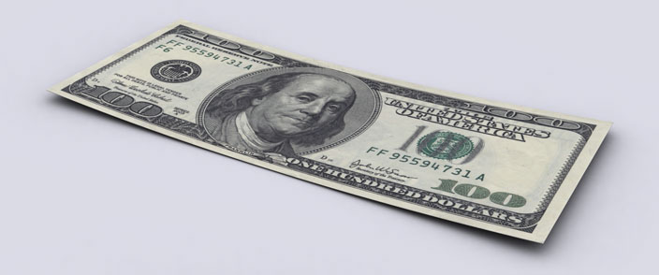

100 Dollars

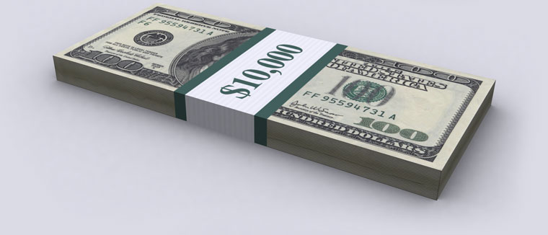

Ten Thousand Dollars

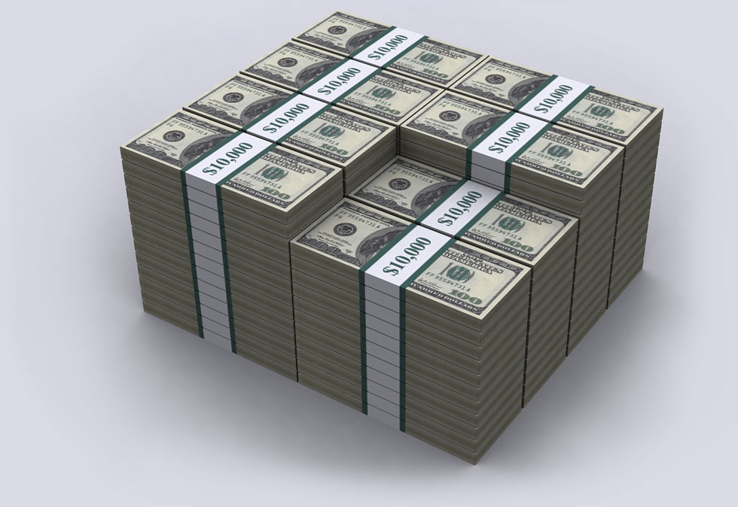

One Million Dollars



One Hundred Million Dollars



One Billion Dollars

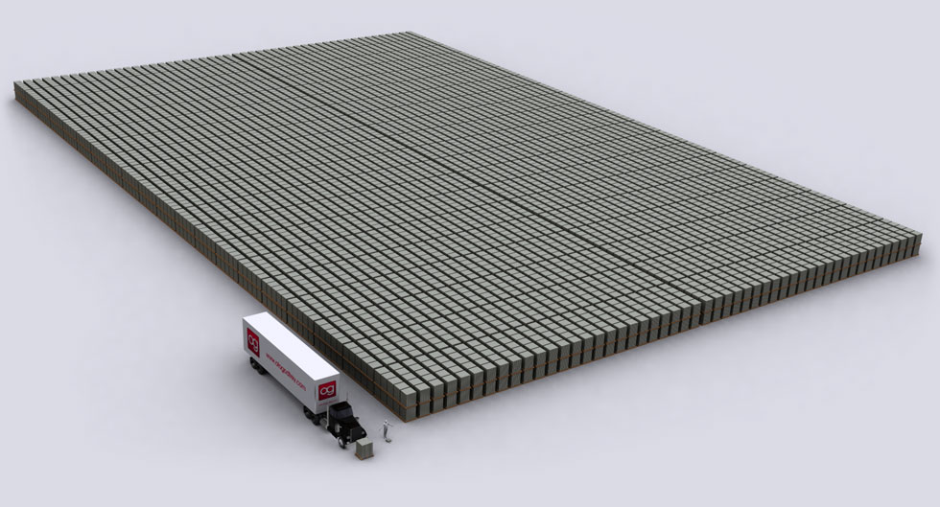

One Trillion Dollars



One Trillion Dollars

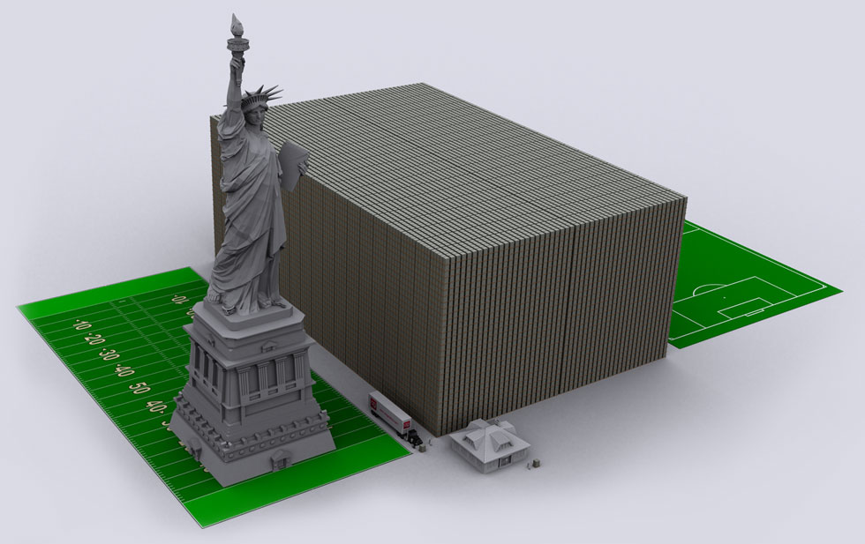

Fifteen Trillion Dollars

CONGRESSMAN GRAYSON SPELLS IT OUT

Fifteen trillion dollars — or one year’s worth of the US National Debt — is a stack of money that is longer and wider than a football field… and over 2/3rds the height of the Statue of Liberty.

If you add another 11 Trillion to get our total of 26 Trillion, that same stack will now be taller than the Statue of Liberty.

This monstrous mass of paper would look as if a gigantic Borg Cube had completely invaded an entire football stadium — past the ceiling.

Here is a small part of the letter where Congressman Alan Grayson reveals how he found this number, in the newly-audited Federal Reserve balance sheets, to John Hively — “The World’s Most Accurate Economic Forecaster Since 1989”.

http://johnhively.wordpress.com/2011/12/05/breakdown-of-the-26-trillion-the-federal-reserve-handed-out-to-save-rich-incompetent-investors-but-who-purchase-political-power/

CONGRESSMAN GRAYSON: I wouldn’t want anyone to think that I’m dramatizing or amplifying what this GAO report says, so I’m just going to list some of my favorite parts, by page number.

Page 131 – The total lending for the Fed’s “broad-based emergency programs” was $16,115,000,000,000. That’s right, more than $16 trillion. The four largest recipients, Citigroup, Morgan Stanley, Merrill Lynch and Bank of America, received more than a trillion dollars each.

The 5th largest recipient was Barclays PLC. The 8th was the Royal Bank of Scotland Group, PLC. The 9th was Deutsche Bank AG. The 10th was UBS AG. These four institutions each got between a quarter of a trillion and a trillion dollars. None of them is an American bank.

Page 205 – Separate and apart from these “broad-based emergency program” loans were another $10,057,000,000,000 in “currency swaps.” In the “currency swaps,” the Fed handed dollars to foreign central banks, no strings attached, to fund bailouts in other countries….

These currency swaps and the “broad-based emergency program” loans, together, totaled more than $26 trillion. That’s almost $100,000 for every man, woman, and child in America.

That’s an amount equal to more than seven years of federal spending — on the military, Social Security, Medicare, Medicaid, interest on the debt, and everything else. And around twice America’s total GNP….

If the Fed had extended $26 trillion in credit to the American people instead of Wall Street, would there be 24 million Americans today who can’t find a full-time job?

TWENTY SIX TRILLION DOLLARS? HOW CAN IT BE POSSIBLE?

Does this upset you? Or have you become so numb that you just want to click away and look at hot models – or read about celebrities? “I don’t want to hear this $#!+. My life is bad enough as it is.”

26 Trillion is a gigantic number. Seemingly unimaginable.

This is a documented, proven fact. Isn’t it strange that you’ve hardly heard anything about this in the mainstream media?

That should be your first clue. Knowledge is power. Instead of feeling sick, angry, paranoid, sad or depressed, be aware that once you know the truth, nothing can stop us.

There will be losses. David and Mackie Hutzler may be two of the most recent ones. However, once a “critical mass” of people possess sensitive information, there is simply no possible way to stop it from spreading.

Most people can’t even comprehend such a vast amount of money as 26 Trillion dollars in practical terms – but we’ll get to that.

The results of the audit were first published on the morning of July 21, 2011.

At first, the most obvious number that jumped out from the report was “only” 16 trillion. You have to add in the ten trillion in “currency swaps” to reach the full 26-trillion-dollar mark.

JUST HOW BIG IS IT?

Let’s stick with the initial figure of 16 trillion for now, as there are very few articles on this subject – and most of them quote that number.

This next article from Unelected.org clearly reveals the scope of the outrage:

http://www.unelected.org/audit-of-the-federal-reserve-reveals-16-trillion-in-secret-bailouts

The results of the first audit in the Federal Reserve’s nearly 100-year history were posted on Senator Sanders’ webpage earlier this morning: http://sanders.senate.gov/newsroom/news/?id=9e2a4ea8-6e73-4be2-a753-62060dcbb3c3

What was revealed in the audit was startling: $16,000,000,000,000.00 had been secretly given out to US banks and corporations, and foreign banks everywhere from France to Scotland.

From the period between December 2007 and June 2010, the Federal Reserve secretly bailed out many of the world’s banks, corporations, and governments.

The Federal Reserve likes to refer to these secret bailouts as an all-inclusive loan program, but virtually none of the money has been returned — and it was loaned out at 0% interest.

Why the Federal Reserve had never been public about this or even informed the United States Congress about the $16 trillion dollar bailout is obvious.

The American public would have been outraged to find out that the Federal Reserve bailed out foreign banks while Americans were struggling to find jobs.

PUTTING IT IN PERSPECTIVE

So how much could this figure of 16 trillion dollars have done if it were redirected into the United States economy, on behalf of the people — rather than rewarding the banks and financial institutions who started all this mess in the first place?

Let’s continue with the article from Unelected.org and find out:

http://www.unelected.org/audit-of-the-federal-reserve-reveals-16-trillion-in-secret-bailouts

To place $16 trillion into perspective, remember that the GDP of the United States is only $14.12 trillion.

The entire national debt of the United States government spanning its 200+ year history is “only” $14.5 trillion.

The budget that is being debated so heavily in Congress and the Senate is “only” $3.5 trillion.

Take all of the outrage and debate over the $1.5 trillion deficit into consideration, and swallow this Red pill: There was no debate about whether $16,000,000,000,000 would be given to failing banks and failing corporations around the world.

In late 2008, the TARP Bailout bill was passed — and loans of $800 billion were given to failing banks and companies. That was a blatant lie — considering the fact that Goldman Sachs alone received 814 billion dollars.

As it turns out, the Federal Reserve donated $2.5 trillion to Citigroup, while Morgan Stanley received $2.04 trillion. The Royal Bank of Scotland and Deutsche Bank, a German bank, split about a trillion and numerous other banks received hefty chunks of the $16 trillion.

IT’S VERY DIFFICULT TO COMPREHEND THE DEPTH OF THE FRAUD

The initial figure of 16 trillion that jumped out of the Federal Reserve audit is more money than all the goods and services produced by every single person in the United States — for any given year.

It is greater than the entire amount of debt ever racked up by the United States in its 235-year history as well.

The 2010 Census estimated there are 114,825,428 households in the US. Sixteen trillion dollars in secret bailouts adds up to 139 thousand and 342 dollars per household.

The full figure of 26 trillion adds up to nearly a quarter million dollars per household – $226,430.68 to be exact.

When you put it in those terms, the full weight of the theft becomes nothing short of staggering.

Imagine if your family had a quarter million dollars saved — and then someone robbed you. What if the thief then told everyone what he did – but no one cared enough to do anything?

That’s what just happened to every single family in the United States of America.

Every single adult in the United States who was unemployed or on public assistance could have been given a job – so they can lead a happy, fulfilling and prosperous life – with plenty of money to spare.

A vast public works program could easily have been created to stimulate the economy – so that the money would become an investment, not a one-time gift.

WHAT COULD WE HAVE DONE?

We could have built high-speed bullet trains to make it easier and faster than flying to travel through congested urban areas — such as the East Coast megalopolis — and other corridors between nearby cities.

We could have restored our archaic, battered fleet of passenger airliners, (which still have ashtrays in the bathrooms,) with all new jets – and bigger, more comfortable seats. (Many flights are delayed or canceled for maintenance. This is a consistent problem when I fly.)

We could have restored our crumbling roads and bridges – increasing comfort, safety and gas mileage.

We could have transformed the inner cities with massive construction and refurbishing projects, and dramatically improved public transportation – making it easier for people to work.

We could have massively upgraded the nation’s fiber-optic capabilities – bringing our Internet access up to speed with most of the rest of the developed world.

We could have completely modernized public schools with enough computers for every kid.

We could have trained or hired teachers to educate our children in the skills and software needed to be competitive in today’s evolving workforce – including touch typing, word processing, spreadsheet, Photoshop, web design, video editing, motion graphics, computer animation and music sequencing.

We could have noticed the enormous popularity of Guitar Hero and RockBand and built sound-proofed music studios in schools, where kids earn lessons and studio time on real musical instruments as an incentive for good grades. If they sign a record deal, a figure such as 25 percent of their advance would be paid back to help finance the school.

We could have boldly invested in clean energy technologies to heal the environment – as China is now doing, to the tune of half a trillion dollars.

And, as Foster Gamble revealed in his groundbreaking independent film Thrive, we could have ended poverty and environmental destruction for as little as 200 billion dollars a year.

Instead of doing any of this, the “one percent” continued to live the lifestyles of the rich and famous — while the poor sank ever deeper into the Next Great Depression, as economist Paul Krugman recently called it.

CONGRESSMAN BERNIE SANDERS STRIPS AWAY THE LIES

In early November, Congressman Bernie Sanders revealed that in addition to handing out 16 trillion dollars, (not counting the ten trillion in “currency swaps” Congressman Grayson pointed out), the Federal Reserve also owns the financial agencies they are supposed to be regulating:

http://www.huffingtonpost.com/rep-bernie-sanders/the-veil-of-secrecy-at-th_b_1072099.html

The GAO [audit] also revealed that many of the people who serve as directors of the 12 Federal Reserve Banks come from the exact same financial institutions that the Fed is in charge of regulating.

Further, the GAO found that at least 18 current and former Fed board members were affiliated with banks and companies that received emergency loans from the Federal Reserve during the financial crisis.

In other words, the people “regulating” the banks were the exact same people who were being “regulated.” Talk about the fox guarding the henhouse!…

For example, the CEO of JP Morgan Chase served on the New York Fed’s board of directors at the same time that his bank received more than $390 billion in financial assistance from the Fed….

Getting this type of disclosure was not easy. Wall Street and the Federal Reserve fought it every step of the way.

But, as difficult as it was to lift the veil of secrecy at the Fed, it will be even harder to reform the Fed so that it serves the needs of all Americans, and not just Wall Street. But, that is exactly what we have to do.

MAINSTREAM MEDIA ATTEMPTS TO LIE ABOUT THE REAL SIZE OF THE BAILOUTS
So far, we’ve seen that the Federal Reserve secretly created 26 trillion dollars, without US government approval. This adds up to nearly a quarter million dollars per household in America.

This money was then handed out to financial institutions like Goldman Sachs, Citigroup, Bank of America, JP Morgan Chase, Morgan Stanley, the Royal Bank of Scotland and Deutsche Bank.

While I was conducting this investigation in mid-December, it felt very surreal to see mainstream media journalists say the entire bailout added up to nothing more than 1.2 trillion dollars. Then they tried to say “this is what a central bank is supposed to do.”

http://www.huffingtonpost.com/2011/12/23/federal-reserve-emergency-loans_n_1168341.html

Add up the emergency loans the Federal Reserve distributed to banks between 2007 and 2009 — when the American economy lurched closer to collapse than anyone had previously thought possible — and it’s an impressive picture.

On Friday, Bloomberg News made available the fullest version yet of its data on Fed emergency lending, a subject the news organization has written about numerous times in the past year. The Bloomberg release includes records of about 50,000 transactions the Fed made through seven different financial mechanisms.

At their peak, these seven programs represented $1.2 trillion in loans to banks and financial institutions — the high-water mark of a massive, systemic bailout whose details the country’s central banking authority has not always seemed eager to divulge….

Even as critics have accused the Fed of being less than forthcoming, few people claim that the central bank did the wrong thing by stepping in to backstop a financial system that seemed to be on the verge of imploding.

“In the middle of the financial crisis, this is what you need. This is what a central bank is supposed to do,” said James Wilcox, a professor at the Haas School of Business at the University of California, Berkeley.

Wilcox compared the financial crisis to a forest fire — except, he said, “forest fires are more predictable in the path they’re going to take.”

The Huffington Post featured the genuine figures earlier, as we just saw — which made this all the stranger.

The utterly fake figures of 1.2 trillion and 7.7 trillion were both refuted on December 13th, 2011 by economist L. Randall Wray, who said the actual number is a full-on 29 Trillion dollars.

http://www.newsmax.com/StreetTalk/Economist-Fed-Exposure-Trillion/2011/12/13/id/420763

The true total of Federal Reserve emergency lending to Wall Street is not $1.2 trillion, as Fed Chairman Ben Bernanke contends, nor the $7.7 trillion figure reported by Bloomberg News, which Bernanke publicly contests.
The real number, argues economist L. Randall Wray, is a staggering $29 trillion.
Wray writes that Bernanke’s recent defense of the lower figure is “misleading” and that the chairman’s claim that Fed bailouts do not constitute a form of spending is plain wrong.

WAS THE 26-TO-29 TRILLION DOLLARS ENOUGH TO SOLVE THE PROBLEM?

There is simply no justifiable explanation for why this much money was needed. It had nothing to do with securing the assets of ordinary Americans, as we will see.

However, let’s ask this question first: Was this enough money to rescue these institutions and restore them to full health? Or, did it merely keep them on life support a little longer?

THEY ARE IN WAY OVER THEIR HEADS

The answer is shocking. The 26 trillion dollars was nothing more than a sudden gasp of air for companies that are still drowning in debt.

Thanks to deregulation, such as the repeal of the Glass-Steagall act, these institutions were allowed to hold one dollar in the bank, but then spend like they had 5, 10, 30 or even 100 dollars.

To put it in perspective, if you had ten thousand dollars in your checking account, you would suddenly become a millionaire if you could leverage it at the “100X” point in one single “trade”.

These financial institutions have manipulated and abused this system to do casino gambling, on a global scale — to the tune of hundreds of trillions of dollars.

It’s a very complex discussion, but when you see the term “derivatives”, this is what it means.

THE 600-TRILLION-DOLLAR TIME BOMB

Incredibly, just four financial institutions have gambled 600 trillion dollars’ worth of money they don’t even have – so this bailout was still not even close to being enough to protect them.

Even if they had all the money in the world at their disposal, they’d still need ten times more to bail themselves out:

http://moneymorning.com/2011/10/12/derivatives-the-600-trillion-time-bomb-thats-set-to-explode/

In 2009, five banks held 80% of derivatives in America. Now, just four banks hold a staggering 95.9% of U.S. derivatives, according to a recent report from the Office of the Currency Comptroller.
The four banks in question: JPMorgan Chase & Co. (NYSE: JPM), Citigroup Inc. (NYSE: C), Bank of America Corp. (NYSE: BAC) and Goldman Sachs Group Inc. (NYSE: GS).
Derivatives played a crucial role in bringing down the global economy [in 2008], so you would think that the world’s top policymakers would have reined these things in by now — but they haven’t.
Instead of attacking the problem, regulators have let it spiral out of control, and the result is a $600 trillion time bomb called the derivatives market….

The world’s gross domestic product (GDP) is only about $65 trillion, or roughly 10.83% of the worldwide value of the global derivatives market, according to The Economist.

So there is literally not enough money on the planet to backstop the banks trading these things if they run into trouble.

WHAT DOES 600 TRILLION DOLLARS LOOK LIKE?

Oto Godfrey has not created a graphic description of 600 Trillion dollars — yet. However, he did create an image of the total amount of unfunded liabilities in the United States — the total amount that will be needed, in the coming years, to pay all the bills.

That comes out to 114.5 Trillion dollars. Remember — the amount that has already been created by the derivatives swindle is at least five or six times this much.

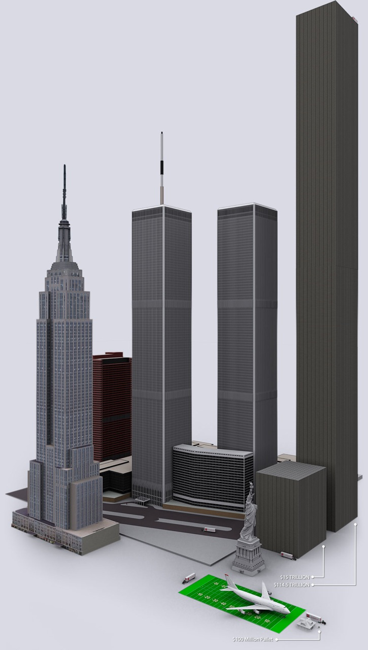

IT’S EASY TO BACK UP THE SAVINGS OF AVERAGE AMERICANS

I personally do not think it is a bad thing to let these companies fail. I fight back with facts – and think for myself instead.

The real money of ordinary people holding accounts in those banks could have been protected for much less than the cost of even the first public TARP bailout.

Just to prove the point, let’s go to billshrink.com and get some provable statistics:

http://www.billshrink.com/blog/10053/how-much-do-american-save/

The average American household income was 50,000 dollars in 2010. The overall tax rate is 19 percent, leaving $40,500 in disposable income.

Overall, Americans spend an incredible 94 percent of their disposable income. The remaining 6 percent is saved in the bank.

This adds up to a mere $2,400 dollars per household. This is not a guess, but a provable statistic.

With 114,825,428 households in the US, it would only take one payment of 275 billion, 581 million dollars to guarantee the savings of all American citizens.

The Fed’s secret bailout of 26 trillion dollars was nearly 100 times greater than that.

WHAT ABOUT THE STOCK MARKET?

Obviously the money being held in the stock market is a lot more than 275 billion dollars – but how much is there, exactly?

We know this figure. All you have to do is add up the value of all the companies on the New York Stock Exchange.

This is called “total market capitalization” or the “Total Market Index.” As of this writing, it is just over 13 trillion dollars:

http://www.gurufocus.com/stock-market-valuations.php

As of today (12/24/11), the Total Market Index is at $ 13,197.2 billion, which is about 88% of the last reported GDP.

This means that even if every single company in the world were to completely stop doing business — abandoning their offices, factories, equipment and services – we could still guarantee every stock on Earth for half the cost of the $26 trillion dollars in interest-free ‘bailout’ loans handed out by the Fed.

Obviously, the offices, factories, equipment, inventory and 95% of the employees could still be used after breaking up these monopolies and arresting the top conspirators. Without the toxic profit losses due to such incredible theft, these companies would probably thrive like never before.

The idea that any company’s entire value to its shareholders would simply disappear in the face of a breakup is completely illogical. Stocks always go down and up, down and up. That’s what they do. People will always need things. There will always be buying and selling.

HOW FAR DOWN DOES THE RABBIT HOLE GO?

Again, the Federal Reserve is a private corporation that prints money for the United States. The US then pays interest for the rights to use these “Federal Reserve Notes.”

The Federal Reserve secretly handed out 26 trillion dollars in bailout money between 2007 and 2010. The top four bailed-out banks are now doing 95.9 percent of all the gambling. Their total risk adds up to 600 trillion dollars – ten times more than all the money in the world.

At this point, it may seem that all we have to do is dismantle the Federal Reserve, let the US Treasury print its own money, back up everyone’s bank accounts for 275 billion dollars, and then allow a handful of “too big to fail” financial institutions to collapse — and be restructured in smaller pieces.

However, we now have scientific proof that this problem goes much deeper than just the Federal Reserve and a few of their closest banking buddies.

Instead, the Federal Reserve appears to be at the epicenter of a vast “interlocking directorate” of companies that may earn up to 80 percent of all the world’s wealth.

This, of course, makes it a lot more complicated to clean things up – but I do still believe it can be done, or else I wouldn’t have conducted this investigation.

USING SUPER-COMPUTERS TO PROVE THE FED RUNS THE WORLD

Ever since Benoit Mandelbrot discovered “fractals” in the 1970s, the fascinating new science of Chaos Theory has become a part of our collective knowledge base.

Mandelbrot discovered a remarkable “geometry of nature” – in which highly complex systems can be reduced down to a few very simple ingredients.



What if we use this same science to “hack” the world’s economy with super-computers – and see how many corporations actually control it?

Three scientists from the Swiss Federal Institute of Technology in Zurich, led by James Glattfelder, recently did this – and their results were published in New Scientist, a respected science magazine.

Glattfelder’s team unleashed a vast armada of supercomputers on Orbis 2007 — a very elaborate database of the top 37 million corporations and individual investors worldwide.

The results were absolutely stunning.

A CORE OF 1,318 COMPANIES EARN 80 PERCENT OF THE WORLD’S WEALTH

The Swiss scientists quickly found a total of 43,060 trans-national corporations in the Orbis 2007 database.

From this group, Glattfelder’s team revealed that a ‘core’ of 1,318 companies directly controlled 20 percent of the world’s wealth.

However, these corporations also appeared to own and control the stock in a majority of the world’s largest companies — whose profits added up to an additional 60 percent of global revenues:

http://www.newscientist.com/article/mg21228354.500-revealed–the-capitalist-network-that-runs-the-world.html

Although they represented 20 per cent of global operating revenues, the 1318 [corporations] appeared to collectively own, through their shares, the majority of the world’s large blue chip and manufacturing firms — the “real” economy — representing a further 60 per cent of global revenues….

[This] core of 1318 companies [had] interlocking ownerships. Each of the 1318 had ties to two or more other companies, and on average they were connected to 20 [other corporations].

A “SUPER-ENTITY” OF 147 CORPORATIONS CONTROL 40 PERCENT OF THE WEALTH

If that isn’t surprising enough for you, then how about this?

Glattfelder’s team then crunched the numbers even harder – and found a very deeply hidden “super-entity” of only 147 corporations – and “much of it” was connected to the 1,318-company ‘core’.

These 147 companies were all interconnected with each other in an “even more tightly knit” pattern than the 1,318 corporations in the ‘core’. To put it simply, they all owned each other’s companies.

[Specifically, each company within the “super-entity” owned shares in all 146 others.]

Together, this super-elite, good-old-boys-club of 147 companies directly earns a whopping 40 percent of all the wealth in the world:

http://www.newscientist.com/article/mg21228354.500-revealed–the-capitalist-network-that-runs-the-world.html

When the team further untangled the web of ownership, it found much of it tracked back to a “super-entity” of 147 even more tightly knit companies — all of their ownership was held by other members of the super-entity — that controlled 40 per cent of the total wealth in the network.

Without the advanced technology of supercomputers and chaos theory, no one would have been able to discover this. History has caught up to the Powers that Were.

THE SAME PEOPLE RUN THE FEDERAL RESERVE

Next question: What kind of companies do you think these top 147 corporations are? Remember – they control a staggering 40 percent of the world’s wealth.

As it says on page 6 of the paper, 75 percent of the corporations within the “super-entity” were financial institutions.

The top 20 financial institutions within the “super-entity” should sound pretty familiar to you by now.

They include Barclays Bank, JP Morgan Chase & Co., Merrill Lynch, UBS, Bank of New York, Deutsche Bank and Goldman Sachs.

THE SCIENTISTS DIDN’T WANT TO STICK THEIR NECKS OUT

To be fair, these scientists did say this could all be due to the magic of Chaos theory.

They said this could all be a “logical phase” of the “self-organizing” nature of complex systems – such as the global economy:

http://www.newscientist.com/article/mg21228354.500-revealed–the-capitalist-network-that-runs-the-world.html

“Such structures are common in nature,” says Sugihara…. Or as Braha puts it: “The Occupy Wall Street claim that 1 per cent of people have most of the wealth reflects a logical phase of the self-organising economy.”

So, the super-entity may not result from conspiracy. The real question, says the Zurich team, is whether it can exert concerted political power.

Driffill feels 147 is too many to sustain collusion. Braha suspects they will compete in the market but act together on common interests….

“It’s disconcerting to see how connected things really are,” agrees George Sugihara of the Scripps Institution of Oceanography in La Jolla, California, a complex systems expert who has advised Deutsche Bank.

THE END OF THE PAPER IS WORDED MORE BOLDLY

You never waste words when you write up a scientific paper after years’ worth of hard work. Bearing that in mind, read the last paragraph of the actual paper itself:

http://arxiv.org/PS_cache/arxiv/pdf/1107/1107.5728v2.pdf

This is the first time a ranking of economic actors by global control is presented. Notice that many actors belong to the financial sector… and many of the names are well-known global players….

This means that they do not carry out their business in isolation but, on the contrary, they are tied together in an extremely entangled web of control.

This finding is extremely important since there was no prior economic theory or empirical evidence regarding whether and how top players are connected.

Finally, it should be noted that governments and natural persons are only featured further down in the list.

Then add this line in from the second-to-last paragraph of the first part of the paper, on page 8:

Our results show that, globally, top holders are at least in the position to exert considerable control, either formally (e.g., voting in shareholder and board meetings) or via informal negotiations.

“Informal negotiations” would be one way to describe the Federal Reserve System secretly handing 26 trillion dollars to the “top holders” within the “super-entity” of 147 corporations.

THIS MAY NOT BE A “NATURAL SELF-ORGANIZING EFFECT” AT ALL

Remember what we learned from Congressman Bernie Sanders after they audited the Federal Reserve?

The directors and board members of the 12 Federal Reserve banks are also running the top financial institutions. They just printed 26 trillion dollars of American money and gave it to themselves.

There’s nothing “natural” about this at all.

Our next task is to “follow the money” – and see if we can find out what corporations and industries are owned, either publicly or in secret, by the Federal Reserve “super-entity”. (Glattfelder’s team has not yet published the full list.)

It’s not that hard to do. If 80 percent of all the world’s profits are going to the Federal Reserve “super-entity”, then they would need to control many of the most profitable industries.

As Glattfelder’s team already said, this entity controls “the majority of the world’s large blue chip and manufacturing firms.”

In case you are unfamiliar with the term “blue chip,” it refers to any large company that consistently draws profits. The Dow Jones Industrial Average tracks the top 30 “blue chip” companies.

WHAT ARE THE MOST PROFITABLE INDUSTRIES TO BE IN?

I was able to find a Fortune 500 listing of the most profitable industries, by percentage, for 2008 – but nothing more recent. (If you can find it, let me know.)

This list only applies to American companies, but it is still very relevant. Here’s how it looks:

http://money.cnn.com/magazines/fortune/fortune500/2009/performers/industries/profits/

The Number One industry on the list is Network and Other Communications Equipment, earning a 20.4 percent profit margin. Number Two on the list is Internet Services and Retailing, at 19.4 percent.

Financial Data Services do not appear until sixth place – at 11.7 percent.

Pharmaceuticals squeak into third place at a 19.3 percent margin. However, this is misleading – because the overall healthcare / pharmaceutical industry is broken up into fully seven different categories:

Pharmaceuticals – 19.3%. Medical Products and Equipment – 16.3%. Insurance: Life, Health (stock) – 4.6%. Health Care: Pharmacy and Other Services – 3.0%. Health Care: Medical Facilities – 2.4%. Health Care: Insurance and Managed Care – 2.2%. Wholesalers: Health Care – 1.3%.

There are only 43 industries on the Fortune 500 list that actually generated profits – and seven of them are healthcare.

Healthcare therefore accounts for 16.28% of all the money-making industries on the Fortune 500 list. Nothing else captures that many different categories.

WHAT ABOUT THE OIL COMPANIES?

The second most-profitable American industry, based on the number of categories it has on the list and how high of a percentage they make, is the petroleum and energy business – which controls six out of 43 spots:

http://money.cnn.com/magazines/fortune/fortune500/2009/performers/industries/profits/

Mining, Crude Oil production – 11.5 percent. Oil and Gas Equipment, Services – 10.2 percent. Utilities: Gas and Electric – 8.7 percent. Petroleum Refining –2.1 percent. Pipelines – 1.5 percent. Energy – 0.9 percent.

The oil companies therefore enjoyed 13.95% of all the most profitable categories of American businesses in 2008.

Together, oil and pharmaceuticals occupy 13 out of 43 slots on the Fortune 500 list of the most profitable American industries – or a stunning 30.23 percent of all the money there is to be made.

THE OIL COMPANIES ARE THE MOST PROFITABLE INDIVIDUAL BUSINESSES

Remember – the above figures only tell us how strong of a profit each of these industries is making. If you invested in an industry that was making 20 percent profit per year, you’d be very happy.

This doesn’t actually tell us how much money they are pulling in. If you had a company that cost ten dollars to run, and you made twelve dollars a year, you’d still be making a 20 percent profit.

In order to figure out how much actual money is being made, you have to look at individual businesses.

Here is a link to the Fortune 500 list of the 50 most profitable American businesses in 2010:

http://money.cnn.com/magazines/fortune/fortune500/2011/performers/companies/profits/

The single most profitable American corporation in 2010 was Exxon Mobil — earning 30 billion, 460 million dollars.

Chevron comes in behind AT&T to take third place at 19 billion, 24 million dollars.

ConocoPhillips was #16 at 11 billion, 358 million. Devon Energy and Occidental Petroleum both made 4.5 billion.

Add it all together and you get 69 billion, 842 million dollars in oil profits for 2010 alone – basically 70 billion – and that’s only the oil companies in America’s top 50.

INTERNATIONAL LISTINGS CHANGE THE PICTURE

The Fortune 500 list only applies to American industries.

You have to go international to include the non-American “supermajor” oil companies – namely BP, Royal Dutch Shell and Total S.A. – each of which are also very substantial – in addition to the American-based Chevron, ExxonMobil and ConocoPhillips.

The full international list with all these companies included is called the Forbes Global 2000. This gives us a better overall sense of what’s going on in the world – but it still only tracks companies that have to publicly report their earnings.

Eight out of the top 20 largest international companies are banks: JP Morgan Chase, HSBC (UK), ICBC (China), Citigroup, BNP Paribas (France), Wells Fargo, Banco Santander (Spain) and China Construction Bank. That’s a total of 40 percent.

Seven of the top 20 public international companies are oil and gas: Exxon Mobil, Royal Dutch Shell, Petro China, Petrobras, Gazprom, Chevron and Total. That’s 35 percent.

So, fifteen out of the top 20 companies on the Forbes 2000 list – seventy-five percent – are either banking or oil. That leaves only five slots left in the top 20.

Let’s also not forget that the Forbes 2000 list only applies to publicly-traded companies.

LET’S LOOK AT THE PHARMACEUTICALS

Let’s go back to the Fortune 500 list of the top American corporations for a minute.

Fully nine out of the top 50 most profitable Fortune 500 companies in 2010 were pharmaceuticals – and they add up to a total of 64 billion, 924.6 million dollars in profits.

These are only the most obvious, verifiable pharmaceutical / healthcare companies on the list, and only those that appear in the top 50 of the Fortune 500 list:

http://money.cnn.com/magazines/fortune/fortune500/2011/performers/companies/profits/

Johnson and Johnson weighs in at ninth place with 13 billion, 334 million. 10th place is Warren Buffet’s Berkshire Hathaway, with 12 billion, 967 million. Then, Procter & Gamble comes in right behind them for 12th place at 12 billion, 736 million.

Pfizer shows up at number 21 with 8 billion, 257 million. Eli Lilly is in 29th place with 5 billion, 69.5 million.

UnitedHealth Group comes in at 32nd place with 4 billion, 634 million. Amgen is right behind them at the 33rd slot with 4 billion, 627 million.

United Technologies appears at 37th place with 4 billion, 373 million. Then lastly we see CVS Caremark at 47th place with 3 billion, 427 million.

Again – nine out of all 50 of the top Fortune 500 companies are pharmaceuticals. These companies alone pulled in almost 65 billion dollars in profits for 2010, close behind the 70 billion made in oil money.

Pharmaceuticals do not jump out this much on the Forbes Global 2000 list. The only pharmaceutical company in the top 20 is Berkshire Hathaway at #8, which is technically a conglomerate that has holdings in other industries as well.

DON’T FORGET THE UNITED STATES DEFENSE BUDGET

The total combined income for oil and pharmaceuticals in the top 50 slots of the Fortune 500 list is 70 billion plus 65 billion — or 135 billion in total.

The United States Department of Defense handed out 721.3 billion dollars in Fiscal Year 2011 alone.

This does not include 20.9 billion for Atomic Energy Defense activities, nor 124.5 billion in veterans’ benefits, nor 10.1 billion in foreign military aid, nor 44.1 billion in foreign economic aid, nor 7.5 billion in defense-related activities.

There are supposedly over 330,000 defense contractors receiving this income.

The top 100 defense contractors in 2010 only earned about $129.48 billion, based on a rough, approximate calculation — out of a total Department of Defense expenditure of 692 billion for that year. That still leaves 562.5 billion dollars unaccounted for.

The top five defense contractors for 2010 were Lockheed Martin at 16.7 billion, Northrop Grumman at 11.1 billion, Boeing at 10.4 billion, Raytheon at 6.7 billion and SAIC at 4.7 billion.

In order for the ‘core’ of 1,318 companies to be earning 80 percent of the world’s wealth, it would be absolutely essential for them to profit from this enormous defense budget. There’s nothing else like it in the world.

Based on the new findings of the Swiss scientists, many of these defense contractors may be part of a single mega-conglomerate working behind the scenes.

A DIRECT CONNECTION TO THE FEDERAL RESERVE

To review, 80 percent of the world’s profits are being earned by a ‘core’ group of 1,318 corporations.

As we look even deeper, we find this ‘core’ is mostly run by a “super-entity” of 147 companies that are totally interlocked. 75 percent of them are financial institutions.

The top 20 companies in the “super-entity” include Barclays Bank, JP Morgan Chase & Co., Merrill Lynch, UBS, Bank of New York, Deutsche Bank and Goldman Sachs.

Many key Federal Reserve personnel work for these companies – and they secretly handed themselves trillions of dollars in free money between 2007 and 2010.

The 147-part “super-entity” has controlling interest in the 1318-part “core”, which in turn has controlling interest in 80 percent of the world’s wealth.

It would be utterly essential for the Federal Reserve corporations, and their beneficiaries, to be heavily invested into oil and pharmaceuticals — as well as the United States defense system — in order to earn such a tremendous percentage.

Is there any proof that the Federal Reserve elites are, indeed, invested in these and other top businesses? Absolutely.

Let’s now do some historical research on the top two Federal Reserve names we always read about – the Rockefellers and Rothschilds – and see what we find.

ROCKEFELLER’S STANDARD OIL COMPANY

John D. Rockefeller, one of the top architects who founded and bankrolled the Federal Reserve System, also owned and ran Standard Oil Company, beginning in 1870. He soon became America’s first billionaire.

Rockefeller’s spectacular oil profits ultimately allowed him to be in a position to essentially buy the United States government — and its ability to print money – via the Federal Reserve.

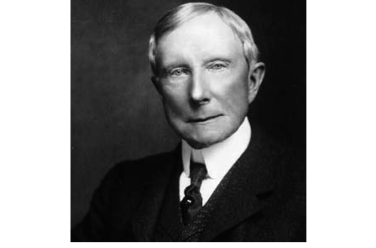

Standard Oil had a virtual monopoly on producing, transporting, refining and marketing oil up until 1911, when it was broken up by an alarmed United States Supreme Court in antitrust legislation.

Standard Oil of New Jersey became Esso, later to be renamed Exxon – which became a key part of ExxonMobil, currently the most profitable company in the world — earning 30 billion, 460 million dollars.

Standard Oil of California became Chevron – currently the third most profitable company in the world at 19 billion, 24 million dollars per year.

Continental Oil Company became Conoco, now a part of ConocoPhillips – currently the sixteenth most profitable company in the world at 11 billion, 358 million dollars.

BP Amoco is a conglomerate of several Standard Oil splinter companies. Yahoo Finance currently lists BP Amoco’s gross profit at 16 billion, 28 million dollars.

Therefore, four out of the six “supermajors” in the oil industry are direct Rockefeller spinoffs – BP, Chevron, ExxonMobil and ConocoPhillips.

Our Swiss scientists proved that these companies never really broke apart. The 1,318 in the “core” and 147 “super-entity” corporations are extremely interlocked with one another.

THE ROTHSCHILD FAMILY

Many researchers and insiders have suggested that the single largest Federal Reserve shareholder is the Rothschild family.

I went straight to the source and read their officially-sanctioned The Rothschilds: A Family Portrait, by Frederic Morton, Atheneum Press, New York, 1962, to learn more about them.

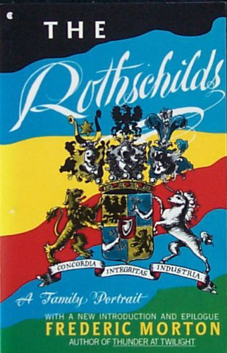

I didn’t realize that Frankfurt, Germany was very hostile to Jews in the late 1700s. The Rothschilds lived in the ghetto, were subject to extreme public humiliation, and were nearly broke as of 1764.

http://www.amazon.com/ROTHSCHILDS-FAMILY-PORTRAIT-frederic-Morton/dp/0020230028/ref=sr_1_1?ie=UTF8&qid=1326081738&sr=8-1

16: On his way Mayer could not escape the street urchins whose favorite amusement was to shout, “Jew, do your duty!”—whereupon the Jew had to step aside, take off his hat, and bow.

Having thus entertained the local children, Mayer reached the heavy chains with which soldiers manacled the Judengasse (Jew Street) every night.

The ghetto… [had] an ordinance that barred Frankfurt Jews from farming, from handicrafts, even from dealing in nobler goods such as weapons, silk or fresh fruit….

Another city edict limited the Jews to five hundred families and to no more than twelve marriages a year.

ANGER TURNS TO ACTION

With such extreme public humiliation and oppression, occurring on a daily basis for generations, the Rothschilds may well have lost faith in the goodness and kindness of humanity.

Mayer Amschel Bauer (later “Rothschild”) was born in 1743. After his father’s death, he apprenticed for three years at the Bank of Oppenheimer and became a junior partner.

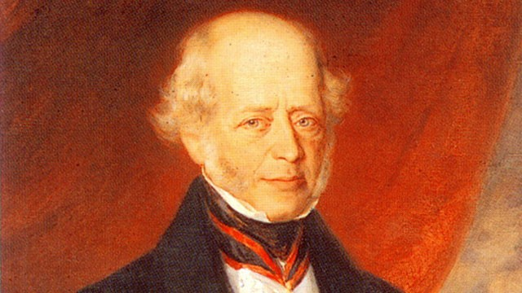

By then, he had earned enough money to buy his father’s counting house, which was adorned with a red shield, symbolizing the desire for Revolution – thus inspiring him to take the last name “Rothschild.” (The family home he purchased later had a green shield.)

Mayer Amschel soon found ingenious ways to make highly intelligent business deals with top royals, providing banking services to handle all the unpleasant transactions they didn’t want to be involved in.

He won over their good graces through a variety of clever techniques, such as selling them rare and precious coins at absurdly low prices.

I was surprised to see how bluntly the author of The Rothschilds spoke about the level of influence Mayer Amschel’s family came to have on the world – but things were very different in 1962, when the book was written.

13: [In] Frankfurt [Germany]… in a cramped ghetto dwelling… with a yellow star pinned to his caftan, Mayer Amschel Rothschild kept a small store two centuries ago.

[He] married Gutele Schnapper, and raised with her those five incredible sons who conquered the world more thoroughly, more cunningly and much more lastingly than all the Caesars before or all the Hitlers after them.

NO ONE DENIES THE POWER OF THE ROTHSCHILDS

The Rothschild name is no longer commonly heard in mainstream media – but this wasn’t the case when The Rothschilds was written in 1962. Their deep connections to royalty were openly admitted in the book.

5: No modern name breathes a more storied eminence. No nonroyal family has held so much power so consistently, so peculiarly….

It would be insufficient to sum up the family as “still very wealthy.” The Rothschild fortunes in England and in France are as ineffable as ever….

6: For generations the people at Buckingham Palace have recognized the kinship: Queen Victoria often dined and slept in Rothschild houses; the Duke of Windsor fled to a Rothschild (an Austrian one) directly after his abdication.

11: The two big [Rothschild] banks in London and Paris (probably the world’s largest private financial institutions)… have not so much as a name plate outside.

Though they control scores of industrial, commercial, mining and tourist corporations, not one bears the name Rothschild.

Being privately held partnerships, the family houses never need to, and never do, publish a single public balance sheet or any other report of their financial condition.

QUITE AN INORDINATELY SUCCESSFUL FAMILY

As we read further in The Rothschilds, we find out that Mayer Amschel’s five male children distributed themselves throughout Europe – becoming essentially the world’s first multi-national corporation.

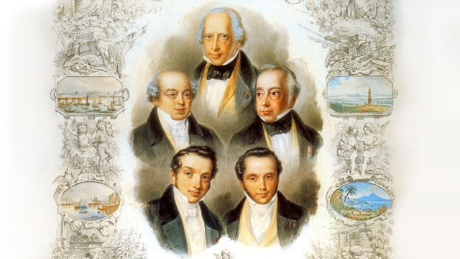

Each of his sons rose to very prominent positions of power – in Germany, Austria, England, Italy and France, respectively.

29: Perhaps the early Romans were the most successful nation we have known; perhaps Napoleon the most formidable individual.

It is quite possible that the people still bustling obscurely at the Green Shield [at the end of the 1780s in Frankfurt’s Jewish ghetto] were the family par excellence in modern history.

As long as Mayer lived alone with his wife, he was… a Caesar without centurions. But soon those boys marched out of Gutele’s womb like so many dauntless legions.

First came Amschel, future treasurer of the German Confederation. Then Salomon, who in the end achieved exactly the exalted station in imperial Vienna that remained [Prince] Landgrave William’s perpetual daydream.

Then Nathan, who rose to more power than any other man in England. Then Kalman, who wound the Italian peninsula around his hand. Then Jacob, who was to lord it in France during Republic and Empire.

NATHAN ROTHSCHILD BUYS THE BRITISH EMPIRE

Morton’s book does not apologize about the Rothschilds’ behavior. One of the most stunning examples is in the discussion of “consols” beginning on page 49.

“Consols” was short for “consolidated annuities” – essentially the stock of the British government after it consolidated its assets in 1751. Trading “consols” was literally trading the wealth of the British empire – and its people.

The French Empire, under Napoleon, was trying to take over everything in Europe. A seven-nation alliance commanded by the British was fighting back. It was commonly expected that the final outcome of this conflict would be decided at Waterloo.

The battle all happened on June 18, 1815. Napoleon was outnumbered – 72,000 to 118,000. Napoleon surrendered as of 10PM – after 25,000 of his men had been killed or wounded. 19,300 men were killed or wounded on the Anglo-Prussian side – all in a single day.

That much death and destruction in one field was a horror show. Four days later, Major W. E Frye surveyed the damage and had to leave, because he was so traumatized he nearly threw up.

http://en.wikipedia.org/wiki/Battle_of_Waterloo

On arrival there the sight was too horrible to behold. I felt sick in the stomach and was obliged to return.

The multitude of carcasses, the heaps of wounded men with mangled limbs unable to move, and perishing from not having their wounds dressed or from hunger, as the Allies were, of course, obliged to take their surgeons and waggons with them, formed a spectacle I shall never forget.

INSIDER TRADING

Nathan Rothschild was one of the very first to get the news of the British victory – on the dawn of June 20th.

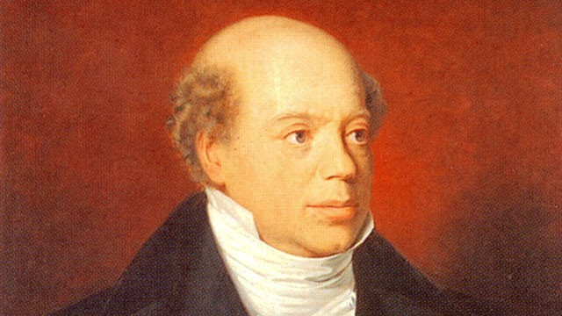

The Rothschilds tells us an agent named Rothworth rushed Nathan the news by boat – beating the official British messenger by several hours.

49: There was no news more precious than the outcome of Waterloo… If Napoleon won, English consols were bound to drop. If he lost, the enemy empire would shatter and consols rise….

Another man in his position would have sunk his worth into consols. But this was Nathan Rothschild… He did not invest. He sold. He dumped consols.

His name was already such that a single substantial move on his part sufficed to bear or bull an issue.

Consols fell. Nathan leaned and leaned, and sold and sold. Consols dropped still more. “Rothschild knows,” the whisper rippled through the ‘Change. “Waterloo is lost.”….

Consols dived, consols plummeted—until, a split second before it was too late, Nathan suddenly bought a giant parcel for a song. Moments afterwards the great news broke, to send consols soaring.

We cannot guess the number of hopes and savings wiped out by this engineered panic… how many liveried servants, how many Watteaus and Rembrandts… [Rothschild] won that single day.

SIX THOUSAND, FIVE HUNDRED-TIMES INCREASE IN WEALTH

According to the meticulous research of Eustace Mullins (1985), in this one single maneuver Nathan Rothschild expanded his fortune by a staggering factor of 6,500 times.

If you don’t understand what happened, he basically tricked everyone into selling everything they had, and then bought it all back on the cheap – right before the stock prices skyrocketed.

MASS PANIC IS BIG BUSINESS IF YOU ALREADY KNOW THE OUTCOME

The single greatest way to make money and secure control is to stage a mass panic. That was the lesson. If everyone sells and you know exactly the right moment to buy, you can achieve seemingly limitless power.

As the Amazon commenter “SmokeNMirrors” pointed out on August 7, 2009,

http://www.amazon.com/ROTHSCHILDS-FAMILY-PORTRAIT-frederic-Morton/dp/0020230028/ref=sr_1_1?ie=UTF8&qid=1326081738&sr=8-1

Nathan himself believed that with that move he came to control the British money supply, and with it the whole of the British Empire.

That wealth begets wealth is well known; if less than 2 centuries ago one family essentially owned the British Empire, there is a very real chance that that fortune is now many times larger than it was then….

What is beyond doubt is that they have controlled the Federal Reserve since its creation (indeed, it was their creation!) and officially the Bank of England since at least the mid-1800s.

THIS IS NOT A “JEWISH CONSPIRACY”

The Rothschilds’ own sanctioned family biography reveals the extent of power they came to hold throughout Europe.

However, blaming all this on the Jewish people would be a fatal and ridiculous mistake. Any time we begin demonizing whole races of people, we have voted for genocide.

The motivations and philosophies behind these “banking families” are rooted in secret societies that have nothing to do with Judaism, as we will soon see.

I do believe that forgiveness – despite the atrocities that have been and are being committed – will serve us much better than any desire for vigilante justice.

I have had multiple, trusted insider contacts tell me that the younger generations of this and other top banking families want to create radical, positive changes.

They do not share the cynical, negative attitude towards humanity that many of their elders still have.

Furthermore, the “system” is so large, so interconnected and so woven through all aspects of our society that the only valid way to transform it is from within.

Knowledge is the key. The system has thrived in secrecy. The truth will set us free.

WHO ACTUALLY RUNS THE FEDERAL RESERVE?

Though this information is a closely-guarded secret, there have been enough leaks to confirm the identities of the key banking families who founded the Federal Reserve.
By now, many of them should sound familiar to you – since they used the Federal Reserve to bail themselves out:

http://www.globalresearch.ca/index.php?context=va&aid=25080

J. W. McCallister, an oil industry insider with House of Saud connections, wrote in The Grim Reaper that information he acquired from Saudi bankers cited 80% ownership of the New York Federal Reserve Bank- by far the most powerful Fed branch- by just eight families, four of which reside in the US.

They are the Goldman Sachs, Rockefellers, Lehmans and Kuhn Loebs of New York; the Rothschilds of Paris and London; the Warburgs of Hamburg; the Lazards of Paris; and the Israel Moses Seifs of Rome.

CPA Thomas D. Schauf corroborates McCallister’s claims, adding that ten banks control all twelve Federal Reserve Bank branches.

He names N.M. Rothschild of London, Rothschild Bank of Berlin, Warburg Bank of Hamburg, Warburg Bank of Amsterdam, Lehman Brothers of New York, Lazard Brothers of Paris, Kuhn Loeb Bank of New York, Israel Moses Seif Bank of Italy, Goldman Sachs of New York and JP Morgan Chase Bank of New York.

Schauf lists William Rockefeller, Paul Warburg, Jacob Schiff and James Stillman as individuals who own large shares of the Fed. [3] The Schiffs are insiders at Kuhn Loeb. The Stillmans are Citigroup insiders, who married into the Rockefeller clan at the turn of the century.

Eustace Mullins came to the same conclusions in his book The Secrets of the Federal Reserve, in which he displays charts connecting the Fed and its member banks to the families of Rothschild, Warburg, Rockefeller and the others. [4]

PHARMACEUTICAL COMPANIES SACRIFICE PEOPLE FOR PROFITS

Now that we’ve touched on the Rockefeller oil and Rothschild banking aspects of the Federal Reserve, let’s move back to pharmaceuticals for a minute.

Again, nine out of the top 50 most profitable Fortune 500 companies in 2010 were pharmaceuticals – at a total of 64 billion, 924.6 million dollars in profits.

Most people are unaware of the blatant crimes against humanity that have been committed by the biggest pharmaceutical companies:

http://www.huffingtonpost.com/johann-hari/the-horrifying-hidden-sto_b_251365.html

The US Government Accountability Office says that far from being a font of innovation, the drug market… spends virtually nothing on the diseases that kill the most human beings, like malaria, because the victims are poor, so there’s hardly any profit to be sucked out….

“ME TOO” DRUGS

Many pharmaceutical companies are in the business of creating “me too” drugs. They take a popular drug, change it by at little as one molecule, and re-release it as a new product.

This generates massive amounts of profits – and it is costing us dearly:

http://www.huffingtonpost.com/johann-hari/the-horrifying-hidden-sto_b_251365.html

A detailed study by Dr Marcia Angell, the former editor of the prestigious New England Journal of Medicine, says that only 14 percent of [pharmaceutical companies’] budgets go on developing drugs — usually at the uncreative final part of the drug-trail.

The rest goes on marketing and profits.

And even with that puny 14 percent, drug companies squander a fortune developing “me-too” drugs — medicines that do exactly the same job as a drug that already exists, but has one molecule different, so they can take out a new patent, and receive another avalanche of profits….

The European Union’s competition commissioner, Neelie Kroes, recently concluded that Europeans pay 40 percent more for their medicines than they should because of this “rotten” system — money that could be saving many lives if it was redirected towards real health care.

ARSENIC IN CHICKEN FEED

The pharmaceutical giant Pfizer manufactures chicken feed for factory-raised birds. The droppings of these birds are then fed to factory-raised cattle.

A recent expose’ revealed that Pfizer has been putting arsenic in their chicken feed to allegedly kill parasites and stimulate faster growth.

For many years they argued this did not pass into the meat, but all went out as waste.

Recently this was proven incorrect by the FDA. All factory-raised chicken meat could have had arsenic in it – a deadly poison. This makes it very likely that factory-raised beef may have had arsenic as well.

Though this product Roxarsone has now been pulled from shelves in the United States, Pfizer indicated it wouldn’t necessarily pull it from about a dozen other countries unless regulators force them to.

The toxic poisoning of arsenic creates health problems. Most people try to solve their health problems by taking pharmaceuticals – rather than changing their diets, such as to ethically-raised organic meats.

THE AMERICAN MEDICAL ASSOCIATION WAS FINANCED BY THE FED

Foster Gamble’s “Fact Checking” section of the Thrive Movement website reveals that the American Medical Association was financed by the Rockefellers (Federal Reserve).

If you own and control the pharmaceutical industry, it would certainly make sense to secretly run the agency in charge of regulating your products:

http://www.thrivemovement.com/fact_checks

Fact: The American Medical Association (AMA) is largely funded by the Rockefellers, who in turn use their funding to influence AMA research and decision-making.

The Rockefeller Foundation website points to various connections between the American Medical Association and the Foundation. Here are a few examples:

Rockefeller Foundation Annual Report, 1932
Rockefeller Foundation Annual Report, 1957
Making the eHealth Connection: Participants
The Long Road to Universal Health Coverage

The American Medical Association has been accepting money from the Rockefeller and Carnegie Foundations from as early as 1910.

In The World Without Cancer G. Edward Griffin makes the argument that the Rockefeller and Carnegie Foundations began to support the AMA in an effort to control the medical schooling establishment and to gain power over this “large and vital sphere of American life.”

WHY WOULD WE KEEP SUCH A CORRUPTED HEALTHCARE SYSTEM?

If the pharmaceutical industry is putting profits over people, and gouging money out of an already strapped economy, then why would we keep it?

Johann Hari reveals the answer – they literally bought the government.

http://www.huffingtonpost.com/johann-hari/the-horrifying-hidden-sto_b_251365.html

Why would we keep this system, if it is so bad?

The drug companies have spent more than $3 billion on lobbyists and political “contributions” over the past decade in the US alone. They have paid politicians to make the system work in their interests.

If you doubt how deeply this influence goes, listen to a Republican congressman, Walter Burton, who admitted of the last big health care legislation passed in the US in 2003: “The pharmaceutical lobbyists wrote the bill.”

IT ALL STARTS TO BLUR TOGETHER

This is where the lines between government, military, finance, defense contractors and corporations all begin to blur. At the core of all this is a “super-entity” of 147 companies – 75 percent of which are financial institutions.

A hugely popular Rolling Stone article by Matt Tabibi systematically revealed how Goldman Sachs is at the center of an incestuous relationship between Wall Street, the elected government and the Federal Reserve.

This article earned 23,000 Facebook Likes and 268 written comments as a result of its stunning journalism – most of which I won’t include here due to its complexity:

http://www.rollingstone.com/politics/news/the-people-vs-goldman-sachs-20110511

[Goldman Sachs] seemed to count on the unwillingness or inability of federal regulators to stop them — and when called to Washington last year to explain their behavior, Goldman executives brazenly misled Congress, apparently confident that their perjury would carry no serious consequences….

Goldman… [is] a powerful, well-connected firm, with the ear of the president and the Treasury, that appears to have conquered the entire regulatory structure — and stands now on the precipice of officially getting away with one of the biggest financial crimes in history.

The fact that this evidence [covered throughout the article] comes from a U.S. senator’s office, and not the FBI or the SEC, is itself an element in the worsening tale of lawlessness and despotism that sparked a global economic meltdown….

If the Justice Department fails to give the American people a chance to judge this case — if Goldman skates without so much as a trial — it will confirm once and for all the embarrassing truth: that the law in America is subjective, and crime is defined not by what you did, but by who you are.

WHAT DO YOU SAY TO THE SKEPTICS?

Most people go with the “gut” rather than with scientific facts.

Go ahead and try to tell someone that a “super-entity” of 147 corporations appears to be running the world, and those corporations are completely interconnected with the Federal Reserve – which handed out 26 trillion dollars in bailouts, without any regulation or oversight from the American government.

You may find yourself coming face-to-face with very strong denial, ridicule and attack — even in the face of undeniable evidence.

Our Swiss scientist James Glattfelder, who used supercomputers to prove that a small number of companies control the majority of the world’s wealth, spoke directly to the skeptics in this next quote:

http://www.newscientist.com/article/mg21228354.500-revealed–the-capitalist-network-that-runs-the-world.html

“Reality is so complex, we must move away from dogma, whether it’s conspiracy theories or free-market,” says James Glattfelder.

“Our analysis is reality-based.”

The next question you would reasonably ask yourself is this: How the hell have these people avoided getting caught for the last 100-plus years?

THE EDUCATIONAL SYSTEM

What if it were possible to discourage critical thinking in the public – so people would never put all the pieces together? One useful way to do this would be to control the educational system.

Again, I understand that I am hitting a brick wall with the “average person” by bringing this up, as they cannot face the possibility that the world they live in has been so deeply manipulated and compromised.

Nonetheless, Foster Gamble’s “Fact Checks” section of the Thrive Movement website makes a compelling case that this is what happened.

THE ROCKEFELLERS “BOUGHT” THE EDUCATIONAL SYSTEM

The Federal Reserve created the National Education Association via the Rockefeller family:

http://www.thrivemovement.com/fact_checks

In the early 20th century both the Rockefeller and Carnegie Foundations were donating large sums of money to education and the social sciences. They supported, in particular, the National Education Association.

By way of grants, they spent millions of dollars — money which was used to radically bend the traditionalist education system toward a new system that favored standardized testing over critical thinking, toward “scientific management” in schools.

This was part of a calculated plan to make the schooling system benefit corporate America, at the expense of the American school child. Powerful foundations with private interests, such as the Ford Foundation, continue to support, and thereby influence the policy of, the NEA to this day.

Additionally, an unprecedented U.S. Congressional investigation into tax-exempt foundations identified the Rockefeller and Carnegie Foundations engagement in an agenda for vast population control.

Norman Dodd, Research Director for the Congressional Committee, found this statement in the archives of the Carnegie endowment:

“The only way to maintain control of the population was to obtain control of education in the U.S. They realized this was a prodigious task… [so] the portion of education which could be considered as domestically oriented [was] taken over by the Rockefeller Foundation and that portion which was oriented to International matters [was] taken over by the Carnegie Endowment.”…

MEDIA CONSOLIDATION

In order for such a vastly interconnected group to avoid detection for this long, it would also be an absolute requirement for them to buy, own and control the media.

You will soon see compelling, documented proof that the power elite were already bragging about this accomplishment by 1815 – the same year Nathan Rothschild won the British government on a bet.

However, we will review recent history first, so as to better understand how today’s world of seemingly hundreds of independent media sources is actually quite tightly controlled.

In 1983, there were 50 different independent media companies in the United States. By 2004, this number had reduced to five key players: Time Warner, Disney, News Corporation (FOX), Bertelsmann of Germany and Viacom (formerly CBS).

Ben Bagdikian expertly lays out all the proof for this media in his updated 2004 edition of The New Media Monopoly.

http://benbagdikian.net/

These five huge corporations — Time Warner, Disney, Murdoch’s News Corporation, Bertelsmann of Germany, and Viacom (formerly CBS) — own most of the newspapers, magazines, books, radio and TV stations, and movie studios of the United States….

These five are not just large — though they are all among the 325 largest corporations in the world — they are unique among all huge corporations: they are a major factor in changing the politics of the United States, and they condition the social values of children and adults alike.

SIX CORPORATIONS DOMINATE THE UNITED STATES’ MEDIA

A more recent investigation by FAIR.org revealed that the vast majority of media in the United States is dominated by six mega-corporations: General Electric, Walt Disney, News Corp, Time Warner, Viacom and CBS.

[As you delve into the individual categories of cable, television, print, telecom and radio, you find a few more companies chasing behind the Big Six – but not many.]

These companies often control the entire creative process of a film or television show from beginning to ending – making it an ideal environment for creating propaganda:

http://www.freepress.net/ownership/chart/main

The U.S. media landscape is dominated by massive corporations that, through a history of mergers and acquisitions, have concentrated their control over what we see, hear and read.

In many cases, these giant companies are vertically integrated, controlling everything from initial production to final distribution.

Three of these mega-conglomerates appear on Fortune 500’s Top 50 Most Profitable list for 2010:

http://money.cnn.com/magazines/fortune/fortune500/2011/performers/companies/profits/

This includes General Electric at 11 billion, 644 million; Walt Disney at 3 billion, 963 million; and Comcast at 3 billion, 635 million.

General Electric is also the world’s third biggest public company – according to the Forbes 2000 list.

AN INTERNATIONAL PLAN TO GENERATE PROPAGANDA?

You may not realize that most of the cable channels on American television are international. Subtitles are used in foreign countries. This is part of why so many people now speak English.

Therefore, the scope of this media consolidation is truly worldwide. Bertelsmann is the only company among Ben Bagdikian’s “Big Five” that is not primarily centered in the United States.

In his seminal work, Bagdikian reveals how these five main companies are shaping and molding society:

http://benbagdikian.net/

These Big Five (with General Electric’s NBC a close sixth) do not manufacture automobiles, or clothing, or nuts and bolts. They manufacture politics and social values.

The media conglomerates have been a major force in creating conservative and far right politics in the country.

They have almost single-handedly as a group, in their radio and television dominance, produced a coarse and vulgar culture that celebrates the most demeaning characteristics in the human psyche — greed, deceit, and cheating as a legitimate way to win (as in the various “reality” shows).

OPERATION MOCKINGBIRD

All this being said, it would be a terrible mistake to arrest and imprison the lower, middle and upper-mid-level staff in the media as if they are all complicit in the problem.

CEOs may not fully understand what’s going on either. They are well-paid to be the scapegoats when all hell breaks loose. The biggest powers are always those who work behind the scenes.

Key managers and directors are likely being bribed, blackmailed and threatened into doing the biddings of the Federal Reserve corporate super-entity – partly by not wanting to disappoint their advertisers.

This was well underway by 1948, with a little-known CIA project called Operation Mockingbird. Many documents have since been leaked or declassified on this subject.

Spartacus Educational is overflowing with documentation and links you can read – including references to multiple academic books investigating the subject.

http://www.spartacus.schoolnet.co.uk/JFKmockingbird.htm

In 1948 Frank Wisner was appointed director of the Office of Special Projects. Soon afterwards it was renamed the Office of Policy Coordination (OPC).

This became the espionage and counter-intelligence branch of the Central Intelligence Agency.

Wisner was told to create an organization that concentrated on “propaganda, economic warfare; preventive direct action, including sabotage, anti-sabotage, demolition and evacuation measures; subversion against hostile states, including assistance to underground resistance groups, and support of indigenous anti-Communist elements in threatened countries of the free world.”

Later that year Wisner established Mockingbird, a program to influence the domestic American media. Wisner recruited Philip Graham (Washington Post) to run the project within the industry….

According to Deborah Davis (Katharine the Great): “By the early 1950s, Wisner ‘owned’ respected members of the New York Times, Newsweek, CBS and other communications vehicles.”…

NEW YORK TIMES EXPOSES OPERATION MOCKINGBIRD

The New York Times actually revealed a small part of this explosive story in 2007.

http://washington.blogs.nytimes.com/2007/06/26/project-mockingbird/

The C.I.A. monitoring of journalists in 1963, 1971 and 1972, including wiretapping their phones and setting up observation posts across the street from their offices to track their comings and goings and their visitors, was a practice that the White House itself employed during the Nixon administration….

As with other questionable or illegal C.I.A. activities that were endorsed by top government officials, this account shows that spying on reporters was approved at the highest levels of the Kennedy administration….

By ordering the director of central intelligence to conduct a program of domestic surveillance, Kennedy set a precedent that Presidents Johnson, Nixon, and George W. Bush would follow.

The top investigative books on this subject include A Very Private Woman by Nina Burleigh, Mockingbird: The Subversion of the Free Press by the CIA by Alex Constantine, The Mighty Wurlitzer: How the CIA Played America by Hugh Wilford, Who Paid the Piper? by Frances Stonor Saunders and The Very Best Men by Evan Thomas.

This consolidated control did not fizzle out in more recent years. It has only gotten worse.

After a shocking betrayal, Conan O’Brien led the pack in revealing how centralized the media still is today.

CONAN O’BRIEN’S SHOCKING BETRAYAL FROM BIG MEDIA

Very few entities within the mainstream media have ever risen up against their own companies – but Conan O’Brien is a rare exception who should definitely be mentioned at this point.

Conan O’Brien was spectacularly humiliated by Big Media in January 2010 – only seven months after NBC made him the host of the Tonight Show, fulfilling a long-term contract from 2004.



NBC felt Conan’s ratings weren’t high enough. In a classic power-play attempt, NBC tried to force Conan to give the coveted 11:30 slot back to Jay Leno and settle for a show that didn’t begin until 12:05 am.

Conan refused to cave in to their power move – and quit.

He soon won a 40 million-dollar settlement for him and his staff due to this obvious breach of contract – and gave a healthy portion of his side of the settlement to his staff as well.

CONAN SANK INTO A DEEP DEPRESSION

After this stunning public humiliation, Conan sank into a deep depression:

http://abcnews.go.com/Entertainment/conan-obrien-quits-declares-tonight-show-time/story?id=9539812

I grew up watching Johnny Carson every night and the chance to one day sit in that chair has meant everything to me.

I worked long and hard to get that opportunity, passed up far more lucrative offers, and since 2004 I have spent literally hundreds of hours thinking of ways to extend the franchise long into the future.

http://www.hollyscoop.com/conan-obrien/conan-obrien-admits-to-depression-following-tonight-show-firing.html

“I felt like I’d just been in a car accident,” O’Brien admits to the mag.

His wife Liza Powel says Conan suffered from depression…

“I hated to see him in such a state of tension and unhappiness,” Powel says on a more serious note. “It was very painful for him to let go of this hallowed ground that he’d finally got a chance to stand on.

CONAN GETS HIS REVENGE – TWO YEARS LATER

In late September 2011, Conan announced on his relatively-new TBS show that he was going to officiate over the first same-sex wedding on television – between his costume designer Scott Cronick and his partner David Gorshein.

The mainstream media covered the story – but not with very much originality.

Fully eighteen different news and entertainment shows, from all different networks, were shown reading the same script – almost always word-for-word.

The key phrase revealed on Conan’s show was “Conan O’Brien may be about to push the envelope on late-night television.”

Conan thinly disguised this as comedy – when in fact it was a shocking, unprecedented expose’ of just how thoroughly centralized and controlled the media really is:

THE MEDIA ALSO OWN THE PHARMACEUTICAL AND INSURANCE INDUSTRIES

These facts clearly establish that the mainstream media is heavily consolidated and controlled – despite there being seemingly limitless television channels and media sources.

However, we still haven’t proven that the largest media corporations are interconnected with the Federal Reserve banking families – which dominate the “super-entity” of the top 147 corporations on Earth.

I was surprised to find out that nine of the biggest media corporations on Earth are also controlling partners in the pharmaceutical / healthcare industry.

http://www.fair.org/index.php?page=3845

A recent FAIR study of nine major media corporations and their major outlets, Disney (ABC), General Electric (NBC), CBS, Time Warner (CNN, Time), News Corporation (Fox), New York Times Co., Washington Post Co. (Newsweek), Tribune Co. (Chicago Tribune, L.A. Times) and Gannett (USA Today) found connections to six different insurance companies.

Five out of the nine media corporations studied shared a director with an insurance company; two insurance companies—Chubb and Berkshire Hathaway—were represented by more than one media corporation director.
The study also found crossover between these media corporations and several large pharmaceutical companies, such as Eli Lilly, Merck and Novartis….

Out of the nine media corporations studied, six had directors who also represented the interests of at least one pharmaceutical company. In fact, save for CBS, every media corporation had board connections to either an insurance or pharmaceutical company….

Media Corporation | Insurance & Pharmaceutical Companies
Disney/ABC | Procter & Gamble
GE/NBC | Chubb, Novartis, Procter & Gamble, Merck
Time Warner | AIG, Health Cap, Paratek Pharmaceuticals
Fox/News Corp | GlaxoSmithKline, Genentech, Hybritech
New York Times Co. | First Health Group, Eli Lilly
Tribune Co. | Abbott Labs, Middelbrook Pharmaceuticals
Gannett/USA Today | Chubb

IT’S NOT AN EASY THING TO ACCEPT

We have been raised in an educational system that rewards us with prestige and social status if we can precisely regurgitate the “accepted” information.

We can then get into the best schools. They may even pay us to go. We work hard… and money, career, success and fortune will follow… or so we were told.

In order to earn these benefits, we have to be right. We cannot be “wrong”. Our opinion — what we have learned — is the strongest asset we have.

If the information we hold as truth is incorrect, within the standards of the educational system, we receive an F….

…for Failure.

If we are a Failure, then that jeopardizes our money, our health, our livelihoods and the lives of those we care about.

“THEY” ARE COMPLETELY WRONG

We have been taught to use the word “They” when we refer to commonly-held, officially-sanctioned information.

For that same reason, I fastidiously avoid using the word “They” when describing a new scientific discovery.

“They said?” They who?

It’s important to know exactly who said what… and question those sources.

WHO, EXACTLY, IS ‘THEY’?

Who are you? And who are they?

Are you really an individual — capable of having your own thoughts?

Or… are you a corporate product?

Are you trained by design to be a sick, depressed, fearful and obedient worker? Sad, pissed off and “Broke as a Joke”?

Given what we have just learned about the media, the American Medical Association and the National Education Association, it’s not much of a leap to figure out that “They” is actually the voice of the Federal Reserve.

These wealthy international bankers literally bought the rights to become the “collective voice” that you instinctively feel must be correct.

SHAME IS THE GREATEST WEAPON

If you read the comments at the end of this investigation, you will see that some people simply do not have the “shame tolerance” sufficient to process this simple, provable, irrefutable truth.

Shame is the single greatest injury we can ever feel. Shame stays with us much, much longer than any physical pain we may feel — such as if we get a cut or a burn.

Shame can persist long after we’ve healed from a broken bone — or even a terrible car accident. Shame can become an emotional state that defines our entire life — our personality, our job, our residence, our relationships… everything.

Shame is what causes us to commit murder — like we may fantasize about if we catch our partner having sex with another person.

Shame is intolerable. Shame sears us with pain. We cry. We shake with rage. We are on the verge of throwing up. We feel as if we are spiraling into catastrophe. We feel there is no hope. All is lost.

We lie in bed, wishing we could sleep, but sweating out each tick of the clock… moment by moment.

Tick. Tock. Tick. Tock. Tick. Tock.

Breathe in. Breathe out. Breathe in. Breathe out.

WHAT IS SHAME?

What is shame?

Shame is nothing more than what other people think about you.

If no one ever had any negative opinions of you, then you would never feel any shame.

Ever.

You see? It’s that simple.

Intellectually you can understand it. There is nothing to it. The truth is right there in front of you.

It’s only your emotions that get in the way.

Who are the most important people you feel you must avoid being shamed by… at all costs?

THEY are.

YOU DO NOT NEED TO ACCEPT THE POISON

If THEY think you are a failure, then you have been taught to feel you are truly lost.

And guess what? THEY have taught you exactly what lines not to cross. THEY reinforce these teachings everywhere you look.

Some thoughts are actually illegal. Particularly if they transform into actions. At that point, you have broken the law — and you will be punished. You are taught what not to do — and you know the consequences.

What if you could love the people in your life who attempt to shame you — without accepting the poison?

What if you could make a decision to simply not be hurt by anyone’s attempt to dump shame on you?

Listen, yes. Make sure you are not violating free will. Avoid manipulating or controlling others. Care about what they have to say. Listen to them. Offer feedback. Be willing to be wrong. Be sensitive to their feelings.

All of this can be done without accepting the poison of shame — or delivering it to others.

You can be a loving person — holding true to all the world’s greatest spiritual teachings — and have the true freedom to think for yourself, and not be bothered by those who would attempt to shame you.

Your survival may well depend on it.

MANY PEOPLE CAN’T HANDLE IT

I can lay all of the evidence out for you… with meticulous, irrefutable references… but if you’re not ready to hear it, you will use a variety of coping mechanisms in order to rebuild the worldview you have chosen to accept as truth.

You will scramble to avoid shame — and maintain the beliefs you have built up throughout an entire lifetime of experiences, day after day, week after week, month after month, year after year.

This, of course, is the worldview that has been fed to you — by the people who then convert your ignorance into profit.

In shame, you pick up the shattered pieces, use a variety of faltering arguments that sound as smart as possible, and proudly strike down any offending thoughts that jeopardize the worldview you have been taught to believe is true.

Deep in your heart, you know you are wrong… but the shame is much too great for you to go there. You have too much at stake. There is too much to lose.

THEY will think you are a failure.

Here’s what I have to say about that.

IT’S NOT YOUR FAULT

Your educational upbringing has constructed a reality for you. It speaks to you from every school. Every university. Every newspaper. Every magazine. Every television station. Every radio station. Many (but thankfully not all) books.

It’s not your fault.

You have absolutely nothing to be ashamed of.

There are so many people who love you. I can promise you that you are not alone. You are loved and cared for… more than you can ever possibly imagine.

I don’t believe this. I know this.

Why? Because I am one of those people.

And there are many, many others just like me.

THAT’S WHY I’M HERE

That’s why I’m putting my life on the line — risking hideous torture and death — to tell you all this.

I could be doing something else. Something much, much safer and easier.

But I’m not. I’m here. Right now.

And with these words, my thoughts of freedom have created immortality.

The idea can never again be silenced. The concept of freedom. The belief in abundance, peace and happiness… for everyone.

You didn’t ask for the world to be this way. You didn’t choose this. It just IS.

And now you and I have to do something about it — and help others who are fighting on our behalf.

In order to do that, my role in this is to continue to educate you. To continue the investigation. We’ve barely even gotten started.

Shame may have prevented you from hearing and understanding the rest of the story — but it’s time for you to know the truth.

STEP BACK AND THINK ABOUT IT

Now step back and think about what we have learned so far in the course of this investigation.

The Federal Reserve handed out 26 trillion dollars in bailout money – to themselves. To their own companies. To their own banks.

That means they’re suffering. This is not something they would have done if they weren’t forced to.

They are experiencing real trouble – and it’s affecting global headlines with rumors of financial collapse.

A 122-NATION ALLIANCE

According to former Forbes Asia-Pacific bureau chief Benjamin Fulford, the 2008 collapse was pushed over the tipping point by an international coalition of countries who are actively resisting the Federal Reserve group.

I can now independently confirm this is true because I am in daily contact with some of their top representatives.

It happened because of my willingness to pursue this investigation — once I saw that the lawsuit Benjamin Fulford had been talking about for over a year was real, and had actually been filed in the Southern District Court of New York.

You are not alone. There are already 122 countries fighting for you. More are preparing to join the coalition. They are afraid to speak out because they know they will be killed if they do. At least for right now.

I have written and conducted this investigation on the direct request of this and other important groups — who are fighting for you.

They have handed me provable evidence to give to you. There is much, much more they will give you through other means.

This is, and will be, evidence that no one has ever seen before. Some of it will be very difficult for you to hear — and see.

THIS IS WHAT WE’VE GOT

“Well, this is just a metaphysical website. This is not CNN. This is nothing. Who the hell are you? This is the best they could do? LOL LOL LOL LOL!!!”

The reason why it’s not someone else is simple. I sought them out. I’ve done the homework. I was extremely lucky to be offered this chance. And I am brave enough to take it.

As of January 23rd, 2012, I have heard from my top insiders that there are seismic waves of shock rippling through this community at the level of bravery I have demonstrated here by revealing all of this to you.

These peacekeepers will, at the right moment, lay down their lives — if necessary — for your freedom.

Hopefully it won’t come to that.

What we seek is a peaceful, negotiated surrender of the people running these organizations. Not genocide. Not masses rising up to torture and destroy them. A world we can all live in and share… together.

In peace. Free from pain. Free from corruption. Free from Financial Tyranny.

LET’S NOT FORGET WHAT WE’VE LEARNED ABOUT THE FEDERAL RESERVE

In order to be free, we must continue the investigation. Let’s not forget what we’ve learned as we head into Section Two.

The Federal Reserve appears to control, directly or indirectly, 1,318 corporations that earn up to 80 percent of the world’s wealth. 147 corporations within that group are totally interconnected with each other, and earn 40 percent of global revenues.

Global media was consolidated from 50 independent corporations to five giants in barely over 20 years – from 1983 to 2004.

One of the top two or three most profitable businesses in America is the healthcare industry. In order for the “super-entity” of 147 corporations to control 80 percent of the wealth, they would almost certainly need to invest in healthcare.

Six out of the top nine media corporations have directors with controlling interests in the pharmaceutical companies.

Eight out of the top nine media corporations have insurance and / or pharmaceutical company executives serving on their Board of Directors.

This is precisely the type of interconnectedness discovered by the Swiss team of scientists – using supercomputers.

Conan O’Brien was burned badly by Big Media – and got his revenge almost two years later, by revealing how virtually every television network was reading off of the same prepared script.

If this all seems very strange to you, it might start making more sense as we head into the next section of our investigation: The History.

CLICK HERE TO READ SECTION TWO: THE HISTORY

THIS PRESENTS US WITH A MAJOR PROBLEM

In Section One, we learned how the Federal Reserve bankers secretly control an astonishing 80 percent of the world’s income-earning businesses. They have rigorously dominated the media through CIA-fronted programs such as Operation Mockingbird.

This obviously presents us with a major problem. These plans are so well-constructed, so interconnected that it seems almost impossible to believe they exist – or could ever be stopped.

Most people automatically put this sort of data into the category of “supernatural.” If they dare to entertain the idea that this is all really true, they will be paralyzed with unspeakable, sleepless paranoia.

In order to get back to leading functional lives, most people naturally go into complete denial – making excuses for why the things they read could not be true.

Let me be clear: that won’t make it go away.

In President Woodrow Wilson’s 1913 book The New Freedom, Section 1, “The Old Order Changeth,” page 13, he said the following:

http://en.wikiquote.org/wiki/Woodrow_Wilson

“Since I entered politics, I have chiefly had men’s views confided to me privately. Some of the biggest men in the United States, in the field of commerce and manufacture, are afraid of somebody, are afraid of something.

“They know that there is a power somewhere so organized, so subtle, so watchful, so interlocked, so complete, so pervasive, that they had better not speak above their breath when they speak in condemnation of it.”

This is only one of a series of revealing quotes at the above link that show how concerned Wilson was about the Federal Reserve.

YOU’RE NEVER GOING TO HEAR ABOUT THIS FROM THE MEDIA

Any serious effort to expose what is going on – or to reveal the insiders responsible for causing the problem – is almost certainly not going to appear in the mainstream media. At least not yet.

As one example, you do not see any disclaimers during television commercials telling you that the network has a controlling interest in the drugs they are advertising – even though this is a conflict of interest.

Hardly anything about Goldman Sachs or the auditing of the Federal Reserve has appeared in the mainstream media – even as we seem to be poised on the brink of a repeat of the 2008 financial collapse.

Now don’t forget what we learned: THEY STOLE TWENTY SIX TRILLION DOLLARS.

How much have you heard about this in the mainstream media?

How much more proof do you need that the Federal Reserve, and its affiliates, control the media?

However, let’s again be clear: a majority of the people in the media want to do an honest job of reporting. As soon as the threat of speaking out is taken away, there will be an incredible abundance of new data.

THIS MUST GO BACK A REALLY LONG WAY

Obviously, such a vastly coordinated effort would require secrecy and planning on an almost unimaginable level — spanning hundreds of years. Few people can even imagine how such a thing could be possible.

In Spring 1992, I crashed into the truth while taking a sociology class at the State University of New York at New Paltz entitled “Contemporary Social Issues.”

Our college professor matter-of-factly informed us of many great conspiracies that I had never heard about before then – setting me on a path that has now led up to our discussion here.

After taking that class, and another one covering similar topics, I wanted more – but there was very little of this sort of material available at the time. I didn’t even know where to look.

Then, in 1994, I found The Character, Claims and Practical Workings of Freemasonry by Rev. C.G. Finney in a used bookstore – and it completely changed my life.

Finney’s book revealed key events that defined American history throughout much of the 1800s.

This knowledge was already starting to be lost to the younger generations – due to deliberate, calculated media suppression – by the time he wrote the book in 1869.

THE MURDER OF CAPTAIN WILLIAM MORGAN

The Masonic Order is normally seen as a fraternal organization that runs hospitals and “lodge” meetings, which sounds pretty boring to most ADD people in today’s world — just a lot of sitting around and talking.

However, in 1826, a man named Captain William Morgan attempted to publish the exact details of the first three degrees of Freemasonry for the general public.

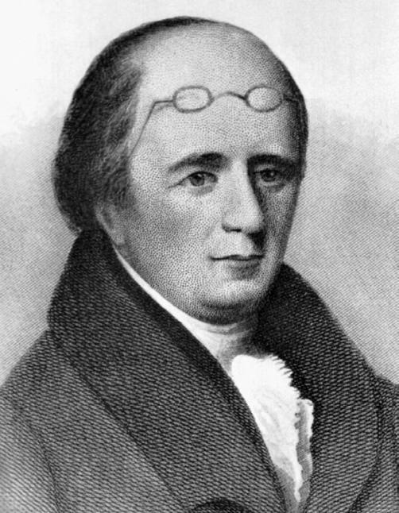

Morgan’s book was entitled Illustrations of Masonry by one of the Fraternity Who has devoted Thirty Years to the Subject. It was finally released in 1827 in Batavia, New York on an independent label.

Freemasons are taught that anyone who reveals the secrets of the Order will be brutally murdered. Morgan was indeed kidnapped and killed by fellow Masons – despite having a wife and two children.

V.I.T.R.I.O.L

Any Mason who joined in the 1800s would have realized there was a dark energy involved. Before you even receive the ceremony for the first degree, you are placed in a “meditation room” — and are asked to write down your philosophical and moral testament.

In this process you confess any and all moral failings you feel you have, in specific detail — giving the group power over you in the process. You acknowledge that you are “profane”… and are about to receive “the light” of Masonry.

This website has a surviving picture of what the “meditation room” actually looked like during those times — as you see below. In case you don’t know, the word “vitriol” means sulfuric acid — but it also refers to severe, searing hatred.

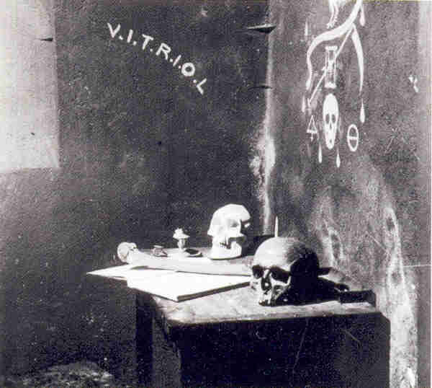

The word is still used a lot today, when you hear about someone mounting a “vitriolic” attack against another person — such as by hate speech on the Internet.

THERE’S MORE TO IT THAN THAT

The word VITRIOL is listed as an acronym — with periods between each letter — suggesting it is a larger phrase. With a little digging, our readers found out what this actually stands for.

http://watch.pair.com/new-earth.html#6.I.OT
Professor Henrique J. de Souza, President of the Brazilian Theosophical Society and a leading authority on the Subterranean World, in his magazine, published an article he wrote, ‘Does Shangri-la Exist?’ from which we quote.
Among all races of mankind, back to the dawn of time, there existed a tradition concerning the existence of a Sacred Land or Terrestrial Paradise, where the highest ideals of humanity were living realities.
This concept is found in the most ancient writings and traditions of the peoples of Europe, Asia Minor, China, India, Egypt and the Americas. This Sacred Land, it is said, can be known only to persons who are worthy, pure and innocent, for which reason it constitutes the central theme of the dreams of childhood.

‘The road that leads to this Blessed Land, this Invisible World, this Esoteric and Occult Domain, constitutes the central quest and master key of all mystery teachings and systems of initiation in the past, present and future. This magic key is the ‘Open Sesame’ that unlocks the door to a new and marvelous world.

The old Rosicrucians designated it by the French word VITRIOL, which is a combination of the first letters of the sentence: `VISTA INTERIORA TERRAE RECTIFICANDO INYENES OMNIA LAPIDEM,’ to indicate that ‘in the interior of the earth is hidden the true MYSTERY.’

The path that leads to this Hidden World is the Way of Initiation.

So, in effect, V.I.T.R.I.O.L., if researched by the new initiate, represents the idea that they will be acquiring “the true mystery” that can be found “in the interior of the earth.”
In traditional terms, the interior of the Earth is associated with Hell — a realm of darkness and evil. Obviously anyone exposed to this teaching is going to wonder if that’s what they meant by V.I.T.R.I.O.L.

45,000 MASONS ABANDONED THE ORDER

The murder of William Morgan became a very public scandal — and ultimately led to over 45,000 out of 50,000 total Masons in the United States “disfellowshipping” and leaving the Order.

Over two thousand lodges completely shut down – including virtually every lodge in the Northern states – within less than a decade.

This is an incredibly important moment in American history. It all happened roughly 180 years ago. I never heard a word about it in the Rockefeller-financed American public educational system.

Batavia, New York erected the William Morgan Pillar in his honor on September 13, 1882, as you see here.

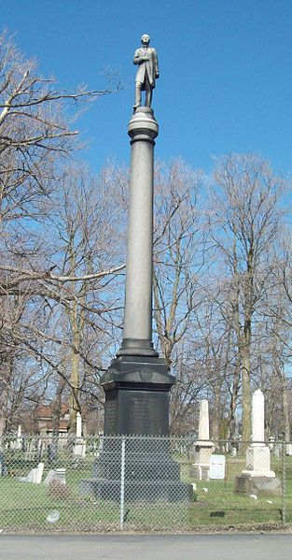

A huge political movement called the Anti-Masonic Party was formed soon after Morgan’s death. A variety of high-level meetings occurred at the state government level to address the problem – and hopefully eliminate it.

Remember that in those days, under the Constitution, the states carried most of the political power. Therefore, a meeting in the assembly hall of the state capitol of New York was extremely significant.

RETRACING THEIR FOOTSTEPS

The key book Finney quoted from in his 1869 text, describing these events, was Light on Masonry by Elder David Bernard — from 1829.

Back in college it was impossible for me to track down Bernard’s book – but now, thanks to the far reach of the Internet, I was able to order two copies of it from Kessinger Publishing.

After publishing this investigation, I found out the entire work can also be read online, thanks to Google Books.

After I quote from Finney’s book, we’ll also read some of the most significant parts of Bernard’s Light on Masonry as well. Taken together, they paint an extremely compelling picture.

By restoring this information that was carefully suppressed from the pages of history, we can clearly identify the blueprints of meticulous planning, over at least the last 200 years — held in the utmost secrecy.

THE CHARACTER, CLAIMS AND PRACTICAL WORKINGS OF FREEMASONRY

Now let’s begin with the most significant quotes from Rev. Finney’s classic book:

Entered according to Act of Congress in the year 1869 by the Western Tract and Book Society, in the Clerk’s Office of the District Court of the United States, for the Southern District of Ohio….

1: Forty years ago we supposed that [Freemasonry] was dead, and had no idea that it could ever revive. But, strange to tell, while we were busy in getting rid of slavery, Freemasonry has revived, and extended its bounds most alarmingly….

9: About forty years ago, an estimable man by the name of William Morgan, then residing in Batavia, N.Y., being a Freemason, after much reflection, made up his mind that it was his duty to publish Freemasonry to the world.

He regarded it as highly injurious to the cause of Christ, and as eminently dangerous to the government of our country.

I suppose [he] was aware, as Masons generally were at that time, that nearly all the civil offices in the country were in the hands of Freemasons; and that the press was completely under their control, and almost altogether in their hands.

Masons at that time boasted that all the civil offices in the country were in their hands. I believe that all the civil offices in the county where I resided while I belonged to them, were in their hands.

I do not recollect a magistrate, or a constable, or sheriff in that county that was not at that time a Freemason….

As you can now see, the control of the media and elected government by a secretive group of powerful individuals was well-known in the early 1800s.

Finney said the press was “completely under their control” – as well as “nearly all the civil offices in the country.”

THE MURDER OF WILLIAM MORGAN – A CONFESSION

Henry L. Valance confessed in 1848 that Morgan was murdered by drowning. Rocks were tied to a rope around his waist. The total weight of the rocks was greater than his own body.

Morgan was then dumped into the Niagara River after crying and pleading with his captors for his life. This obvious Masonic murder ultimately caused the whole story to break open.

[Years later, ex-Masons working at the state government level created a substantial trust fund to help compensate Morgan’s wife and children for their loss.]

Let’s continue with the excerpts from Finney’s book:

11: Two or three [Masons] have since, upon their death-bed, confessed their part in the [murder of William Morgan]….

The account of the manner in which this was done will be found in a book published by Elder Stearns… entitled “Stearns on Masonry”.

It contains the deathbed confession of one of the murderers of William Morgan. On page 311, of that work, you will find the confession….

“CONFESSION. The Murder of William Morgan, Confessed by the Man Who, With His Own Hands, Pushed Him Out of the Boat Into Niagara River!”

17: [The Masons] also kidnapped Mr. Miller, the publisher; but the citizens of Batavia, finding it out, pursued the kidnappers, and finally rescued him.

THE COURTS WERE NOT EFFECTIVE

11: The courts of justice found themselves entirely unable to make any headway against the wide-spread conspiracy that was formed among Masons in respect to this matter.

These are matters of record. It was found that they could do nothing with the courts, with the sheriffs, with the witnesses, or with the jurors; and all their efforts were for a time entirely impotent.

Indeed, they never were able to prove the murder of Morgan, and bring it home to the individuals who perpetrated it.

45,000 OUT OF 50,000 MASONS LEFT THE ORDER

18: In consequence of the publication of Morgan’s book, and the revelations that were made in regard to the kidnapping and murdering of Mr. Morgan, great numbers of Masons were led to consider the subject more fully than they had done; and the conscientious among them almost universally renounced Masonry altogether.

I believe that about two thousand lodges, as a consequence of these revelations, were suspended.

The ex-president of a Western college, who is himself a Freemason, has recently published some very important information on the subject, though he justifies Masonry.

He says that, out of a little more than fifty thousand Masons in the United States at that time, forty-five thousand turned their backs upon the lodge to enter the lodge no more.

ALL THE SECRETS FOR EVERY DEGREE WERE PUBLISHED

18: Conventions were called of Masons that were disposed to renounce it. One was held at Leroy, another at Philadelphia, and others…

At one of these large conventions they appointed a committee to superintend the publication of Masonry in all its degrees.

19: Elder Bernard… with the assistance of his brethren who had been appointed to this work, obtained an accurate version of some forty eight degrees.

He published also the proceedings of those conventions… and also several speeches that were made by prominent men in the State of New York.

This work was entitled “Light on Masonry.”… Great pains were taken to secure the most accurate knowledge of the degrees published by the committee….

MEDIA CONTROL CONTINUED

20: In the Northern or non-slaveholding States Masonry was almost universally renounced at that time.

But it was found that it had taken so deep a root that in all New England there was scarcely a newspaper in which the death of William Morgan, and the circumstances connected therewith, could be published.

This was so generally true throughout all the North that newspapers had to be everywhere established for the purpose of making the disclosures that were necessary in regard to its true character and tendency.

The same game is being played over again at the present day. The “Cynosure,” the new anti Masonic paper published at Chicago, is constantly intercepted on its way to subscribers…. The editor informs me that the [issues] are constantly intercepted….

It was found that Masonry so completely baffled the courts of law, and obstructed the course of justice, that it was forced into politics; and for a time the anti-masonic sentiment of the Northern States carried all before it.

Almost all Masons became ashamed of it, felt themselves disgraced by having any connection with it, and publicly renounced it.

If they did not publish any renunciation, they suspended their lodges, had no more to do with it, and did not pretend to deny that Masonry had been published.

SHOCKING THAT MASONRY MANAGED TO RECOVER

21: Now these facts were so notorious, so universally known and confessed, that those of us who were acquainted with them at the time had no idea that Masonry would have the impudence ever again to claim any public respect.

I should just as soon expect slavery to be re-established in this country, and become more popular than ever before – to take possession of the Government and of all the civil offices, and to grow bold, impudent, and defiant – as I should have expected that Masonry would achieve what it has….

POLITICAL ACTION WAS REQUIRED

34: It was found that there was no other way than for the people to rise up and take the offices out of their hands by political action.

At first there was no thought on the part of any one, so far as I could learn, that it would ever become a political question. But it was soon found that there was no other alternative.

41: In February, 1828, a convention of seceding Masons was held at Le Roy, in the County of Genesee [New York], composed of some thirty or forty of the most respectable citizens.

They published a declaration to the world under their signatures… [that] the revelations of William Morgan… [were] strictly true and accurate.

In the course of the same year, Elder Bernard, a Baptist clergyman of good character, and who was a distinguished Mason, published… “Light on Masonry”….

MASONRY EXPOSED IN THE STATE COURTS

41-42: In 1829, on the trial of Elihu Mather, in Orleans County, the obligations of the first three degrees and of a Royal Arch Mason, were proved, at a Circuit Court held by Judge Gardiner, by the testimony of three seceding Masons and one adhering Mason.

In obedience to a resolution of the Senate of New York, Judge Gardiner reported this evidence, and it was printed by order of the Senate.

In 1830, on a trial in Rhode Island, the same obligations were proved in open court, and the trial was published at large in the newspapers.

In 1831, on the trial of H.C. Witherell, at New Berlin, in Chenango County, the same obligations were proved by the oaths of three adhering Masons, among whom was General Welch, the sheriff of the county.

In the year 1830, Avery Allyn, a regular Knight Templar, published a book, called the “Ritual of Freemasonry,” in which the ceremonies of initiation, the lectures oaths and mummeries of thirty-one degrees are fully exhibited.

Thousands of Masons individually have, under their names in the public papers, declared these publications of Bernard and Allyn to be strictly accurate.

MY MASONS, RIGHT OR WRONG… INCLUDING MURDER AND TREASON

90: All Masons above the third, or Master’s degree, are sworn to keep inviolate the secrets of a brother, murder and treason excepted, up to the seventh, or Royal Arch degree.

In the oath of this degree the candidate… swears to keep all the secrets of a companion of this degree, murder and treason not excepted. All Masons of and above this degree are solemnly bound to do this….

After swearing to the same points contained in previously taken oaths, the kneeling candidate, with hands on the Holy Bible, proceeds: “I furthermore promise and swear, that I will aid and assist a companion Royal Arch Mason when engaged in any difficulty, and espouse his cause so far as to extricate him from the same, if within my power, whether he be right or wrong.”

THAT’S ALL I HAD

What you’ve just read are the passages I highlighted in my copy of Finney’s book back when I first read it – along with a few others that jumped out at me as I reviewed it for this investigation.

At the time, I felt Bernard’s Light on Masonry was totally lost – a victim of crushing media suppression. It was only while working on this investigation that I tried to find it on Amazon.

My two copies of Light on Masonry only arrived in the mail a few weeks ago. I was not disappointed.

You can also read the whole thing here at Google Books.

It took some time, but I worked my way through the book and found the most important passages – as you are about to read.

LIGHT ON MASONRY

Light on Masonry – David Bernard – 1829

Secretary of the Convention of Seceding Masons, held at Le Roy, July 4th and 5th, 1828.

William Williams, Printer, Utica, NY, 1829.

NORTHERN DISTRICT OF NEW-YORK, TO WIT:

BE IT REMEMBERED, that on the thirteenth day of April, in the fifty-third year of the Independence of the United States of America, A.D. 1829, David Bernard, of the said District, hath deposited in this office the title of a book, the right whereof he claims as author, in the words following, to wit:

“Light on Masonry: a collection of all the most important documents….”

R.R. Lansing, Clerk of the District Court of the United States; for the Northern District of New-York.

A WORLDWIDE PROBLEM

392: An Address to All Honest Masons. In Eight Numbers. (Originally published in 1828, in the Le Roy Gazette, Genesee county, N.Y.)

395: No. III. [Written address submitted by an anonymous former Mason.]

It is well known to all ‘active Masons’ and to persons generally, that in the dark conclave and secret meetings of Masons, have been planned conspiracies that have caused convulsions which have been felt in every part of the government under which they were bound to live as good citizens.

There has been planned and executed deeds by them in their midnight conspiracies, (I cannot call such meetings by a more gentle term,) at which humanity has revolted.

In France all was thrown into confusion, and anarchy came near ruling a people striving for liberty, by the society of Free Masons. At one time, considering they had all power, they throw off all disguise and discovered their real object….

But France is not alone in having her liberties invaded by Masons. It at one time came near overthrowing the government of Germany, and those that were honest Masons among them separated and forsook the institution….

396: Masonry was considered in Spain, Portugal, and Russia, of such a dangerous tendency, that it was put down by the strong arm of the law. It is now disturbing the tranquility of our brethren in South America.

ANTI-MASONIC CONVENTION OF THE NEW YORK STATE GOVERNMENT – FEB. 1829

(Appendix, pg. 27)

Appendix, No. II. Proceedings of a Convention of Delegates, from the different Counties in the state of New-York, opposed to Free Masonry.

Held at the Capitol in the City of Albany, on the 19th, 20th and 21st days of February, 1829.

THE CONVENTION,

Of whose proceedings the following sheets furnish a history, was called by the following notice:–

ANTI-MASONIC STATE CONVENTION.

28: PROCEEDINGS, &c.

The Delegates met in the Assembly Chamber of the Capitol at the City of Albany, on the 19th day of February, 1829, at four o’clock, P.M., and were called to order by Samuel M. Hopkins, delegate from Albany County….

33: More than four hundred initiates, within our own state, including Members of every Degree, from an Entered Apprentice to the Thrice Illustrious Knights of the Holy Trinity, have publicly renounced the Institution.

Thousands have silently withdrawn, and it cannot be presumed that any good man, who received it upon trust, will continue his connexion with the Fraternity after he has thoroughly examined the tendency of its principles.

BRAINARD’S BOLD AND AUDACIOUS SPEECH REVEALING THE TRUTH IN 1825

34: Perhaps we cannot convey a bolder or more comprehensive view out of fancied power and unchastened ambition of Free Masonry, than is found in the Oration of the late W. F. Brainard, at New-London, Ct., before the Union Lodge, June 24, 1825, on the recurrence of one of her fabulous Anniversaries.

Mr. Brainard says—

“What is Masonry now? IT IS POWERFUL. It comprises men of RANK, wealth, office and talent, in power and out of power; and that in almost every place where power is of any importance.

And it comprises among other classes of the community, to the lowest, in large numbers, active men, united together, and capable of being directed by the efforts of others, so as to have the FORCE of CONCERT throughout the civilized world!

They are distributed too, with the means of knowing one another, and the means of keeping secret, and the means of co-operating, in the desk – in the legislative hall – on the BENCH – in every gathering of business – in every party of pleasure – in every ENTERPRISE of GOVERNMENT – in every domestic circle – in peace and in war – among enemies and friends – in one place as well as in another!

SO POWERFUL indeed, is it at this time, [June 24th, 1825] that it fears nothing from violence, either public or private; for it has every means, to learn it in season to COUNTERACT, DEFEAT and PUNISH IT!”

CONVENTION PRESIDENT FINN ADDRESSES THE NEW YORK STATE DELEGATION

50: ADDRESS TO THE PEOPLE OF THE STATE OF NEW-YORK.

FELLOW-CITIZENS— A great crisis has occurred in our social condition.

The peace of this community has been extensively disturbed, the domestic security of the citizens openly violated, their property unlawfully invaded, and the life of one of them, without doubt, feloniously destroyed.

And these calamitous events have proceeded from a source which threatens our most valuable institutions, and all those possessions which make life desirable.

With these facts deeply impressed upon our hearts, we have been delegated to assemble here, to consult together, and advise upon the proper course to be pursued, in so momentous an emergency….

When the public peace, our domestic safety, our property, our life, our reputation, our equal rights as citizens, are all assailed, by the concerted action of numerous, wealthy, intelligent, and powerful bodies of men;

and the regular operations of our constituted authorities is found unable to protect us, then, it is most equally becoming to our minds and hearts, to our self-respect, and the most cherished interests of human liberty, that we should protect ourselves whatever evils may ensue….

THE POWER SHOULD BELONG TO THE PEOPLE

53: In our country the people are the only legitimate source of civil power. It is the will of the people by which laws are enacted, and applied to the various rights and pursuits of life.

This will calls into employment, elective, legislative, judicial, and executive bodies, which are only the instruments by which it is brought into visible and useful action.

But the will of a state, or nation, like the will of an individual, depends upon opinion,—the opinion of a majority of the people of a state, or nation; and the opinion of such majority is PUBLIC OPINION.

—Public opinion, therefore, controlling the will of the people, in every free country, must govern every thing, which is properly subject to governmental power.

This is the theory of our government. It is clearly the only theory consistent with the rights of man. And among us, it has been so well applied in practice, heretofore, as to ensure the good anticipated by the framers of our government.

But we have recently witnessed an alarming change. The machinery of our government has become obviously disordered.

—Free Masonry has come into violent collision with it; and its healthful operations are now either suspended, or rendered ineffectual.

And the great question is now presented to the people of this state, what shall be done to restore it to its salutary and effectual operation….

FREEMASONRY ACTS AS ITS OWN, WORLDWIDE GOVERNMENT

Free Masonry is a distinct, peculiar, independent government. It acknowledges no allegiance to civil government, nor alliance with it.

It has departments of its own, titles of its own, officers of its own, laws of its own, revenues of its own, oaths of its own, penalties of its own, sympathies of its own, and purposes of its own.

All the nations of the earth, however diverse their forms of government, or distant their territories, are but its provinces. It has no jurisdictional limits but the habitable globe.

Throughout its whole extent, it secures the loyalty of its subjects, by cords most ingeniously twisted, and of surpassing strength….

The possibility of its existence is dangerous; its actual occurrence demands instant, resolute, continued, and united, though prudent, exertion, till it shall become impossible….

WILLIAM FINN, President…. Rochester, March 15, 1829.

THE ANTI-MASONIC PARTY

These meetings and speeches directly led to the formation of the Anti-Masonic Party, the first “third party” in the history of American politics.

William A. Palmer was elected governor of Vermont in 1831, on an Anti-Masonic ticket, and held that office until 1836. Joseph Ritner was elected governor of Pennsylvania from 1835 to 1838.

William Wirt ran for President on the Anti-Masonic ticket in 1832, and won all seven electoral votes from Vermont as well as 7.78 percent of the popular vote.

After this Presidential defeat in 1832, the Anti-Masonic Party merged with the Whig Party. I heard about the Whigs briefly in grade school, but had no idea of the suppressed history behind them.

WORLDWIDE RESISTANCE

In December 1996, my knowledge on this subject took a quantum leap when I found New World Order: The Ancient Plan of Secret Societies by William T. Still, at Borders Bookstore in Albany, New York.

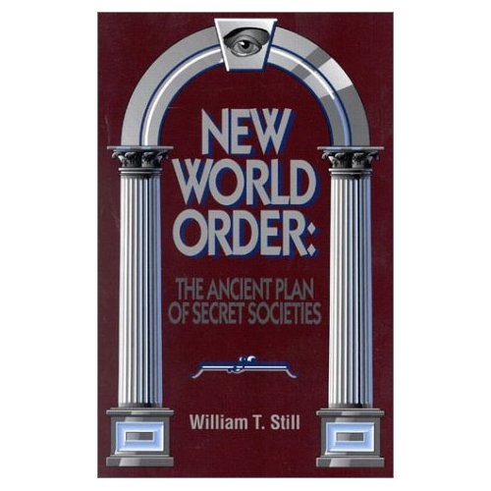

I still consider this book to be the defining standard of scholarship for this subject. It quotes from Finney’s book and many, many others, forming a much more complete picture of these events:

118: The furor over the murder of William Morgan in 1826 had caused American Masonry to almost cease to exist, and European Masonry was in turmoil as well.

Bavaria had forbidden Masonry as a danger to the state in 1784, then again in 1845.

In 1814, the Regency of Milan and the Governor of Venice had acted in a similar manner.

King John VI of Portugal prohibited Freemasonry in 1816, and renewed it in 1824.

In 1820 several lodges were closed in Prussia for political intrigues, and in the same year Alexander I banished the order from the whole Russian empire. A similar occurrence took place four years later in Spain….

108: As a result of this [Morgan] scandal, the anti-Masonic party was formed. It polled 128,000 votes in the 1830 election and carried Vermont in the 1832 presidential election.

Rhode Island and Vermont passed laws against blood oaths. Thousands of Masons burned their aprons. In a few years’ time, membership in the New York lodges dropped from 30,000 to 300 as a direct result of the Morgan incident. [29]

[29. William J. Whalen, Christianity and American Freemasonry, (Milwaukee, WI: Bruce Publishing Co., 1958), p. 9.]

DUNCAN’S MONITOR ATTEMPTS TO DOWNPLAY THE SCANDAL

By 1866, every degree of Masonry had been published and widely scrutinized – particularly by people in the Northern states.

In response, the Masonic establishment decided to release Duncan’s Masonic Ritual and Monitor. It revealed the first seven degrees in detail – including illustrations of the gestures and handshakes.

[Now, Masons tell me they are strictly forbidden from reading this or other books that expose the inner workings of the Order.]

Interestingly, the very first paragraph of the book addresses the Morgan scandal, and attempts to downplay it:

http://www.sacred-texts.com/mas/dun/dun01.htm

3: [Freemasonry] has, at various times and in several countries, incurred the ill-will of political parties and of religious bodies – in consequence of a belief, on their part, that the organization was not so purely benevolent and philanthropic as its members proclaimed it to be.

In the State of New York, many years ago, it was supposed, but we think unjustly, to wield a powerful political influence, and to employ it unscrupulously for sinister ends.

The war between Masonry and Anti-Masonry which convulsed the State at that period is still fresh in the remembrance of many a party veteran.

The Order, however, has long since recovered from the obloquy then heaped upon it, and is now in a flourishing condition in most parts of the civilized world.

KEY DIFFERENCE BETWEEN “LIGHT ON MASONRY” AND “DUNCAN’S MONITOR”

Finney’s book reveals that one of the main focal-points of Anti-Masonic sentiment was the oaths that a seventh-degree Royal Arch Mason would be forced to swear to.

There is a small but very significant difference between the Masonic oaths published by Ballard as opposed to those in Duncan’s Ritual Monitor of Freemasonry.

Here are some of the key quotes from Ballard’s Light on Masonry that created so much distress as to nearly destroy Masonry in America – causing 45,000 out of 50,000 members to quit.

Masons must swear on pain of death to uphold these principles.

130: I will promote a companion Royal Arch Mason’s political preferment in preference to another of equal qualifications. [Some lodges also include “I will vote for a companion Royal Arch Mason, before any other of equal qualifications.”]

Furthermore, do I promise and swear, that a companion Royal Arch Mason’s secrets, given me in charge as such, and I knowing them to be such, shall remain as secure and inviolable in my breast as in his own, murder and treason not excepted.

Ballard reveals that the line “murder and treason not excepted” was only administered in some of the Masonic chapters. It did not appear in Duncan’s Monitor – but it is still implied, as we will see.

Furthermore, the line about promoting a fellow Royal Arch Mason politically was completely deleted from Duncan’s Monitor.

WHAT DOES DUNCAN’S MONITOR SAY?

Since the Masonic oaths are orally transmitted, there are superficial differences throughout Duncan’s Monitor and Ballard’s Light on Masonry.

However, despite deleting the phrases about politics, murder and treason, Duncan’s Monitor still maintained much of the original, troubling verbiage – as we see here.

http://www.sacred-texts.com/mas/dun/dun08.htm

230: I furthermore promise and swear, that I will employ a Companion Royal Arch Mason in preference to any other person of equal qualifications.

I furthermore promise and swear, that I will assist a Companion Royal Arch Mason when I see him engaged in any difficulty, and will espouse his cause so far as to extricate him from the same, whether he be right or wrong.

I furthermore promise and swear, that I will keep all the secrets of a Companion Royal Arch Mason (when communicated so me as such, or I knowing them to be such), without exceptions….

To all which I do most solemnly and sincerely promise and swear, with a firm and steadfast resolution to keep and perform the same, without any equivocation, mental reservation, or self-evasion of mind in me whatever;

binding myself under no less penalty, than to have my skull smote off, and my brains exposed to the scorching rays of the meridian sun, should I knowingly or willfully violate or transgress any part of this my solemn oath or obligation of a Royal Arch Mason.

So help me God….

WHAT HAPPENS AS YOU READ THE HIGHER DEGREES?

Scottish Rite Masonry goes up to 33 degrees – though the 33rd is an honorary title reserved only for a select few. Light on Masonry reveals data from all 33 degrees – and other offshoots.

The Anti-Masonic Party was deeply concerned about Freemasonry’s openly blatant attack on Christianity – particularly in the 28th degree of Masonry, Knight Adept of the Sun (or the Eagle).

Here is a direct excerpt of what the initiate hears as he is receiving the 28th degree.

265: Requisitions to make a good Mason.—If you ask me what are the requisite qualities that a Mason must be possessed of, to come to the centre of truth, I answer you, that you must crush the head of the serpent of ignorance.

You must shake off the yoke of infant prejudice, concerning the mysteries of the reigning religion, which worship has been imaginary, and only founded on the spirit of pride….

[The reigning religion] employs every matter to satisfy carnal desires, and raises to these predominant passions, altars, upon which she maintains, without ceasing, the light of iniquity, and sacrifices continually offerings to luxury, voluptuousness, hatred, envy, and perjury.

Behold, my dear brother, what you must fight against, and destroy, before you can come to the knowledge of the true good and sovereign happiness!

Behold this monster which you must conquer – a serpent which we detest as an idol, that is adored by the idiot and the vulgar under the name of RELIGION!!!

THIRTY-SECOND DEGREE DIRECTLY TARGETS MUSLIMS

According to the author’s written-in commentary on the thirty-second degree, or Sublime Prince of the Royal Secret, Prince of Masons, an apocalyptic war with Arabs is highly desired.

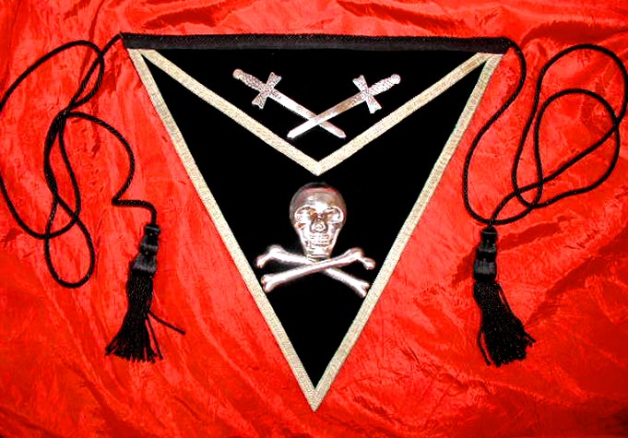

Historic 1800s-Era 32nd Degree Masonic Apron with Skull and Crossbones

294: The ostensible object of this [thirty-second] degree is the invasion of the Holy Land, and its deliverance from the infidels.

This is to be effected by uniting all the Masons, ancient and modern, under one commander, and directing them ‘en masse’ upon the Mahometans, who have wickedly established themselves in that sacred region.

Hence the complexion of this degree is military. The draft or carpet contains the plan of this ‘MASONIC ARMY!’…

It is believed that the ceremonies of initiation have never been committed to writing, or practiced in North America; hence, though many have received the obligation, words, signs, &c. formally, they remain like the rest of the world ignorant of the peculiar rites of the degree.

HATRED IS ONE OF THE ULTIMATE GOALS

There is very little about the 33rd degree in Light on Masonry. However, when you read through the 32nd degree, you can clearly see that Masons are being taught to hate.

This hate is supposed to become such a passion that it blinds them to all else in life.

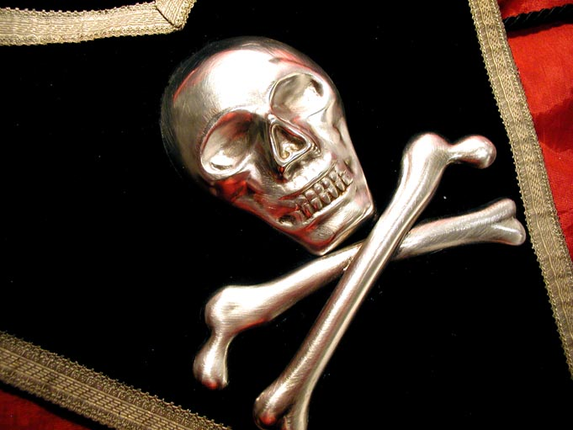

You may not be aware that the legend of “Friday the 13th” being unlucky may stem from a mass arrest of Knight Templars, including their leader Jacques De Molay, that occurred on Friday, October 13th, 1307.

Not all scholars agree with this, but it was presented in “The Da Vinci Code” as if it were the truth.

What you are about to read is directly spoken to the 32nd degree candidate during his initiation.

300: The captivity of the Grand Elect and Sublime Masons, (i.e. by the Chaldeans,) shows us the persecution of the Christian religion under the Roman emperors, and its liberty under Constantine the Great.

It also calls to our remembrance the persecution of the Templars, and the situation of Jacques De Molay, who lying in irons nearly seven years, at the end of which our worthy Grand Master was burnt alive with his four companions, on the eleventh of March, 1314, creating pity and tears in the people, who saw him die with firmness and heroic constancy, sealing his innocence with his blood.

My dear brother, in passing to the degree of Perfect Master, in which you shed tears at the tomb of Hiram Abiff, and in some other degrees, has not your heart been led to revenge?…

By the degree of Master Elect and Kadosh [30th degree], you are properly disposed to fulfill all your engagements, and to bear an implacable hatred to the Knights of Malta*, and to avenge the death of Jacques De Molay.

[*The reader must not suppose that the Masonic Knights of Malta are here intended; the reference is to the ancient order of that name, which, when the order of Templars was suppressed, received their estates.]

Your extensive acquaintance with symbolic Masonry, which you have attained by your discretion, leaves you nothing more to desire here.

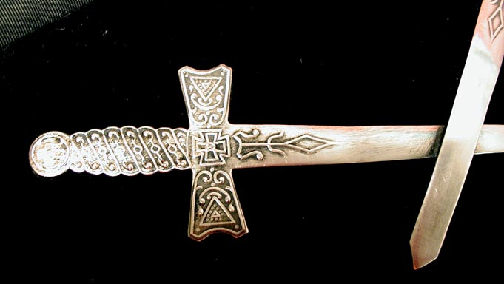

THIS ALL CAME ABOUT IN THE 1760s

The addition of the Knight Templars material, and most of the higher degrees of Freemasonry, did not come about until the 1760s.

In The New Knighthood, historian Malcolm Barber explained this in detail.

It was during the 1760s that German masons introduced a specific Templar connection, claiming that the Order, through its occupation of the Temple of Solomon, had been the repository of secret wisdom and magical powers, which James of Molay had handed down to his successor before his execution and of which the eighteenth-century Freemasons were the direct heirs.

Barber, Malcolm (1994). The New Knighthood: A History of the Order of the Temple. Cambridge: Cambridge University Press. ISBN 0521420415, pp. 317–318.

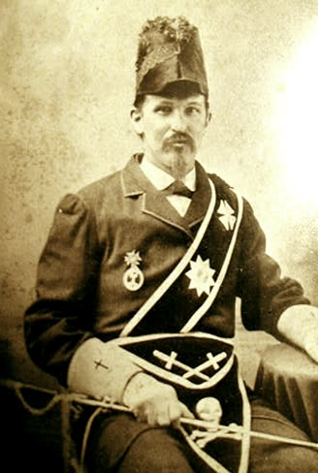

YOU BECOME ROYALTY AT THE 32ND DEGREE

Some Masons have told me the 32nd Degree initiates are now simply known as Knight Templars.

If we continue directly from where we left off, we also see that the 32nd degree Mason is told he has now entered into the ranks of bloodline royalty – not by birth, but by his membership in the Order.

The modern-day Masonic sash for the 32nd degree features a crown on it — clearly symbolizing the attainment of this illustrious goal. The “32” in the triangle is surrounded by sacrificial daggers — situated directly above the skull and crossbones on the apron.

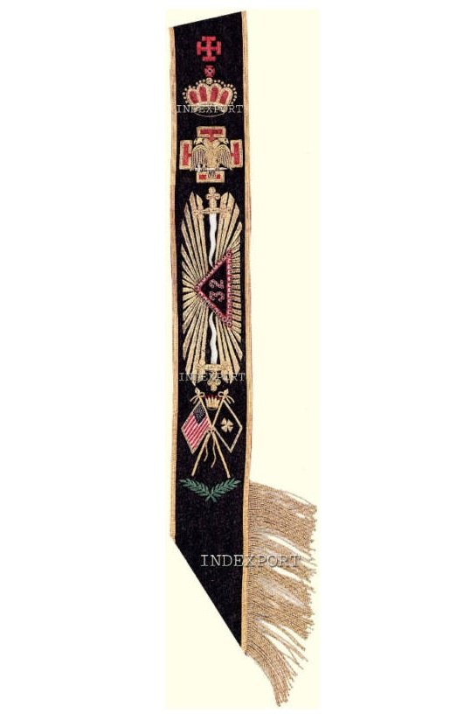

This rank is conferred by a mysterious “society of men” that is only referred to in passing, as the initiate continues to be spoken to during his ceremony.

300: You see, my dear brother, how, and by whom, Masonry has come to us.

You are to endeavor by every just means to regain our rights, and to remember that we are joined by a society of men, whose courage, merit, and good conduct, hold out to us that rank that birth alone gave to our ancestors.

You are now on the same level with them.

Avoid every evil by carefully keeping your obligations, and carefully conceal from the vulgar what you are, and wait that happy moment when we all shall be reunited under the same Sovereign in mansions of eternal bliss.

“The vulgar” is a term Masons use for anyone who is not a member of their group. This same “society of men” instructed the initiate in the 28th degree to “crush the head of the serpent… of RELIGION.”

I’m not sure I would use the term “good conduct” to describe the actions of this society of men.

WHAT HAPPENS ONCE YOU REACH THE ALL-IMPORTANT 33RD DEGREE?
All you read in Light on Masonry for the final 33rd degree is a rather ominous-sounding description of what the room is like where “the obligation” is accepted.

When you first walk in, you see the words “Deus meum que jus” over the door. This roughly translates as “God’s [Deus] Authority [Jus] is mine [Meum],” or “God [Deus] is mine [meum] as well as [que] Reason and Authority [jus].”

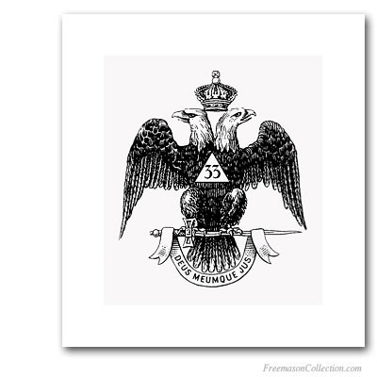

A transparent glass equilateral triangle then hangs down before you enter into a canopy of purple curtains.

The room is then dominated by a triangular altar, guarded by a full-sized skeleton holding a Masonic staff and a poniard – a long, lightweight thrusting knife most people would identify as a “sacrificial dagger” – in attack position.

“Death’s heads” and skull and crossbones images are all seen as well.

The highest-ranking officer, or Thrice Puissant Sovereign, wears a blood-red robe with a black sash. He has a stunning crown on his head like a European king – and he carries a sword.

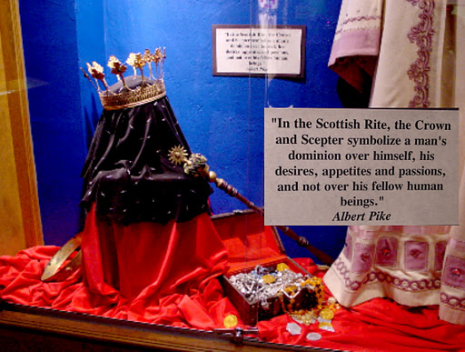

The bottom of the sash has a rose of red, white and green. The center of the sash has the number 33 inside a triangle with rays coming off of it, and the image of a poniard dagger running through the triangle.

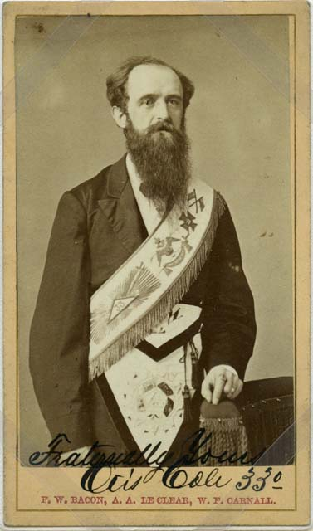

The jewel that is mounted on the sash is a double-headed eagle clutching a sword. The eagle’s beak, claws and sword are made of gold.

WHY DO THEY WANT TO DO ALL THIS?

Back when Light on Masonry was written, no more than nine 33rd-degree Masons were allowed in any given kingdom or republic.

What we do not see in any of the degrees is a clear indication of why they want to control the media, dominate the financial system, or attempt to create a global control matrix.

It appears that Masonry is only a cover for the “society of men” referred to in the 32nd degree – who despise religion, elevate their highest members to the level of royalty, and say “God’s Authority is Mine.”

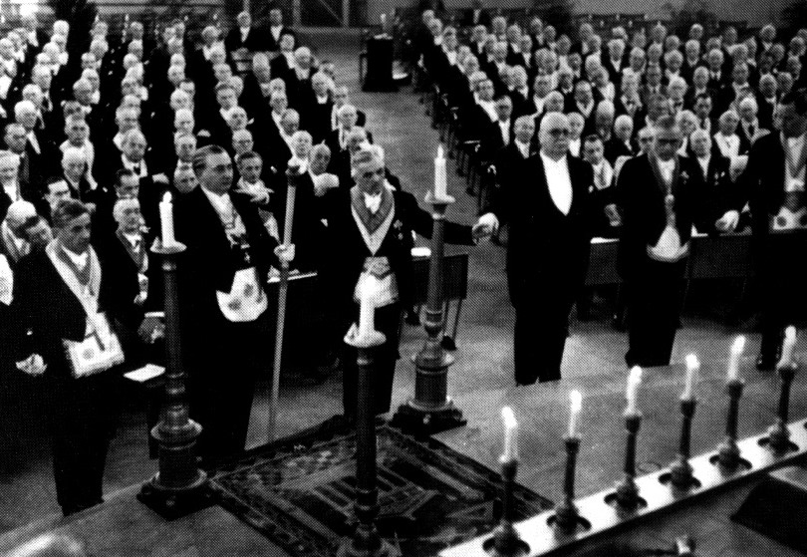

Were they wise enough to insure that their ultimate intentions were not explicitly written into the Masonic oaths and obligations?

Apparently so.

THE GREAT PLAN

William T. Still’s 1990 book New World Order: The Ancient Plan of Secret Societies fills in the missing details – through the words of other esteemed Masonic scholars.

30: One of the greatest secrets of Masonry, and of all the secret societies, is something called the “Great Plan,” the details of which are known only to those with access to the inner doctrine. As one Masonic scholar explained:

Though the whole extent and origin of the plan was known only to an initiate few, members of the outer order were subjected to a selective system by which they could attain to numerous degrees and proportionately receive deeper insight into the work.

This in turn spurred them to greater effort and endeavor in their various occupations and stations in life, and made them useful instruments. [38]

[38. Marie Bauer Hall, Collections of Emblemes, Ancient and Moderne, by George Wither to which is Added Foundations Unearthed, (Los Angeles: Veritat Foundation, 1987), p. 14.]

This outer doctrine allows the average member to see his organization as little more than a social fraternity involved in a few charitable works.

However, for those who are judged ready, or “worthy” to accept it, the inner doctrine drops all pretense of this idealism.

THE BAVARIAN ILLUMINATI

What exactly is this “Great Plan” that Still is referring to? Apparently we’re seeing it now. Masonry provided the secrecy necessary for a small group to gain control of the planet and its resources.

It is a documented historical fact that Adam Weishaupt headed a group in Bavaria (now a part of Germany) that called themselves the Illuminati – meaning the Enlightened Ones. This is thoroughly examined in Chapter Five of Still’s book, “Weishaupt’s Illuminati.”

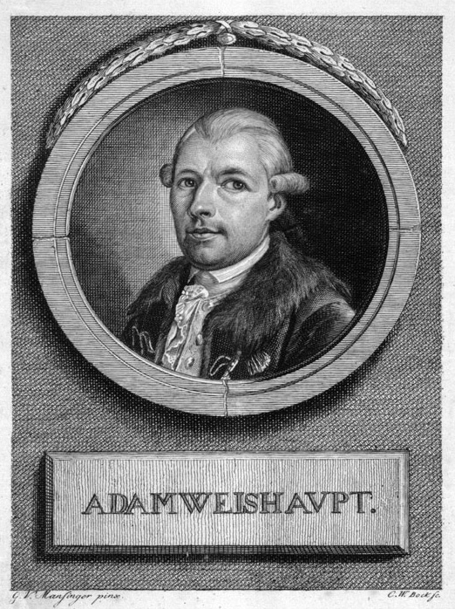

According to a research paper by Andrew Hitchcock, Adam Weishaupt was paid to start this group by none other than Mayer Amschel Rothschild – in 1770.

On page 69, Still says Weishaupt was indoctrinated into Egyptian occultism in 1771 by a merchant named Kolmer – and spent five years formulating the plan to consolidate all occult systems into a single organization.

One book that suggests the Rothschilds financed the Bavarian Illuminati is Pawns in the Game by Wm. Guy Carr – which is listed with publication dates as far back as 1956 on Amazon.

Carr’s book alleges that Mayer Rothschild convened a meeting of twelve other wealthy men at his home in Frankfurt, Germany as of 1773 – back when his family still lived under the Green Shield in the ghetto.

From there, they created a 25-point strategy for Rothschild’s new group, “The Illuminati.”

Let’s not forget that the higher degrees of Freemasonry had only been created in the late 1760s.

DIVINE INTERVENTION REVEALS THE PLAN

In a seeming act of Divine Intervention, lightning struck a courier who was riding to the meeting on horseback, carrying the full 25-point strategy in his inside jacket pocket. He was killed instantly.

The authorities went through all the courier’s belongings and were shocked to find this document. All 25 points are published, in full, on various websites, such as this one.

I’m not going to list all 25. You can read them at the above link. I have specifically chosen the most shocking and, I believe, important ones so you don’t get distracted as you read it.

Remember – this is not a conspiracy theory; the seizure of this document was an established fact, causing extreme concern in the Bavarian government.

#1 Use violence and terrorism rather than academic discussions….
#4 Any and all means were justified, on the grounds that a moral code left a politician vulnerable….

#6 Remain invisible until the very moment when it has gained such strength that no cunning or force can undermine it….

#7 Use Mob Psychology to control the masses. “Without absolute despotism ” one cannot rule efficiently

#8 Advocate the use of alcoholic liquors, drugs, moral corruption and all forms of vice, used systematically by “agenteurs” to corrupt the youth

#9 Seize property by any means and without hesitation, to secure submission and sovereignty.

#10 Foment wars, but direct the peace conferences so that neither of the combatants gain territory. They would be placed further in debt and therefore into our power.

#12 Choose candidates for public office who will be servile and obedient to our commands, so they may be readily used as PAWNS IN OUR GAME

#13 Use the Press for propaganda to control all outlets of public information, while remaining in the shadows, clear of blame

#14 Make the masses believe they had been the prey of criminals. Then restore order to appear as the saviors.

#15 Create financial panics; use hunger to subjugate the masses.

#16 Infiltrate Freemasonry… “When the hour strikes for our sovereign Lord of all the World to be crowned, these same hands will sweep away everything that might stand in his way.”….

#18 a Reign of Terror is the most economical way to bring about speedy subjection.

#19 Masquerade as political, financial and economic advisers to carry out our mandates… without fear of exposing “the secret power behind national and international affairs.”
#20 ULTIMATE WORLD GOVERNMENT is the goal. It will be necessary to establish huge monopolies, so even the largest fortunes… [will] go to the bottom together with the credit of their governments ON THE DAY AFTER THE GREAT POLITICAL SMASH.”

#21 Economic War. Rob the Goyim of their landed properties and industries with a combination of high taxes and unfair competition.

#22 Make the Goyim destroy each other so there will only be the proletariat [poor] left in the world, with a few millionaires devoted to our cause, and sufficient police and soldiers to protect our interest.

#23 Call it THE NEW ORDER. Appoint a Dictator….

CREEPY STUFF

I understand how disturbing this must be. The farther into this investigation we go, the more unsettling it becomes – and we’re not done yet.

The principles of this 25-point document appear to have been meticulously followed in the 238 years since its original drafting.

In fact, it is quite remarkable to see how precisely this document outlines the plans we are seeing come to fruition today.

Despite the discovery of this 25-point document in 1773, Weishaupt still launched the Order of the Illuminati on May Day, 1776.

William T. Still says the Bavarian Illuminati’s exposure and downfall was primarily due to a high-level disagreement that began in 1786.

The details of this exposure were published by the highly respected British historian Professor John Robison — a professor of natural philosophy at Edinburgh University and a Mason for many years.

Robison’s book Proofs of a Conspiracy exposed the Illuminati in 1798 — and “caused a sensation in the United States” among the Founding Fathers.

HOW IT ALL FELL APART

On page 74-75 of Still’s book, he reveals that candidates for the Illuminati were “almost always drawn from Masonic lodges of the day,” just as we saw in Point #16.

Baron von Knigge was the third-highest ranking member of the original Rothschild / Weishaupt Illuminati, and took on the code-name of Philo.

Von Knigge began to disagree with Weishaupt’s plan to try to push atheism on the members of the lower degrees. He felt it was better to “defer the development of the bold principles till we had firmly secured the man.”

As time went on, von Knigge realized that Weishaupt’s ultimate goal was to instill a belief in Lucifer as a benevolent God-figure. This caused him to feel the Order had been “painted… in the colors of hell, and would have scared the most intrepid.” (Still, p. 79.)

Von Knigge left in 1783, and informed the Bavarian government of the danger the Illuminati presented. The government then banned all secret societies the following year.

Four other Illuminati members, each of whom were professors, fled the order in April 1785. The Bavarian government summoned them to a court of inquiry — and they all spilled the beans.

The professors revealed that the Illuminati wished to annihilate all religion, all love of country and all love between parents and children.

Suicide was to be encouraged as a “voluptuous pleasure.”

BAVARIAN GOVERNMENT RAIDS THE ORDER AND SEIZES DOCUMENTS

This testimony was more than enough legal grounds to act. Nonetheless, the Bavarian government was very careful – and they didn’t make their move until the following year.

On October 11, 1786, the Bavarian government raided the chief Illuminati lawyer Herr von Zwack’s home – and seized a treasure-trove of documents.

These documents were then published and widely distributed as Original Writings of the Order of the Illuminati.

The Bavarian government sent this book to every government in Europe – but no one took it seriously, even though the members of the Illuminati acknowledged the documents were real.

EUROPEAN MASONRY MERGED WITH ILLUMINATI IN 1782

Still also reveals that European “Continental” Masonry was wedded with the Illuminati — beginning with a written agreement as of December 20, 1781.

This was finalized in the still-secret Congress of Wilhelmsbad in July 1782. The Comte de Virieu spoke out in his biography about what had occurred at this meeting.

82: All this is very much more serious than you think. The conspiracy which is being woven is so well thought out that it will be… impossible for the Monarchy and the Church to escape it. [46]

[46. Nesta H. Webster, World Revolution, (Devon, UK: Britons Publishing Co., 1971 edition, originally pub. 1921), p. 31.]

According to Still, after this agreement in 1782, the headquarters of “Illuminized” European Freemasonry was moved to the Rothschilds’ home town of Frankfurt — and was securely within their control.

GUISEPPE MAZZINI INHERITED THE EUROPEAN “ILLUMINATI”

According to Monsignor George Dillon, the Illuminati – i.e. “the supreme government of all the Secret Societies of the world” – fell into the hands of Italy after Weishaupt’s death in 1830 (Still, p. 119).

[Monsignor George E. Dillon, D.D., Grand Orient Freemasonry Unmasked as the Secret Power Behind Communism, (Metairie, LA: Sons of Liberty revised edition 1950; original edition New York: Burns and Oats, 1885), p. 50-51.]

Guiseppe Mazzini was the head of the highest Italian lodge, the Alta Vendita, at this time.

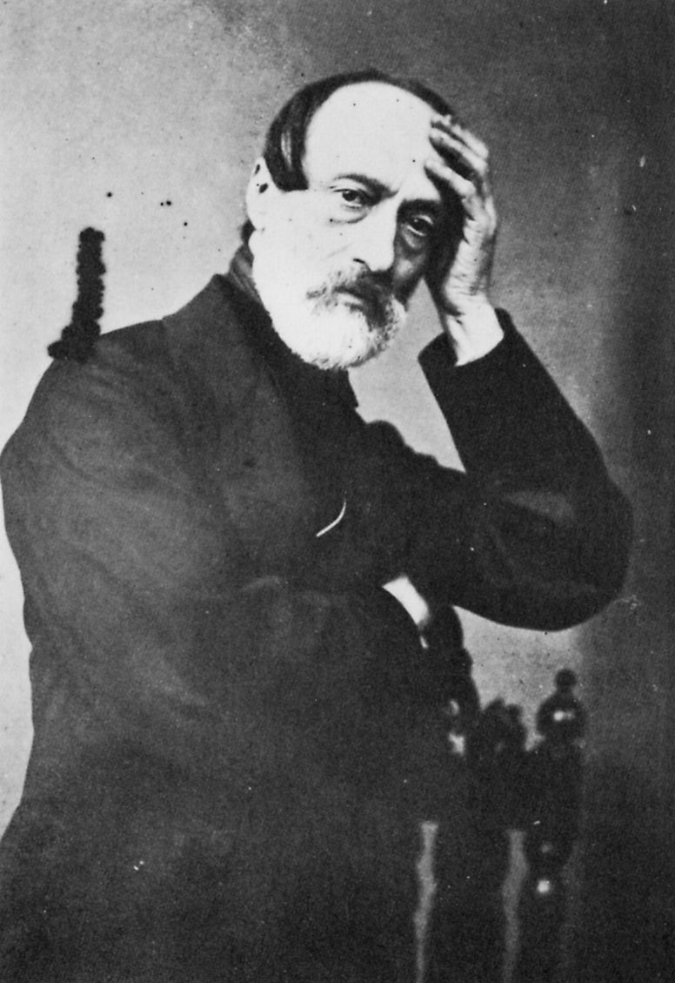

The Alta Vendita controlled the French, English and German lodges at the highest levels.

The Alta Vendita was originally started by none other than Kalman (Karl) Rothschild, “who wound the Italian peninsula around his hand,” as we learned on page 29 of The Rothschilds.

Mazzini’s dream was not going to be easy to achieve. The Anti-Masonic Revolt was in full swing in the United States by this time – and it was creating public and governmental uprisings all over the world.

One of the top Alta Vendita chiefs named Nubius died mysteriously in the 1830s – and this released many incriminating documents that allowed historians like Monsignor Dillon to put the pieces together.

The Illuminati’s plans at the time included the legitimizing and legalizing of prostitution, the elimination of morality from literature, and the introduction of atheism and hostility towards religion into education.

MAZZINI AND PIKE PLAN TO UNIFY EUROPEAN AND AMERICAN MASONRY

From here, Still’s book reveals how Mazzini worked to unify all Masonic circles in the world – ultimately gaining the allegiance of Albert Pike, who had become the unifying head of Masonry in the United States.

121: Even though Mazzini was able to take control of Italian Masonry, the task of uniting World Masonry was still formidable. Italian Masons in particular, and World Masonry in general, were divided into numerous rival sub-groups, frequently hostile to one another.

Around 1860, after many years of struggling to unite European Masonry, Mazzini wrote to Albert Pike, the recognized leader of Scottish Rite Masonry in the United States, to discuss the possibility of including the United States in an international group.

After the 1826 murder of Captain William Morgan, Pike tried to regroup American Masonry, which had been all but eliminated between 1830 and 1840. Many American lodges were forced to disband until the storm of public criticism abated….

123: So pronounced was anti-Masonic sentiment that it was an issue when Congress tried to impeach President Johnson in March 1867.

THE PALLADIAN RITE

Ten years after Mazzini first wrote to Pike, they were able to hammer out an agreement to unify all the Masonic groups in Europe and America.

This agreement also allowed more of the Illuminati philosophy to be blended into the Masonic groups at the highest degree levels.

In order to understand the agreement Mazzini and Pike made, some further context needs to be filled in first.

The secret beliefs of the Illuminati included the idea that there is a “Great Architect” of the Universe, divided into two polarities – the Christian God, which they called Adonay, and Lucifer.

In this system, Lucifer is not seen as “the bad guy” – merely one of the two Divine aspects of the Great Architect.

The idea of Lucifer falling and becoming “Satan” is rejected within the inner teachings of this philosophy.

In the Bible, Lucifer originally appears as the highest and brightest angel of all. Illuminists believe Lucifer was kicked out because the Christian God was actually the bad guy.

Their arguments were founded on the Church’s suppression of freedom, sexuality and scientific inquiry – wisdom. The Church was the government back then, and they demanded obedience.

Jacques DeMolay, whose agonizing death we heard about in the 32nd degree of Freemasonry, was tortured by the Church – as were many others who preserved the ancient mystery school traditions.

While I agree that the Church had become a repressive system, I don’t see the need to demonize every Bible teaching as the work of an evil, jealous, power-mad god – but that’s what happened.

PIKE’S HINTS ABOUT LUCIFER IN “MORALS AND DOGMA”

“Morals and Dogma” was Pike’s most popular book – released in 1871, a year after his secret agreement with Mazzini was formalized.

Morals and Dogma is considered an essential text of Masonry, providing commentary on each and every degree. Pike’s true opinions on Lucifer are only hinted at, in commentaries on the third and nineteenth degrees.

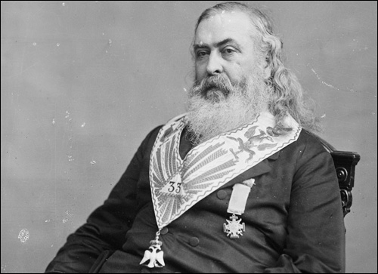

http://www.sacred-texts.com/mas/md/md04.htm

III. The Master….

The true name of Satan, the Kabalists say, is that of Yahveh reversed; for Satan is not a black god, but the negation of God. The Devil is the personification of Atheism or Idolatry.

For the Initiates, this is not a Person, but a Force, created for good, but which may serve for evil. It is the instrument of Liberty or Free Will.

They represent this Force, which presides over the physical generation, [i.e., sex] under the mythologic and horned form of the God PAN; thence came the he-goat of the Sabbat, brother of the Ancient Serpent, and the Light-bearer or Phosphor, of which the poets have made the false Lucifer of the legend.

Gold, to the eyes of the Initiates, is Light condensed.

http://www.sacred-texts.com/mas/md/md20.htm

Council of Kadosh: XIX, Grand Pontiff….

The Apocalypse is, to those who receive the nineteenth Degree, the Apotheosis of that Sublime Faith which aspires to God alone, and despises all the pomps and works of Lucifer.

LUCIFER, the Light-bearer! Strange and mysterious name to give to the Spirit of Darkness! Lucifer, the Son of the Morning!

Is it he who bears the Light, and with its splendors intolerable blinds feeble, sensual, or selfish Souls? Doubt it not!

THINK ABOUT IT

Let’s put together what Pike just said here. First of all, he feels Lucifer is a force created for good, which may serve for evil but doesn’t necessarily have to.

“Feeble, sensual or selfish Souls” will be blinded by the “light” that Lucifer bears.

Pike implies that anyone who is not “feeble, sensual or selfish” may be able to experience the “good” aspect of the Luciferian force.

These “hints” could cause some Masons to start asking questions – which might ultimately cause them to be invited into the Illuminati.

Pike says that the Luciferian force is “Liberty or Free Will.” This apparently indicates that Luciferians can practice Free Will to its fullest extent – doing whatever they choose, without ethical or moral constraints.

This becomes clearer in other secret documents that were leaked, as we shall see.

PIKE AND MAZZINI CREATE “THE PALLADIAN RITE” IN 1870

In 1870, the year before he published Morals and Dogma, Pike finalized the agreement with Mazzini that led to the consolidation of all Masonic groups in Europe and the United States.

As we see in this quote from Still’s book, they brought more of the teachings of the Illuminati and Luciferianism into Masonry, through introducing the “New and Reformed Palladian Rite”.

123: In 1870, Mazzini and Pike reached an agreement for the creation of the new supreme rite, to be called the New and Reformed Palladian Rite….

Membership in the “Palladium” was very limited, and its deliberations were shrouded in the strictest secrecy:

No mention of it would ever be made in the assemblies of the Lodges and Inner Shrines of other rites… for the secret of the new institution was only to be divulged with the greatest caution to a chosen few belonging to the ordinary high grades.

Palladism is essentially a Luciferian rite. Its religion is Manichean neo-gnosticism, teaching that the divinity is dual and that Lucifer is the equal of Adonay…. [25]

[25. Edith Starr Miller, Occult Theocracy. Hawthorne, CA: The Christian Book Club of America, 1933, p. 217.]

PIKE MAKES HIS INTENTIONS CLEARLY KNOWN

By 1889, Pike had surpassed Mazzini to become the head of World Masonry, as well as American Masonry and D.C. Masonry.

From this power position, he wrote an edict for the “23 Supreme Councils of the world” on July 14, 1889. These appear to be the top-ranking control groups for all Masonic circles in Europe and America.

This, again, was a highly secret document — leaked by those who saw the danger it presented. It is only thanks to these heroes that we are aware of what the ultimate plans of this group have always been.

This all-important quote can be found in A.C. De La Rive’s book, La Femme et l’Enfant dans la Franc-Maconnerie Universelle, and appears on page 123 in Still’s book.

That which we must say to the crowd is—We worship a God, but it is the God that one adores without superstition.

To you, Sovereign Grand Inspectors General, we say this, that you may repeat it to the Brethren of the 32nd, 31st, and 30th degrees—The Masonic religion should be, by all of us initiates of the high degrees, maintained in the purity of the Luciferian doctrine.

If Lucifer were not God, would Adonay (The God of the Christians) whose deeds prove his cruelty… and hatred of man, barbarism and repulsion for science, would Adonay and his priests calumniate him?

Yes, Lucifer is God, and unfortunately Adonay is also God. For the eternal law is that there is no light without shade, no beauty without ugliness, no white without black.

That is why the intelligent disciples of Zoroaster, as well as, after them, the Gnostics, the Manicheans and the Templars have admitted, as the only logical metaphysical conceptions, the system of the two divine principles fighting eternally, and one cannot believe the one inferior in power to the other.

Thus, the doctrine of Satanism is heresy; and the true and pure philosophic religion is the belief in Lucifer, the equal of Adonay; but Lucifer, God of Light and God of Good, is struggling for humanity against Adonay, the God of Darkness and Evil. [27]

[27. Miller, p. 220-221; secondary quote from A.C. De La Rive, “Instructions” issued by Gen. Albert Pike on July 14, 1889, to the 23 Supreme Councils of the world as recorded in La Femme et l’Enfant dans la Franc-Maconnerie Universelle, p. 588.]

AN INTERESTING CONTRADICTION IN PIKE’S LOGIC

Pike was clearly wrong about Zoroastrians saying these “two divine principles” are “fighting eternally” and are of equal power.

As I write in The Source Field Investigations, Zoroastrianism does acknowledge a negative force in the universe, which they call “The Adversary”.

However, the most current research from Boyce and Grenet has clearly revealed that God created the Adversary to be defeated at the end of the Age – which they called “Fraso-Kererti”.

They said the Adversary would be defeated gradually, and finally groan to a halt — thanks to “the focused efforts of the just.”

The Zoroastrian description of the End of the Age is very similar to what we see now.

This cycle shift-point from one Age to the next has been calibrated by many ancient cultures as occurring on or around the end of this year 2012 – as I reveal in my new bestseller, The Source Field Investigations.

I worked very carefully to insure the absolute secrecy of the content of this book right up until it was actually in published form — specifically because we were well aware of the dangers involved in telegraphing the move.

MAZZINI AND PIKE PLAN FOR THREE WORLD WARS – IN 1871

Some people could conceivably argue that Luciferianism is merely a philosophical construct that should be protected under the banner of religious freedom like any other.

Obviously, Christians have a knee-jerk reaction to the word Lucifer – but ultimately, if Luciferians respect the rights and sovereignty of others, under the US Constitution, they can think whatever they want.

However, Still’s book reveals that Pike and Mazzini made major additions to the plan for how their secret group – the “Illuminati” – could seize control of the planet, financially and politically.

Their plan was to deliberately create three world wars – on false pretenses. This means killing people and orchestrating events behind the scenes to create death and bloodshed on a level never before seen.

Two out of three of these wars appeared exactly as planned. The third World War – a battle with a ragtag group of terrorists in the Middle East – has been attempted for some time, but still has not succeeded.

Nonetheless, it is obvious that the struggle to create this Third World War is very much a present-day issue. The Federal Reserve “super-entity” is still following the old script as if it were Scripture.

The fact that this document was kept in plain, public view for many years in the British Museum Library shows that the truth is indeed out there – for those who are capable of hearing it.

Again, I wouldn’t write about any of this if I didn’t firmly believe this group is about to be defeated.

STILL’S BOOK REVEALS THE PLAN FOR THREE WORLD WARS

Here are the key passages in Still’s book that had such a huge effect on me when I first read them in 1996.

127: Although they had finally united Italy, Mazzini and Pike realized that the unification of all Europe under the banner of Illuminism would be extremely difficult, if not impossible.

Nationalism runs strongly in the human spirit, and is very difficult to erase, especially on a continent divided by warfare for many centuries.

Therefore, they set to work on their greatest plan — a plan so vast in scope that only a reader familiar with the great power wielded by the secret societies could begin to believe it.

In 1871, Mazzini issued a letter in which he outlined the final three-part plan of the Illuminati: their grand design for ridding not just Europe, but the entire world of Christianity, and bringing it under the “illuminated” dictatorship of Luciferianism.

This remarkable letter was for many years on display in the British Museum Library in London. [32]

[32. Salem Kirban, Satan’s Angels Exposed, 1980, p. 161.]

PLANS TO CREATE A ONE-WORLD GOVERNMENT

127: Mazzini proposed a series of world wars.

These wars were to embroil every nation in a conflict so bloody and chaotic that eventually every nation would surrender its national sovereignty to an international government, like the League of Nations, or the second attempt – the current United Nations – in order to prevent subsequent global bloodletting….

The first of these world wars, they hoped, would topple the Czarist government of Russia and establish an Illuminized dictatorship – a new level in the game of control of populations.

This would give the Illuminists a secure base from which to operate, with a large population and vast natural resources to fuel the new engine of Illuminism.

The second World War would allow the new Soviet Russia to capture Europe – or as it turned out, half of it.



The third World War would be in the Middle East between the Moslems and the Jews, and would bring about the biblical Armageddon.

Certainly by the end of this Third World War, the battle-wearied nations would be ready to accept any proposal so long as it promised peace, uniting the entire world under the fatal banner of the Luciferian New World Order. [34]

[34. Kirban, p. 162-163.]

PIKE REVEALS THE PLAN IN HIS OWN WORDS TO MAZZINI

127: Pike wrote to Mazzini about the consequences of the Third World War in 1871:

[It will] provoke a formidable social cataclysm… and the most bloody turmoil.

Then everywhere, the citizens, obliged to defend themselves against the world minority of revolutionaries [terrorists], will exterminate those destroyers of civilization, and the multitude, disillusioned with Christianity,…

…will be without a compass, anxious for an ideal, but without knowing where to render its adoration, will receive the true light through the universal manifestation of the pure doctrine of Lucifer, brought finally into public view.

[This is] a manifestation which will result from the general reactionary movement which will follow the destruction of Christianity and atheism, both conquered and exterminated at the same time.

THE REVEALING

Everything I’ve shared with you is documented, historical fact. Much of it came from insiders who broke away from the group and revealed their testimony.

This is still happening in the present day – and as a result, we have strong reason to believe the Illuminati is very much alive and well.

I have had personal interaction with a woman named Svali, who claims to have been a mid-level member of the modern-day Illuminati – the living inheritors of this plan – up until she escaped in the early 1990s.

Svali’s writings are extremely extensive – enough to fill several books. I was directly responsible for orchestrating and transcribing her one and only surviving radio appearance – on Greg Szymanski’s show on Republic Broadcasting Network, on January 17, 2006.

While studying her discussion forum on her website at the time, lionlambministries.org, I saw her say in December 2005 that she was ready to break her silence and go on the radio.

Greg Szymanski’s name came up as one of two choices. I immediately wrote him an urgent letter with her contact info. She and I also began a written communication that unfortunately ended after the show.

I appeared as a call-in guest on the show towards the end and thanked her for her bravery. I deliberately misspelled my own last name in the transcript to make it less obvious that I had helped orchestrate this.
https://divinecosmos.com/Illuminati_Defector_Svali_Speaks.mp3

Svali has never again made a single written, public statement anywhere after this show aired in January, 2006, but we do know that she is alive. She was severely tortured for doing this radio show.

THE REVEALING

If Svali is correct, this “pure doctrine of Lucifer, brought finally into public view” is called The Revealing. She had been told it was planned for the year 2020.

The Revealing was not planned to occur on any ordinary day. The formula calls for a global economic collapse to provoke the “formidable social cataclysm” planned by Pike and Mazzini.

I do not believe The Revealing will ever happen — due to the widespread awakening now reaching critical mass in the public.

Pike and Mazzini were not wise enough to have foreseen the possibility of a worldwide, totally free and unregulated media – thanks to the Internet. This was the single most critical failure in their plan.

The resulting public awakening has now created an alliance of 122 nations, as we will soon discuss, who plan to break the media stranglehold, expose the truth and free the planet.

Things had to get to a critical crisis-point in order for there to be a strong enough will, worldwide, for this group to finally be defeated – but that will has finally been achieved.

SHATTERING THE DENIAL

However, before we discuss the resolution of this problem, there are yet additional walls of denial that need to be shattered.

I understand that these following sections will be the most troubling parts of the investigation – but again, we have reached a planetary crisis point, and we can no longer afford to stay in denial of the truth.

What you are about to read is excerpts from a written interview Svali gave with H. J. Springer, the founder of the now-defunct Centrex News website, in 2000.

I pulled the original links below off of archive.org.

All of Svali’s works, including these written interviews and the transcript of the radio show, have now been compiled and arranged at http://svalispeaks.wordpress.com.

Let me make it very clear that eyewitness testimony is considered evidence admissible in court. Should that evidence then be verifiable, that testimony is considered legal proof.

Other authors who heavily validate and support Svali’s testimony, and are extremely challenging to read, include Brice Taylor (Thanks for the Memories), Cathy O’Brien (Trance-Formation of America and Access Denied), Annie McKenna (Paperclip Dolls), Kathleen Sullivan (Unshackled), Carol Rutz (A Nation Betrayed,) Lynn & Cheryl Hersha (Secret Weapons) [some argue this book is a CIA whitewash], Wanda Karriker (Morning, Come Quickly), “Mauri” (Vatican Ratline), Janet Thomas (Day Breaks Over Dharamsala), James Shelby Downward (King-Kill 33 and The Carnivals of Life and Death), and Fritz Springmeier (Bloodlines of the Illuminati, The Illuminati Formula Used to Create an Undetectable Total Mind-Controlled Slave and Deeper Insights Into The Illuminati Formula).

A wealth of additional resources and witness testimonies can be found here.

After we discuss Svali’s testimony, we will briefly explore tangible information that verifies Svali’s allegations in the everyday world.

UTTERLY COMPELLING

The volume of written data generated by Svali is very extensive – several hundred pages. The radio show I linked to above is extremely gripping… and utterly compelling.

She talks with speed and confidence about very complex and difficult subjects. Furthermore, our historical research verifies many of the key aspects of her testimony.

Svali’s life was threatened after she did that show, and she went into hiding. She never once attempted to profit off of the hundreds and hundreds of pages’ worth of material she wrote to expose this group.

Though other survivors have come forward, Svali was the highest-ranking member thus far, and has provided the greatest amount of written documentation of her knowledge and experience.

After her radio interview, I alerted Henry Makow to her work, as he was already publishing investigations along these lines. Soon afterwards, he wrote an article that gave a great overview of her testimony:

http://www.rense.com/general30/illuminatidefector.htm

I’ve tried to avoid the “ritual abuse” discussions as much as possible in these excerpts, so as to protect you from having to read about these troubling subjects unless you decide to get more involved.

Suffice it to say that hallucinogenic drugs, hypnosis and torture — primarily through electroshocks — can apparently create personality fragments that have their own separate sense of self, and can be isolated from the others by “amnesic barriers.”

For now, let’s focus on some of the specific facts about the organization itself that Svali gave.

WHAT IS THE ILLUMINATI?

http://web.archive.org/web/20030813222809/http://www.centrexnews.com/columnists/svali/2000/12/svali02.html

Q: Svali, I think our readers are wondering ‘Is the Illuminati a religion, secret society, satanism or is it a combination of it, or something different all together, or more sinister?’

A: The Illuminati is a group that practices a form of faith known as “enlightenment”. It is Luciferian, and they teach their followers that their roots go back to the ancient mystery religions of Babylon, Egypt, and Celtic druidism.

They have taken what they consider the “best” of each, the foundational practices, and joined them together into a strongly occult discipline.

Many groups at the local level worship ancient deities such as “El”, “Baal”, and “Ashtarte”, as well as “Isis and Osiris” and “Set”.

This said, the leadership councils at times scoff at the more “primitive” practices of the anarchical, or lower levels.

I remember when I was on council in San Diego, they called the high priests and priestesses the “slicers and dicers”, who kept the “lower levels happy”.

This is not to offend anyone, it only shows that at the leadership levels, they often believe they are more scientifically and cognitively driven. But they still practice the principles of enlightenment.

There are 12 steps to this, also known as “the 12 steps of discipline’ and they also teach traveling astral planes, time travel, and other metaphysical phenomena. [DW: We will cover the 12 steps in a minute.]

Do people really do this, or is it a drug induced hallucination ? I cannot judge.

I saw things that I believe cannot be rationally explained when in this group, things that frightened me, but I can only say that it could be a combination of cult mind control, drug inductions, hypnosis, and some true demonic activity.

How much of each, I cannot begin to guess. I do know that these people teach and practice evil.

WHAT ABOUT THE HIGHER LEVELS?

http://web.archive.org/web/20030813222809/http://www.centrexnews.com/columnists/svali/2000/12/svali02.html

At the higher levels, the group is no longer people in robes chanting in front of bonfires.

Leadership councils have administrators who handle finances (and trust me, this group makes money. That alone would keep it going even if the rest were just religious hog wash).

The leadership levels include businessmen, bankers, and local community leaders. They are intelligent, well educated, and active in their churches.

Above local leadership councils are the regional councils, who give dictates to the groups below them, help form the policies and agendas for each region, and who interact with the local leadership councils.

At the national level, there are extremely wealthy people who finance these goals and interact with the leaders of other countries.

The Illuminati are international. Secret? By all means. The first thing a child learns from “family, or the Order” as they are called, is “The first rule of the Order is secrecy”.

This is why you don’t hear from more survivors who get out. The lengths that this group goes to, to terrify its members into not disclosing, is unbelievable.

Q: Is this the same Illuminati that was created by Adam Weishaupt in Germany?

A: Weishaupt did not create the Illuminati. They chose him as a figurehead and told him what to write about.

The financiers, dating back to the bankers during the times of the Templar Knights who financed the early kings in Europe, created the Illuminati. Weishaupt was their “go fer”, who did their bidding.

WHAT IS THE CONNECTION BETWEEN FREEMASONS AND THE ILLUMINATI?

http://web.archive.org/web/20030810070816/http://www.centrexnews.com/columnists/svali/2000/12/svali04.html

Q: Svali, one of the more important points, which I am sure a lot of readers would like to know more about, is, what is the Illuminati /Freemason connection, as far as you are aware of, given your previous position in the Illuminati?

Q: Was – and is – there an infiltration of the Masonic Order?

A: The Freemasons and the Illuminati are hand in glove. I don’t care if this steps on any toes, it’s a fact.

The masonic temple at Alexandria, Virginia (the city itself was named after Alexandria, Egypt, and is a hotbed of Illuminati activity) is a center in the Washington, DC area for Illuminati scholarship and teaching.

I was taken there at intervals for testing, to step up a level, for scholarship, and high ceremonies. The leaders in this masonic group were also Illuminists.

This has been true of every large city I have lived in. The top Freemasons were also top Illuminists.

My maternal grandparents were both high ranking Masons in the city of Pittsburgh, Pa. (president of the Eastern Star and 33rd degree Mason) and they both were also leaders in the Illuminati in that area.

Are all Masons Illuminati? No, especially at the lower levels, I believe they know nothing of the practices that occur in the middle of the night in the larger temples.

Many are probably fine businessmen and Christians. But I have never known a 32 degree or above who wasn’t Illuminati, and the group helped create Freemasonry as a “front” for their activities.

THE ILLUMINATI BELIEVE THEY ARE GOOD – NOT EVIL

http://web.archive.org/web/20030810070328/http://www.centrexnews.com/columnists/svali/2000/12/svali03.html

I want to address another misconception. That is, the one that the Illuminists know that they are evil.

When I was in the group, I and those around me were ideologically committed to the agenda as being GOOD.

I thought I was helping others reach their full potential when I was a trainer.

I believed that after years of sweat and hard work, that my intelligence won out, and that I made an excellent leader.

I fought Jonathan and others on the council when I thought they were unfair, and stood up for the people beneath me. Others did the same. They honestly think they are doing a GOOD thing, and if you told them it was wrong, or evil, they would look confused.

It took a LOT of therapy and deprogramming myself, doing reality checks with noncult people to realize that it was all a lie.

I was devastated. I had dedicated my life to helping others bring in the glorious new order, and then found out it was EVIL and abusive. I went through a period of intense grieving/mourning over this.

Most Illuminists I knew weren’t evil, they were deceived. Only the top leadership perhaps were consciously being hurtful.

ARE THE ILLUMINATI TRYING TO RUN THE WORLD?

http://web.archive.org/web/20030813222809/http://www.centrexnews.com/columnists/svali/2000/12/svali02.html

The Illuminati believe in controlling an area through its: banks and financial institutions (guess how many sit on banking boards? You’d be surprised)

Local government: guess how many get elected to local city councils?

Law: children are encouraged to go to law school and medical school.

Media: others are encouraged to go to journalism school, and members help fund local papers.

FUNDING THE “NEW WORLD ORDER”

http://web.archive.org/web/20030608223845/http://www.centrexnews.com/columnists/svali/2000/12/suite101_07.html

I saw a large amount of money being used to fund the projects of this group, funds that poured in from around the northern hemisphere and the world.

Couriers were sent to the corners of the globe, and many of the top financial institutions had a vested interest in bringing this “new world order” to pass.

This was discussed in leadership meetings; shown in videos to members of the group (such as the grainy films I saw in the 1960s showing a large round table with 13 members sitting around it, and the words “these are your leaders” spoken as the members rose and pledged allegiance to the coming new order.)

I will not mention the figures shown in this film in order to avoid the claim of “libel” but they were well known, influential, and many were behind the banking system of the modern world.

[DW: In this subsequent article, Svali revealed that the Rothschilds and Rockefellers both hold seats on the Supreme World Council that is intended to rule in “the New Order to come.”]

The Illuminati are funding this coming world order quietly, behind the scenes.

They believe that money not only “talks” as the saying goes, but buys media coverage, or silence; protection; and the influence needed to shape our modern world….

Are the Illuminati out to rule the world? Yes, and this is what they teach their members. They are working avidly towards this goal even as I write.

THEY ARE A VERY SMALL BUT POWERFUL MINORITY

http://web.archive.org/web/20030810071654/http://www.centrexnews.com/columnists/svali/2001/01/Q_A01.html

The Illuminati and their followers are a minority of our world’s population. In San Diego county, where the population is over 2 million, there existed 5 years ago 24 sister groups with membership of roughly 60 to 75 each. Leadership council over the county was 13 members.

So, in a metro center with over 2 million, the active Illuminists comprised less than 1500 members. The Illuminati are possibly 1% to 2% of the population in the US.

What this means is that 99% of the people you know and work with are NOT Illuminati. They are good, hard working people (at least most are) who want a paycheck, and a good family life.

MOST of the leaders in our communities and financial systems have never heard of the Illuminati, because they are a minority.

So, why worry about them? Because a small group of evil people can do great damage. I will use an analogy.

MOST people in our society are not involved in child pornography, consider it a crime against children, and would fight against it given the chance.

Yet, the small minority of those involved in it do incalculable damage to the children involved. The effects of the crime are greater than the bare numbers involved.

Why isn’t child pornography stopped? We have the evidence, law enforcement knows it exists, yet it is a multi-billion dollar industry.

HOW do these people “hide” from justice and capture? Why don’t the police stop them? Because they aren’t stupid.

They work under secrecy. They change locations frequently, and kill those who talk to law enforcement. Bribes and other means are used to cover their tracks, and they hire excellent lawyers.

Okay, now lets look at the Illuminists. The 1% of our nation involved are extremely intelligent. They have sworn an oath on pain of death from toddlerhood on to never reveal their true allegiance to outsiders.

WHAT ARE THE BIGGEST WEAKNESSES OF THE ILLUMINATI?

http://svalispeaks.wordpress.com/2008/09/12/part-7-illuminati-symbols-and-clues-level-of-infiltration/

1. They are arrogant, and this could be their downfall. They view the common man as “sheep” with no intelligence.

They are full of pride, believe they are invulnerable… and that any press about them is the equivalent of a gnat to be swatted.

Arrogant people make mistakes, and they are becoming more blatant and open in recent years.

2. They believe they can overcome God, which is a huge mistake. God can stay the hand of history, and has so far, in the hope that more from this group will get out, because He is merciful.

3. Most of them are wounded, abused victims, who don’t realize that it is possible to leave the group.

There is a lot of discontent in the ranks, and there would be a mass exodus if the members believed it were really possible to get out (and live).

Many of the trainers I knew (I know, wicked, torturing pedophiles) were NOT happy with what they did.

They would whisper quietly, or give a look, to show that they disagreed with what they had to do. They would resignedly do their jobs, in the hope of advancement.

Know what one of the biggest carrots offered to those who advance up in the group is? That you don’t have to hurt people anymore, and that you can’t be abused.

(It’s true: only those higher than you in the group can abuse you, so everyone wants to move up, where the pool of candidates becomes smaller).

Of course, people can choose to abuse anyone beneath them, and that motivates some (but not all!) to move up.

SVALI ANSWERS WILCOCK QUESTIONS IN PRIVATE EMAIL

Even with everything Svali revealed publicly – of which the above is just a very small sample – I still felt there were some unanswered questions.

As a direct result of our negotiations to get her on the radio, she indicated a willingness to answer my personal questions. This is the first time I have ever made those results public.

I will be the first to acknowledge that her answers are controversial. They imply that black magic is being used in the group, and that tangible results are apparently being obtained at times.

These visions and experiences could be the result of drug-induced hallucinations, which can be shared – based on my research in The Source Field Investigations.

In the interest of full disclosure, I will not censor anything she said.

SVALI’S EMAIL TO WILCOCK — INTRODUCTION

—–Original Message—–
From: Svali
Sent: Saturday, January 14, 2006 1:54 PM
To: David Wilcock
Subject: to David from svali

David,

I promised to answer some questions, and so will now. Also, I did contact Greg, and he will be interviewing me this Wednesday.

This is the second of only two radio interviews I have ever granted. But both you, and a long-time friend have vouched for him, so I will do this.

FIRST QUESTION TO SVALI

WILCOCK: You have said there are six branches of study in the Illuminati, and different members specialize in different areas, depending on their proclivities.

Three of them are easy to figure out: Military, Media and Leadership. The other three, “Scholarship,” “Sciences” and “Spiritual”, seem to be very difficult to pinpoint.

If you could give a more detailed description, by category, of what each branch does, that would be very useful to people trying to really understand this.

THE SCIENCES BRANCH (SVALI’S OWN SPECIALIZED AREA)

SVALI: Sciences was involved in overseeing the areas of scientific study and research, including behavioural science, brain mapping, experimental drugs, [hypnotic] induction techniques, and how to implement training more quickly and reliably.

They truly do follow the “scientific method”, and have numerous national and international research protocols.

The top trainers and scientists in the group are heavily involved in this branch. Also children undergo at least some training in sciences; but the ones with a real aptitude and the right intelligence are directed here.

Those in sciences hold regular (yearly) conferences, to teach others, and in fact, teaching new techniques and disseminating the results of recent research are quite important.

Sciences also oversees such things as ensuring that training protocols based upon observation are followed, and that those involved in training and research are skilled in observing and recording changes in physiology, behaviour and stress patterns.

Sciences can include observing children behind a one-way mirror and observing normal patterns, as well as patterns when an external stimulus or change is introduced.

It may also involve monitoring how well an individual is coping with being “tanked” (placed in an isolation tank), to ensure that they aren’t over-stressed.

SVALI ON THE SCHOLARSHIP BRANCH

SVALI: Scholarship is heavily involved in the oral teaching of family history; in the research and passing down of genealogy, and the study of new learning.

Languages, including learning ancient languages, goes under this branch.

More recently, training in computer science and hacking has gone under scholarship (yes, they have very, very skillful hackers).

If a tradition, oral history, or story is important to the group, it will go under scholarship.

Those heavily involved in this area are outstanding teachers, and will supplement the teaching with dramatization of the history being taught.

They are also skilled at testing knowledge.

SVALI ON THE SPIRITUAL BRANCH

SVALI: Spiritual is the branch of the group involved in spiritual enlightenment. Again, while all members undergo training in this area, those especially skilled are selected to specialize in this.

Spiritual covers the following:

– intense mentoring by one’s spiritual mentor, a person skilled in this area;
– the ability to travel dimensions and through time, psychically travel (“out of body”);
– strength in power battles;
– the ability to wound or kill others psychically, and other paranormal phenomena.

Training in spiritual can include being tortured, and then passing to another dimension and reporting what one sees there.

Spiritual may also involve a visit to StoneHenge (yes, it really is a spiritual place for the group), going through a ceremony, and going through a portal back in time.

This training may also feature a chess game with a “chess master” with pieces that animate on the board, demonically.

Strange sounding stuff, to say the least, but this is what spiritual does. They are also in charge of rituals, or what is sometimes referred to as “slicing and dicing” by those who are not in spiritual.

WHAT ARE THE “TWELVE STEPS OF ENLIGHTENMENT?“

WILCOCK: Also if you could spell out in detail what these 12 steps of so-called enlightenment are, that would also be beneficial in helping to track how you say some Hollywood films try to teach it.

People might also see that it was not something you would have invented off the top of your head because it is probably quite comprehensive, albeit confused and distorted because of what it obviously leads to.

SVALI: In my book, “Breaking the Chain”, I outline these. [Here is a current link to it on the website containing her material.]

Basically, the goal of these steps is the ultimate goal of enlightenment: to become a god. The Illuminati believe that the truly enlightened, at the top of the journey, become a god — they really do.

This is the aim of all the pain, torment, and training for these people.

And some of the top trainers (such as Mengele, and others I knew) had parts inside that really did believe they were a “god”, and insisted on being addressed as so.

THE FIRST THREE STEPS

SVALI: The first three steps involve abandonment, not wanting and not needing, or a breaking away from physical needs.

The child is conditioned to [1] never ask, [2] never want, and [3] never need through horrific experiences and teaching sessions.

These are designed to break down their will and sense of self; and teach them to look to external people for cues as to what they should want.

STEPS THREE THROUGH SIX

SVALI: The next three steps involve a breaking away from emotional relationship with others.

[4] To hurt is love; [5] to care brings pain, and at step six, [6] betrayal is the greatest good.

The child is taught to rely first and foremost upon themselves, and to never trust another.

A lot of spiritual training is also put in at this point. For instance, the child will have a trusted spiritual mentor, who has been a patient teacher for years.

Suddenly, the mentor turns on the child, and tries to kill them psychically, forcing the child to call on their own psychic protector (demon) to save their life.

If the child fails the test, they may die or be wounded terribly, and take months to recover.

Those who pass are able to fight their mentor and maintain, but at great spiritual cost, since protectors always take their “pound of flesh” emotionally and spiritually in return for sparing a child’s life (they don’t do this out of kindness).

STEPS SEVEN THROUGH NINE

SVALI: The next three steps instill deep loyalty (7-9), with the directives to [7] never disobey, [8] never question and to [9] protect the triad (the three adults the child is enmeshed with through a trauma bond).

This is the point where most of the assassin training is put in as well, and also suicide programming.

(For example: the child is given the command to suicide by their trainer. They must actually be falling down onto a knife to pass this test. The trainer and two assistants stop the child before they can succeed).

TEN THROUGH TWELVE: SPECIALIZATION IN THE CHOSEN BRANCH

I am sorry if this is upsetting for you to read. Some people will have no trouble with it. Others will be feeling extremely saddened, terrified and depressed at this point. I do understand that.

These overwhelming emotions have served very well in stopping us from studying and understanding the problem on any widespread level – but unless we know what’s going on, we cannot expect it to stop.

As you can see, these “stages of enlightenment” are nothing more than horrific abuse and trauma, leading to a fully suicidal personality. Such trauma also makes a person capable of committing murder.

Svali later clarified, in a short letter, that the last three stages are different, depending upon which branch the child has chosen and / or has been selected for.

Each branch has different requirements for leadership. Many children are unable to move past even the ninth stage – where they protect the lives of their abusers over their own.

The farther a child can go through these last three stages, the higher and more influential they will become in the Order – and in the public eye, particularly in Leadership, Media and Military.

Leadership graduates may become politicians, church leaders, judges or heads of corporations, for example.

Media graduates may end up as visible actors on television and film, news journalists or career musicians – though not all of them will work in the public eye.

Military graduates may end up with commanding positions for national defense in their native country, but may also work behind the scenes – such as for defense contractors.

SVALI EXPLAINS STAGES TEN THROUGH TWELVE

SVALI: 10-12 are steps of leadership; at the end of level 12, the child will have received their diamond. [This is a ring worn in ceremonies to connote high rank.]

Examples at one step are military leadership, with lessons taught such as, “If one member of the group is holding the others back, and it places your unit in danger, get rid of them (and they don’t mean send the person home)”.

At this point, the child will have shown their area of expertise, and is considered an adult within the group after passing the highest level they will achieve (not all children go to level 12; some go to level 9, 10, or 11).

I hope this is helpful.

Best wishes,
svali

HOW, WHEN AND WHERE DO THEY HAVE THEIR MEETINGS?

Many people don’t see how it would be possible for a group like this to function with such secrecy in the course of people’s daily lives.

Svali’s key article explaining how, when and where this group meets is “A Day in the Life of a Trainer.” Here are some of the highlights:

http://www.suite101.com/article.cfm/ritual_abuse/84219

9:30 I get ready to go to bed. I have to get ten to twelve hours of sleep a night, or I am completely exhausted. Many times, I fall asleep reading to my two children.

Just before falling asleep, I say to my husband, “Remember” and give him the code that lets us know we have to wake up later….

1:00 am. My husband wakes me up. He and I take turns being the one to wake up the others. We don’t need an alarm, because our internal body clocks wake us up. I am in my sweats, I fell asleep dressed to make it easier when I rise in the middle of the night….

“Get the kids,” he says in a low tone. I go upstairs and tell them, “Get ready, now.”

They are up instantly, completely obedient which is very different from during the day. Quickly, silently they put their shoes on and I take them down to the car.

My husband drives, I am in the passenger seat. He drives with the headlights off until we are on the road so we won’t wake our neighbors up….

WHAT HAPPENS ONCE THEY ARRIVE?

1:20 am We are at the first checkpoint at the military base. We drove in the back entrance and are waved through, the lookouts recognize our car and our license plates. They would stop anyone who wasn’t familiar or authorized to be there.

We will pass two more checkpoints before coming to the meeting area. It is at a large field on a major marine base that includes hundreds of acres.

Small tents are erected, and temporary bases set up for the night’s exercises. We come either here, or to one of three different meeting places, three times a week.

People are chatting and drinking coffee. There are a lot of friendships here, because everyone is working towards the same goal. The work is intense and the friendships are just as intense….

I go to the tent to change into my uniform. We all wear uniforms at night, and we all have ranks too, based on how high we are in the group and how well we do….

1:45 am We start going to our assigned tasks….

3:30 We have changed out of our uniforms, which are placed in a special hamper to be cleaned. My clothes, which were neatly folded on a shelf are back on, and we are all in the car on the way home….

4:00 am We are home and collapse into bed, instantly asleep….

7:00 am I wake up to the alarm, tired. It seems I am always tired, and this morning I have a slight headache. I hurry to get the kids up and get ready to teach another day.

REVIEW AND ANALYSIS

As you can see from Svali’s testimony, they have meetings two or three times a week.

The three most frequent locations for meetings would be military bases, private estates and Masonic lodges, though some meetings are apparently held in churches as well.

On those nights, a member’s first sleep cycle will be almost three and a half hours, from 9:30-9:45 until 1AM. Then three more hours of sleep occur between 4AM and 7AM, adding up to a total of six.

This is how the members of this group can have a sustainable lifestyle – though the traumas they go through obviously are a major cause of the constant fatigue Svali reported having.

Each meeting allows for 10-15 minutes of social time at the beginning, and over and hour and a half of focused work in their chosen area of specialty.

If there are three meetings a week, that allows for over four and a half hours of highly specialized training per week: 18 hours a month and 216 hours a year.

Svali also said that some of these meetings are specifically ceremonial in nature – such as re-enactments of historical events. These ceremonies would help to increase a sense of group cohesiveness.

You can certainly read more about all this if you like, but I have made an effort to trim out the discussions of abuse and trauma so you can more easily understand how this works.

Click on the first “Next” link below as we head into the next section — showing how the Illuminati discussion has now affected the “Real World” we all have to share.

CLICK HERE TO READ SECTION THREE: THE REAL WORLD

POSSIBLE PHYSICAL PROOF OF SVALI’S ASSERTIONS

I have asked Svali and other insiders if I inadvertently stumbled over a “ritual site” back in 1990, in Scotia, New York – and they said it probably was.

Let me say, up front, that I do not believe the vast majority of Masons have any knowledge of these activities, nor anything to do with them. I feel it would be grossly unfair to blame them for this.

We did reveal how Masonic oaths could be used to conceal damaging secrets. However, that doesn’t change the fact that most Masons are good, kind-hearted people who do not want to participate in anything nefarious.

Approximately one mile away from a Masonic lodge in my home town of Scotia, New York, just east of Collins Lake, Sunnyside Avenue became a bridge that crossed over railroad tracks.



In 1990, a friend of mine was riding his motorcycle under this bridge when he saw something truly terrifying. He rushed over to my house and told me I had to come see it right away.

He wouldn’t say more.



I went there with him and was shocked by what I saw. It was a gigantic, Egyptian Left Eye of Horus – the classic Illuminati symbol – painted in full colors — bright red, bright blue, bright yellow, jet-black and white — under the bridge.



The spots of dirt on the Eye are my footprints from the day before. The Eye is about 40 feet wide.



The paint was very fresh, colorful and crisp in 1990. There was no other graffiti in the area. Not a single thing other than this Eye. No other designs. No scribbles. Nothing. Just the Eye.

I was surprised at how little it had degraded, overall, when I went back to photograph it in 2004. There was a lot of new graffiti, but nothing else even came close to the Eye in the quality of its execution.

Admittedly I was terrified to go there and do this, but I did it anyway.



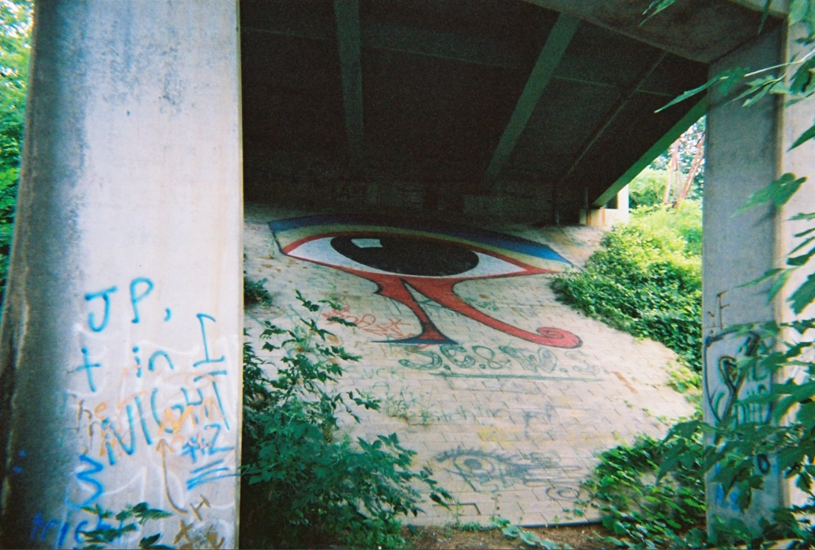

GRAFFITI NEXT TO THE EYE SOUNDED LIKE THE KU KLUX KLAN

In this next image, I used simple Transform filters in Photoshop to get the Eye looking the way it did when it was originally drawn – before they drafted it all out as a mural, using the bricks as a grid.

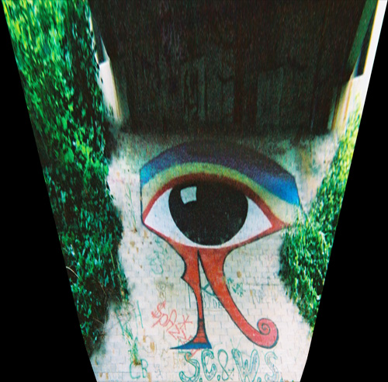

What I found even more troubling was that when I returned there in summer 2004, I found extremely hateful, and in some cases satanic graffiti – particularly under the opposite side of the bridge.



Jews and African-Americans were specifically targeted. Swastikas were drawn, as well as other symbols I could not identify. Next you will see one of the (believe it or not) less-offensive but nonetheless all-inclusive examples.

I went back a third time in winter 2004 and captured video film of this and much more of what was under there. I drive directly from the Masonic Lodge, around the corner, down the street, park in the lot, walk to the bridge, go under the bridge and see this.

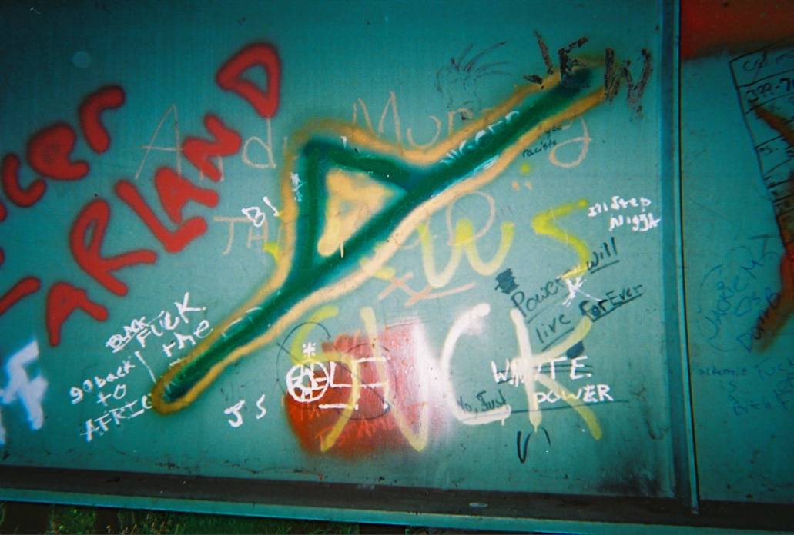

My friend and I both felt an oppressive sense of evil when we were there in 1990. We realized that people could do ceremonies under this bridge and be undetected. There was a huge parking area nearby.

Back at the time we had no idea that there would be a connection between Egyptian symbols and black magic rituals – but why else would someone paint this huge, utterly perfect Eye, and not one other thing?

It was also strange to go back in 2004 and see that someone had repainted the Eye any time other graffiti was placed over it — such as the “tags” of whomever called himself “M-Side.”

Paint seems to degrade very fast on concrete, particularly in cold climates. Graffiti I see on a regular walk I take has already faded almost to invisibility in less than a year. It would appear the Eye has enjoyed regular upkeep and maintenance since I first saw it.

I really didn’t understand what I saw, or how it all fit together, until I read Still’s book in December 1996 – and particularly after reading Svali, beginning in 2001.

THE WEIRDEST, SCARIEST THING FROM MY CHILDHOOD

As I read Svali, I also felt like I finally had an explanation for something my parents saw one night, when I was maybe seven years old, that utterly terrified them with supernatural dread.

The house across the street from us was owned by a successful local car dealer. At the far south end of our street lived a family that owned a local oil company, a local bank, and also won positions in local elections.

In the middle of the night, my parents watched at least three different couples walk down the street and enter the house across the way from us.

There were no lights on outside or inside the house. They did not knock – they just opened the door and walked in. They walked almost like a military march – no talking, no gesturing, just very stiff.

My father was completely terrified and told us never to say anything to anyone about this. Neither of my parents like it when I ask them to tell me the story – and it’s always the same after all these years.

At least one of the couples they saw was Masonic. Mr. W was an elderly member of the Masons. His wife was a member of Eastern Star, the female version of Masonry.

We had at least three elderly male Masons and their wives living on our street – the Ws, the Fs and the Ms – all within no more than four houses’ distance from the one across from us. These were probably the people my parents saw.

The Ms were an Italian family that owned a local shoe repair shop. I wondered if there was a mafia connection, as periodically they would host large parties where lots of cigars were smoked.

Down the north end of the street, we had a group of guys stand in formation, wear kilts and play bagpipes every year. This would happen for one or two days. They were rehearsing for a local parade.

LET’S NOT FORGET THE POSITIVE SIDE

Both of these things really happened to me as a kid. What my parents saw was very real. The eye under the bridge was very real. Later on, all this research helped me put the pieces together.

You may be having a very strongly negative reaction as the full scope of this investigation becomes clear. You may feel too sick to keep reading, but you still want to. I do understand that.

That Eye really freaked me out when I was a high school student. It was way too perfect to have been done for no reason.

When I read Svali’s materials in the summer of 2001, I felt like the world was closing in on me. I had trouble sleeping and I felt a continuing sense of dread and anxiety.

Unlike many people, I did not have reactions of denial, ridicule, sarcasm and hatred. I had too much of a background – too much education – to fall into that trap.

The only way I could read about all of this was to take it in small doses, which I would then balance out with reading positive, uplifting inspirational material.

It took months for me to work through the grief, fear and disgust that came up for me as I learned about all of this. I have since become vastly more confident in a positive outcome.

This is our planet. This is who we have living here. This is the situation. I do believe in positive, angelic forces guiding and protecting our planet – and I also believe they need our help.

One of the strongest inspirations I saw in Svali’s testimony was the fact that the vast majority of these people don’t like what is happening to them, and would get out and help the world if they could.

The same thing happened during the Anti-Masonic Revolt of 1826 to circa 1840.

WILCOCK PUBLISHED AN INVESTIGATION UNDER A PSEUDONYM IN 2003

When I read Svali, I had seven years of studying and integrating Finney’s book into my daily thoughts, and five years to take in the much bigger picture of the history and goals of the “Illuminati” revealed in Still’s book.

I was stunned by the degree to which Svali’s testimony validated these provable, historical facts. Furthermore, there was plenty of evidence in the present world that such a group did exist.

This included a wide variety of movies that I would have never shown any interest in watching – but once I knew what to look for, I considered this to be a necessary form of research.

I did not want to publish my findings about all of this on my own website, under my own name, at the time, though I have since lost that fear.

On July 27, 2003 I briefly took on the pseudonym “Art Aqua” and published a comprehensive investigation of Svali and various corollary materials on Joe Mason and Dee Finney’s website GreatDreams.com.

I wrote about the Eye, but I couldn’t remember where it was at the time – and didn’t have pictures. I retraced my footsteps on a trip to New York the following summer and found it.

IF YOU WANT MORE PROOF, WATCH CERTAIN MOVIES

Certain Hollywood films provide excellent proof to validate Svali’s testimony once you know what you are looking for. In many, many cases, the agendas of this group are being presented in these movies.

I revealed the best examples in Part Three of my investigation, with specific details.

There have obviously been others since 2003 – but I largely abandoned this ‘research’ practice as it was emotionally disruptive. Each time I saw one I was vividly reminded of how real this all is.

Three films that actually exposed the group’s agenda – albeit in a very creepy and disturbing way – were David Lynch’s Mulholland Drive, Stanley Kubrick’s Eyes Wide Shut and The Skulls.

Two of the most popular film series of all time directly expose their agenda in thinly-veiled symbolism, thus helping to ensure their defeat: The Lord of the Rings series and the Star Wars series.

Additional expose’ films include Dr. Strangelove, The Parallax View, and both versions of The Manchurian Candidate.

Other than many obvious examples of horror films, the movies I saw that seemed to most directly promote this group’s agenda, as I discussed in detail, are:

The Lawnmower Man, Independence Day, Starship Troopers, Total Recall, Fight Club, The Cell, The Devil’s Advocate, The Game, Conspiracy Theory, A Beautiful Mind, Signs, X-Men I and II, The Matrix, The Matrix Reloaded, Face/Off, Tomb Raider, The Core, DareDevil, Hulk and Terminator III.

I apologize to M. Night Shyamalayan for having included “Signs” in this list, as I do not believe he is a member of this group – only that they liked his concept.

BLATANT EXAMPLES IN THE RECENT PAST

Since 2003, there have been other blatant examples. I was stunned when I watched Harry Potter and the Prisoner of Azkaban, as the treatment of Gary Oldman’s character “Sirius Black” seemed to precisely mirror how Svali says this group sees Lucifer.

The power battles against “Dementors” in that movie were quite disturbing for a children’s movie as well. In the series finale, Harry has to let Voldemort kill him in order to “win” – another common theme.

Batman Begins and The Dark Knight Rises are both loaded with obvious correlations once you’ve familiarized yourself with Svali’s material. The villains are used to reveal the group’s agenda.

A Series of Unfortunate Events is one of the most blatant examples of all time – almost like a love letter from the group to its own children. The All-Seeing Eye appears constantly in this movie.

The Golden Compass was a big-budget flop that is thoroughly loaded with symbolism and programming.

The Imaginarium of Doctor Parnassus, Heath Ledger’s last film before his drug overdose, is an extremely obvious example – and reveals that the group knows they are losing, and desperately need a pep talk.

Inception is so closely related to the “training” Svali discusses that it would seem its ultimate creators must have been fans of her website – and / or that she is telling us the truth.

I went back and watched Dark City upon recommendation, and this also had many correlations. ExistenZ is another older (1999) example that seems heavily influenced by the group. Be warned that both of these films are difficult and disturbing to watch, although ExistenZ is also corny and lacks believability.

Hundreds of thousands, if not millions of people are now investigating this subject and looking for examples. Certain music videos are quite blatant as well as certain video games.

THERE IS MASSIVE RESISTANCE – INCLUDING FROM THE MILITARY ITSELF

You have probably seen at least a few of the movies I’ve just mentioned. Now that I’m finally giving you all the pieces I’ve been putting together, you may very well be feeling overwhelmed.

That’s exactly what they want.

Denial is their first line of defense – creating a sarcastic disbelief in which people boost their egos by convincing themselves this is all a joke, and then attacking and humiliating anyone discussing it.

Their next line of defense is fear. The people within this group do literally believe that if you fear them, you worship them. They see fear and worship as interchangeable.

There are many, many people who begin acquiring knowledge about this group, but then conclude it is completely hopeless for anyone to stand up to them.

I do not fear them. I published this all at once for my own protection. We had hundreds of letters asking me when this would be finished, but for my own safety it was important that it all come out at once.

I understand we have a very serious problem – and I have now had contact with a massive 122-nation alliance that has formed to solve it.

Particularly since 9/11, a majority of the active and retired United States military has become completely aware of this group, its agendas and ultimate intentions – and apparently intends to stop them.

Fulford’s Pentagon sources assert that we will soon see mass arrests. There may be a public unveiling of evidence like what I have presented. This “history lesson” may soon become common knowledge.

THINK BACK TO THE ANTI-MASONIC REBELLION

There is a historical precedent for what could be about to happen now.

180 years ago the Anti-Masonic Revolt was in full swing. A staggering 45,000 out of 50,000 Masons fled the group once they realized they could. Masonry was nearly destroyed in America as a result.

These people had taken their oaths. They were well aware of the secrecy, preferential treatment and loyalty they had sworn to uphold – upon pain of death.

Nonetheless, after this happened they became some of America’s strongest and bravest allies.

Using this written history as our guide, let’s again remember what Svali said:

http://svalispeaks.wordpress.com/2008/09/12/part-7-illuminati-symbols-and-clues-level-of-infiltration/

3. Most of them are wounded, abused victims, who don’t realize that it is possible to leave the group.

There is a lot of discontent in the ranks, and there would be a mass exodus if the members believed it were really possible to get out (and live).

Many of the trainers I knew (I know, wicked, torturing pedophiles) were NOT happy with what they did.

They would whisper quietly, or give a look, to show that they disagreed with what they had to do.

PROJECTION IS A CLASSIC TRAP

There is an incredibly vast amount of material about the Illuminati on the Internet. Much of it is of very poor and unconvincing quality.

The overwhelming majority of these articles are loaded with anger, victimhood and the witch-burning mentality. I hardly ever see any acknowledgement of the humanity of the people stuck in these groups.

I believe this “projected” anger happens when we cannot face our own shadow side – the pain, humiliation and sense of inadequacy and defeat that goes back to early childhood, when we first heard the word “NO”.

This buried shame can lead to the use of alcohol and drugs to numb it out, as well as many other addictive and compulsive behaviors.

Unhealed pain creates a ‘victim’ mentality, in which we are constantly searching for an external enemy to blast with our repressed rage. We project this rage onto a convenient, easy target.

If we can blame someone for why we feel bad, then for a short time we feel better.

If we haven’t forgiven and accepted ourselves, and those who hurt us, and stepped into a true knowing of our own value, we will keep seeking revenge over and over again.

This is nothing short of an epidemic in our society. Just look at the comments on any YouTube video as an obvious example.

THERE ARE ALREADY SIGNS OF REBELLION

The “Internet Conspiracy Theorists” channel this repressed rage and self-loathing into a mythical scenario that is extremely destructive to individuals, groups and nations.

Many of them seem utterly incapable of healing, or even realizing what they’re doing.

In this scenario, it becomes black and white. God Versus Satan. People versus Things. Good Guys versus Bad Guys. Us Versus Them.

Look at what happens when you think like this. Everyone in the government is the enemy. Everyone in the military is the enemy. Everyone in a corporation is the enemy. Everyone in the media is the enemy.

Our warriors have pledged their lives to protect us. That is a truly valiant sacrifice. Our own fathers and brothers paid the ultimate price for our freedom — with their blood.

I will not dishonor the brave men and women of our armed forces by suggesting, for even one minute, that “they are all in on it.”

Some of them are. Absolutely. But most of them are not. They have chosen to risk torture and potentially sacrifice their lives to protect the will, the freedom, the safety and the lives of the people.

They have not chosen to increase the comforts of a small group of wealthy bankers.

Anyone who works inside or outside the system, and chooses to stand and fight, has become a soldier for Truth — protecting the people who are still half-“asleep” and cowering in fear.

We have a word for those who stand and fight to protect and defend others. They are called heroes.

HEROES IN THE MEDIA AND MILITARY

One of the most heroic exposures of Truth, paving the way for much more that will follow, aired on CNN in January, 2010. Videos of this stunning expose are still available.

I have transcribed this clip in case it should ever be taken offline, as the information is too important to ignore. It features an interview between Anderson Cooper and Republican senator Charles Grassley.

This expose’ could not have come about without the coordinated, heroic efforts of military, media and governmental officials. I first wrote about it here, in 2010.

TRANSCRIPT OF COOPER AND GRASSLEY’S STUNNING EXPOSE’

http://www.youtube.com/watch?v=AATULb8MJcQ
http://www.youtube.com/watch?v=bf8rOGLC898

ANDERSON COOPER: Keeping them honest tonight. Potentially hundreds of military employees and contractors who may have bought child pornography online, and haven’t been prosecuted or in some cases even investigated.

That’s right, you heard me. Child pornography. As many as 1700 names, according to a US Senator, on a list of 5200 from an Internet sting operation – overlooked the first time around, four years ago.

Only now are they supposedly getting a second look, and only after pressure from investigative reporters and the US Senator you are about to hear from – Republican Charles Grassley.

The Pentagon porn story began in 2006. An immigration and customs enforcement child pornography sting operation called Project Flicker produced payment records of about 5200 people – many of whom provided Army or fleet zip codes, or military email addresses.

Subsequently, the Pentagon’s investigative branch, DCIS, began going through the ice list to identify who actually was a DOD employee or a contractor.

The investigation, however, only ran for eight months – and only cross-checked some 3500 names for Pentagon ties, according to the senator.

According to DCIS documents, revealed in a Freedom of Information Act request, out of that 3500, investigators uncovered 264 employees or contractors – including staffers for the Secretary of Defense and contractors at the NSA.

Nine people had top security clearances. But only about 20 percent of those 264 people were completely investigated. Fewer still were prosecuted, and after about eight months, the entire probe was halted.

It left about 1700 names totally unchecked. 1700 alleged kiddie porn customers – an unknown number of whom may still work in some capacity for the Defense Department.

Late last summer, after investigations by the Boston Globe and Yahoo News revealed the figures, a Pentagon spokesman promised to re-open the investigation, conceding that DCIS had stopped due to lack of resources.

DCIS says it is now revisiting all 5200 names, telling Senator Grassley’s staff they have now identified 302 employees or staffers. The Pentagon’s IG telling us, quote,

“Any suggestion that the D.O.D. Office of Inspector General or its criminal investigative arm, the DCIS, is not taking Operation Flicker and the issue of child pornography seriously is in error.”

Senator Grassley says he is still not getting the cooperation he needs from the Pentagon. I spoke to him earlier…. [snip]

AC: One of your staffers told us that getting information from the Defense Department on this has been like pulling teeth. Is that how you’d describe it?

SG: I’ve been involved in oversight of the Defense Department for almost all the years I’ve been in the United States senate.

It is very difficult to get answers from a lot of bureaucracies, but it’s quite more difficult in the Defense Department.

AC: Senator Grassley, I appreciate your time. We will continue to follow this. Thank you.

TWO WARRING FACTIONS IN THE PENTAGON

What you are seeing here is the result of two warring factions in the Pentagon. The minority “Illuminati” loyal faction still enjoys an institutionalized cover-up that protects certain members from being prosecuted.

Based on firsthand witnesses leaking intel to former Forbes bureau chief Benjamin Fulford, we have every reason to believe that the majority of the Pentagon, and the military, are fully aware of this problem.

They have listened to the will of the people – particularly since 9/11 – and they intend to do their job to protect the people… and save our planet from a plan that very few people really want.

If the rumors Fulford is hearing are correct, such an operation would have required an extraordinary degree of international cooperation and secrecy – and stunningly deep espionage.

Pentagon sources have said the trillion-dollar lawsuit I have reported on, and will cover again here, is one of several key strategies to make us aware of the urgent need for these mass arrests.

The group must be tackled by strictly legal means, so there is no possibility of confusion. Then, in the ensuing investigation, many other suppressed truths will emerge.

David DeGraw covered many of the under-reported news stories behind this takedown on September 3, 2011, in an article entitled Full-Blown Civil War Erupts on Wall Street. These stories are still extremely current.

A WORLD EVENT MUCH BIGGER THAN 9/11 IN SCOPE AND IMPACT

Cell phone and Internet service will nearly grind to a halt if / when something like this happens. Twitter and Facebook will overload and crash. It will be much bigger than 9/11 in scope.

Undoubtedly, many people will believe this is a worldwide military coup, and be terrified by it.

Nonetheless, I feel confident that the Pentagon and their international allies wouldn’t do this unless they had information that will leave little doubt of the need for action – and for why it had to be done.

I am not in denial. Neither should you be. Facts are facts. This group exists. The media can’t talk about it without being killed. A coalition of the willing is increasingly rising up to defeat Financial Tyranny.

By writing this and setting it free to the Internet, I have done my part. I have never seen any other presentation of this data all in one place, with the full sensitivity to the history involved.

I have no involvement in this possible military operation other than to have written this investigation — to help pave the way for the major changes and the complete honesty and truth-telling that is required.

I do not believe we will be ‘rescued’ by UFOs, ETs, angels or otherwise. While I do admittedly believe in such things, I also feel that this is our problem – and we are the ones who have to solve it.

In this sense, the military would merely become the instrument for the will of the people. We have said what we want, on a massive level. You can help by understanding what is coming, in advance — and helping to educate your friends and family, to reduce propaganda and panic, once it actually occurs. I very much believe it will.

We may never be able to predict how this change will occur, but I do believe events are now reaching a critical mass. Powerful alliances and opposing factions are closing in on this group from all sides.

I will now cover some additional, critical evidence before we head into a discussion of the lawsuit itself, and present the back-story and supporting material that I have only recently been made aware of.

This will be the last of the material that is upsetting to read. It is important to understand that the Penn State trial is only a brief glimmer into the world of organized pedophilia – and it must be stopped.

NAMBLA

If you go to NAMBLA.org, you will find the official website of the North American Man-Boy Love Association. Seriously.

Just the name sounds like the punch line of a joke – and Season Four, Episode Six of South Park, “Cartman Joins NAMBLA,” was devoted to it.

I feel this episode is crude and insensitive, as are almost all of them – yet humor was used to expose a very real problem.

Most of the people watching this episode had no idea that NAMBLA is a real organization – and are disturbed if and when they find out the truth.

The NAMBLA logo features an offset, capital M and a lower-case B. Any image or video file will have a certain number of “megabytes” on a computer.

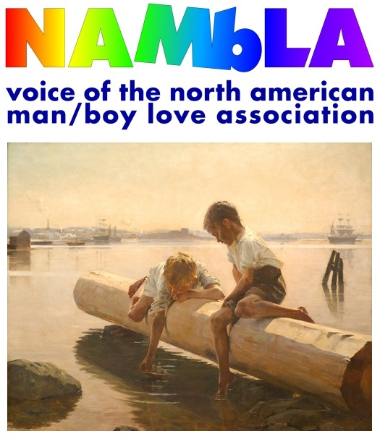

Megabytes are also delineated as Mb – the “Man-Boy” within the NAMBLA logo.

Therefore, the NAMBLA logo implies that by becoming a member of this group, you will have access to the same “Man-Boy” materials Anderson Cooper and Senator Grassley said were being downloaded by various members of the Department of Defense.

AN EXCERPT FROM THE NAMBLA WEBSITE

Since NAMBLA receives hardly any media coverage whatsoever, I have found that even very open-minded, clear-thinking people have a hard time believing me when I tell them about it.

Yet, you can go to their website yourself and see how extensive it is. This excerpt says it all:

http://www.nambla.org/welcome.html

WELCOME! The North American Man/Boy Love Association (NAMBLA) was formed in 1978….

NAMBLA is strongly opposed to age-of-consent laws and all other restrictions which deny men and boys the full enjoyment of their bodies and control over their own lives….

We call for fundamental reform of the laws regarding relations between youths and adults….

We provide factual information and help educate society about the positive and beneficial nature of man/boy love.

Other parts of the NAMBLA website feature graphic fantasy descriptions of erotic encounters between men and boys, clearly intended to help pedophiles get “in the mood.”



Again: just as Svali said, this is right out in the open – but no one seems to be paying attention.

NAMBLA WAS INFILTRATED BY THE F.B.I.

The “good guys” in the FBI created a long-term sting operation against NAMBLA – thanks to the work of Bob Hamer, a 30-year veteran operative who spent three years infiltrating the organization.

A 1995 FBI investigation revealed NAMBLA had 1,100 registered members. The article featuring this information appears to be blocked – I had to leave it up on my browser for hours before it loaded.

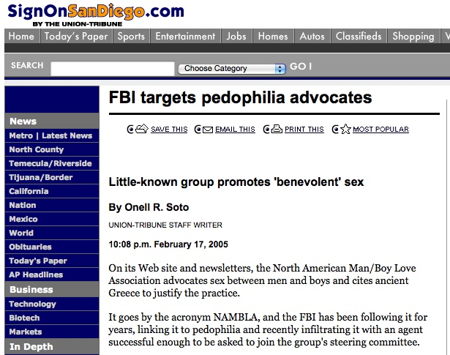

Agent Bob Hamer ultimately wrote The Last Undercover – The True Story of an FBI Agent’s Dangerous Dance with Evil, a groundbreaking book about his investigation.

This book is currently available for free download here. Please donate or buy the hardcover version to support Hamer’s work.

As this next video shows, Hamer discovered that this group was primarily focused on coordinating efforts to find and have sex with boys – not as the legal lobbying group it claimed to be.

Unfortunately, Hamer’s investigation did not go very far up the ladder – but the Franklin Cover-Up revealed much more, thanks in part to the testimony of Paul Bonacci, a child NAMBLA victim.

THE FRANKLIN SCANDAL AND COVER-UP

The original book investigating these issues, The Franklin Cover-Up, features graphic descriptions of ritual abuse and murder similar to what you find in some of Svali’s materials – which I did not publish here.

The author, a 16-year senator from Nebraska, tells his story in the documentary A Conspiracy of Silence, which got pulled from Discovery Channel before airing in 1994 – but is now widely available on YouTube.

More recently, Nick Bryant wrote The Frankin Scandal – and substantially added to the scope and the amount of provable data in this investigation.

Bryant’s book is also written with much greater sensitivity to the reader – and does not provide the graphic depictions of abuse that make The Franklin Cover-Up so difficult to read.

This Amazon review of Bryant’s book by “Puzzlenomics” reveals the scope of what it contains.

http://www.amazon.com/Franklin-Scandal-Story-Powerbrokers-Betrayal/product-reviews/0977795357/ref=cm_cr_pr_btm_link_3?ie=UTF8&showViewpoints=0&pageNumber=3&sortBy=bySubmissionDateDescending

I applaud Nick Bryant for bravely and selflessly investigating the inner workings of local, state, and federal officials to conceal the sexual terrorism, murder, and blackmail of many Nebraskan underage children by some of America’s most affluent, successful, and revered men in government, law enforcement, education, and clergy….

In this utterly disturbing work, Bryant deftly elucidates the confluence of the “real” powers within our taxpayer-funded government to craftily coordinate assets within key judicial, media, and law enforcement agencies to effect its will to suppress worldwide exposure of a possibly CIA-sponsored (blackmail) operation — pandering minors to some of the country’s most influential, affluent, and powerful men in business, media, and government.

This network of judges, policemen, lawyers, FBI agents, and media figures is so extensive, so deep, that the “powers” seemingly have an inexhaustible supply of “assets” ready to carry out their assigned tasks at a moment’s notice.

NAMBLA INVOLVED IN CHILD SEX TRAFFICKING

Paul Bonacci was directly involved in the Franklin cover-up, and is featured in the book. You can see part of Bonacci’s testimony about NAMBLA to FBI agent Ted Gunderson in this video.

In The Franklin Cover-Up, Bonacci claims that NAMBLA was used to coordinate child auctions.

https://s3.amazonaws.com/bk1/bk2/the-franklin-coverup.pdf

229: The North American Man-Boy Love Association, or NAMBLA, figured prominently in what else Bonacci could recall.

The motto of NAMBLA is “Sex before eight, or it’s too late.” Bonacci reports… that he witnessed NAMBLA-organized auctions of children.

300: Paul Bonacci reports… trips on behalf of the North American Man-Boy Love Association (NAMBLA), the pedophile group now given semi-official status by the United Nations.

Paul cites travel to the Netherlands and Germany carrying child pornography for subsequent “import” to the U.S.A. to avoid prosecution.

In Amsterdam, he names “Charles Hester,” and the British “Tommie Carter,” who had on computer a global list of child pornography users. NAMBLA is also cited for organizing auctions of children.

AN IMPORTANT CLARIFICATION

It is a misnomer to think that most of these children are being snatched off the street. If parents have their children take normal precautions outdoors, they should be fine.

The evidence does not support paranoid assertions that most missing children were dragged into pedophile rings that may be organized by groups like NAMBLA.

The reality is that many of these kids were sexually abused by their parents first, and the parents were offered freedom in exchange for allowing their children to participate in “medical experiments.”

Many, if not most of the kids involved in this are from within the group itself, or “sister groups” that work with the Illuminati. Some kids are specifically trained to specialize in this kind of work.

I am not at all trying to cover for this group. Nor does this in any way undermine the seriousness of what is going on, or of the need for it to be stopped immediately.

I just do not want loving parents to be living in constant fear when the odds are extremely small that anything like this would happen to their children.

FAMOUS CHILD ACTORS COME FORWARD

Regardless of what you may think about FOX, they have very bravely carried this and other shocking and important stories — and for that they deserve credit.

In December 2011, three new witnesses joined the team of former child actors claiming they were repeatedly sexually abused in the film and television industry – going back to the 1950s.

http://www.foxnews.com/entertainment/2011/12/05/recent-charges-sexual-abuse-children-in-hollywood-just-tip-iceberg-experts-say/

If a spate of recent allegations proves true, Hollywood may have a hideous epidemic on its hands. The past two weeks have brought three separate reports of alleged child sexual abuse in the entertainment industry….

Revelations of this sort come as no surprise to former child star Corey Feldman.

Feldman, 40, himself a survivor of childhood sexual abuse, unflinchingly warned of the world of pedophiles who are drawn to the entertainment industry last August.

“I can tell you that the No. 1 problem in Hollywood was and is and always will be pedophilia,” Feldman told ABC’s Nightline. “That’s the biggest problem for children in this industry… It’s the big secret.”

Another child star from an earlier era agrees that Hollywood has long had a problem with pedophilia.

“When I watched that interview, a whole series of names and faces from my history went zooming through my head,” Paul Peterson, 66, star of The Donna Reed Show, a sitcom popular in the 1950s and 60s, and president of A Minor Consideration, tells FOXNews.com.

“Some of these people, who I know very well, are still in the game.”

“This has been going on for a very long time,” concurs former “Little House on the Prairie” star Alison Arngrim. “It was the gossip back in the ‘80s. People said, ‘Oh yeah, the Coreys, everyone’s had them.’ People talked about it like it was not a big deal.”

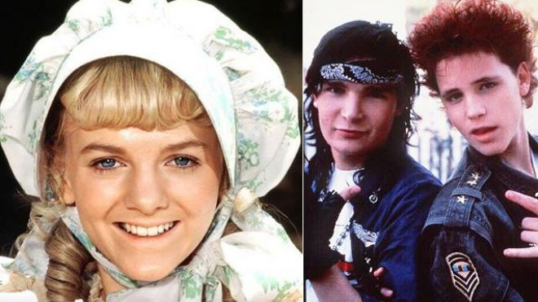

Arngrim, 49, was referring to Feldman and his co-star in “The Lost Boys,” Corey Haim, who died in March 2010 after years of drug abuse.

“I literally heard that they were ‘passed around,’” Arngrim said. “The word was that they were given drugs and being used for sex.

It was awful – these were kids, they weren’t 18 yet. There were all sorts of stories about everyone from their, quote, ‘set guardians’ on down that these two had been sexually abused and were totally being corrupted in every possible way.”…

Even though Feldman spoke candidly about the abuse, he hasn’t named the predator. “People don’t want to talk about this because they’re afraid for their careers,” says Peterson.

“From my perspective, what Corey did was pretty brave.

It would be really wonderful if his allegations reached through all of the protective layers and identified the real people who are a part of a worldwide child pornography ring, because it’s huge and it respects no borders, just as it does not respect the age of the children involved.”

WHAT TO DO IF YOU ARE A VICTIM OF ABUSE

Once the secrecy around this issue is broken – and I do believe that it will be – there will be a vast, unprecedented need for psychologists, counselors and social workers to provide effective treatment.

Whether you are a victim of abuse or you find yourself in a position to help survivors, there are resources available that will greatly assist you.

The top book recommended by Svali is Breaking the Circle of Satanic Ritual Abuse: Recognizing and Recovering from the Hidden Trauma by Daniel Ryder.

Another very useful classic that focuses in more specifically on the sexual abuse aspect is The Courage to Heal, by Ellen Bass and Laura Davis.

Svali’s own writings provide detailed information about how the “programming” is done, making it much easier to anticipate what could happen — and recognize it when it does.

FURTHER COMMENTS FROM “THE FRANKLIN COVER-UP”

This comment appears on the Franklin Cover-Up Amazon page, and was written by Jed Schlackman on August 5, 2003.

http://www.amazon.com/Franklin-Cover-up-Satanism-Murder-Nebraska/dp/0963215809/ref=sr_1_1?ie=UTF8&qid=1325807271&sr=8-1

It’s interesting that former CIA director Bill Colby ambiguously acknowledged to the author that the scenario described is real, and not long thereafter Colby turned up dead under suspicious circumstances.

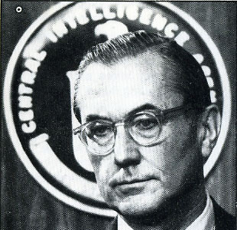

This comment by John Doe “JD” (NJ), on February 8, 2011, also spells out a typical reaction from someone who reads the book.

http://www.amazon.com/Franklin-Cover-up-Satanism-Murder-Nebraska/product-reviews/0963215809/ref=cm_cr_dp_all_helpful?ie=UTF8&showViewpoints=1&sortBy=bySubmissionDateDescending

This makes Rosemary’s Baby and An Invitation to Hell look like bake sales. The scope of the crimes, people involved and lack of justice is overwhelming….

Chief of Police, District Judge, Senior Editor, Senator, President, Foster Care worker, FBI, is anyone in power not a raving lunatic?

Drugs, child pornography, prostitution, murder, embezzlement, satanism, all with the help of very powerful friends in Omaha and D.C.

DECAMP SAYS “GO AHEAD AND SUE ME”

This quote inidicates that former Rep. DeCamp welcomes anyone to sue him if they can disprove what he has written.

Comment by Emi (MD, USA) – December 25, 2007

http://www.amazon.com/Franklin-Cover-up-Satanism-Murder-Nebraska/product-reviews/0963215809/ref=cm_cr_pr_btm_link_next_3?ie=UTF8&showViewpoints=0&pageNumber=3&sortBy=bySubmissionDateDescending

Mr. Decamp so much as said that if anyone believes that he is lying, or being untruthful about ANYTHING he’s written in his book, then that person should just ‘go ahead and sue him’.

He wrote that, he in fact, “welcomes” any suits that anyone would like to bring against him challenging his honesty in what he’s written in this book….

Ultimately, Mr. Decamp concludes that the reason why this huge cover-up has gone on for so long, is because there are very prominent people who like where they are in the social hierarchy.

If this scandal were to reach the mainstream, then the whole “system” itself would collapse entirely, thus threatening the security of their position.

KEY QUOTES FROM FORMER CIA DIRECTOR WILLIAM COLBY

Knowing the penalty of lying in such a sensitive, controversial case, Rep. John DeCamp revealed the content of his conversations with former CIA director William Colby in the beginning of his book.

The “Larry King” being mentioned is not the former television news anchor, just to be clear.

https://s3.amazonaws.com/bk1/bk2/the-franklin-coverup.pdf

Colby and his wife, Sally Shelton Colby, a United States ambassador under President Jimmy Carter, were at that very moment warning me to get away from the Franklin child abuse investigation, Larry King, and anybody else linked with Franklin, as quickly as possible for the sake of my own life and safety.

Sally and Bill had never talked to me like this before. They sat me down, made it clear that this was not one of our routine discussions about life and health and happiness, and emphasized to me the serious nature of what and whom I was dealing with.

“What you have to understand, John, is that sometimes there are forces and events too big, too powerful, with so much at stake for other people or institutions, that you cannot do anything about them, no matter how evil or wrong they are and no matter how dedicated or sincere you are or how much evidence you have.

That is simply one of the hard facts of life you have to face. You have done your part. You have tried to expose the evil and wrongdoing. It has hurt you terribly. But it has not killed you up to this point.

I am telling you, get out of this before it does.

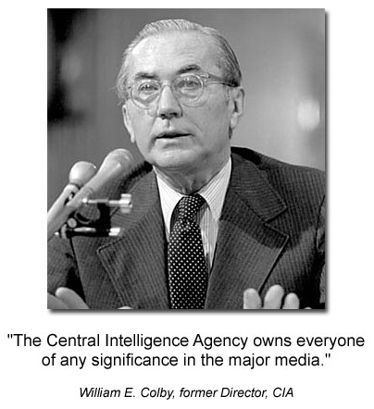

Sometimes things are just too big for us to deal with, and we have to step aside and let history take its course. For you, John, this is one of those times,” Bill warned, with Sally nodding her head in affirmation….

“But Bill,” I argued, “somebody has to do something. The problem here is that our institutions of government have been corrupted.

If there is a cover-up — and I now absolutely believe there is, even though originally I thought this whole Franklin story had to be a fantasy — then that cover-up can only take place with the cooperation and even the active assistance of some of our key institutions of government, from the courts to the cops, from the highest politicians, to the media representatives, to the wealthiest business leaders of our community and country.

“I can’t believe what you are telling me, Bill. Are you saying I should just lay it down, and walk away from this, when I know kids are being abused and killed; when I know our most respected citizens and business leaders are up to their eyebrows in drug dealing and official corruption; when every bone in my body tells me that evil is triumphing and everybody who is anybody is scared beanless to do something about it, for fear of one thing or another?

How can any honest or intelligent person do this? If I, or someone like me, do not keep pursuing this, then who will? And if we quit now, then when, if ever, will the truth come out and something be done about this evil and this corruption?”….

“So, what’s the message?” I asked. “What are you trying to tell me?”

“Sometimes,” Bill said, “There are forces too powerful for us to whip them individually, in the time frame that we would like.

We have to keep working at our goal. But we have to be sensible enough, not to risk everything and get ourselves destroyed or killed in the process. That victory we seek may take much longer than we wanted, and come in ways we never anticipated.”

I believe that victory that Colby spoke of – and may have been killed for – is upon us now.

I also want to be clear in saying that not everyone in these insider groups is a pedophile. The problem is that some of them are – and the group as a whole is concealing their crimes.

Now we will turn our discussion back to subjects that are a lot easier to talk about – with a greater focus on the solutions that are now emerging.

PUBLIC OUTRAGE REACHES A NEW EXTREME

This stunning Federal Reserve bailout figure of 26 trillion dollars, and other evidence like it, has directed the people’s wrath towards the financial industry… rather than the elected government.

Nothing like this has ever happened before.

Millions of people have taken to the streets in the “Occupy Wall Street” movement. It has pulled back due to cold weather, fatigue and threats of arrest, but is certainly far from over.

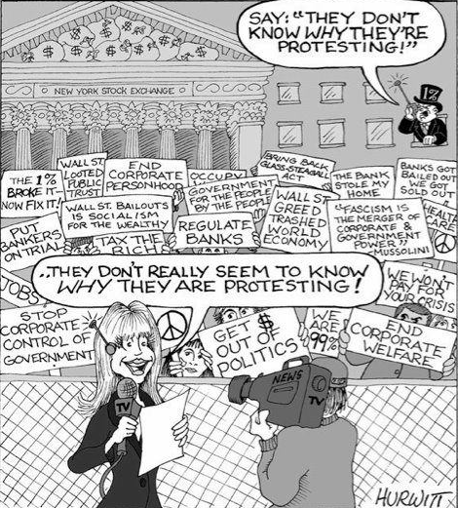

By October 10, 2011, the movement had spread to fully 900 different cities:

http://www.huffingtonpost.com/2011/10/10/occupy-wall-street_n_1002809.html?ref=occupy-wall-street

Occupy Wall Street, a movement that began as a small band of protesters in Zuccotti Park, gained endorsements from major unions and progressive leaders as well as prominent politicians.

Within a few short weeks, it has come to resemble a movement with more than 900 meetups in 900 cities across the country.

It has even gone international with Occupy sites in Australia and London and other cities saddled with long unemployment lines, gross income disparities, and hapless politicians.

THE “1 PERCENT” ARE SCARED OUT OF THEIR WITS… BELIEVE IT

I do believe the “1 percent” are scared out of their wits of a mass, public uprising. I believe there is clear evidence to prove it.

We’ve already seen Occupy Wall Street protestors gathering directly in front of the homes of key figures in financial and media corporations:

http://money.cnn.com/2011/10/10/news/economy/occupy_wall_street_protest/index.htm

NEW YORK (CNNMoney) — Occupy Wall Street is on the move … uptown.

Why uptown? Because that’s where the rich folks live!

Organizers are planning a march on Tuesday that will visit the homes of JP Morgan Chase (JPM, Fortune 500) CEO Jamie Dimon, billionaire David Koch, hedge fund honcho John Paulson, Howard Milstein, and News Corp (NWSA, Fortune 500) CEO Rupert Murdoch.

The millionaires and billionaires are being targeted for what event organizers called a “willingness to hoard wealth at the expense of the 99%.”

DESPERATE COUNTER-MEASURES

In desperation, the United States Congress passed the National Defense Authorization Act (NDAA).

If you don’t know what this is, you should. It is a declaration of war against the people of the United States by the insiders running their government:

http://www.washingtonsblog.com/2011/12/new-bill-authorizes-rendition-of-american-citizens-living-within-the-united-states-to-other-countries-for-torture.htm

Top experts – including the sponsors of the bill – say that the newly-passed National Defense Authorization Act authorizes indefinite detention of Americans living within the United States.

Top legal experts point out that the government claims the right to assassinate American citizens on U.S. soil without any charges, trial or other constitutional protection.

I noted last month that Congress was considering repealing prohibitions against torture. (I wrote to attorneys at the ACLU, but haven’t received word yet on whether such a provision has been enacted).

However, Mother Jones notes today that Congress has explicitly authorized rendition, allowing American Citizens on U.S. soil to be sent to other countries which do torture.

NDAA — A BLATANT COUNTER-ATTACK BY THE FEDERAL RESERVE CABAL

Here are two other articles that came out shortly after Obama actually signed the bill — but only by adding a “signing statement” to it that attempted to de-fang it of its power.

Obama Signs NDAA Into Law – But Won’t Detain Americans
http://www.infowars.com/president-obamas-ndaa-signing-statement-i-have-the-power-to-detain-americans-but-i-wont/

Revised Bill Still Gives Obama Right to Lock Up Citizens
http://www.huffingtonpost.com/2011/12/13/indefinite-military-detention-defense-bill-citizens_n_1146181.html

RIFT BETWEEN CONGRESS AND THE PRESIDENT

The members of Congress may be all under death threats, forcing them to sign the NDAA bill — despite it being political suicide to do so, as it gives permission for the US to lock up its own citizens, without a trial, and throw away the key — forever.

However, it was very clear that Obama did not want to sign it at all. He put in a “signing statement” that clearly contravened the underlying intent of the bill.

Obama Signs NDAA Bill Despite “Serious Reservations”
http://www.huffingtonpost.com/2011/12/31/obama-defense-bill_n_1177836.html

“I have signed this bill despite having serious reservations with certain provisions that regulate the detention, interrogation, and prosecution of suspected terrorists,” Obama said in the signing statement.

Presidents issue such statements when they feel a law conflicts with the executive’s constitutional powers. Obama criticized them during the Bush administration, but has found the practice useful on a handful of occasions.

In this case, Obama argued that the changes Congress made to the bill affirm only authorities that the Bush and Obama administrations have already claimed in fighting terrorism.

But he noted that the codification of those powers in law was unnecessary and perhaps harmful. And he insisted he would not use the powers to detain citizens without trial.

“I want to clarify that my administration will not authorize the indefinite military detention without trial of American citizens,” Obama wrote.

“Indeed, I believe that doing so would break with our most important traditions and values as a Nation.

“My administration will interpret section 1021 [of the bill] in a manner that ensures that any detention it authorizes complies with the Constitution, the laws of war, and all other applicable law.”

Civil liberties advocates like Romero pointed out that once the provisions are law, however, they will be available to a President Newt Gingrich or Mitt Romney or any future president, who could choose to use the powers granted more aggressively.

“We are incredibly disappointed that President Obama signed this new law even though his administration had already claimed overly broad detention authority in court,” said Romero. “Any hope that the Obama administration would roll back the constitutional excesses of George Bush in the war on terror was extinguished today.”

DOES NOT APPLY TO AMERICAN CITIZENS

This article from Politics USA attempted to diminish the hysteria around this NDAA bill by explaining what this “signing statement” really means.

Others disagree with this, as we see — but the important point is that Obama did not blindly sign it. We can clearly see that there is an epic power struggle going on, right now, at the highest levels.

It is literally quite amazing that we are seeing such a blatant example of the war between the “insider” government and the elected government — playing out right in front of our eyes, for all to see.

The trick was that this same NDAA bill is required to make sure the military receives funding. By withholding that, the country would have been completely and utterly defenseless — and that is an intolerable situation.

Obama’s Signing Statement Prevents NDAA From Applying to American Citizens
http://www.politicususa.com/en/obama-ndaa-statement

Those who believe that Obama should have vetoed the NDAA don’t seem to realize that what they are asking for is that the military go unfunded.

The NDAA is a yearly funding measure, and as such could be amended when a new, and hopefully saner Congress is sworn into session to remove the war on terror language that this Congress — foolishly, in a bit of near-election-year pandering — passed.

Too many Democrats went along with supporting the NDAA, and those members of Congress along with their detention and torture-loving GOP colleagues must be held accountable. I know that it is easier to blame the president for everything, because he is but one man, but the truth is that we need to clean out and disinfect this Congress.

Yes, Obama signed the NDAA. Even if he would have vetoed it, an override would have been likely. His veto would have been nothing more than an empty symbolic gesture that would have caused more problems than it solved.

The NDAA does a lot of things, but the one thing it does not do is authorize the detention of American citizens. As we head into to 2012, can we finally put this bogus piece of misinformation to bed?

PUBLIC OUTRAGE KEEPS GROWING AND GROWING

Obama’s signing statement wasn’t enough to satisfy many people. There is a growing paranoia online about the depth and severity of threat presented by this bill.

Look. It’s obvious. The Federal Reserve elites are trying to scare you out of protesting, or even reading about this stuff. They want to make you afraid that you will be hauled off and thrown away. The Constitution is completely toast.

Even if Obama tried to avoid endorsing NDAA, the underlying threat it represents is so severe that no one is happy about it at all.

NDAA Outrage Continues to Grow Online – January 5, 2012
http://www.businessinsider.com/ndaa-outrage-continues-to-grow-online-2012-1

This is day three of living in post-NDAA America.

In case you’ve been living under a particularly large and comfy rock, the NDAA is a radical and dangerous bill — which Barack Hussein Obama quietly signed into law on New Year’s Eve, while almost every American was preoccupied with New Year’s binge drinking.

(His administration had previously vowed to veto the NDAA, before strangely reversing course and signing it into law. He issued a signing statement saying his administration would not use the controversial indefinite detention provisions.

This promise, however, is not legally binding — and it also does not prevent future Presidents from detaining and torturing American citizens without the right to a trial or attorney, and without bringing formal charges against them.

The signing statement is the legal equivalent of a Post-it note affixed to a manuscript.)

How bad is this law, really? Here are some experts:

Presidential candidate Ron Paul on NDAA: “…bold and dangerous attempt to establish martial law in America.”

Rep. Justin Amash: NDAA was “carefully crafted to mislead the public.”

Amnesty International: “Provisions that were snuck into the bill with little notice from mainstream media could spell indefinite detention without a hearing, keep Guantanamo open, and hinder fair trials.”

And Americans, despite some pro-Obama spin to the contrary, are definitely targeted by NDAA’s indefinite detention provisions. As Salon columnist and constitutional lawyer Glenn Greenwald explained:

“Myth #3: U.S. citizens are exempted from this new bill: This is simply false, at least when expressed so definitively and without caveats. The bill is purposely muddled on this issue which is what is enabling the falsehood.”

The American broadcast media has been eerily silent on NDAA’s passage into law, despite the fact that foreign newspapers and broadcast networks have been covering this as one of their top international stories.

Yesterday, however, FOX News began to let NDAA mentions seep into their news coverage….

Jonathan Turley in The Guardian (UK): “President Barack Obama rang in the New Year by signing the NDAA law with its provision allowing him to indefinitely detain citizens.

It was a symbolic moment, to say the least. With Americans distracted with drinking and celebrating, Obama signed one of the greatest rollbacks of civil liberties in the history of our country … and citizens partied in unwitting bliss into the New Year.

Ironically, in addition to breaking his promise not to sign the law, Obama broke his promise on signing statements and attached a statement that he really does not want to detain citizens indefinitely.”

Petitions and online protests like this one, which call for the impeachment of Obama and recall of Senators who voted in favor of NDAA, are also beginning to appear.

This should be an interesting year. If you don’t see any future articles or tweets from me, you’ll know I’ve been relocated to the Guantanamo Beach Club.

THE BRITISH TOSS IN THE IDEA THAT THE UNITED STATES IS AN “ILLEGAL” COUNTRY

In the midst of all these other things going on, I chuckled when I read this.

Still, after all these years, certain members of the British press are insinuating that the United States is an illegal country, and should still rightfully be a colony of Great Britain.

This may be another sign that we are truly reaching what some insiders have been calling a “Reset Point” — in which geopolitical events could cause rapid, almost unprecedented changes.

Is the US Declaration of Independence Illegal?
http://www.bbc.co.uk/news/magazine-15345511

SUDDEN RESIGNATION OF THE HEAD OF THE NEW YORK TIMES

In another sign of imminent trouble, breakdown and chaos at the highest levels, the head of the New York Times resigned very suddenly and out of nowhere in December.

Everyone knows newspapers are losing money. Profit losses do not explain her panicked, spontaneous and total withdrawal, as if some major disaster is about to happen and she didn’t want to get caught in the middle of it.

NY Times CEO Exiting, Without Explanation
http://www.reuters.com/article/2011/12/16/us-newyorktimes-ceo-idUSTRE7BE29W20111216

Robinson, who steered the company through one of the harshest business environments it has ever faced, underscored the struggle her company faces during a presentation at the recent UBS investor conference in New York.

The Times Co gave no explanation for Robinson’s sudden departure, which caught analysts as well as company insiders by surprise.

Speculation among industry observers and the analyst community centered on the company’s faltering stock price, which has declined more than 80 percent since Robinson was appointed CEO in December 2004. This year alone, shares are down nearly 25 percent….

“It is very unusual to have a long-time CEO suddenly announce her leaving within two weeks with no replacement,” said Evercore Partners analyst Douglas Arthur….

Within the New York Times’ newsroom, word of the shakeup began to spread about 20 minutes before the announcement.

“No one had an inkling this was coming,” said a source at the paper, who declined to be named. “As recently as last week she was taking meetings with people and mapping out business plans for well into next year.”…

HUFFINGTON POST SCOOPING UP JOURNALISTS

The Huffington Post has been quietly absorbing journalists who have broken away from The New York Times and other Mockingbird-dominated sources. It definitely appears that “HuffPo” is much less controlled than other, more traditional media outlets.

Mass “Defection” of NYT Reporters to HP
http://www.wwd.com/media-news/digital/huffing-and-puffing-5331908

Times lawyers fired off a cease-and-desist letter to Arianna Huffington on Monday, claiming that The Huffington Post’s new blog, Parentlode, is a rip-off of the Times blog Motherlode and she better change the name or else.

Longtime Times writer and Motherlode founder Lisa Belkin decamped to The Huffington Post earlier this month and began writing for the new blog on Monday in a post titled, “Welcome to Parentlode.”…

In the last year, Times writers and editors like [Lisa] Belkin, Tim O’Brien, Peter Goodman and Tom Zeller have all jumped to The Huffington Post. In the spring, then executive editor Bill Keller dedicated part of a Times Magazine column to trashing HuffPo’s aggregating ways and its merger with AOL.

ANOTHER MOVE FROM THE CABAL: FRAME THE 99 PERCENT AS “DOMESTIC TERRORISTS”

In addition to passing the NDAA bill, it appears that the Federal Reserve insiders’ cabal created the “Tom Clancy’s Rainbow 6: Patriots” game as a form of propaganda.

In this game, the people who marched in the Occupy Wall Street movement are framed as if they are domestic terrorists — and should be hauled away into “detention camps” as the NDAA bill recommended.



http://www.rawstory.com/rs/2011/12/21/tom-clancy-game-casts-99-percent-as-domestic-terrorists/

An upcoming game in the Tom Clancy franchise is ruffling some feathers for depicting a domestic terrorist attack staged by individuals who sound sympathetic to the 99 Percent movement.

“Tom Clancy’s Rainbow 6: Patriots,” due out in 2013 for Xbox 360, PlayStation 3 and PC, was teased in a recent trailer released by French publisher Ubisoft, which produced a clip wherein a collection of American mercenaries raid a corporate boardroom and murder the CEO.

“This all started when you became bigger than the governments,” a narrator’s voice explains. “And governments became bigger than the people. That’s how the land of the free became the kingdom of the few — a few like you, Mr. Walsh.

It’s time for a new balance of power. You may not answer to the government, but you will answer to us.”

And like a scene from a Wall Street CEO’s worst nightmare, the captive is strapped with explosives and hurled from the skyscraper office down to the street below, where the bombs detonate seconds before he hits the pavement.

Conservative blogs have been rather appreciating how these fictional terrorists mirror the message of the 99 Percent movement, although it’s not yet clear what the characters’ true motivations are.

STILL ADDITIONAL BAILOUTS REQUESTED

Even with the 26 to 29 Trillion dollars in bailouts we described earlier in this investigation, there is still such a great insolvency in the Western institutions that Obama was forced to ask for yet another bailout on December 27th.

It was an additional 1.2 Trillion — added to the “debt ceiling” of the United States.

Obama Asks for 1.2 Trillion-Dollar Bailout (Tuesday 12/27)
http://www.reuters.com/article/2011/12/27/us-usa-treasury-debt-idUSTRE7BQ0KU20111227

The approval is expected to go through without a challenge, given that Congress is in recess until later in January and the request is in line with an agreement to keep the U.S. government funded into 2013.

The debt is projected to fall within $100 billion of the current cap by December 30, when the United States has $82 billion in interest on its debt and payments such as Social Security coming due.

President Barack Obama is expected to ask for authority to increase the borrowing limit by $1.2 trillion, part of the spending authority that was negotiated between Congress and the White House this summer.

Under the agreement struck in August during the showdown over the government’s debt limit, the cap is automatically raised unless Congress votes to block the debt-ceiling extension.

Lawmakers have 15 days within receiving the request to vote, which is largely symbolic because the president can veto it and Congress would be unlikely to muster the two-thirds majority to override it. Moreover, the U.S. House of Representatives also is in recess until January 17.

The deal called for raising the debt ceiling by $2.1 trillion to serve the nation’s borrowing needs into 2013 and also included mandatory cuts to the federal budget deficit. Since then, the extension has been increased twice by a total of $900 billion.

The debt limit currently stands at $15.194 trillion and would increase to $16.394 trillion with the request.

ADDITIONAL PROPAGANDA — DISINFORMING THE PUBLIC ABOUT AN INTERNATIONAL UPRISING

China has a key role in the 122-nation alliance that has banded together to take down the Powers that Were.

Such an event seems imminent enough now that on December 31st, there was a mainstream media article that seemed to be getting people ready for it.

The ‘spin’ here is that it would be a terrible thing if this were to happen — akin to an invasion while America is at its weakest moment.

2012 Voters Feel Dispirited
http://www.huffingtonpost.com/2011/12/31/2012-presidential-election_n_1177897.html

Republicans or Democrats, liberal or conservative, young or old, they lack confidence – in the country’s potential to be great again, in their elected leaders’ ability to do the right thing, in the economy and in themselves.

It’s not that they feel incapable of doing what needs to be done, as much as they are uncertain about what that right thing is and whether anything they can do will have any real impact….

In Lima, Ohio, where people have seen America’s industrial might falter: “I’m just waiting for China or somebody to take us over. That’s the way it seems,” says Becky Jamison, 36, who has watched her 18-year-old son look unsuccessfully for work for months. “Because we’re just falling apart.”

WARS ARE NOT WHAT WE HAVE BEEN LED TO BELIEVE

By now, the public is realizing that war is big business. It’s all about money, power and control. 9/11 was immediately turned into an excuse to invade Iraq. As soon as US forces got there, it was all about the oil.

All Wars are Fought Over Natural Resources
http://development.thinkaboutit.eu/think3/post/all_wars_are_fought_over_natural_resources

Wars for Oil
http://www.serendipity.li/wtc9.htm

Skipping over a long history of U.S. imperialist aggression against other countries, we may note that the U.S. did not go to war in the Persian Gulf in 1991 to liberate Kuwait from Iraqi aggression (to which its ambassador to Iraq, April Glaspie, had given a green light) but rather to move military forces into the area and to establish military bases so as to exercise greater control over the area’s oil.

Talk of removing “that evil dictator Saddam Hussein” is simple obfuscation.

Bush, Cheney and Rumsfeld are lying to the American people when they pretend to be outraged at the actions of the Iraqi dictator (whom the U.S. supported right up until 1991, including Saddam’s use of chemical weapons against the Kurds).

In fact it is control of Middle Eastern oil which is the primary motivation for U.S. military plans for that area.

BOTH SIDES AGAINST THE MIDDLE

The Federal Reserve has been lending money to foreign banks for a lot longer than you might think.

You may also be surprised who they were lending to — but then again, after all you’ve read, maybe you’re starting to get the point. This is another excerpt from Still’s book, New World Order: The Ancient Plan of Secret Societies.

150: Less than four years after its passage in 1913, with World War I in progress, the Federal Reserve loaned American dollars to the Soviet Communists immediately following the Russian revolution. As we will see, a similar injunction of American cash occurred less than thirty years later during the next World War.

On June 15, 1933, Congressman McFadden explained to Congress what the Federal Reserve, along with the Rockefellers’ Chase Bank (soon to merge with the Warburg’s Manhattan Bank to form Chase-Manhattan Bank), had done on behalf of the fledgling Communist government.

The Soviet Government has been given United States Treasury funds by the Federal Reserve Board and the Federal Reserve Bank acting through the Chase Bank… you will be staggered to see how much American money has been taken from the United States Treasury for the benefit of Russia. [23]

[23. Daniel Plemmons, The Illuminati, (self-published tract, 1979), p. 28-29.]

9/11 EXPOSED BY A TOP CIA AGENT

Another extremely vital “leak” of information that came to my attention during this investigation is from Susan Lindauer, who worked for the CIA in the lead-up to 9/11.

Lindauer wasn’t just any CIA employee. She was the chief liaison between Iraq and the Bush Administration.

What she reveals in this videotaped testimony is astonishing. The Iraqis wanted peace, and were willing to do anything, trade anything, give up anything to get it. They were flatly refused.

Furthermore, she reveals that she was warned not to go to New York in the weeks leading up to 9/11. She was told that miniature nuclear devices were going to be used and there would be radioactive fallout.

By blowing the whistle and revealing that there was prior knowledge of 9/11 at the highest levels, she suffered a prolonged imprisonment — but was ultimately freed.

She also asserts that the pilot who shot down Flight 93 over Shanskville, Pennsylvania is still incarcerated, and is being drugged into a “chemical straight jacket.”

CIA Asset Susan Lindauer Blows the Whistle 10 Years Post-911
http://www.youtube.com/watch?feature=player_embedded&v=GxJTwbHdH6k

As we head into the next section, we will tie all these pieces together by revealing the Occult Economy — and how this trillion-dollar lawsuit could break open the whole thing, and free us from Financial Tyranny.

CLICK HERE TO READ SECTION FOUR: THE OCCULT ECONOMY

THE MAGIC PRINTING PRESS

The greatest victory of the Federal Reserve cabal has been the ability to print money out of thin air. Creating 26 Trillion dollars of bailouts for their own banks and financial institutions was quite a stunt — as we discussed.

This “magic printing press” technology did not come easily. The only way you can print money out of thin air and have people use it is to confiscate most of the world’s gold and treasure first — so no one has access to it in the open market.

Individuals and nations will not give up their gold easily. As we will see, it takes something on the scale of a World War — make that two World Wars — in order to fully accomplish such a stunning feat of financial engineering.

Despite my deep involvement in researching these subjects since 1992, I only learned about this aspect of the Federal Reserve agenda very recently — but it nonetheless is of vital importance in understanding the Big Picture.

In this section I will reveal highly classified information that has only rarely been made public — in the interest of securing a better future for everyone. Also, by revealing all my secrets on this subject, I am no longer a threat — as there is nothing left to hide.

A 786-PAGE HISTORY LESSON

The secret Western plan for a worldwide “magic printing press” began in 1776 with the publication of Adam Smith’s “An Inquiry Into the Nature and Causes of the Wealth of Nations” — or “The Wealth of Nations” for short.

This meticulously researched 786-page monster document formed the intellectual, philosophical and economic argument behind the creation of the current “free market” global financial system — and is well-known to insiders.

This document also helped to establish the criteria and reasoning for creating the secret, “off-market” central-bank trading platforms that were backed by all the hidden, stolen gold. [I will explain how these platforms work as we go on.]

Several university websites offer a PDF version of this document for download. Here is Penn State’s version:

http://www2.hn.psu.edu/faculty/jmanis/adam-smith/Wealth-Nations.pdf

SMITH’S VISION WAS MISUSED

Though at its core, Smith’s masterwork had positive ideals, intended to create a better world for everyone, most nations of the world now feel Smith’s vision has been wildly distorted and misused within the current economic system.

Many strategies are secretly being used to combat this global crisis — including the trillion-dollar lawsuit mentioned in Section One and in earlier reports I have written.

This entire “Illuminati” financial system is finally breaking open and becoming public — for the first time since its inception.

Most scholars who are aware of Smith’s work focus on his defense of “free market” economics — which is still a cornerstone of many political arguments today.

Smith argued that government tariffs and oversight will restrict economic growth. Politicians can be bought off and manipulated by big corporations, keeping prices high and quality low.

However, without government restrictions, the people will democratically “vote with their wallets” for whatever is best — and in a truly fair and open game, they will ultimately get better products at better prices.

We do not have a “truly fair and open game” at this time. As we saw in Section One, an “interlocking directorate” of 147 corporations, headed by the top Federal Reserve financial institutions, apparently earns and controls 80 percent of the world’s wealth.

DEMOLISHING THE GOLD STANDARD

Smith’s core argument is rarely discussed in the public world.

In his monster document, Smith argued — quite convincingly — that no country could legitimately remain on a gold standard if we wanted world peace.

It is astonishing to remember that this was all laid out in 1776 — which, interestingly enough, was the same year Adam Weishaupt was financed to start the Illuminati in Bavaria. Smith was likely paid very well for his work — as was Weishaupt.

Although there may well be truth in Smith’s argument, there was a deeper agenda hidden behind it — which was the exact opposite of what he seemed to be saying.

If no country or group is left with any gold, then no country or group can financially oppose the ruling cabal.

Even if a world leader of typical intelligence could only make it through the first 44 pages of this book, he or she would already have a strong sense of inevitability regarding Smith’s ultimate position on gold.

Here are four of Smith’s most compelling arguments that emerge just within the first 44 pages. It’s important to understand the logic behind this plan, and how far back it goes in history.

1. INFLATION IS INEVITABLE ON A GOLD STANDARD

First of all, if a country only has a certain, fixed amount of gold, massive inflation is inevitable.

More people will be born, and those people will produce more goods and services. Immigration also increases your population — and you may end up with a lot more people.

All of this forces you to print more money — but the problem is that you don’t have more gold.

The more money you print, the less gold anyone can actually get for it. This makes their money worth less and less over time.

Everyone who has paper money in the bank — or stashed in their closet — will find it continually decreasing in purchasing power.

This problem would inevitably cause suffering, riots and ultimately mass casualties as the public realizes their money is worthless — and / or when other nations refuse to honor their currency.

This could ultimately choke off an entire nation from needed survival supplies, because they can’t afford to buy them — causing grave humanitarian disasters by the sheer force of market economics.

2. A COUNTRY CAN BE DESTROYED BY SIMPLY MOVING THE GOLD

Second of all, what if someone within a given country feels they either own the gold or could successfully steal it — including the ruling party or some of their minions?

This individual or group — which may just be a warring, pissed-off faction within the overall power structure of the nation — could mount a sting operation, take the gold out of the country, bring it somewhere else and then defend their actions with military force.

How hard is it, really, to transport a few thousand tons of this shiny, yellow metal? How many soldiers and guards do you need to kill, in the middle of the night, as your teams swoop in and move it out — in massive shipments?

Ask Hitler. He did it all over Europe. We’ll be talking more about that later on.

Thanks to the invention of the wheel, and the inevitable availability of large groups of mercenaries to do the work, you just send in a bunch of guys and haul it the hell out of there. With enough planning and logistics, it could all happen in one night.

By simply moving the gold from one nation to another, by whatever violent means were required, someone could instantly and completely destroy the nation they took the gold from.

3. ANY COUNTRY WITH GOLD IS A PRIME TARGET FOR INVASION

Thirdly, if one country has gold reserves and others do not, they become a target for invasion.

Natural human greed and violence would inevitably doom the people in that country to invasion by others wishing to steal it.

The only way to solve that problem is to insure that no one nation has gold-backed currency.

That way the game is fair for everyone… all across the board.

4. THE COUNTRIES WITH GOLD WILL ONLY BECOME MORE AND MORE POWERFUL AS TIME GOES ON

Lastly, any country who does have a gold-backed currency will have an unfair advantage over other nations.

The people of the world will naturally want to invest in a gold-backed currency rather than one that is just “worthless paper”.

Why take a piece of paper that is backed by nothing when you can have a piece of paper that is literally “as good as gold” — and you can go get the gold out of a bank in exchange for the paper?

The “Golden Rule” is “He who has the gold… makes the rules.”

Therefore, on a gold standard the powerful will only get more powerful, while the weak become systematically weaker.

The nations with the gold will quickly scoop up all the world’s investments, as everyone wants gold-backed currency.

SMITH DOES SOUND A LITTLE TOO DESPERATE IN SOME PLACES
The above four arguments are definitely compelling. However, when you read The Wealth of Nations with a discerning eye, there are places where Smith sounds a little desperate — and seems to be trying a bit too hard.

On page 40, and again on page 44, he implies that coins should not be used for money because they degrade over time from “rubbing and wearing”. Smith argued that merchants would offer less for degraded coins than they would for fresh ones.

40: “The silver coin still continues in the same worn and degraded state as before the reformation of the gold coin. In the market, however, one-and-twenty shillings of this degraded silver coin are still considered as worth a guinea of this excellent gold coin.”

44: “But if, by rubbing and wearing, forty-four guineas and a half generally contain less than a pound weight of standard gold, the diminution, however, being greater in some pieces than in others, the measure of value comes to be liable to the same sort of uncertainty to which all other weights and measures are commonly exposed….

In consequence of a like disorder in the coin, the price of goods comes, in the same manner, to be adjusted, not to the quantity of pure gold or silver which the coin ought to contain, but to that which, upon an average, it is found, by experience, it actually does contain.”

I was interested in numismatics for a while and held modest numbers of gold and silver coins. Gold bullion coins, even going back to the Napoleon III era in the 1800s, when 1/5th-ounce coins were in widespread circulation, hardly ever show any significant wear and tear.

I did have some American silver coins that had worn down — but these dated back to the early 1800s, and you could still make out what they said. Once they get that old, you wouldn’t use them as typical money to pay for something anyway.

THIS IS HOW IT HAPPENED

In summary, The Wealth of Nations was used to tell the leaders of the world that eliminating gold-backed currency was the only way they could be safe — and insure world peace. Instead of a gold standard, money could be issued via fiat.

Though the term “fiat” is akin to saying “the Devil’s Pitchfork” to anyone who reads this sort of material, the original idea behind fiat currency was simply that it would be backed by the wealth created by the people.

Adam Smith made this point right from the beginning in The Wealth of Nations — as we can see here in a quote from page 31.

31: “It was not by gold or by silver, but by labour, that all the wealth of the world was originally purchased; and its value, to those who possess it, and who want to exchange it for some new productions, is precisely equal to the quantity of labour which it can enable them to purchase or command.”

In its ideal form, a nation calculates the actual amount of wealth created by its people, and then issues currency in proportion to that equity. With the Internet, this could be openly calculated and audited by the public with complete transparency.

In this setting, no economic collapse ever needs to happen again — and the more motivated a country is to produce wealth, the more wealth it can generate for itself. This, according to Smith’s vision, could not be accomplished with the gold standard.

However, as you’re about to see, the world is still on a gold standard. It’s simply been kept very, very secret — and has been highly abused. Those who wish to straighten it out have been opposed at every step with deadly force.

PLANS TO INVADE AND PLUNDER ASIA

According to Benjamin Fulford, the former Asia-Pacific bureau chief for Forbes Magazine who broke open this whole investigation for the public, fully eighty-five percent of the world’s gold ended up in Asia — over thousands of years of time.

Historically, Asia was the only place to buy fine silks, elaborate vases, gorgeous china, exotic spices and plenty of opium. The Roman Empire and later the Spanish Empire splurged on Asian goods. The Asians would only accept payment in gold.

The Spanish Empire and other such groups had acquired their gold and treasure by various means — including robbing and plundering every nation they could manage to conquer, such as the Mayan and Aztec Empires.

As I revealed in Part Two of our original investigation, a credible, high-level Asian insider also told me there are vast gold mines in China that have been kept strictly confidential. If they needed more gold, all they had to do was dig it out of the ground.

By the 1700s it was well known that much of the world’s gold had ended up in Asia. Adam Smith, and the people financing him, obviously were well aware of the massive storehouse of treasure that was hidden there.

Asia was the number-one enemy to creating a worldwide fiat currency. The gold had to be withdrawn and hidden away in order to create this new economic system. The only way to do this would be to invade and plunder China — as well as its neighbors.

This plan ended up requiring over 150 years to be fulfilled — but the amazing part is that it actually did work.

JAPAN WAS KEY

The British Empire, secretly headed by the Rothschild clan, saw Japan as the best nation for establishing a beachhead — so they could ultimately grab all the Asian gold. It was a medieval country, with very little technology, but a huge population center.

As Fulford indicated in our interview, the Satsuma and Choshu clans in southern Japan were outfitted by the British with modern weapons and military strategies — and they quickly subdued the rest of the country.

This led to the “Meiji Restoration” of 1868, in which young Japanese people were put in power.

The term “Meiji” means “Enlightened Rule” — and as I said in the original article, which now has over 700,000 views, the name “Meiji” is therefore interchangeable with the Western term “Illuminati”.

It took time, effort and a great deal of money to make Japan powerful enough to invade and plunder China. Japan was a very, very large bet — financed by the most powerful and secretive entity in the world.

This is apparently why Japan experienced the fastest economic boom and Westernization in recorded history — beginning directly after the Meiji Restoration. They went from utterly medieval to highly modern and competitive in the span of less than 40 years.

Japan was very active in World War One. Great atrocities occurred on an absolutely unprecedented scale — but the situation in the world was no different afterwards. The same tensions still existed, and no conflicts had been truly resolved.

ORIGIN OF THE FEDERAL RESERVE AND BANK OF INTERNATIONAL SETTLEMENTS

The Federal Reserve began on December 23, 1913. President Woodrow Wilson expressed grave concerns about the seriousness and the danger of what had just occurred — the overthrow of the American economic system by a group of private bankers.

The first major spark to begin World War I occurred the following June, when Archduke Francis Ferdinand, the heir to the Austria-Hungary throne, was assassinated — along with his wife.

As we revealed in Section Two, World War One had been planned by Guiseppe Mazzini, the head of European Freemasonry, and Albert Pike, the head of American Freemasonry, back in 1871. Their plans were proudly displayed at the National Museum Library in London.

In June 1914, Archduke Ferdinand was assassinated by a nationalistic member of a different country — Serbia. Then, most likely thanks to press manipulation, the public was whipped up into a frenzy — and they were told that this was an act of war.

Assassinations are very easy to stage. That appears to have been a key part of how Pike and Mazzini’s plan to start World War One was realized in practical terms.

The outrage from this assassination spread throughout Europe. The controlled press in different countries most likely contributed by manipulating their people into taking sides.

Germany quickly sided with Austria and Hungary. Germany then declared war on Serbia and her ally, Russia, seeking vengeance for the murder of Archduke Ferdinand.

IT SOON SPIRALED OUT OF CONTROL

Germany’s declaration of war was on August 1, 1914 — and very soon afterwards, the whole world began spiraling out of control.

Germany invaded Luxembourg, declared war on France and invaded Belgium to have an attack point against France. Britain declared war on Germany in defense — and even Canada joined the fight.

This all occurred in 1914, and the battle raged on until 1919 — with several other countries getting drawn in along the way. Germany was crushed at the end of the war, and the Treaty of Versailles was drawn up to help rebuild their economy.

By 1921, it was clear that nothing had really changed in the world. The rich still got richer, the poor still got poorer, and no one really “won” the Great War — as it was called back then.

Within the insider circles of the international community, much of the problem was blamed on the gold standard — for the reasons outlined in Adam Smith’s The Wealth of Nations from 1776.

The degree of atrocity that was suffered from the gold standard was sufficient to convince Emperor Hirohito of Japan to travel to the United Kingdom and sign a secret pact, in 1921, to create the Bank of International Settlements (BIS).

The BIS was created by the founders of the Federal Reserve, which had started about seven years earlier. We will learn a lot more about them — and read from their own official documents — in Section Five.

The BIS was intended to expand the powers of the Federal Reserve into a truly global reach… and it worked.

HIROHITO ACCEPTS THE PLAN TO START THE BANK OF INTERNATIONAL SETTLEMENTS

The plan Hirohito accepted was also secretly agreed to by several other nations in the 1920s. It took time, but a consensus was reached within less than a decade — and they eventually went public about their new alliance.

Whether voluntarily or involuntarily, all the most significant supplies of gold and silver in the world were turned over to the Federal Reserve and Bank of International Settlements and “blacklisted” — that is, taken off-market.

The idea was obviously not to destroy all the gold and treasure — that would be a stupid and needless tragedy. Instead, the various leaders were told they merely had to put all their gold on deposit. Secret deposit.

Everyone still got to keep their gold — only the public would be told it was missing, or it had never existed in the first place. The Asians certainly hadn’t gone public with how much they really had, so that whole story could be easily kept secret.

BONDS WERE ISSUED IN EXCHANGE FOR THE GOLD

Each country that handed over its gold — and / or had its gold forcibly taken — was given certificates of deposit, or bonds, in exchange for what they gave up.

The bonds were issued by the Federal Reserve, through their various banks in major cities of the United States. These bonds were considered to be as valuable and as redeemable as cash.

The problem was that the Federal Reserve printed vastly, vastly, vastly more money in these bonds than existed in the open, honest economy — trillions upon trillions of dollars’ worth, beginning in the 1920s.

Remember — the amount of gold that actually existed was much greater than anyone could have ever imagined, since the Asians had kept it all very secret.

Had the public found out how much gold there really was, it would have created a massive economic shock. Gold would have become practically worthless overnight.

The world leaders needed to know that the gold they put on deposit was still worth its actual value in conventional dollars. Otherwise, they would be really pissed off about not getting “fair market value” for what they were “depositing” with the Federal Reserve.

EVERYTHING WAS PACKAGED VERY NICELY — AND VERY SECURELY

The bonds looked very sexy — and had huge numbers on them.

There were 100,000-dollar gold certificates, million-dollar gold certificates, 100-million-dollar bonds and even billion-dollar bonds.

That’s right. Single sheets of paper were allegedly worth a billion dollars in some cases.

I am aware of how crazy this sounds, but the intel on this is very good — including pictures that David and Mackie Hutzler may have given their lives for us to see.

As an investigator, my job is to pass along the information to you. I cannot assume that I know everything, or that every piece of data is correct. However, when I have multiple, totally independent sources tell me the exact same things, I listen.

Though there were several different types of storage containers, many of these bonds were put into 8.5×11-sized boxes carved out of a single piece of durable wood — about two and a half inches deep, making them almost as big as a typical ream of 500 sheets of paper.

THEY NEEDED TO STAY SECURE FOR 60 YEARS

The wooden boxes were then glued shut. That way, the bonds were much less likely to get moldy — after being stored in a chest and buried underground in a secure location for 60 years.

After the 60 years, the Asian countries were told they could dig up the chests, cash out the bonds and get their money back if they wanted to.

According to Fulford, Keenan and other sources, in 1938, the Kuomintang dynasty in China sent seven battleships’ worth of gold — a staggering amount — to the United States to protect against it being stolen by the Japanese.

This is a key aspect of the trillion-dollar lawsuit we have been discussing.

In response, the United States issued massive amounts of 1934-series Federal Reserve bonds — carefully sealed in boxes, which were then sealed in locked chests — and handed them back to China as collateral.

THE 60 YEARS WERE UP IN 1998 — AND THE FEDERAL RESERVE LOST THE CASE

In 1998, the 60 years were up. The Kuomintang had fled to Taiwan and were no longer the ruling party in China, but they still wanted their gold back. The Federal Reserve fought them in a secret international court at the Hague — and lost.

The Federal Reserve was ordered to pay out the debt as of September 11, 2001. They did not. We all know what did happen that day.

What very few people knew, until now, was that all the Kuomintang gold was being stored under Building 7 at the World Trade Center. After the towers came down, the vaults were “mysteriously” found to be empty.

The Kuomintang have been fighting ever since to get their gold back. The size and scope of such a “winner takes all” heist is truly extraordinary — but something outrageous and unprecedented in any known laws of physics did happen that day.

Susan Lindaeur is now the highest-level, most credible witness to have added significant strength to the story that “9/11 was an inside job.”

The lawsuit Neil Keenan has filed on the Dragon Family’s behalf could potentially break the whole story open before the eyes of the world — and again, this lawsuit has the backing of a 122-nation alliance.

I have written this investigation to help end the deadly silence — so justice can be served. Ultimately, this is everyone’s war — not just those seeking to reclaim their stolen property.

THE BOXES WERE COVERED WITH ENGRAVED COPPER

Before we go into more detail about the BIS and the open, provable aspects of the story, it’s important to fill in a few more of the technical details about the bonds, the bond boxes and the bond chests.

The 8.5×11-sized wooden bond boxes were faced and sealed with bronze-colored sheet metal — for extra protection from the elements underground.

The sheet metal on the boxes had elaborate, official engravings on every side. The engravings indicated that the bonds were issued by the Federal Reserve. They indicated which Federal Reserve bank, from which American city, had issued the bonds.

The range of serial numbers for the bonds were also engraved into the sheet metal — as well as the staggering value of the financial instruments inside.

MORE ABOUT THE CHESTS

Many of the larger chests, particularly in the 1934 series, held a total of 13 of these boxes. They did very much look like the classic “treasure chest.”

Twelve of the bond boxes inside these chests were about two and a half inches wide, as we said — and the thirteenth was only half that width and was actually a “Book of Redemption”, not containing bonds but rather instructions on how to redeem them.

Each chest also contained a single, small cylindrical “Information Scroll” mounted in a clamp. All thirteen of the boxes fit neatly and snugly into the chest like a row of books.

The chest was then also covered with engraved sheet metal. The engravings said the bonds were issued by a Federal Reserve bank from a given American city. The serial numbers of the bonds were listed, as well as the total value of everything in the box.

Many of these 1934-series chests carried a written value of Three Trillion Dollars — and a substantial number of them were produced. Each chest was padlocked shut for even further protection.

THE BONDS WERE NEVER MEANT TO BE USED IN THE “OPEN” ECONOMY

Even though the Kuomintang had the option to reclaim their gold after 60 years, the bonds were never meant to be used as cash. The money was still expected to be held on deposit and used as collateral for the existing “open” currencies of the world.

If the bonds were freed up and actually cashed, they could ruin the United States economy — which had nowhere near as much money in it as the Federal Reserve had printed in the bonds.

The whole idea was to keep the bonds on deposit — as well as the gold they were issued against.

The bonds represented how much value a given country held in the BIS system. We will explore the inner workings of this system in Section Five.

Most importantly, the bonds, boxes and chests all contained deliberate, glaring errors in spelling and grammar. That way, if anyone did actually try to use them, the authorities would say they were “Fake”.

It is not clear whether the Asians and other foreign nations were aware of these deliberate errors or not. Probably some of them were, and some of them were not.

Meanwhile, anyone who actually tried to cash the bonds would be lucky to escape from their plan alive.

HOW DID I KNOW ALL THIS?

The reason why I know all this is rather convoluted, but compelling. In mid-December, once I knew what questions to ask, a top insider described to me what these bond boxes actually looked like. He had also toured some the vast facilities where the gold was held.

I then emailed Neil Keenan, the principal in this trillion-dollar lawsuit, with the information. Less than 15 minutes later, he sent me an avalanche of pictures that looked exactly the same as what I had just described — even though he had never met my insider.

Bear in mind that I’d already been in contact with Keenan for nearly three weeks by this point. There was no possible way he could have moved fast enough to create fakes that matched what my insider had just described.

I never thought I was going to do this, but since there are already two other online sources that have leaked very similar images, here are some of the pictures Neil Keenan sent me.

NEIL KEENAN / DRAGON FAMILY PHOTOGRAPHS OF BONDS

This is the world debut of these photographs — exactly as they were sent to me, a mere 15 minutes after I wrote Neil and told him what my insider said they should look like.

I was absolutely shocked at how perfectly they fit the description. Many of these images are larger than they appear, so you can save them to your computer and zoom in on them with various programs.

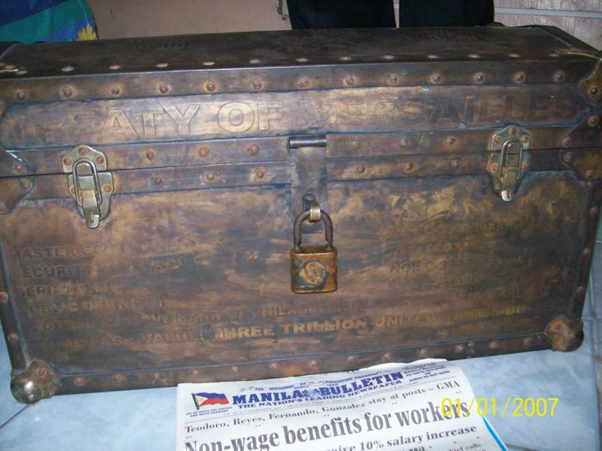
Federal Reserve Bank of New York Bond Chest — Front View

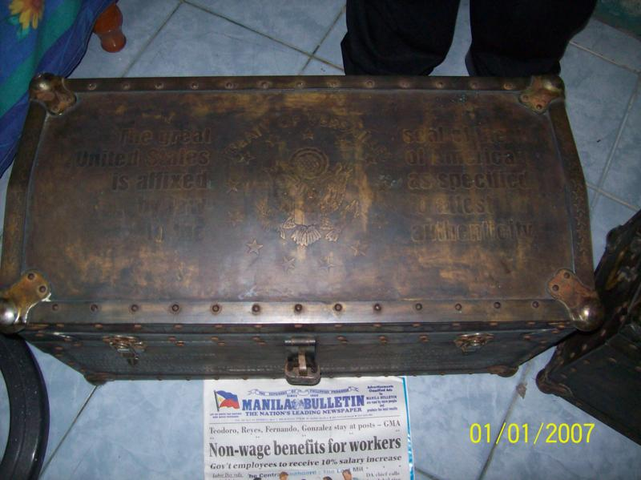
Federal Reserve Bank of New York Bond Chest — Top View

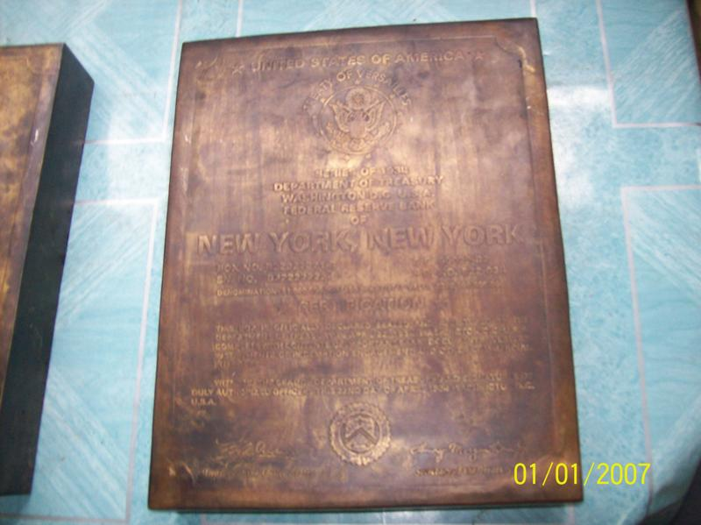
Federal Reserve Bank of New York Bond Box

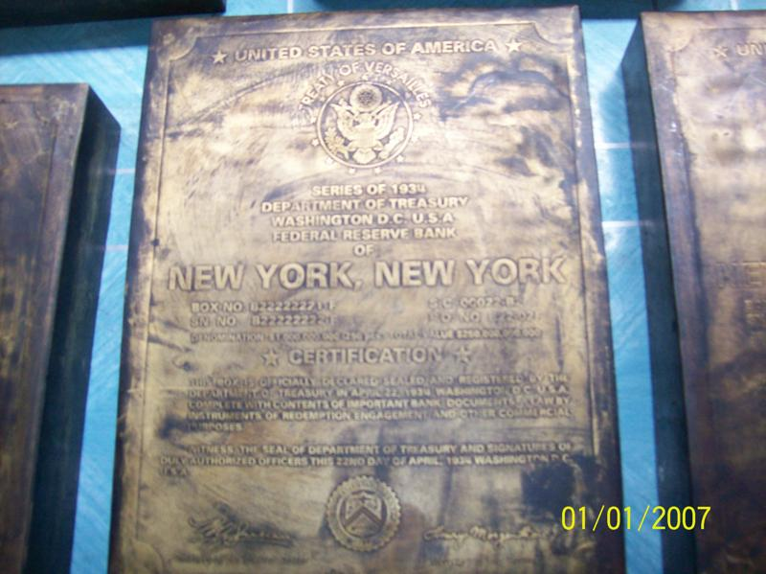
Federal Reserve Bank of New York Bond Boxes

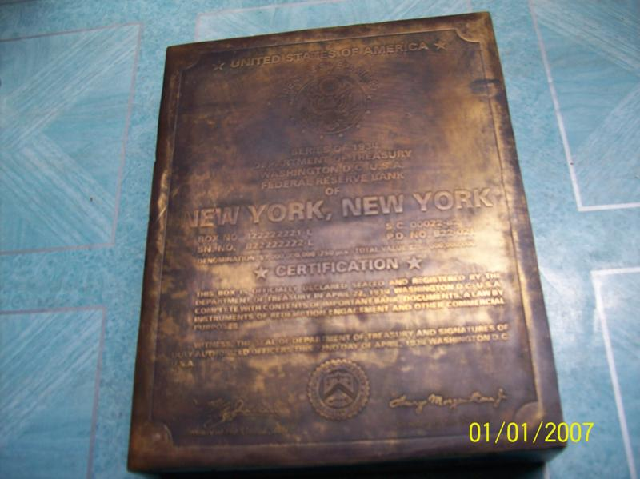
Federal Reserve Bank of New York Bond Box

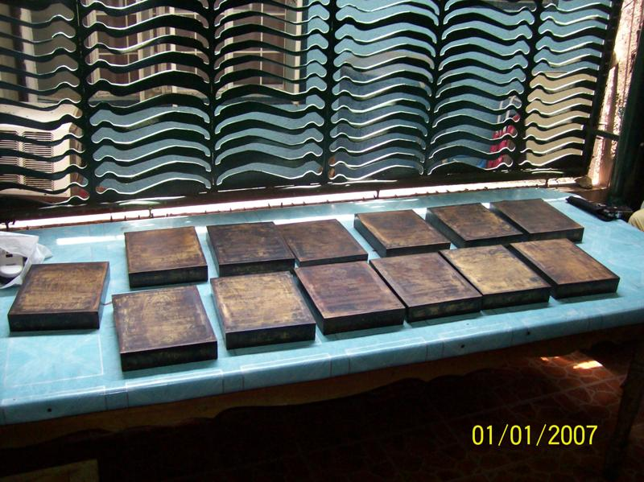
Federal Reserve Bank of New York Bond Box Collection

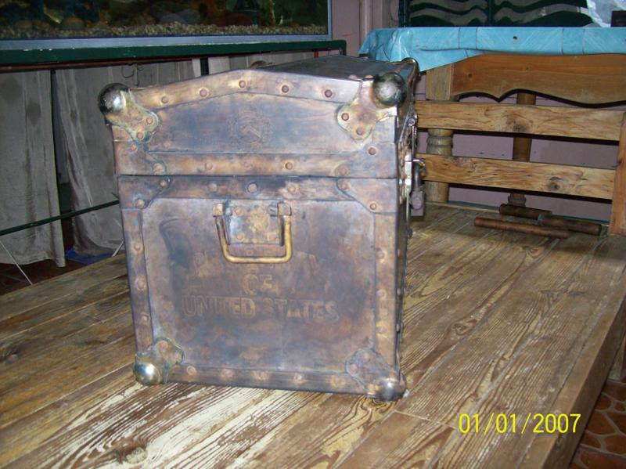
Federal Reserve Bank of New York Bond Chest #2

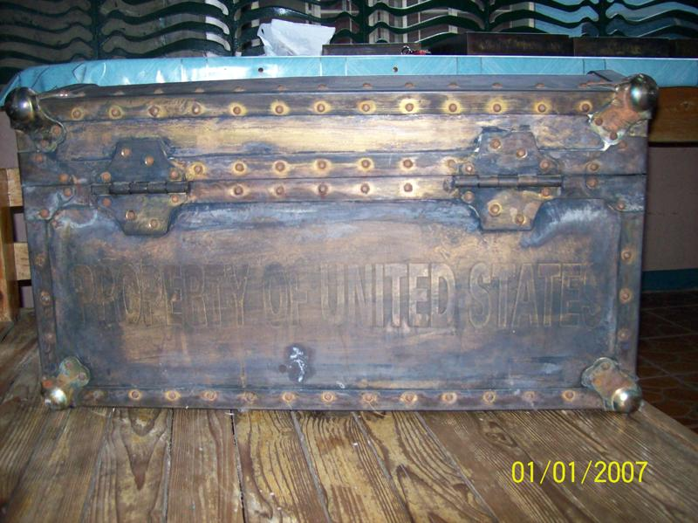
Federal Reserve Bank of New York Bond Chest #2 — Back Side

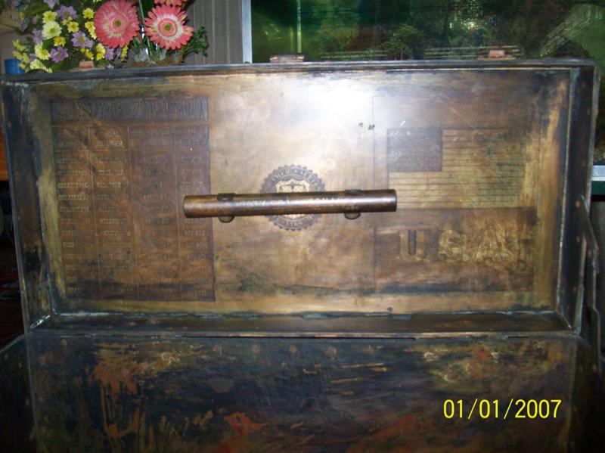
Federal Reserve Bank of New York Bond Chest — Interior

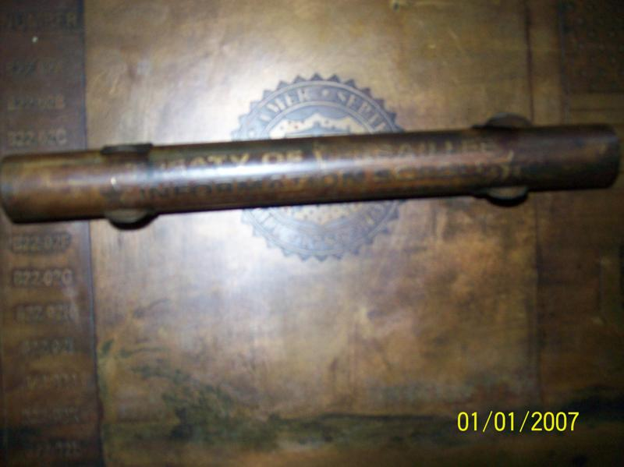
Federal Reserve Bank of New York Bond Chest — Interior Scroll

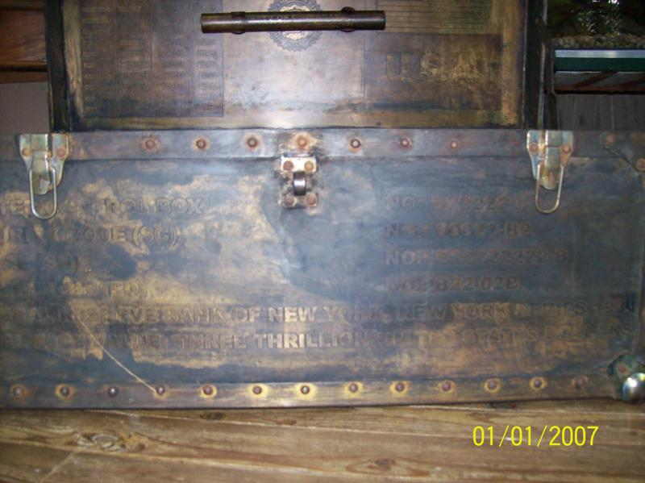
Federal Reserve Bank of New York Bond Chest — Front and Interior

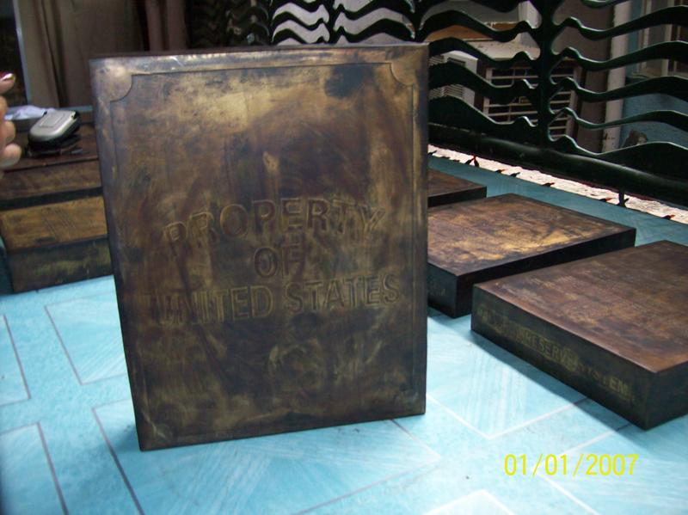
Federal Reserve Bank of New York Bond Chest (Side View) and Bond Boxes

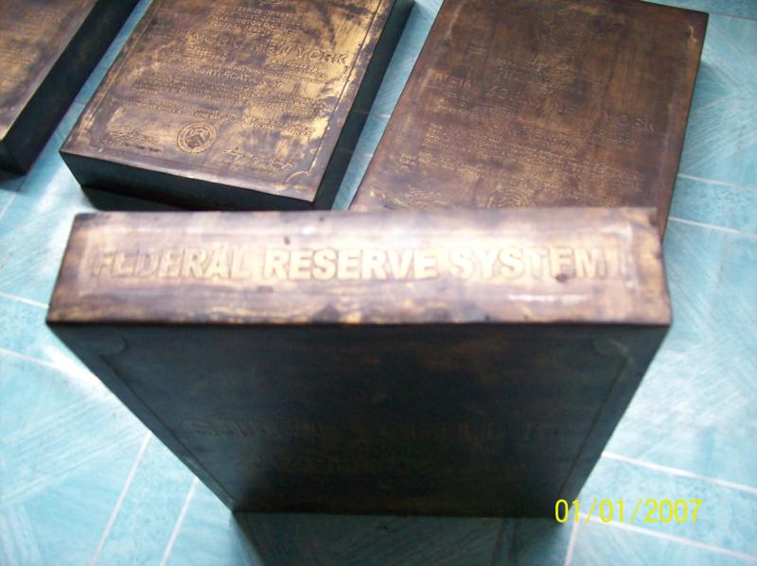
Federal Reserve Bank of New York Bond Box — Bottom-Down View

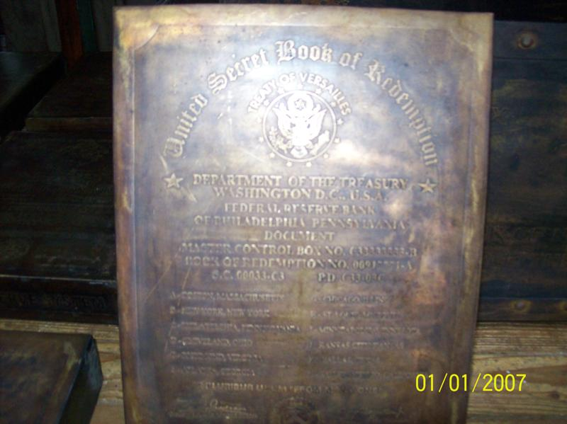
Federal Reserve Bank of Philadelphia Half-Depth “Book of Redemption” Box

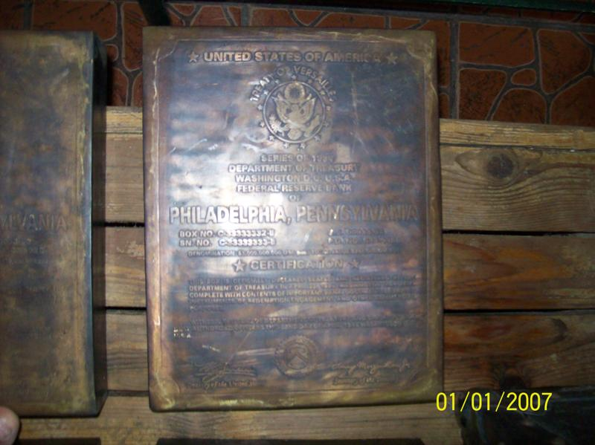
Federal Reserve Bank of Philadelphia Bond Box

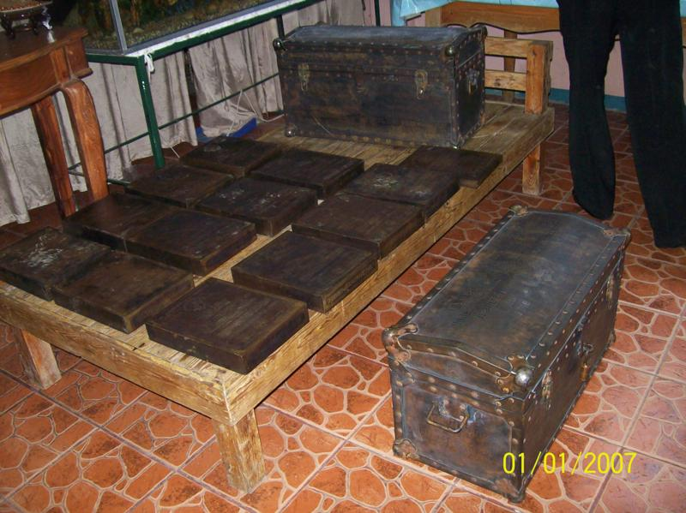
Federal Reserve Bond Chests and Boxes


Federal Reserve Bond Chests and Boxes
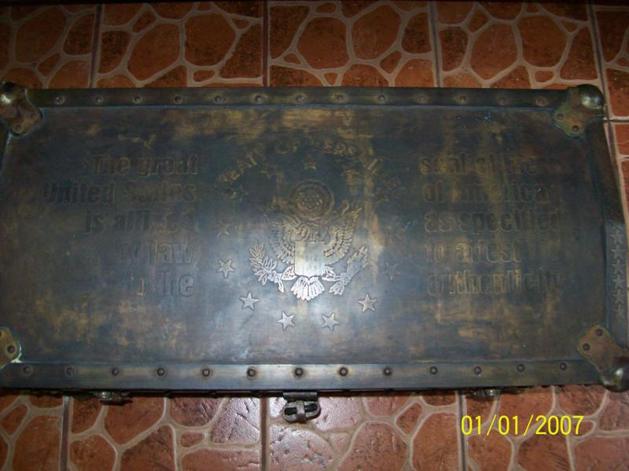
Federal Reserve Bank of Philadelphia Bond Chest — Top View

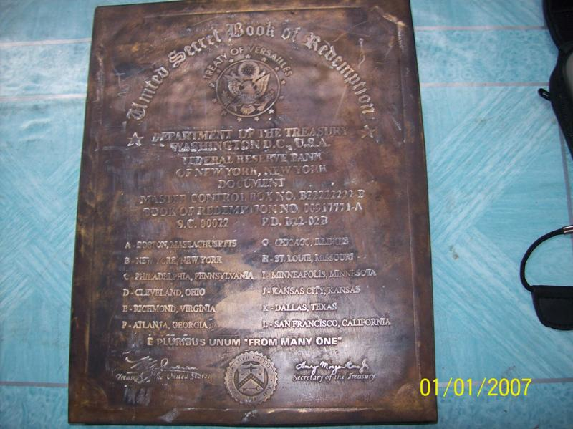
Federal Reserve Bank of New York Half-Depth “Book of Redemption” Box

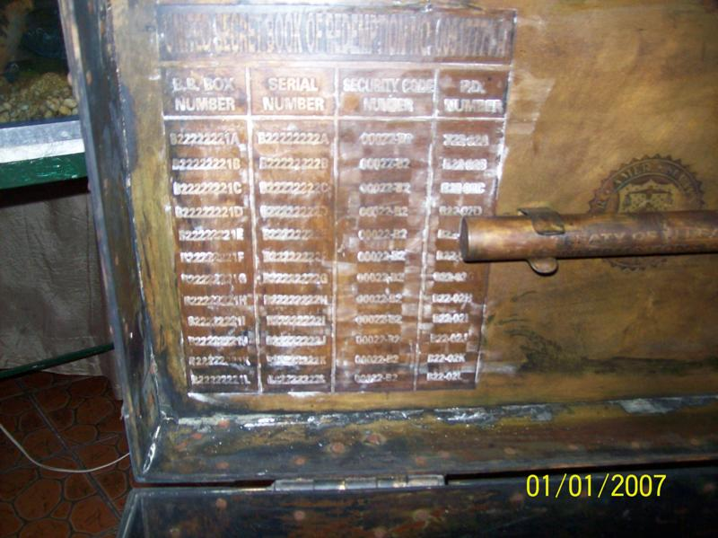
Federal Reserve Bank of Philadelphia Bond Chest — Interior Serial Numbers

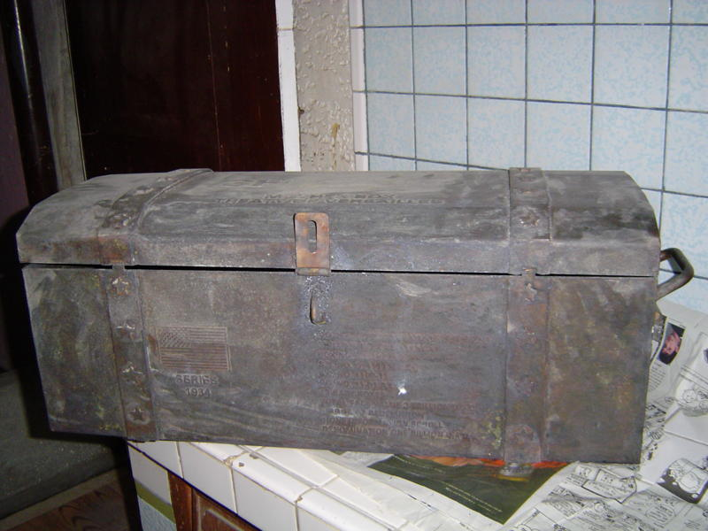
Federal Reserve Bank of Chicago Bond Chest — Front View

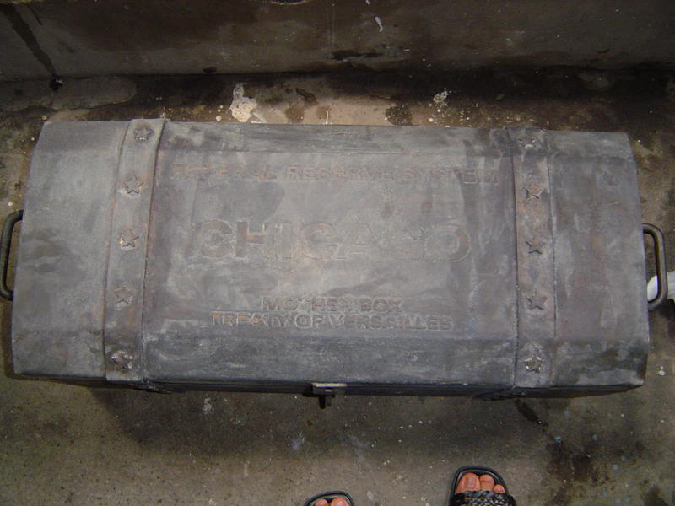
Federal Reserve Bank of Chicago “Mother Box” Bond Chest — Top View

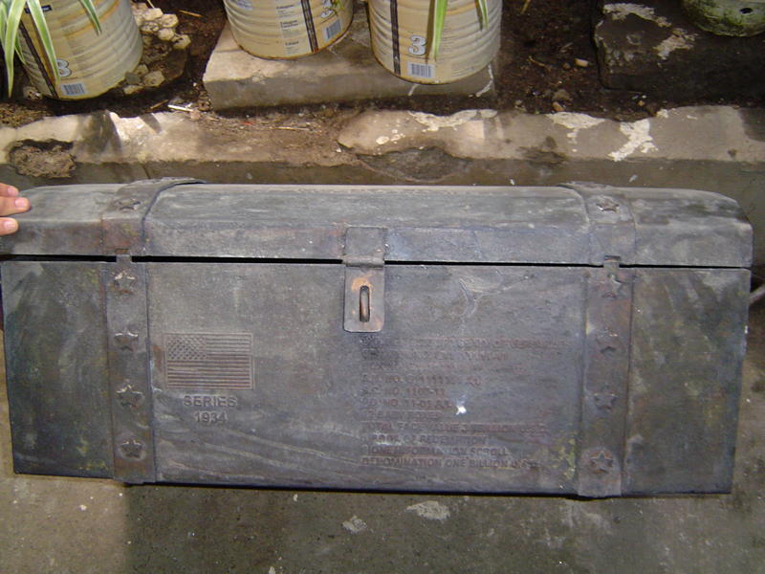
Federal Reserve Bank of Chicago Bond Chest — Front View

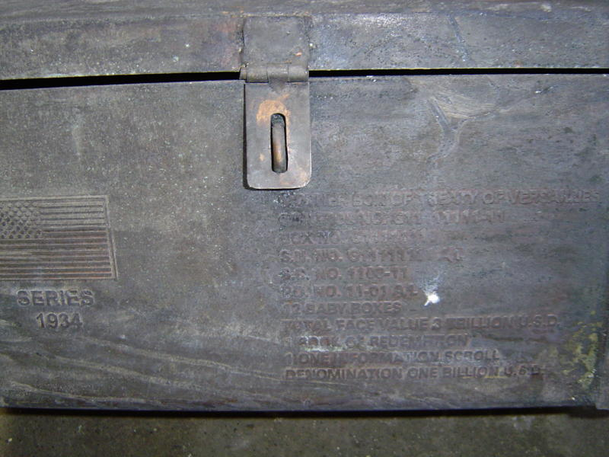
Federal Reserve Bank of Chicago Bond Chest — Front View Close-Up

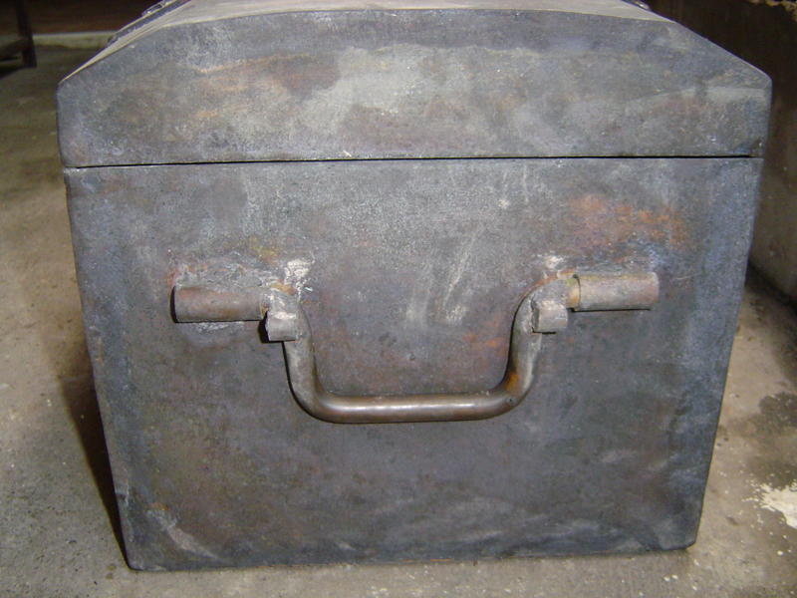
Federal Reserve Bank of Chicago Bond Chest — Side View

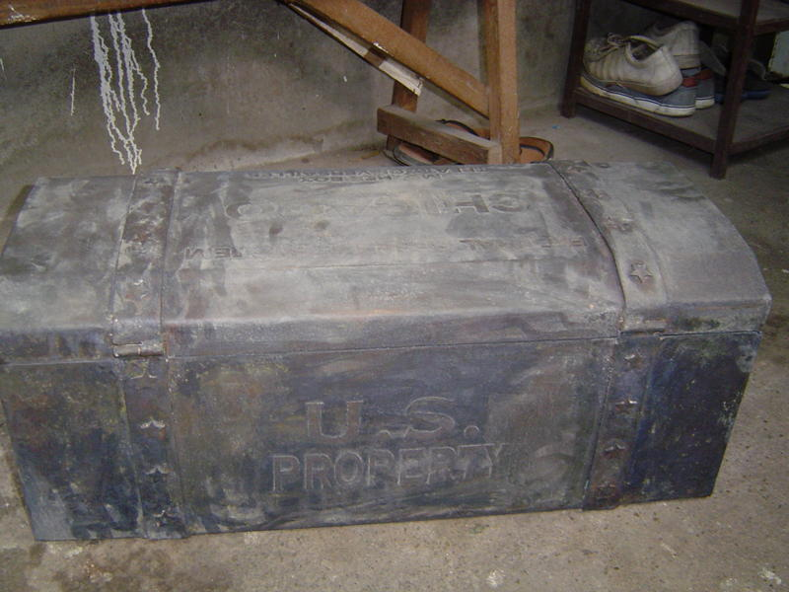
Federal Reserve Bank of Chicago Bond Chest — Rear View

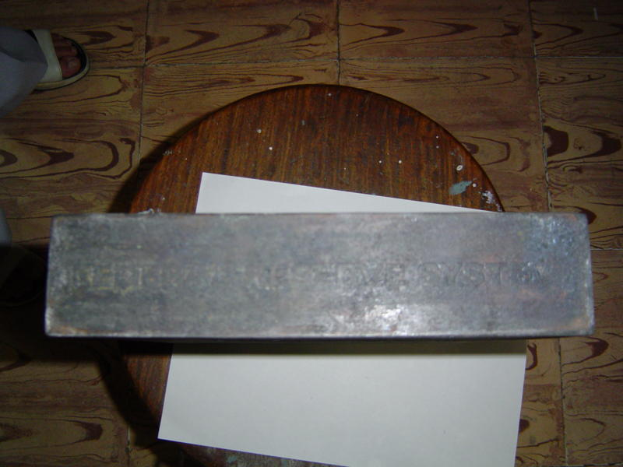
Federal Reserve Bank of Chicago Bond Box — Top View

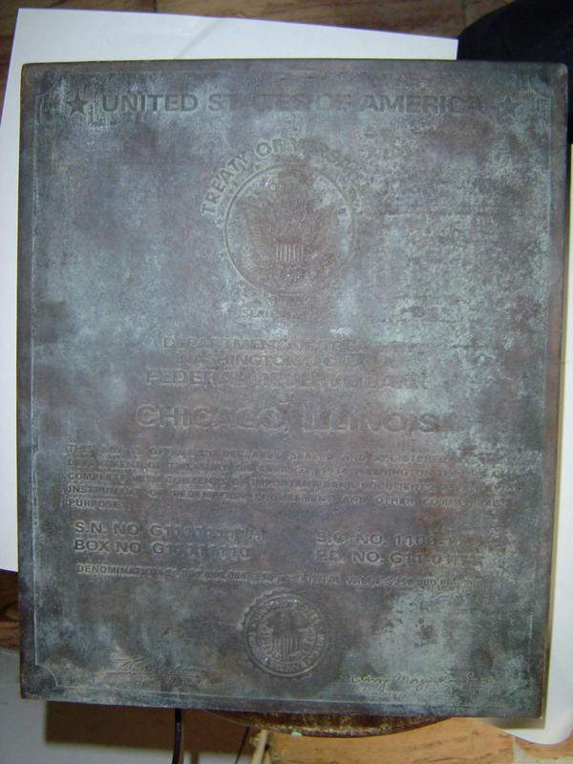
Federal Reserve Bank of Chicago Bond Box — Front View
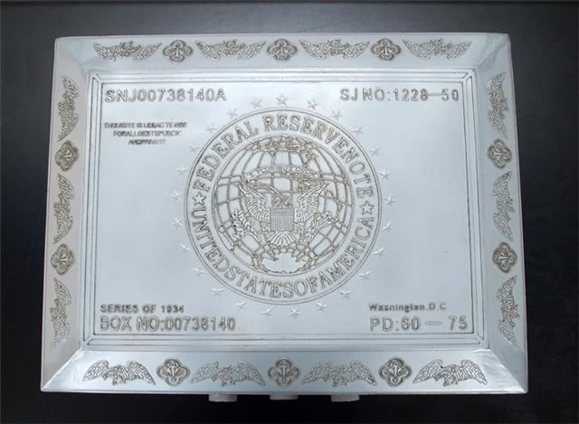
Federal Reserve Bond Box — Washington DC Series 1934 — Top View

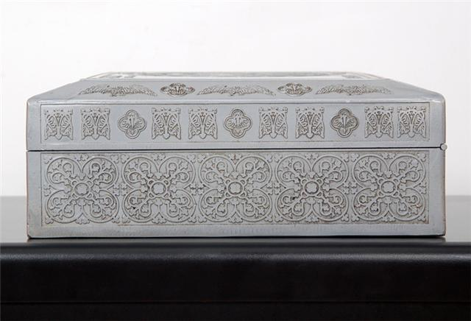
Federal Reserve Bond Box — Washington DC Series 1934 — Front View

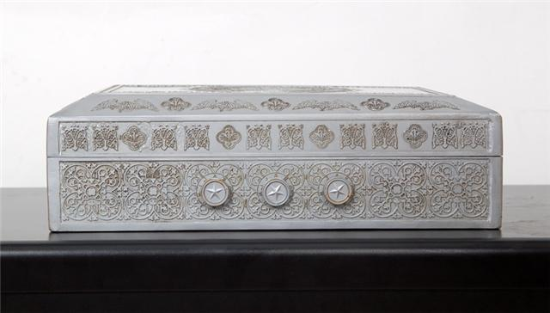
Federal Reserve Bond Box — Washington DC Series 1934 — Back View

THERE WAS ONE PROBLEM
As soon as I looked at these pictures, I felt like there might be a problem with the font on top of the two chests, as we see here. It looked just like a Windows font.
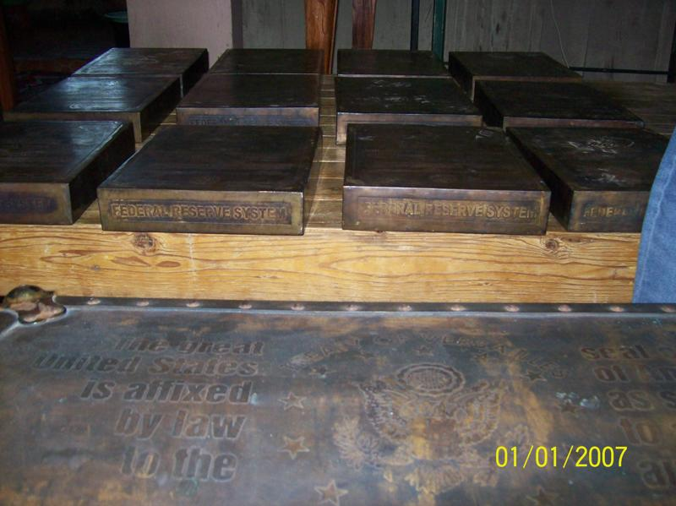
Federal Reserve Bank of Philadelphia Bond Chest and Boxes
However, upon further investigation, I found out that the modern Arial font is very similar to Akzidenz-Grotesk, which the Berthold Type Foundry released in 1896.
Here is an image of the original 1896 font. This was an early, successful “sans serif” font, and many others were released afterwards.


Since these bonds were actually issued in 1938, it is possible that in the ensuing 42 years, a different sans serif font was created — perhaps for newspaper headlines to cram into a smaller space, while also being more readable from a distance — that looked like what we see on top of the chest.
By narrowing the height of the top halves of lower-case letters like h, f, b, d, k and t, and widening the letters, readability was greatly enhanced.
Therefore, even though Microsoft Word does have a similar font, this does not mean it is Arial and therefore couldn’t have existed before 1982.

STEVE BECKOW INDEPENDENTLY GETS PICTURES OF BONDS FROM A NEW INSIDER
Less than two weeks later, on December 30th, Steve Beckow published pictures of bond boxes on his website — except that these were from a 1928 series, unlike the 1934 series boxes I had seen.
Other than the dates, they were very, very similar-looking to the ones I had — far beyond the likelihood of chance — and I was amazed.

Keenan had sent me the original bond pictures 15 minutes after I told him what the boxes looked like. Now I had yet another insider giving me the same information — an insider who risked everything to reveal his real name — Udo Pelkowski.

Udo did not know my own source, as I immediately confirmed with a phone call, and he did not know Neil Keenan or his people either. English is not his first language, but I do believe his intent is pure.

http://the2012scenario.com/2011/12/evidence-corroborating-david-wilcocks-recent-allegations-philippine-gold/

Dear Steve, the time has come. My friend J.P. van den Berk and me are without fear. Please give this important information to David Wilcock and Ben Fulford. We have more photos and more information about this findings to share.

We have NO FINANCIAL or any other interest, but to share the truth.

We did inform Barack Hussein Obama, President of The United States of America, Anna Escobedo Cabral, Treasurer of The United States of America and James Dimon, Chairman of the Board of JPMorgan Chase & Co.

We sent the letter with Fax and Email twice. We followed them up per phone twice too. Nothing happened for a while. Some months later JPMorgan Chase Manhattan & Co opened a Bank here in Cebu.

Best regards, Udo

STUNNING IMAGES

Pelkowski sent Beckow these stunning images, but Beckow didn’t publish them until after I released Part One of my initial investigation.

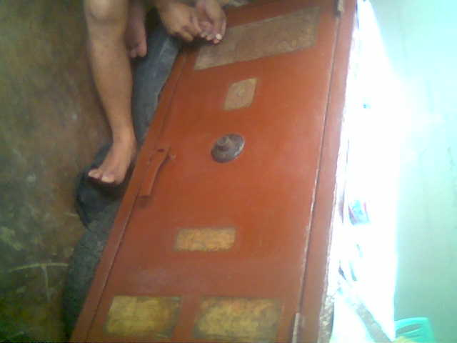

Wells Fargo Safe Holding Federal Reserve Bonds

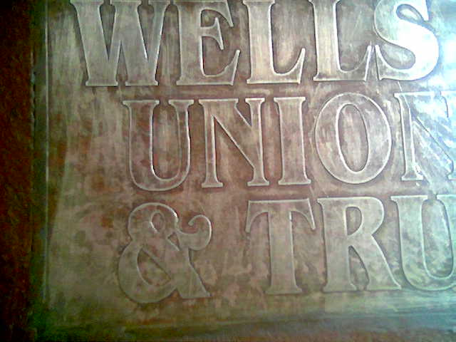

Detail of Wells Fargo Inscription on Safe Containing Federal Reserve Bonds

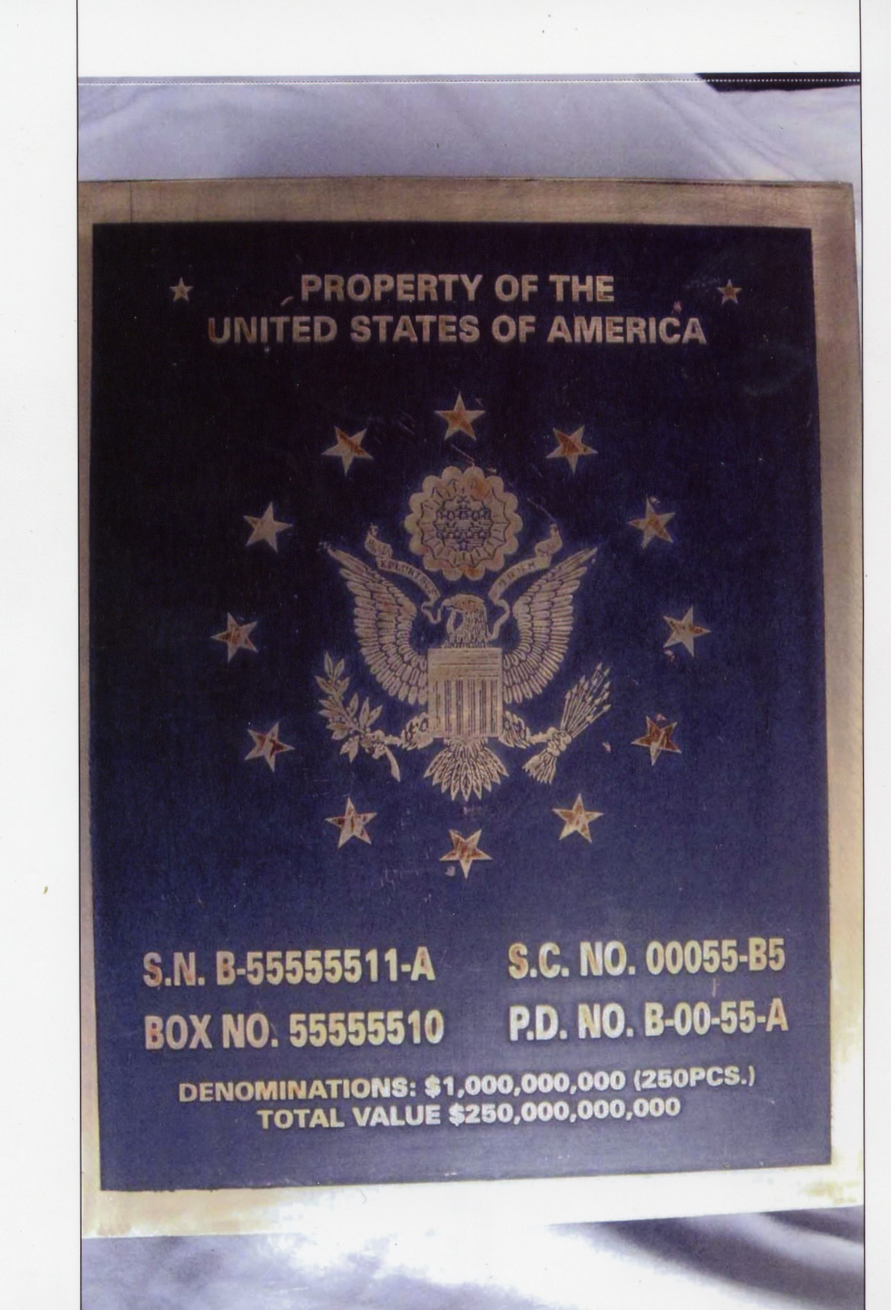

250 Billion-Dollar 1928 New York Federal Reserve Bond Box — Back

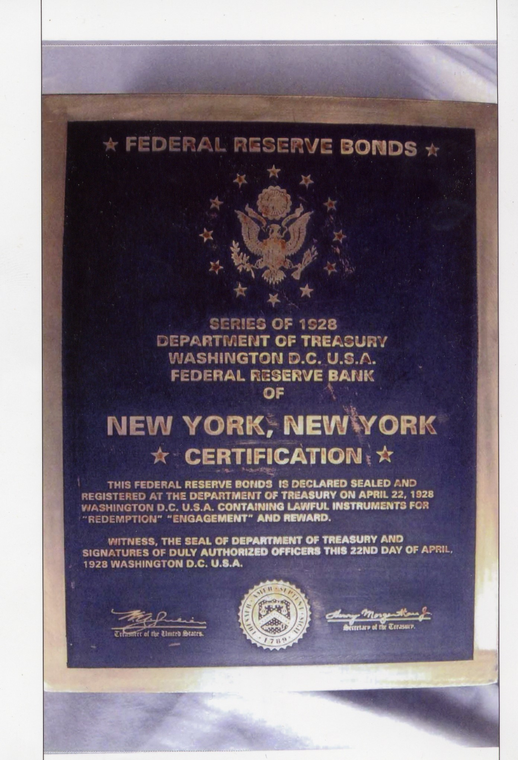

250 Billion-Dollar 1928 New York Federal Reserve Bond Box — Front
(Notice Deliberately Poor Grammar — “This Federal Reserve Bonds is Declared Sealed and Registered….”)

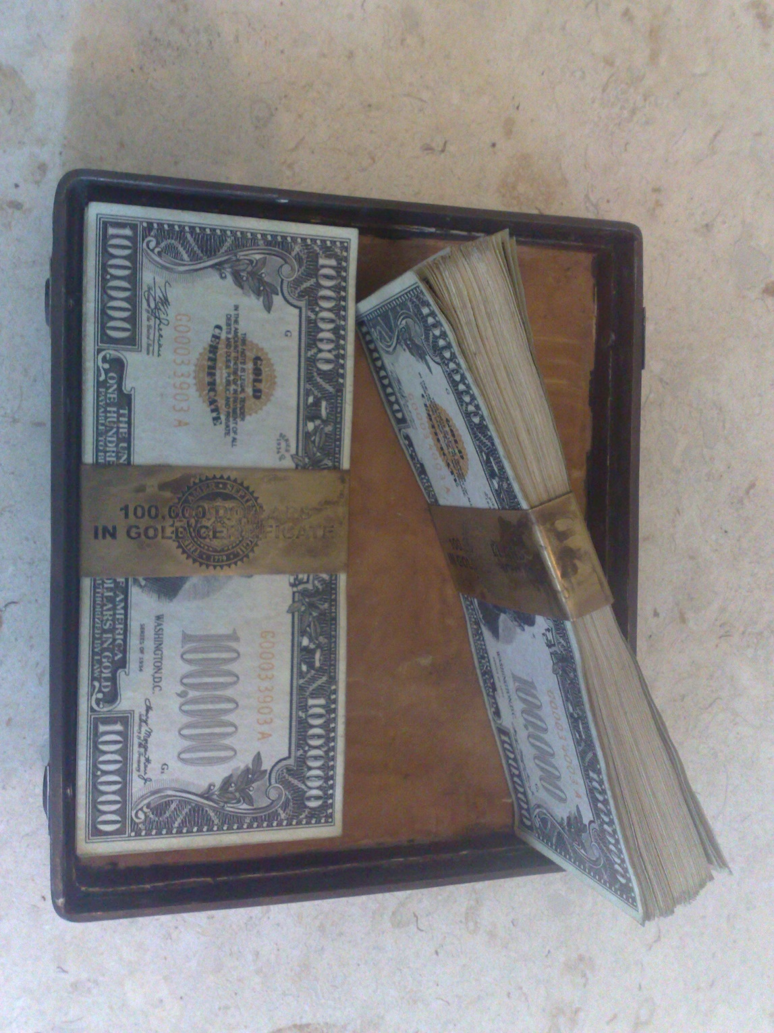

Separate Federal Reserve Bond Box From Above — Interior, Showing Smaller-Denomination 100K Gold Bonds

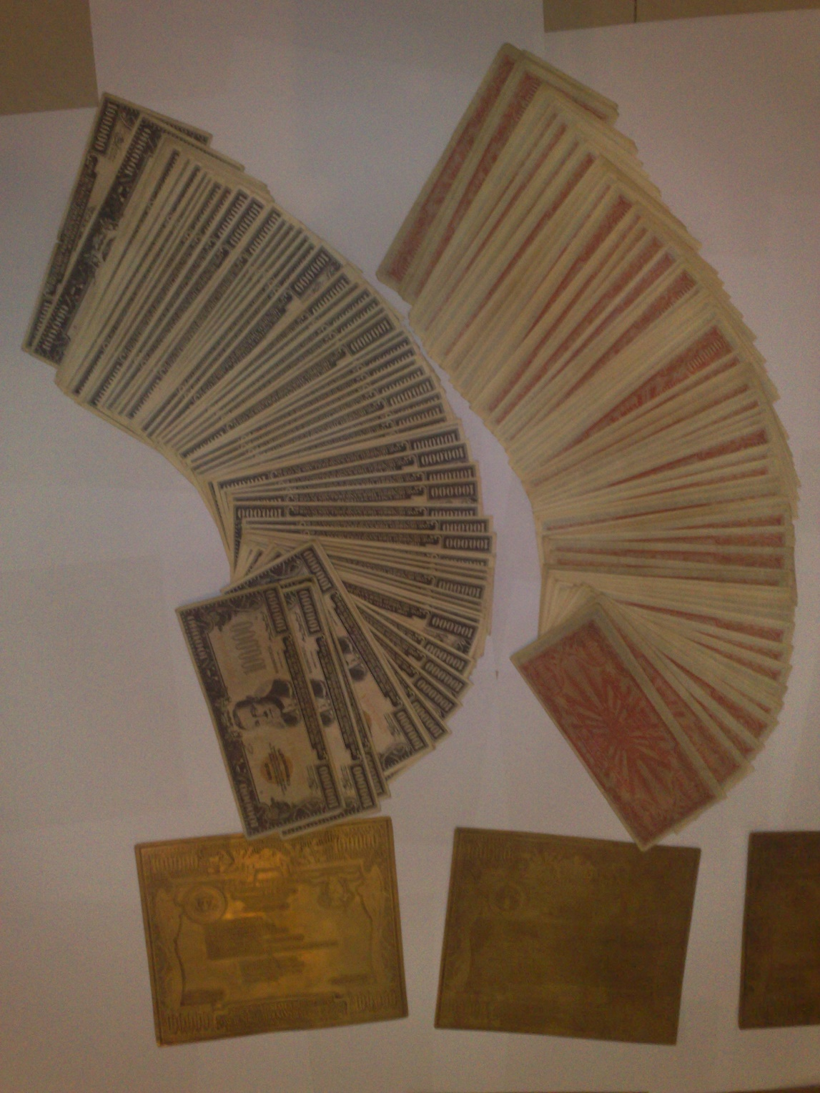

100K Gold Bonds — All Fanned Out For Detail

There were other images as well, but these were by far the most compelling. The gold certificates inside the boxes perfectly matched some of the other images Neil Keenan had already sent me. I’ve only shared a small portion of all the documentation I received.

The last picture came from a subsequent update Udo sent to Steve Beckow, as you can read here.

Then, the very next day, the story got even more outrageous… and even more believable.

DAVID AND MACKIE HUTLZER — UNWANTED PUBLICITY

The following day, December 31st, 2011, Benjamin Fulford wrote me a brief letter, and asked David Hutzler, known as “Hutz” on his discussion forum, to post it for him.

The letter was a link to Unwanted Publicity Intelligence — a website that featured even more pictures of these same types of bond boxes.

This public message from Ben, through “Hutz,” soon reached me when someone else re-posted it as a comment on my original article. Fulford had been receiving serious death threats during this same time — and so had I.

Ben asked me to post this I dont know what it is ,,
shall we take a look together ?

David,
Please post this link for people who want more evidence:
http://upintelligence.multiply.com/?&show_interstitial=1&u=
Benjamin Fulford 古歩道ベンジャミン 090-3439-5558
Comment by hutz the Vandalia Solution and World news click here on December 31, 2011 @ 10:29 am

wow
this is good stuff!
http://upintelligence.multiply.com/video/item/17

Comment by hutz the Vandalia Solution and World news click here on December 31, 2011 @ 11:32 am

THE SECOND TIME IN 24 HOURS — BUT IT CAME AT A TERRIBLE COST

I clicked on the link and could hardly believe my eyes. I had been told that it was potentially lethal to publish any images of these bonds, but this was the second time in 24 hours that I was looking at images that were nearly identical to what I’d received from Keenan.

I had no idea that David and his eight-year-old son Mackie would burn to death in their home, just a week after he conveyed Ben’s message to me, on January 6th. This may be the last known picture of them.

Accelerants were found outside the residence, and arson was not ruled out.

I do not want their deaths to be in vain. This tragic event made it much more likely that these bonds are real, and that someone was blatantly warning me to call off this investigation.

Fear obviously did not deter me from publishing. Otherwise I’d have to live with being a coward, and potentially allowing this innocent father and son to have died for nothing. I would then have to deal with that pain for the rest of my life.

Even if this was all somehow an elaborate hoax, involving a coordinated effort between multiple, seemingly independent players — which I highly doubt — whoever is playing this game and feeding Ben and me “disinformation” is willing to kill all of us.

And that upsets me.

Greatly.

UNWANTED PUBLICITY BONDS COLLECTION

Here are the most striking images that jumped out at me when I browsed through the various collections on the Unwanted Publicity Intelligence website.

Again, there are absolutely irrefutable, undeniable similarities to what we have just seen from Neil Keenan and Udo Pelkowski — and what my own insider had described to me before I ever got to see a picture.

In particular, I found a chest issused by a different Federal Reserve bank — this time in Dallas, Texas — that was almost identical to the images of the 1934 series boxes that Neil Keenan had sent me.

Unwanted Publicity also had more pictures of the bonds that were inside the boxes — some of which looked quite outrageous, and were elaborate, detailed and sexy enough to be believable — despite their seemingly astronomical denominations.

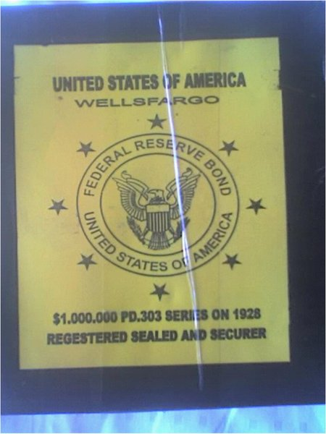
1928 Series Wells Fargo Federal Reserve Bonds. Notice deliberate misspellings of “Registered” and “Secured.”

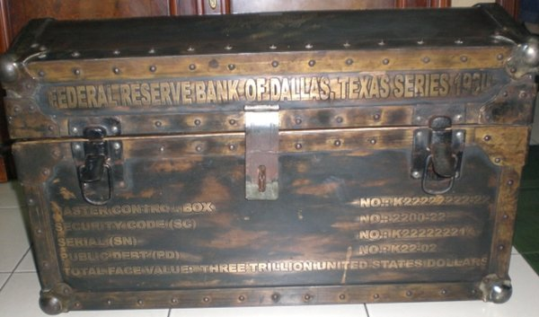
Federal Reserve Bank of Texas 1934 Series Three Trillion Dollar Bond Box — Front View

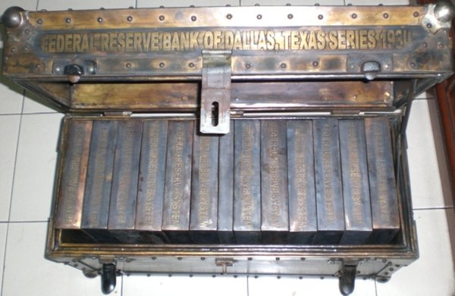
Federal Reserve Bank of Texas 1934 Series Three Trillion Dollar Bond Box — Interior View

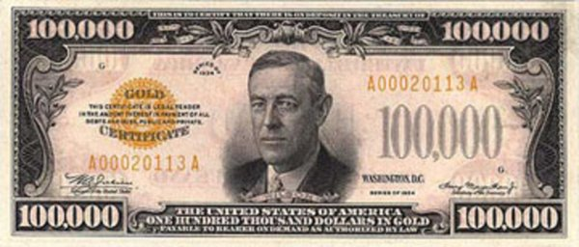
100,000-Dollar Federal Reserve Gold Certificate — From “Unwanted Publicity”

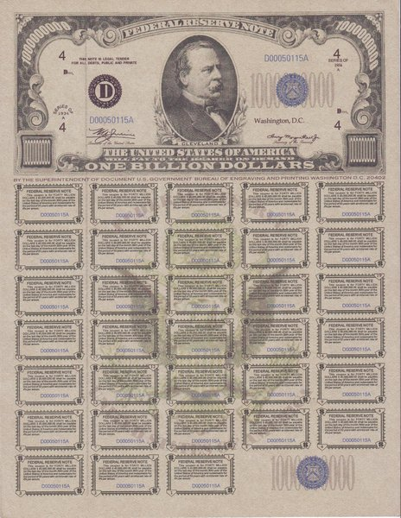
One Billion Dollars Cleveland Federal Reserve Bank Bond — From “Unwanted Publicity”

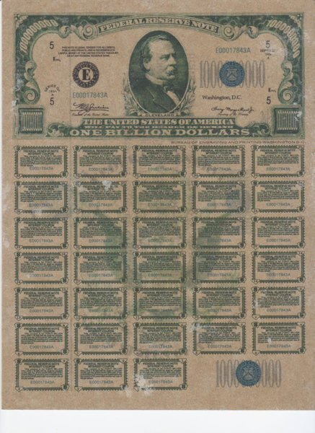
One Billion Dollars Federal Reserve Bank Bond — From “Unwanted Publicity”

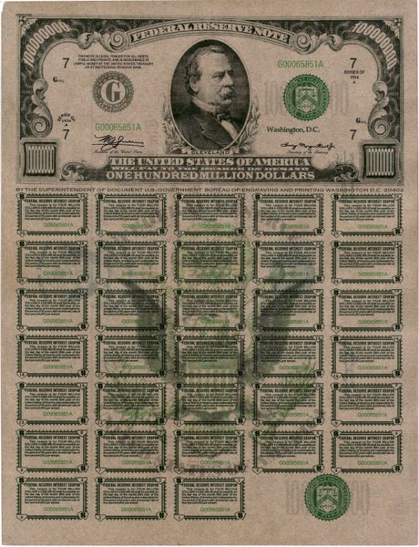
One Hundred Million Dollars East Chicago Federal Reserve Bank Bond — From “Unwanted Publicity”

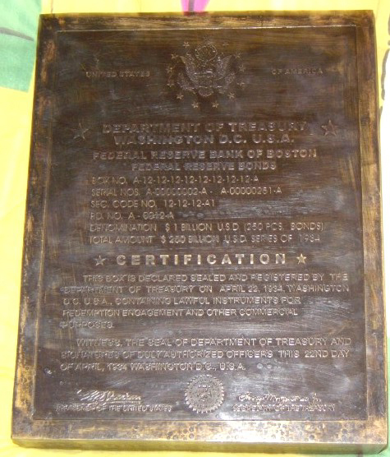
Federal Reserve Bank of Boston 1934 Series Bond Box — Containing 250 One-Billion-Dollar Bonds

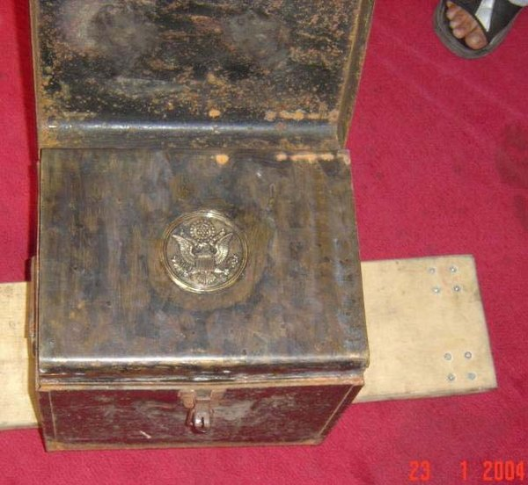
Smaller 1934 Series Bond Chest — Top-Down View of Interior, With Lid Open

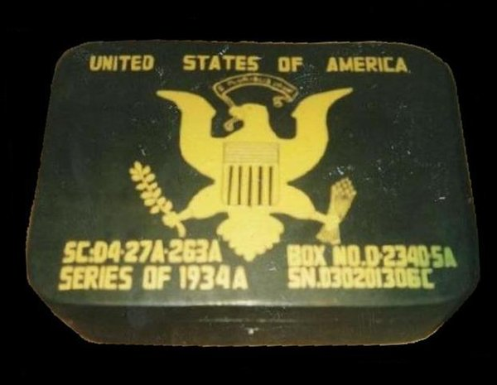
1934 Series Bond Box

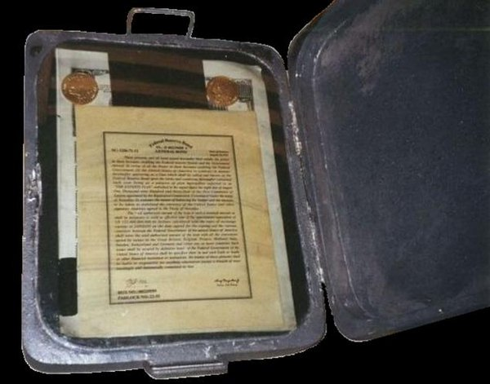

1934 Series Bond Box — Interior

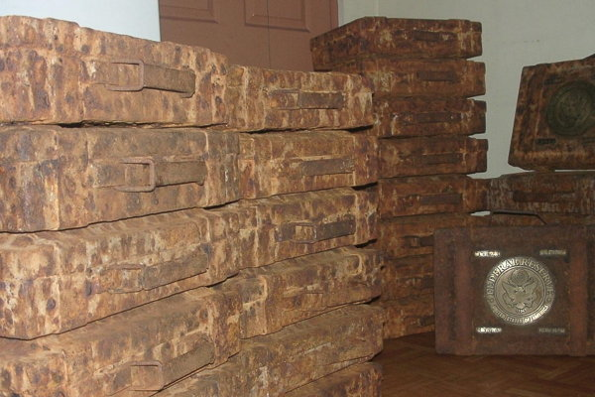

Stacks of 1934 Series Federal Reserve Bond Boxes from Unwanted Publicity Intelligence

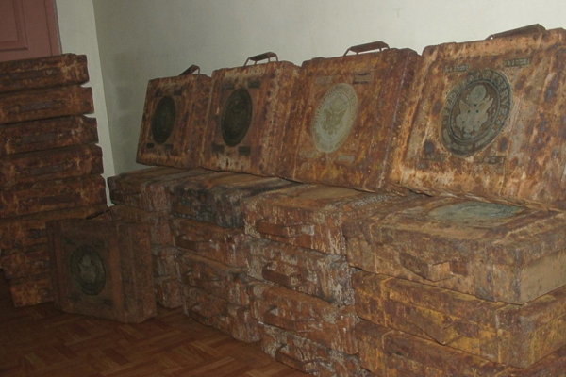

Stacks of 1934 Series Federal Reserve Bond Boxes from Unwanted Publicity Intelligence

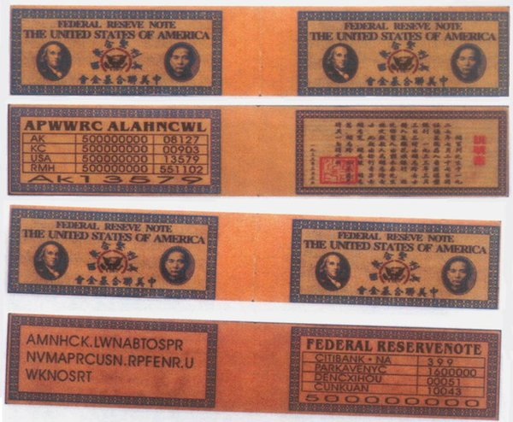
500 Million Dollar Chiang Kai Shek Federal Reserve / Citibank Bonds from “Unwanted Publicity”
(Notice deliberate misspelling of “Reserve” on front side.)

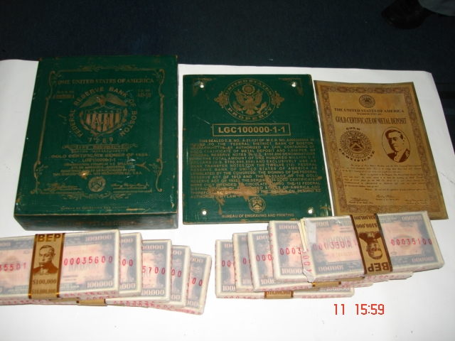
100 Million-Dollar JP Morgan / Federal Reserve 1934 Bond Box — Faceplate, Box and Interior Contents

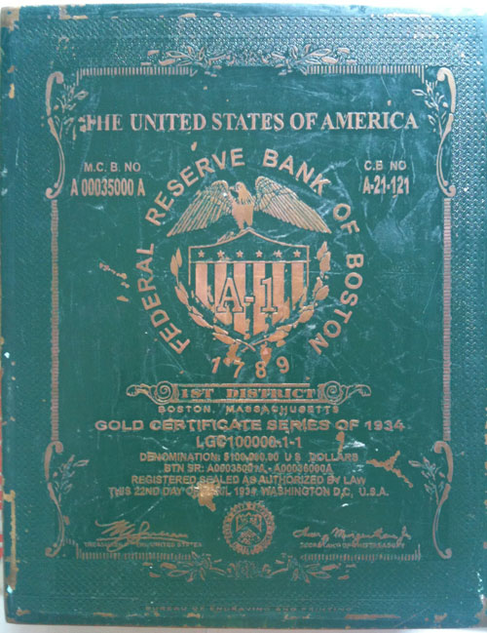
JP Morgan / Boston 1934 Federal Reserve Gold Certificate Box — Front View
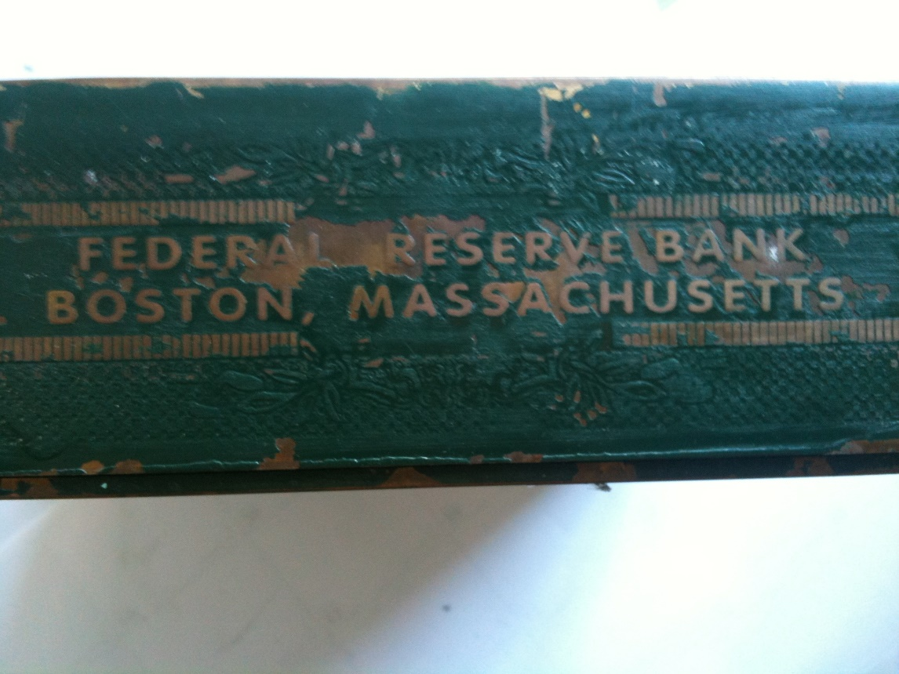
JP Morgan / Boston 1934 Federal Reserve Gold Certificate Box — Top-Down View

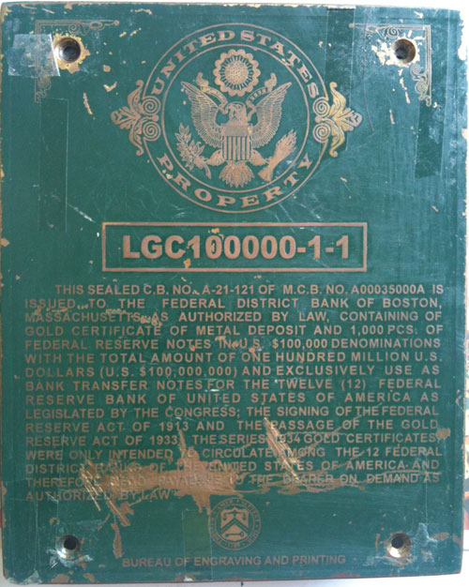
JP Morgan / Boston 1934 Federal Reserve Gold Certificate Faceplate
(Notice Deliberate Grammatical Errors. “Containing of gold certificate of metal deposit.” “…for the twelve (12) Federal Reserve bank of United States of America.” Et cetera.)

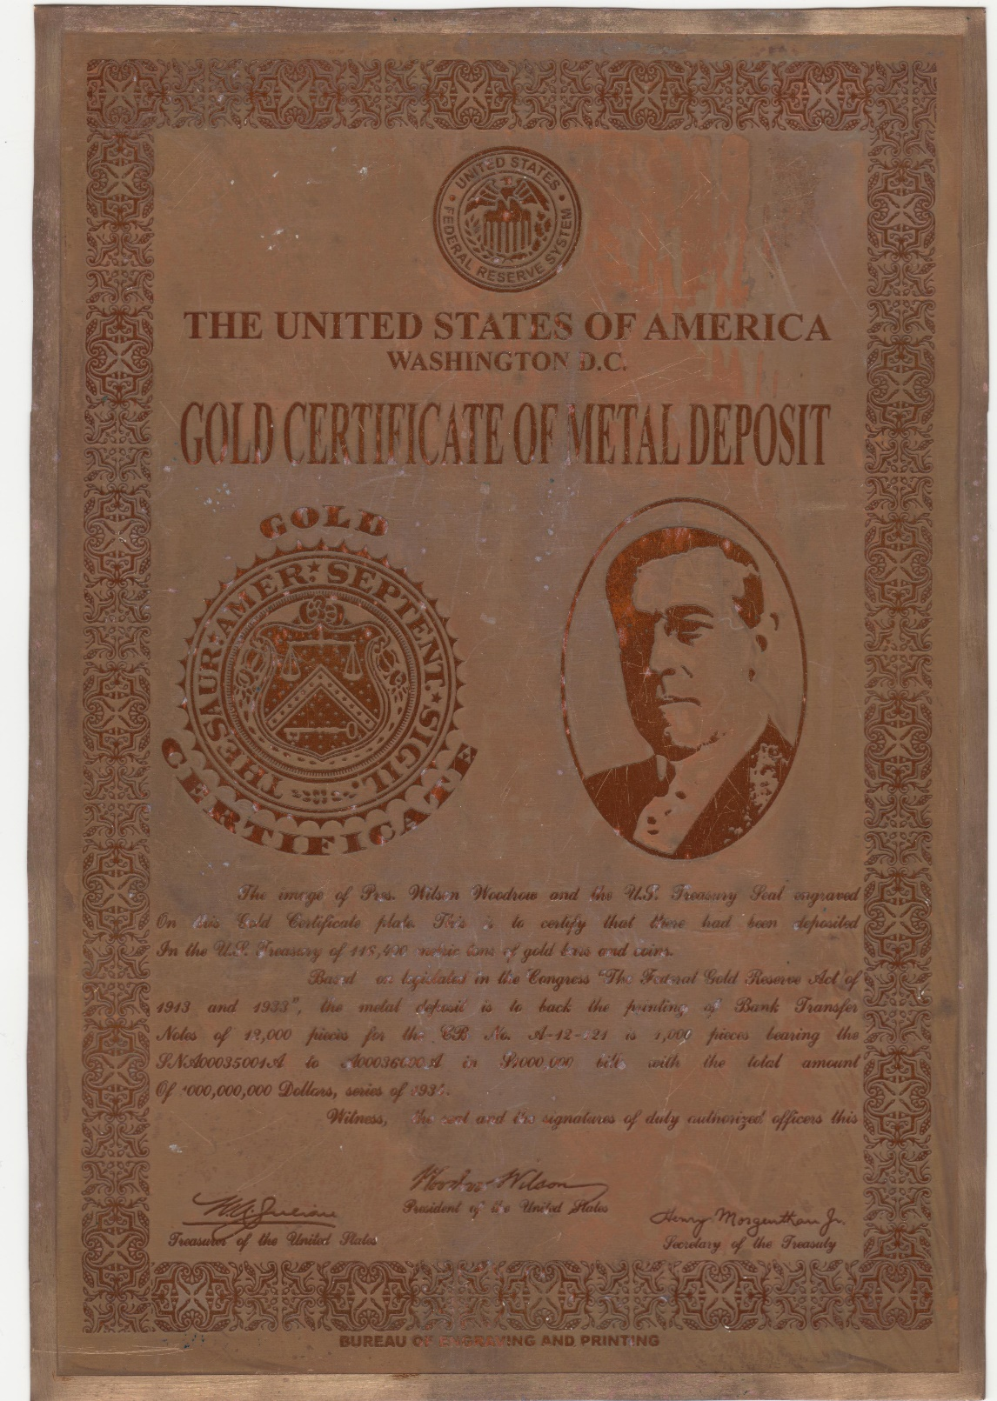
JP Morgan / Boston 1934 Federal Reserve Interior Certificate of Gold Metal Deposit
(Notice deliberate error in the first sentence: “The image of Pres. Wilson Woodrow”… et cetera.)

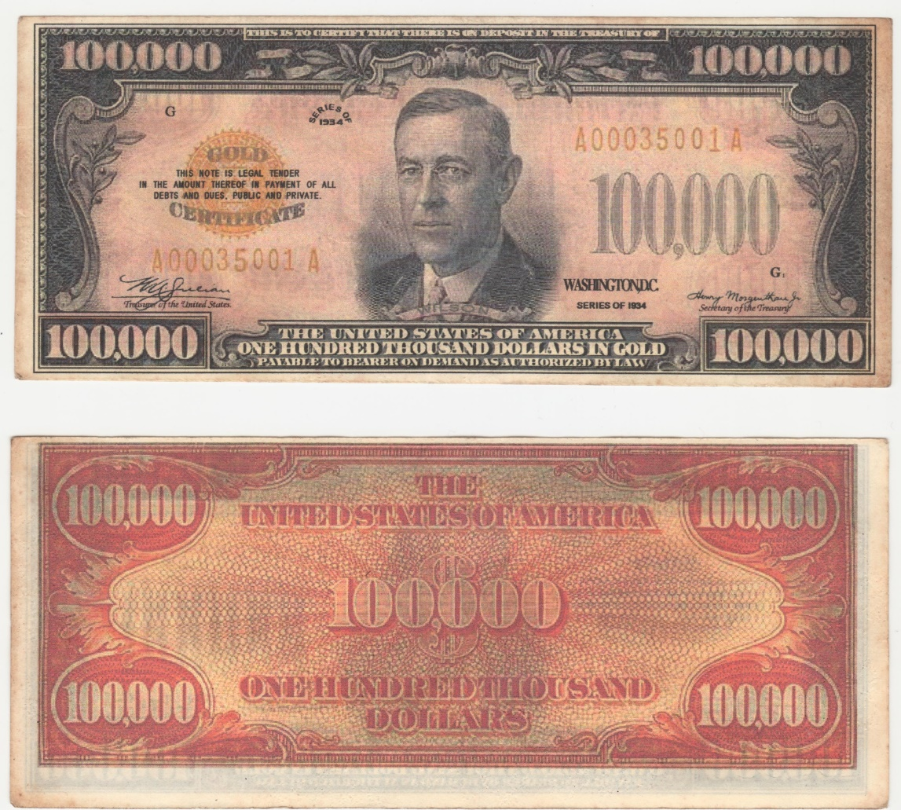
Detailed View of JP Morgan / Boston 1934 Federal Reserve Gold Certificate

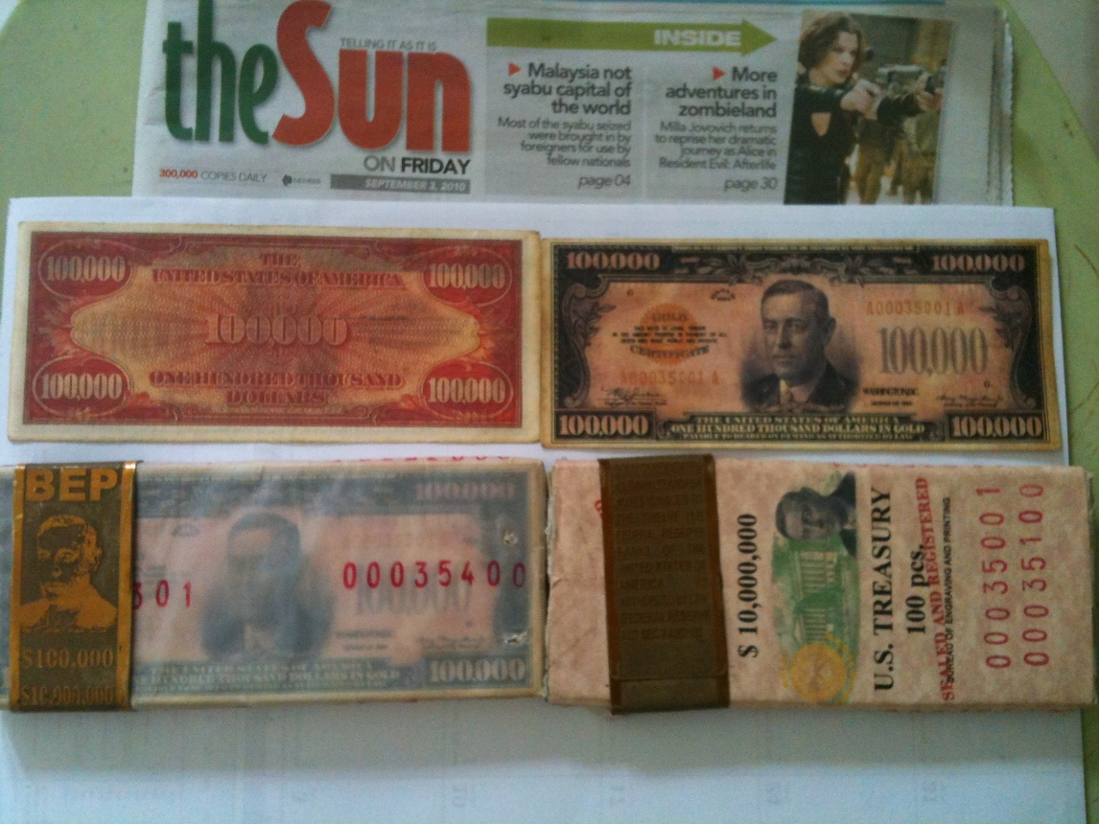
JP Morgan Gold Certificates — Close-Up View

COUNTER-INTELLIGENCE FROM THE MAINSTREAM MEDIA
Yet another stunning confirmation came a mere twelve days after David and Mackie Hutzler’s death — while I was still frantically working to finish this investigation.

Bloomberg News published a story that directly named and attacked the 134.5 billion-dollar bonds theft that is behind our investigation.

This appeared to be the big “kill shot” that was planned to come out in the mainstream media — as a counter-move to this lawsuit.

Furthermore, the Bloomberg article published pictures of bonds that were painfully obvious fakes — and said there is a rich market for fraud in this business, which undoubtedly is true.

However, these fake bonds were ridiculously bad imitations of the real thing. An image of the US dollar was obviously photoshopped, the other bonds are a joke and the chests also look like crap compared to what we have just seen — but here you are.

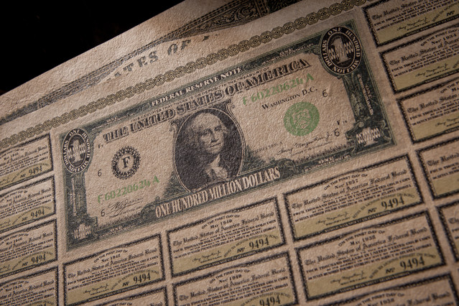

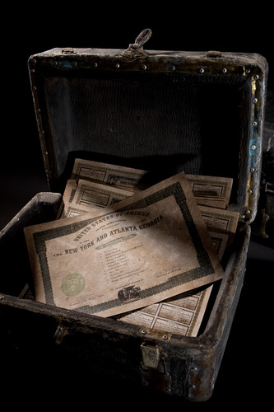

[Interestingly, this picture was put in at 333 pixels wide.]

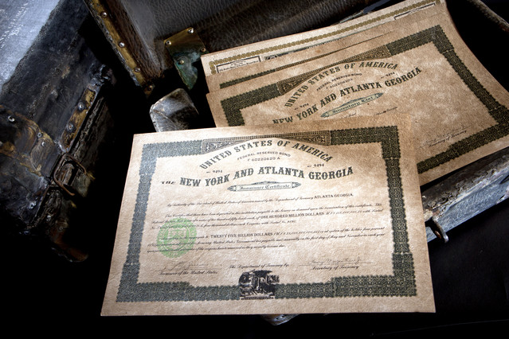

LET’S READ THE ARTICLE FOR OURSELVES

http://www.bloomberg.com/news/2012-01-18/no-one-knows-truth-about-300b-bonds-from-alleged-plane-crash.html

Chris Estrella, a Filipino social worker, says he led a troop of five porters out of a Mindanao jungle in January 2000 with a weather-beaten iron and leather box crammed with $25 billion of U.S. government bearer bonds.

“The elders of the Umayamnon tribe told me an American plane crashed in their river in the 1930s,” Estrella, 47, says by mobile phone from a footpath between the tribal village and Davao, the largest city on the Philippine island. “The river dried up in the 1990s, and the natives went into the plane and found 12 boxes that contained $300 billion in bonds.”

Each box, emblazoned with the Great Seal of the United States and the words “Federal Reserved Bond,” held five gold coins struck with a portrait of George Washington on one side, Estrella says.

They rested atop stacks of certificates purporting to have been issued by the Federal Reserve Bank of Atlanta in 1934 and redeemable in gold bullion. The notes bore the signature of then Treasury Secretary Henry Morgenthau Jr….

Ponte Chiasso
It wasn’t the first time a cache of bogus U.S. bonds emerged from the Philippines.

“We were matching wits with the underworld on an op in southern Italy when the call came in,” says U.S. Secret Service Special Agent Robert Gombar, head of the agency’s Rome office.

The date was June 16, 2009, and Gombar, 65, recalls rolling his eyes at the news delivered by Italy’s Guardia di Finanza fiscal police via his liaison officer in Rome.

“The Guardia caught two Japanese guys secreting U.S. Treasury bonds in the false bottom of a suitcase aboard a freight train about to cross into Switzerland,” Gombar says, twirling a pencil behind his desk inside the U.S. Embassy in Rome. “It was suspicious, so we jumped an express north.”

What Gombar found in the border village of Ponte Chiasso was a stack of 1934 U.S. Treasury bearer bonds with a face value of $134 billion, making the two suspects the U.S. government’s fourth-biggest creditor at the time, behind Russia with $138 billion of U.S. debt and ahead of the U.K. with $128 billion.

Hybrid Counterfeits

Although a local magistrate released the suspects because of a lack of evidence of intent to sell or proof the pair was involved in the manufacture of what turned out to be a suitcase of sham bonds, the incident marked the sixth time Italian authorities had called upon Gombar to authenticate a haul of what looked to be smuggled U.S. securities.
Like most of the other cases, this one pointed to Asia: The two Japanese suspects had arrived in Italy from the Philippines, Gombar says.
“We call these bonds hybrid counterfeit instruments because there’s no such thing as a $500 million Treasury bond,” explains Gombar, who has chased global funny-money rings from the Secret Service’s Rome outpost since 1998. “It’s like counterfeiting a $3 bill, something that doesn’t exist.”

Although Treasury securities were shifted from paper to electronic form in the 1980s and the government stopped issuing bearer bonds in 1982, Gombar says the pre-World War II provenance of the bogus bonds, stamped with Morgenthau’s forged signature, remains a lure in the con artist’s tackle box.

Fictitious Instruments

“People are gullible,” Gombar says. “Even those who work in the financial world. The $134 billion worth of 1934 Morgenthau bonds seized in Ponte Chiasso was nearly five times more than America’s $27 billion national debt that year.”

The largest U.S. Treasury bond ever issued had a face value of $10 million, says Gombar’s partner, Special Agent Michael Giovanniello. Only about $105.4 million in outstanding bearer bonds have yet to be cashed in, he says.

“Bogus bonds are officially referred to as fictitious financial instruments,” Giovanniello, 44, says. “Counterfeit financial instruments reflect something that actually exists. Either way, it’s a fraudulent scheme that we’re extremely interested in pursuing.”

The Secret Service averages about 100 cases a year related to bonds and other fictitious instruments, resulting in about 70 arrests, says Special Agent Edwin Donovan, a spokesman for the agency in Washington. The average annual loss to victims is about $11 million, he says.

‘Great Extremes’

….“Nowadays the bonds are almost always U.S. Treasuries from the 1930s, and the forgers have grown more sophisticated,” Gombar says.

“They go to great extremes, putting them in antiquated treasure chests stuffed with newspaper clippings from the 1930s. It takes a great deal of time and trouble to print these bonds and establish the con.”

LET’S GET CLEAR ON THIS…

Benjamin Fulford has never once tried to profit off of this bonds story. Nor has Udo Pelkowski, who clearly said he had no financial interest in publishing his images. The insider who first told me what the bonds looked like has never once asked me for money.

The author of Unwanted Publicity Intelligence has made no effort, anywhere on his website, to say that he has bonds for sale. In fact, I have heard that he is quite impoverished and has had his life destroyed from publishing his findings.

Neil Keenan has never once tried to solicit money from me, or tell me that I can “get in now” and make money on these bonds once they come out. Nor have I been able to find a single shred of evidence that he or his associates have done this with anyone else.

The same thing goes with the Dragon Family / Kuomintang, who issued two different sets of bonds that started this whole mess — each of which was approximately a trillion dollars in its interest-matured value.

The face value of the set that was seized in Chiasso, Italy was 134.5 billion. The set entrusted to Neil Keenan, which was later stolen by Daniele Dal Bosco, thus leading to the filing of this lawsuit, was a total of 144.5 billion.

The Dragon Family wishes to recoup the losses incurred from both sets of these bonds. Callous media disinformation, death threats and ritual murders are not going to solve the Federal Reserve’s problem.

They lied. They stole. And Keenan’s lawsuit has absolute, irrefutable proof to back up these claims.

As we head into Section Five, we will drill down even more into the details of Financial Tyranny — the provable information of how it works, and more importantly of what we can do about it.

CONTINUE TO SECTION FIVE

THINGS ARE REALLY HEATING UP

We are investigating Financial Tyranny — on a global scale — and what we have just learned in the previous four sections is shocking.

80 percent of the world’s wealth appears to be earned by a “core” of 1,318 corporations, which in turn are being controlled by only 147 companies. 75 percent of these companies are financial institutions — and the top companies on the list are the Federal Reserve banks.

The media has been systematically bought out and controlled by this group — on a global scale — meaning that until the rise of the Internet, most people didn’t have a clue about what was really going on.
The Federal Reserve created 26 to 29 trillion dollars’ worth of bailouts for their own companies between 2007 and 2010. This was revealed in their own audit statements — and confirmed by United States Congressmen and prominent financial analysts.
This situation did not happen by accident, nor by “natural self-organizing complexity”. It is the result of an incredibly well-orchestrated plan for global control — rooted in highly occult practices.
There has been almost no media coverage whatsoever of this staggering theft. This demands an immediate, focused, sustained response — until real change occurs.

HUNDREDS OF YEARS IN THE MAKING
We have traced this plan back to the 1700s, with the astonishing rise of the Rothschild family from poverty and obscurity to world control.
As many of our commenters have noted, other investigators have followed the trail much farther back in time — such as through the Knight Templars and/or the Vatican.
The Masonic Order was built up in the late 1700s — apparently to provide a front organization for this plan of global control to be realized. Well-meaning men were brought into a world in which secrecy was enforced on pain of death.
Most Masons were, and still are, unaware that their entire Order was created by another, far more secretive group. These hidden insiders chose the name “Illuminati” — meaning “The Enlightened Ones.”
The Illuminati originated in Bavaria (now a part of Germany) in the late 1700s — and were very likely financed by the Rothschilds as well as other powerful banking families.
The Bavarian government ultimately exposed and drove out the Illuminati — but this did not stop them. It merely forced them to move elsewhere, such as to Italy, as they continued to develop and carry out their plans.

THE “ILLUMINATI” STILL EXIST TODAY
We have explored stunning new testimony from Svali — a woman who claims to have escaped from this same group in modern times, and has written hundreds of pages of highly detailed, technical, and at times, extremely disturbing information about them.
The correlation between Svali’s modern-day testimony and our historical research is absolutely one-to-one.
Here are some additional Svali quotes that are very relevant to the news headlines we are seeing today. Bear in mind that I do not believe these plans will work. Otherwise I would not have risked my life to publish this investigation.
http://web.archive.org/web/20030810094231/http://www.centrexnews.com/columnists/svali/2000/10/chapter03.html

The Illuminati has planned first for a financial collapse that will make the great depression look like a picnic.

This will occur through the maneuvering of the great banks and financial institutions of the world, through stock manipulation, and interest rate changes.

Most people will be indebted to the federal government through bank and credit card debt, etc. The governments will recall all debts immediately, but most people will be unable to pay and will be bankrupted.

This will cause generalized financial panic which will occur simultaneously worldwide, as the Illuminists firmly believe in controlling people through finances….

The Illuminati banking leaders, such as the Rothschilds, the Van derBilts, the Rockefellers, the Carnegies, and the Mellons, as examples, will reveal themselves, and offer to “save” the floundering world economy.

A new system of monetary exchange, based on an international monetary system, and based between Cairo, Egypt and Brussels, Belgium will be set up. A true “one world economy”, creating the longed-for “one world order”, will become reality….

Obviously, if the Federal Reserve insiders are actually defeated, we are still going to need to create a new financial system in the aftermath.

However, if mass arrests occur as Benjamin Fulford and others have suggested, the truth may become quite inescapable. A tidal-wave of suppressed knowledge will become public domain in the corporate media — for the first time in history.

How could the Federal Reserve bankers set the stage for a truly “global economic collapse” that would give them the chance to seize control of the planet in a “New World Order”?

They knew they had to eliminate the majority of the world’s gold and treasure from the open market — so no alternative gold-backed currency could offer them any competition.

In order to get the world leaders behind them, they had to weave a compelling story — and offer them impressive-looking Federal Reserve bonds, in shiny bronze boxes stacked in “treasure chests”, in exchange for all the real wealth.

SIX KEY AREAS THE ILLUMINATI TARGETED TO INFILTRATE AND TAKE OVER

As we continue from the above Svali excerpt, we find out that there are six key areas the Illuminati targeted for infiltration — in order to hopefully insure their plans would succeed.
http://web.archive.org/web/20030810094231/http://www.centrexnews.com/columnists/svali/2000/10/chapter03.html

At present, the Illuminati have quietly and covertly fostered their takeover plan by their goals of the infiltration of:

1. The media
2. The banking system
3. The educational system
4. The government, both local and federal
5. The sciences
6. The churches

They are currently, and have been working the last several hundred years, on taking over these six areas.

In my groundbreaking new book The Source Field Investigations, I have presented an unprecedented amount of information revealing the extent to which the sciences have been manipulated and distorted — apparently by direct intent.

I drew almost entirely from little-known, media-suppressed scientific discoveries from credible Ph.D.’s to make the case.

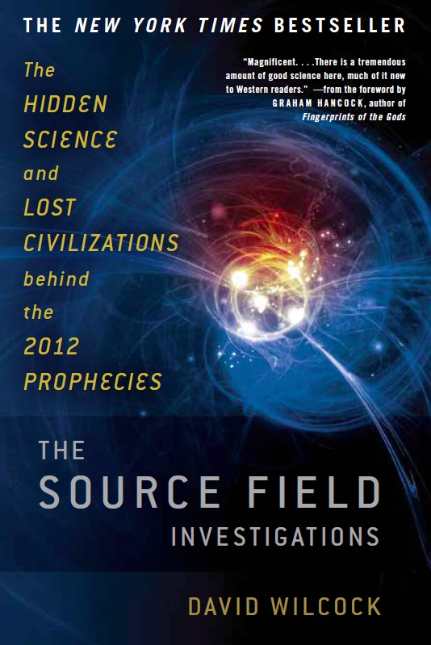

Together, it is a very impressive mosaic — and it reveals that all the phenomena associated with UFOs and science fiction are achievable — and scientifically sound.

This includes, but is not limited to, remarkable healing technologies, gravity shielding, “free energy”, teleportation and time travel.

Furthermore, we can totally shatter the Darwinian model of “random” evolution in favor of an energetically-driven model. This model has nothing to do with Creationism and is not religious in nature.

DARWIN CAME FROM A MASONIC FAMILY

This investigation by Cornelius B, published at Henry Makow’s website, reveals that Charles Darwin came from a Masonic family. To this day, any questioning of Darwinian evolution is smashed down by the media.

http://www.henrymakow.com/was_darwin_an_instrument_of_th.html

Darwinism, the theory of “natural selection and survival of the fittest”, is of major importance to the Illuminati. We know this because, as Richard Milton explains in his article, “Darwinism – The Forbidden Subject”, public debate of Darwinism is forbidden.

“Most educated, rational people will find it almost impossible to believe that the debate of Darwinism through mainstream news papers and the principal TV channels is forbidden. I still find it hard to believe myself,” Milton writes.

While there is no [direct] evidence that Darwin was a Mason, the males in his family were Freemasons, and so were his close colleagues and friends.

Before coming to Derby in 1788, Dr. Erasmus Darwin (1731-1802), physician and biologist, grandfather of Charles, became a Mason in the Lodge of Cannongate Kilwinning, No. 2, of Scotland.

Sir Francis Darwin, (1786-1859), physician and traveler, brother of Charles Darwin’s father, became a Mason in Tyrian Lodge, No. 253, at Derby, in 1807.

The name of Charles Darwin does not appear on the rolls of the Lodge, but it is very possible that he also was a Mason….

DIRECT CONNECTION BETWEEN DARWINIAN EVOLUTION AND ADAM SMITH’S “WEALTH OF NATIONS”

Dr. Stephen Jay Gould noticed a strong connection between the philosophies of Smith’s “The Wealth of Nations,” which is of very key importance in this investigation, and Darwin’s Theory of Evolution.

http://www.henrymakow.com/was_darwin_an_instrument_of_th.html

In his essay, “The Structure of Evolutionary Theory” (2004), Stephen Jay Gould finds a strong kinship between Darwin’s “natural selection” and “the invisible hand of the market” of Adam Smith in “The Wealth of Nations.” (1776)

According to Smith, each individual is in a constant search to satisfy his own interests, to best employ his capital and to better sell his work.

The establishment of the relationship of “genuine competition” of all private interests in a “free market” would result in “the greatest wealth and happiness for all.”….
With his vision of the economy, Smith introduced the destruction of the social bonds — of neighborhood, of trade corporations with their ancient solidarity, of inter-help and reciprocity.

This ideology undermined the traditional mutual help and assistance between the members of the same family.

All these relations that enriched the social fabric, and the quality of life, were reduced to the notions of cold personal interest, selfishness and the quest of money….
Smith’s free market competition corresponds to Darwin’s survival of the fittest. The rest of the population becomes disposable, and therefore eventually must disappear — or may be disposed of as pleased.

This discussion is well outside the scope of our current investigation — but I have written extensively about it in other articles on divinecosmos.com. My book is available online and in many bookstores — in hardcover, ebook and audio format.

In The Source Field Investigations, I present a wealth of scientific evidence that humanity is still in an active process of evolution. No one is used to thinking like this, because the discussion itself has been completely suppressed.

I believe that the defeat of Finanical Tyranny is very essential to helping us achieve our next big advance — in every aspect of civilization, including the sciences.

Once this group is defeated, we will immediately inherit a wealth of technology that is so advanced we could barely have even dreamed it were possible. Over 1000 academic references make the case in Source Field Investigations.

I intend to work directly to help make these technologies a reality once Financial Tyranny has been defeated.

THESE PEOPLE DO NOT APPEAR TO BE NEGATIVE

Svali, our modern-day Illuminati whistleblower, also makes a very important point about how the members of this group appear in everyday life.

There is no easily obvious way to tell if these people are engaged in anything negative.

http://web.archive.org/web/20030810094231/http://www.centrexnews.com/columnists/svali/2000/10/chapter03.html

If you met them in person, you would probably instantly like any of these intelligent, verbal, likeable, even charismatic people.

This is their greatest cover, since we often expect great evil to “appear” evil, led by media portrayals of evil as causing changes in the face and demeanor of people, or marking them like the biblical Cain.

None of the Illuminists I have known had unkind or evil-appearing persona in their daytime lives — although some were dysfunctional, such as being alcoholics….

THERE IS A GREAT SICKNESS
We will feature even more Illuminati whistleblower evidence in this Section — including rarely-ever-seen documents.
We will also feature two disturbing photographs from directly inside what appears to be a very high-level ritual site.
I believe it is important that we see all of this, because it reveals that there is a great sickness in our world.
The scope of the problem is much greater than most people want to think about.
As a result, denial — out of fear — has provided an excellent cover for this group and its operations.

THERE IS PLENTY OF HOPE FOR A SOLUTION
Perhaps the most significant aspect of Svali’s revelations is the understanding that the majority of people in this group would quit, in a “mass exodus,” if they saw the opportunity to escape — and live.
A similar historic event occurred in the United States, beginning with the Masonic murder of William Morgan in 1826.
Within a few years, 90 percent of all Masons left the Order — 45,000 out of 50,000 members, including every single lodge in the Northern states.
In practical terms, the widespread unrest within the modern-day Illuminati means any significant uprising against them could exponentially multiply, within days — once the members realize they can actually get out.
It is very important that we support and protect these heroes when they do this — just as the early Americans supported all those who came forward in the Anti-Masonic Revolt.

A WORLDWIDE GOLD GRAB
The Wealth of Nations, Adam Smith’s 786-page “manifesto,” was published in 1776 — the same year as the founding of the Illuminati.
It was presented to world leaders as “proof” that the gold standard had to be eliminated in order for there to be world peace.
Nearly a century later, Guiseppe Mazzini, the head of European Masonry, and Albert Pike, the head of American Masonry, created a plan for three world wars that were intended to seize total control of the planet.
Their plan was all written down and finalized as of 1871 — and publicly displayed at the British Museum Library for many years.
When we add this to the overall weight of information — some of which we haven’t explored in detail just yet — it leaves little doubt that World Wars I and II were deliberately orchestrated and engineered.
A key objective of these two wars was to confiscate the majority of gold and treasure in the world. This aspect of the plan was not directly written into Mazzini and Pike’s blueprints — as the knowledge was far too sensitive.
Thanks to multiple insiders, we now know that leaders who surrendered their gold and treasure, and/or had it forcibly stolen from their countries, were given bronze boxes filled with Federal Reserve bonds in exchange for their assets.
The value of these bonds is much, much greater than the amount of money in the legitimate world economy. This is part of why the secret has been so jealously guarded.
If the truth were known, and the gold was revealed, it would destroy Financial Tyranny.

NEVER BEEN MADE PUBLIC BEFORE
Many of the images of bonds you just saw in Section Four have never been made public before. Click here if you haven’t read the new Section Four yet — and go take a look for yourself.
Four different sources, each completely independent, gave me the exact same information about these bonds — and what they looked like — in a two-week period.

Three out of the four sources — Neil Keenan, Udo Pelkowski and “Unwanted Publicity Intelligence” — provided pictures of the bonds. They were all nearly identical.

David Hutzler and his son Mackie very likely gave their lives for us to see the bonds from the Unwanted Publicity website.

They did not do this willingly. They appear to have been murdered — to threaten me into abandoning this investigation.

All this did is inspire me to do a much, much more thorough job than I had already planned.

The leaders who received these chests of bonds were explicitly instructed to bury them underground — where they could never be found or stolen without explicit instructions.

As a result, the chests and the bonds often look quite rough by the time they are dug up out of the ground.

Furthermore, the Federal Reserve made sure to include deliberate errors in spelling, grammar and punctuation, so that if anyone ever did steal the bonds, they could be written off as fakes.

DISINFORMATION

Early in January 2012, Bloomberg News published an article asserting that any and all such pictures of Federal Reserve bonds are fakes. This article was released just as we were finishing our investigation — and the timing was suspect to say the least.

One of the Federal Reserve bond chests we saw in Section Four had what appears to be a Microsoft Windows Arial font on the top. This obviously posed another problem.

After I released Section Four of this investigation, Keith Scott revealed to me that the Federal Reserve has continued issuing 1934-series bonds straight through to the present day.

Slight design changes in the chest, therefore, are perfectly reasonable — and may even help convince people the bonds are counterfeit if they ever get exposed to the public.

The reason why these bonds are still being issued is simple. As the price of gold increases, the original owners of the gold have demanded that more bonds be printed — to match the full value of their “deposits.”

This is perhaps the single biggest reason why there has been such an incredible effort to depress the price of gold. This has been well-documented by the Gold Anti-Trust Action Committee at gata.org.

FORMER FEDERAL RESERVE BOARD OF GOVERNORS MEMBER BLOWS THE WHISTLE

Kevin M. Warsh, a former member of the Federal Reserve Board of Governors, came forward on January 26, 2012 with explosive new information — at the Stanford University Institute for Economic Policy Research.

Warsh revealed that the price of gold is rigorously controlled by central banks. If the legitimate demand for gold was reflected in its current price, it would almost certainly be much higher.

http://www.gata.org/node/10927

Central banks are now so heavily influencing asset prices that investors are unable to ascertain market values, former Federal Reserve Board of Governors member Kevin M. Warsh told the Stanford University Institute for Economic Policy Research tonight.

This influence is especially evident, Warsh said, with the Fed’s purchase of government bonds, which has made it impossible for investors to use bond prices to learn anything about markets.

Warsh, who disclosed during GATA’s freedom-of-information litigation with the Fed in 2009 that the central bank has secret gold swap arrangements with foreign banks (http://www.gata.org/files/GATAFedResponse-09-17-2009.pdf), added that the Fed is trying to do too much and the rest of the government not enough to encourage economic growth.

While he said nothing explicitly about gold, Warsh seemed to come pretty close to your secretary/treasurer’s observation almost four years ago that there are no markets anymore, just central bank interventions. (See http://www.gata.org/node/6241.)

The countries who handed over their gold are very upset about how the promises have not been kept. Furthermore, if they ever actually tried to cash these bonds, there would be lethal consequences.

A REMARKABLE REVELATION OF SUPPRESSED TRUTH

In addition to the Dragon Family / Neil Keenan / Keith Scott lawsuit we have been discussing, another intriguing lawsuit emerged on December 23, 2011 — exactly one month after the Keenan suit — that sheds even more light on our story.

This only came to my attention after publishing Section Four. This lawsuit appeared before the bonds I got from Keenan and the ones Beckow got from Pelkowski were published online — and yet there is an overwhelming, undeniable similarity amongst all of them.

By now, this should all look and sound very familiar. Joseph Riad acquired three “sealed and certified bronze boxes” that contained a total of 750 billion dollars in Federal Reserve bonds — from a representative of the South African government.

Each bond was a billion dollars in its denomination. All the images you are about to see are from the lawsuit that resulted.

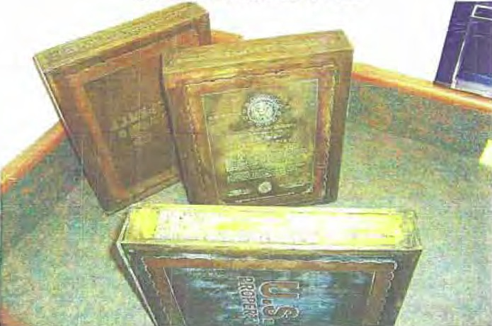

Courthouse News Service reported on this very real lawsuit shortly after it was filed. Joseph Riad has obviously devoted years of his life, and untold amounts of money in legal fees, to prepare this 15-billion-dollar lawsuit against the United States Government.

You can download the complaint and read it for yourself here: http://www.courthousenews.com/2011/12/23/PhillyBonds.pdf

The “Affidavit of Procurement” with all the pictures is here: http://www.courthousenews.com/2011/12/23/RiadAffidavit.pdf

JOSEPH RIAD’S LAWSUIT COVERED ON COURTHOUSE NEWS SERVICE

Here is an excerpt from Courthouse News Service’s coverage of this fascinating story.

Strange Tale of Billions in U.S. Bonds

http://www.courthousenews.com/2011/12/23/42507.htm

PHILADELPHIA (CN) – A man from suburban Philadelphia claims to have 735 $1 billion Federal Reserve Bonds stashed in a bank outside the city, and that 15 more have yet to be returned to him by a scheming agent from the Department of Homeland Security.

Joseph Riad claims the 15 bonds came from three ultra-rare “sealed and certified bronze boxes,” each of which contains 245 $1 billion 1934 Federal Reserve Bonds.

[DW: This was a slight mistake. The boxes contain 250 bonds each, but 15 out of 750 were stolen by the DHS.]

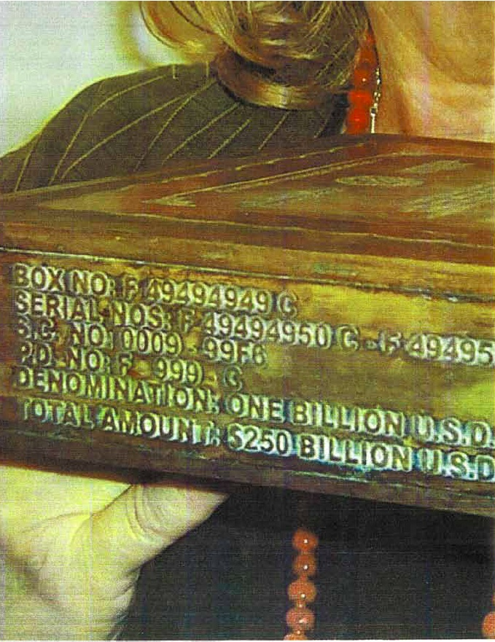

Riad sued the United States for $15 billion, in Federal Court.

The billion-dollar bonds allegedly were used by the government for debt-management purposes in the 1930s when physically moving lower-denomination currency or gold was impractical.

[DW: In reality, it wasn’t practical to move the gold because it had been put “on deposit” with the Federal Reserve banks, worldwide.]

While there have been reports of fake billion-dollar bonds turning up in the past, Riad claims his bonds are genuine, and that several experts support that contention.

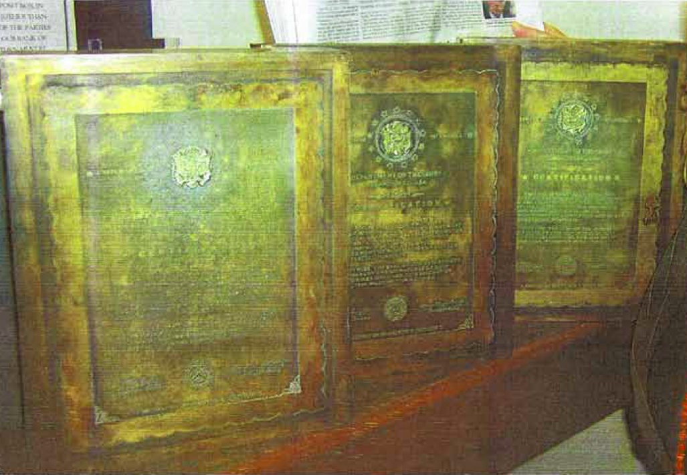

But no federal agency will redeem them, he says, despite “extensive and exhaustive proof of the authenticity of the Bonds.”

According to what he calls an Affidavit of Procurement, filed as an exhibit to his complaint, Riad claims the boxes became his collateral for more than $76,000 in loans he made to a “mandate to the South African government.”

RIAD COMES INTO CONTACT WITH GOVERNMENT AGENTS WHO CONFIRM THE BONDS ARE REAL

It may seem rather ridiculous that representatives of the South African government would give Joseph Riad 750 billion dollars in bonds as collateral for a 76,000-dollar loan.

This may have been done deliberately — perhaps because the bonds had been stolen in the first place, and the representative knew they could not be cashed without him being killed — and were therefore worthless.

However, this theft has now led to a lawsuit that is helping us break the entire story open.

Riad first acquired the bonds in 2006. If you go through and read all the documentation, you will see that Riad has done a staggering amount of work to prove these bonds are real — including meeting with government agents.

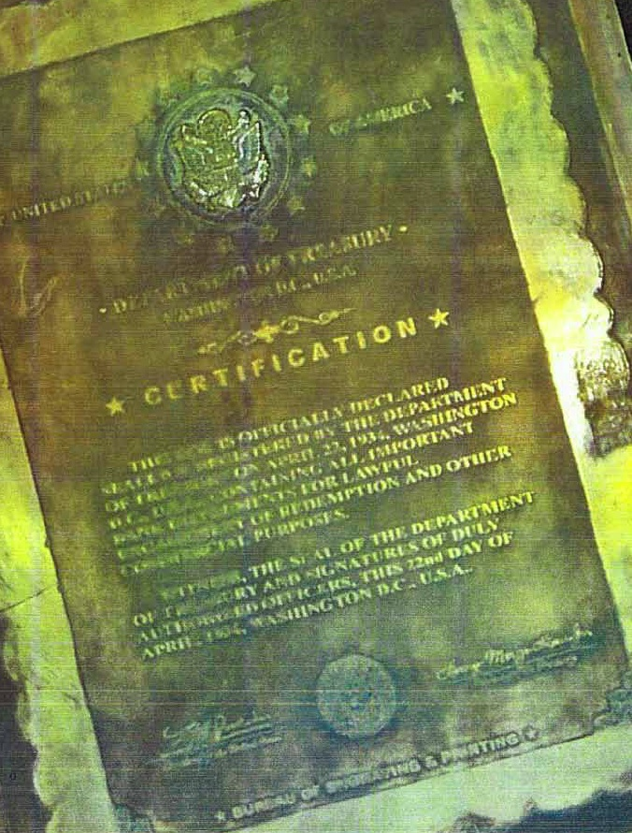

A VISIT FROM THE SECRET SERVICE
As this stunning lawsuit continues, we find out that the plaintiff was contacted by the Secret Service, who told him the bonds were indeed real — and wanted to help him put them back into the system.

http://www.courthousenews.com/2011/12/23/42507.htm

Riad says his bonds are the real deal, and that the Secret Service has indicated as much.

He contacted that agency in mid-2008, then met with two Secret Service agents at his then-lawyer’s Houston law office, according to his complaint.

The agents referred him to an official at the Bureau of Public Debt (BPD), but when Riad contacted BPD official Donna Ayers, she “categorically denied the existence of bonds such as plaintiff’s bonds,” according to the complaint.

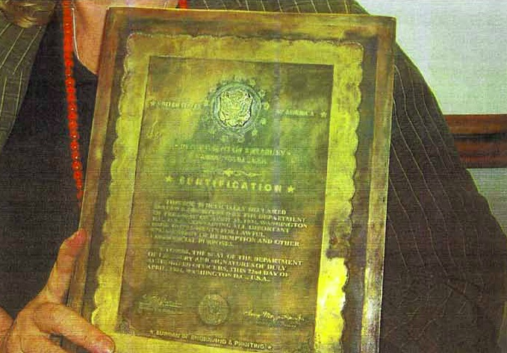

Ayers bounced him back to the agents, who “inspected plaintiff’s bonds, reviewed the accompanying expert reports, and performed their own evaluations and tests so as to render their own opinion as to the authenticity of plaintiff’s bonds,” Riad says.

The agents then contacted Ayers “and informed her that plaintiff had completed the appropriate and required examination and authentication of the Bonds and that the redemption of said bonds did fall under the purview of the BPD, since the Bonds were outstanding government issued securities/debts,” according to the complaint.

DEPARTMENT OF HOMELAND SECURITY AGENT STEALS 15 BILLION IN BONDS

At this point the story gets even more interesting.

Another government agent — this time from the Department of Homeland Security — got involved, confirmed the bonds were real, and then ended up running off with 15 billion dollars’ worth of them.

http://www.courthousenews.com/2011/12/23/42507.htm

Finding no luck with the BPD, Riad says he continued his quest of “repatriating the bonds to the U.S. Treasury, with his intent being to assist in reducing outstanding U.S. debts.”

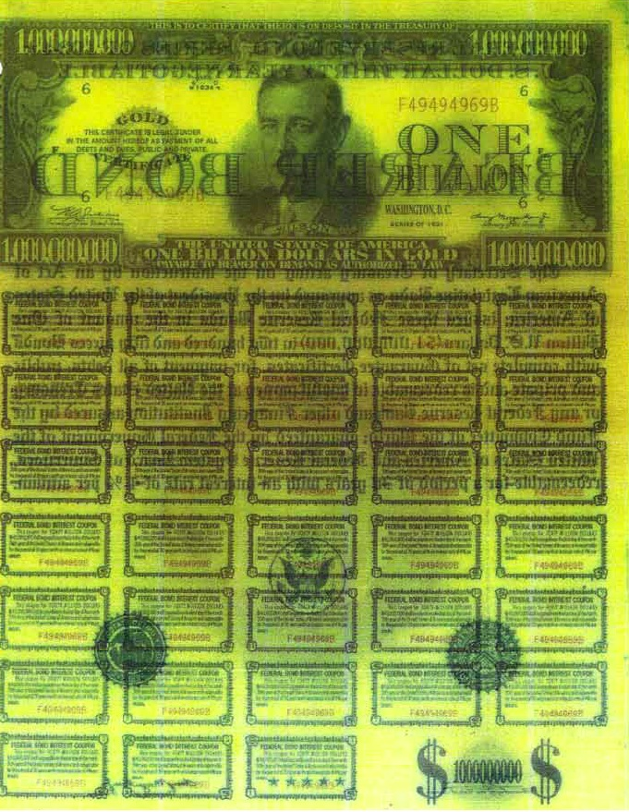

During his quest he encountered Nickolaus Jones, an agent for the Department of Homeland Security, who was bent on “fraudulently” obtaining the bonds, Riad says in his complaint.

Riad says he learned about Agent Jones through a man who called himself Neil Gibson.

Gibson was “an alleged British financial consultant who claimed to have experience in the repatriation of high-denomination U.S. government bonds…

“[Gibson] represented to plaintiff that he had a contract with the U.S. government to complete such transactions, and that he had successfully handled such projects on behalf of the U.S. government in the past,” according to the complaint….

Riad says Jones told him that he could share his analysis of the bonds only with a federal agent possessing a sufficiently high clearance level, which, “fortuitously,” Riad’s bond expert, Kermit Harmon, a former security director for the Dallas Federal Reserve Bank, did have….

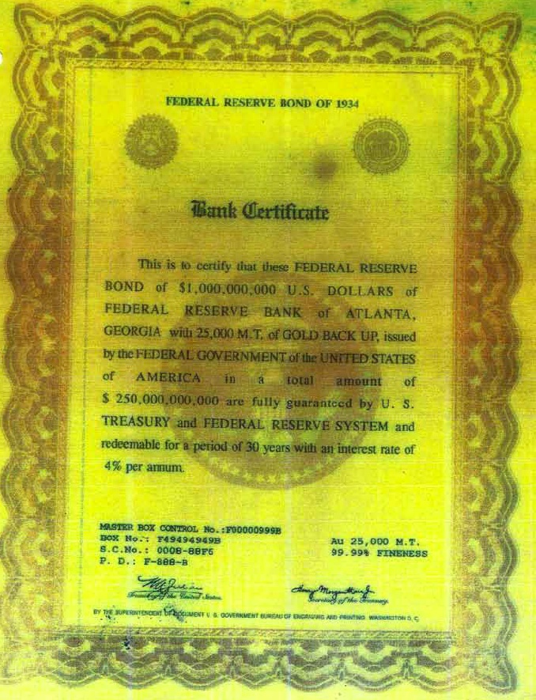

Federal Reserve Bank of Atlanta Bank Certificate.

[Notice deliberately bad grammar: “these FEDERAL RESERVE BOND… of FEDERAL RESERVE BANK”, the word “BACK UP”, and the phrase “are fully guaranteed by U.S. TREASURY”.]

The complaint continues: “At or about this same time, Agent Jones sent plaintiff and Mr. Oxford emails, demanding that plaintiff’s three (3) bronze boxes and the remaining seven hundred thirty-five (735) bonds and supportive documents be surrendered to him immediately.

Agent Jones also threatened plaintiff that he would be prosecuted under federal law for refusing to turn over the bonds, citing specific U.S. Code provisions as authority for his threats.

However, due to the unethical and uncertain circumstances surrounding Agent Jones, it appeared to plaintiff and Mr. Oxford that Agent Jones was attempting to scare plaintiff in order to secure personal possession of the bonds and the bronze boxes.

Upon the advice of Mr. Oxford, plaintiff ignored Agent Jones’ demands and threats.

THERE IS NO REASON WHY THE MEDIA SHOULDN’T COVER THIS STORY
Joseph Riad’s lawsuit is not ‘crazy’ — particularly in light of all the supporting evidence we have presented, including photographs from three other completely independent sources — Keenan, Pelkowski and Unwanted Publicity.
I found out that Riad has since been contacted by Neil Keenan’s team, and is now a contributing partner in the greater initiative to end Financial Tyranny.
Given the tremendous amount of evidence we have surveyed thus far — including these four independent sets of images and two comprehensive lawsuits — there is absolutely no reason why the media shouldn’t be covering this story.
As we revealed in Section One, the Federal Reserve effectively bought the media — and the facts have remained extremely well-hidden as a result.

THE BANK OF INTERNATIONAL SETTLEMENTS
Though these and other bond boxes were issued by the Federal Reserve, they are all part of an even larger banking network.
Very few people have heard of the Bank of International Settlements, or BIS — but this is the global version of the Federal Reserve.
Keith Scott casually quoted from the BIS charter in an email he sent me — right as I was getting ready to publish this section of the investigation.
I immediately asked him if this was online or classified. When I found out that everything was public, I got very excited, as this made it much easier to develop our case.

LOOK AT THE LOGO

First of all, notice that the BIS logo is a stylized Eye — only in this case it has a diamond-shaped iris with lines coming off of each corner.



Everything you are about to read came directly off of the official BIS website — in the Legal Info section:

http://www.bis.org/about/legal.htm

I have provided links where you can download each of these documents for yourself, directly off of the BIS website.

BANK OF INTERNATIONAL SETTLEMENTS — BRUSSELS PROTOCOL

This first excerpt is from the Brussels Protocol document. It spells out who joined the BIS, when it was officially created (originally in 1929 and 1930), and what its purpose was.

As I said in Section Four, the initial meetings included Japanese emperor Hirohito in 1921 — but it took almost a decade to bring in all the countries that ultimately became signatories to the agreement. Here I will add emphasis where I feel it is appropriate.

Bank of International Settlements Legal Info – Brussels Protocol
http://www.bis.org/about/protocol-en.pdf

Protocol regarding the immunities of the
Bank for International Settlements
(of 30 July 1936) [1]

The duly authorised representatives of the Government of His Majesty the King of the Belgians, the Government of the United Kingdom of Great Britain and Northern Ireland, the Government of Canada, the Government of the Commonwealth of Australia, the Government of New Zealand, the Government of the Union of South Africa, the Government of India, the Government of the French Republic, the Government of His Majesty the King of the Hellenes [Greece], the Government of His Majesty the King of Italy, the Government of His Majesty the Emperor of Japan, the Government of the Republic of Poland, the Government of the Republic of Portugal, the Government of His Majesty the King of Roumania, the Government of the Swiss Confederation, the Government of His Majesty the King of Yugoslavia;

Whereas

In accordance with Article X, paragraph 2 of the Agreement with Germany [2], which was signed at The Hague on the 20th January 1930 and has duly come into force, their respective Governments (with the exception of the Swiss Confederation) have conferred upon the Bank for International Settlements, the establishment of which was laid down by the Experts’ Plan of the 7th June 1929, certain immunities regarding its property and assets as well as those which might be entrusted to it;

Article 1

The Bank for International Settlements, its property and assets as well as all the property and assets which are or will be entrusted to it, whether coin or other fungible goods, gold bullion, silver or any other metal, precious objects, securities or any other objects the deposit of which is admissible in accordance with banking practice, are exempt from the provisions or measures referred to in paragraph 2 of Article X of the Agreement with Germany and in Article 10 of the Constituent Charter consecutive to the Convention with Switzerland, of the 20th January 1930.

The property and assets of third parties, held by any other institution or person, on the instructions, in the name or for the account of the Bank for International Settlements, shall be considered as entrusted to the Bank for International Settlements and as enjoying the immunities laid down by the Articles above-mentioned by the same right as the property and assets which the Bank for International Settlements holds for the account of others, in the premises set apart for this purpose by the Bank, its branches or agencies.

DID YOU CATCH THAT?

The BIS charter clearly states that it is a worldwide central bank that has taken in “deposits” from all the member nations — as well as “third parties”, which could include individual people.

These “deposits” include coins, gold bullion, silver and precious objects. The part most people do not understand is how this secret, coordinated, worldwide effort was made to confiscate all the world’s gold and treasure — and put it on deposit with the BIS.

The three nations that confiscated the most gold, during this time, were Germany, through Hitler’s efforts; Japan, through plundering wealth from Asia, particularly China; and the United States, during the course of World War II.

Hitler invaded a wide variety of countries in Europe — and systematically plundered their central banks at every stop. Japan was equally aggressive throughout Asia. This was all part of the secret plan — and we will learn more about it as our investigation proceeds.

WILLFUL SURRENDER — SUCH AS FROM THE UNITED STATES

Other nations, such as the United States, willingly surrendered the gold from their own central banks, and forced their private citizens to give up their gold as well. All of this gold was secretly put on deposit with the BIS, as per the protocol you just read.

In 1933, President Roosevelt passed Executive Order 6102, which made it illegal to own gold — in a desperate effort to end the Great Depression. Private citizens were ordered to sell their gold to the Federal Reserve at $20.67 an ounce.

This was legally enforced by the Gold Act of 1934. Those citizens who did not comply had their seemingly private “safe” deposit boxes looted of any and all gold. Everything was then deposited into the BIS.

As the BIS Protocol document states, once these deposits were put in, they were “entrusted to the Bank of International Settlements” — and the member nations enjoyed “immunities” as a result.

The Charter of the BIS goes into more detail about what, exactly, these immunities consist of.

THE BIS CHARTER

When you read the BIS Charter off of the official BIS website, you find out that the BIS is not just composed of the central banks of its member nations.

It is also composed of a “banking group” that includes, but is not limited to, J.P. Morgan, the First National Bank of New York and the First National Bank of Chicago — i.e. the Federal Reserve member banks — as well as an unnamed “financial institution of the United States of America” — which is obviously the Federal Reserve.

The amounts that were listed as being put on deposit with the BIS were much lower than what they really had, based on what we now know. However, the charter itself allows for much more to be deposited — without any public knowledge or oversight.

Furthermore, the Federal Reserve banks are held completely immune from any and all taxation on their profits from the BIS, thanks to the way the charter is written.

BIS Charter
http://www.bis.org/about/charter-en.pdf

Constituent Charter
of the Bank for International Settlements
(of 20 January 1930) [1]

Whereas the Powers signatory to the Hague Agreement of January, 1930, have adopted a Plan which contemplates the founding by the central banks of Belgium, France, Germany, Great Britain, Italy and Japan and by a financial institution of the United States of America of an International Bank to be called the Bank for International Settlements;

And whereas the said central banks and a banking group including Messrs. J. P. Morgan & Company of New York, the First National Bank of New York, New York, and the First National Bank of Chicago, Chicago, have undertaken to found the said Bank and have guaranteed or arranged for the guarantee of the subscription of its authorised capital amounting to five hundred million Swiss francs equal to 145,161,290.32 grammes fine gold, divided into 200,000 shares;….

6. The Bank shall be exempt and immune from all taxation….

7. All funds deposited with the Bank by any Government in pursuance of the Plan adopted by the Hague Agreement of January, 1930, shall be exempt and immune from taxation….

10. The Bank, its property and assets and all deposits and other funds entrusted to it shall be immune in time of peace and in time of war from any measure such as expropriation, requisition, seizure, confiscation, prohibition or restriction of gold or currency export or import, and any other similar measures.

WHAT DO THEY MEAN BY “IMMUNE?”

Number 10 in the Charter says that “The Bank, its property and assets and all deposits and other funds entrusted to it” shall be “immune… from… seizure [or] confiscation.”

What this means in practical terms is that every ounce of gold and treasure put on deposit with the BIS is registered and tracked.

If you ever dared to try to go after any of this gold, you would very likely be killed. Deadly force is used to insure that these assets will remain “immune from seizure or confiscation” — as otherwise various groups would obviously attempt to steal them.

This is obviously why Joseph Riad was handed three 250-billion-dollar bond boxes in exchange for a $76,000 dollar loan. The perpetrator knew Riad could never cash them — they belonged to the BIS.

David Hutzler and his 8-year-old son Mackie may have been killed just for conveying Ben’s message to me — telling me to send you to Unwanted Publicity Intelligence, so you can see real pictures of these Federal Reserve bonds and learn the whole story for yourself.

PRIVATE SHAREHOLDERS

Even more is revealed, in open and public view, when we dig into the statutes of the BIS. We find, among other things, that “private shareholders” can be a part of the BIS — not just central banks.

There is nothing written in the BIS statutes that says these entities could not be private, individual shareholders.

Furthermore, these “private shareholders” can enjoy the profits from the BIS — all of which are, as we just saw, completely non-taxable.

This may not seem like a big deal until we find out, a bit later, how enormous these profits are. It’s literally a magic printing press — where anything goes and nothing is sacred.

This little-known fact is only one of a series of interesting things that jump out when you read the BIS statutes.

THE BIS STATUTES

BIS Statutes
http://www.bis.org/about/statutes-en.pdf

Article 3
The objects of the Bank are: to promote the co-operation of central banks and to provide additional facilities for international financial operations; and to act as trustee or agent in regard to international financial settlements entrusted to it under agreements with the parties concerned.

Article 18(A) – In accordance with the resolutions of the Extraordinary General Meeting held on 8 January 2001 and in order to implement Article 15 of the Statutes as amended, the Bank will, on a compulsory basis, repurchase each share which, as of that date, is registered in the name of a shareholder other than a central bank (a “private shareholder”)….

Article 23
The Bank may enter into special agreements with central banks to facilitate the settlement of international transactions between them.

For this purpose it may arrange with central banks to have gold earmarked for their account and transferable on their order, to open accounts through which central banks can transfer their assets from one currency to another….

Article 27
The Board shall be composed as follows:

(1) The Governors for the time being of the central banks of Belgium, France, Germany, Great Britain, Italy and the United States of America (hereinafter referred to as ex-officio Directors).

Article 29
Directors must be ordinarily resident in Europe or in a position to attend regularly at meetings of the Board.

Article 48
The financial year of the Bank will begin on 1st April and end on 31st March. The first financial period will end on 31st March, 1931.

Article 51
The yearly net profits of the Bank shall be applied as follows:….

(4) The disposal of the remainder of the net profits shall be determined by the General Meeting on the proposal of the Board, provided that a portion of such remainder may be allotted to the shareholders by way of a transfer to the Special Dividend Reserve Fund.

Article 55
(1) The Bank shall enjoy immunity from jurisdiction….

(2) Property and assets of the Bank shall, wherever located and by whomsoever held, be immune from any measure of execution (including seizure, attachment, freeze or any other measure of execution, enforcement or sequestration),….

LET’S REVIEW WHAT WE JUST LEARNED HERE…

If you were reading this carefully, you would see that the BIS acts as an intermediary and trustee for the “settlement of international transactions” between central banks.

Specifically, the gold that is held on deposit within the BIS system can be transferred from one account to another. This also allows central banks to “transfer their assets from one currency to another.”

The Statutes also indicate that this whole process is “free from jurisdiction” outside the BIS system. Best of all, some of the shareholders who take part in this system can be “private”… and are “other than a central bank.”

These “private” shareholders can enjoy the profits from the “settlement of international transactions” where gold held on deposit within the BIS is transferred from one account to another — and massive profits are generated in the process.

Wouldn’t it be nice if you could be one of those shareholders enjoying the profits, free from taxation and jurisdiction?

I was faced with that very same question — and it was very real in my case. I did not get involved, but I did listen — as the offers came in from several different sources within a fairly small window of time.

THE BRETTON WOODS AGREEMENT CLARIFIED AND ENHANCED EVERYTHING

It wasn’t until the end of World War II that the foundation we just learned about from the official BIS website was fully clarified and extended — into a worldwide economic system.

730 delegates from all 44 Allied nations met in Bretton Woods, New Hampshire, as we are about to see.

What we do not see, in any public records I am aware of, is that these delegates agreed that in order for the world’s economy to run properly, they had to be able to create money by fiat — i.e. out of “thin air.”

This was exactly what Adam Smith had argued in The Wealth of Nations — which was the visible prototype for this entire finanical agreement that most of the delegates were already familiar with.

The delegates knew this fiat currency would be secretly backed by all the gold that had been put on “deposit” with the BIS. That helped them feel more comfortable that it wasn’t actually “funny money,” backed by nothing.

The details I am about to share with you are considered to be some the most heavily-guarded secrets on Earth. I only learned about them through conversations with multiple insiders.

PRIVATE INDIVIDUALS HAD TO ACT ON BEHALF OF CENTRAL BANKS
Many of the 730 delegates at Bretton Woods were paranoid about the centralization of world power. As a result, they agreed that central banks could not trade directly with each other.
The potential for back-alley deals and secret transactions was far too great in such a system.

Instead, private individuals were required to actually facilitate the trades between central banks.

The central banks were only able to vote “yes” or “no” on any particular “trade” that came their way.

A central bank could also offer a trade of their own, and put it on the market — but a private individual would then have to apply for the trade, and find another central bank to act as a buyer.

In effect, these private individuals became brokers for the trades that needed to occur between central banks — in order to keep their currencies functioning properly.

PRIVATE INDIVIDUALS HAD TO HOLD THE COLLATERAL IN THEIR OWN ACCOUNTS

Furthermore, the paranoid Bretton Woods delegates also agreed that the central banks could not hold the collateral in their own accounts.

All the money had to be held in the accounts of the private individuals — and it was all very strictly regulated.

This was intended to prevent the central banks from looting these accounts, as they did not have direct access to them.

They could only use the accounts as collateral for their own transactions — such as in the “Forex” currency exchange and other markets.

As a result, you could have one individual who has an account that holds, say, 100 Billion dollars. However, that 100 Billion could actually be providing collateral for several different central banks.

Meanwhile, the 100 Billion in that account is backed up by the gold that is secretly being held on deposit by the BIS.

NO LEGAL REPRESENTATION

The whole plan was meant to be kept highly secret, in order to preserve the health and safety of these private individuals — so they could do their jobs.

In order to protect secrecy, it was decided that these private individuals could not have a broker, lawyer or other representation.

The only way you could learn about the system was to have someone else teach you how it works — but they could not be a licensed financial analyst either.

The transactions of these private individuals were also subject to rigorous auditing and regulation from the United Nations and the SEC in the United States, among others.

From what I’ve heard, many of the private individuals with the largest accounts in this system are members of the “Illuminati families” — but that should come as no surprise by now.

All of this information came to me by way of several different insiders over the years — each of whom said essentially the same things.

AN INCREDIBLE AMOUNT OF JARGON TO LEARN

The jargon that has since been created within this insiders’ financial system is massive.

When I first heard people using this jargon in a fast-moving conversation, I felt like I was trying to understand a foreign language.

Private Placement Programs. (PPPs.) Tranches. Medium Term Notes. (MTNs.) Stand-By Letters of Credit. (SBLC.) Aged Shelf corporations. Bullet trades. Safe Keeping Receipts. (SKR.)

However, by paying rigorously close attention and memorizing every term as it came out, I was gradually able to link the pieces together — and in a fairly short period of time I was able to sound somewhat intelligent in the discussion.

LOTS OF TRAPS TO DISTRACT ANYONE WHO STUMBLES OVER THIS

Almost every person I met who was involved in this system gave me strict warnings to never put any of these terms into Google as a search.

That alone could be enough to have Feds come knocking at your door… or so I was told.

I was also told that deliberate, highly compelling disinformation had been put out on the Internet to make people think the whole thing was a very elaborate scam.

This article on “Prime Bank / High Yield Investment Schemes” is a great example — and we will read some of it a bit later.

There is very good evidence that this insiders’ system is NOT a scam, as we will see.

SOME PEOPLE DO GET PULLED OUT OF THE REAL SYSTEM DUE TO DISHONESTY

A certain number of “traders” who get too greedy in the real system are deliberately pulled out.

Once they get tossed out, they are told the whole thing was a fake — and they got ripped off.

The litigation that then results makes the claims that it is all a “Ponzi scheme” sound legit.

Nonetheless, spending $7500 of “real money” and ending up with millions of dollars in tax-free profits is unlike any other Ponzi scheme I’ve ever heard of.

A Bernie Madoff-type Ponzi scheme is pathetic by comparison — in which you only earn back a measly 20 percent interest per annum.

I WILL SHOW YOU HOW IT IS DONE

In this section I will show you how you could quickly become a multi-millionaire, with millions more in profits every month, off of a 7500-dollar investment — providing you know the right people.

I have had several deals like this offered to me in the last few years — in an obvious attempt to “buy” me so I could be bribed, blackmailed and ultimately destroyed.

I was warned that this was a very elite insiders’ club — and simply looking up the terms online could get me in serious trouble.

A friend of mine actually did do a search for these dangerous financial terms, using IP-address-scrambling software.

He found this website, Inside Trade LLC — and if I had read all of it back before I was in some of those meetings, I could have gotten up to speed a lot faster.

“HUMANITARIAN RELIEF”

These trades were built to generate profits out of thin air. The Bretton Woods delegates all agreed this was necessary. The amounts of profits these trades could potentially generate were spectacular.

For this same reason, the 730 delegates were quite paranoid about generating money out of thin air.

They did not want it to end up back in the hands of the wealthy bankers — including the Nazis, who were still members of the BIS… as we will see.

A majority of delegates agreed that 70 percent of the profits must go to humanitarian relief programs.

However, the remaining 30 percent could be invested into non-humanitarian programs of the private shareholders’ own choosing.

If these private shareholders were involved as directors of these programs, they could then pay themselves a healthy salary for their work.

Later in this section, we will explore solid evidence that this system of “trading” is alive and well.

THE WRITTEN DESCRIPTION OF BRETTON WOODS

http://en.wikipedia.org/wiki/United_Nations_Monetary_and_Financial_Conference
The United Nations Monetary and Financial Conference, commonly known as the Bretton Woods conference, was a gathering of 730 delegates from all 44 Allied nations at the Mount Washington Hotel, situated in Bretton Woods, New Hampshire, to regulate the international monetary and financial order after the conclusion of World War II.^{[1]}

The conference was held from 1-22 July 1944, when the agreements were signed to set up the International Bank for Reconstruction and Development (IBRD), the General Agreement on Tariffs and Trade (GATT), and the International Monetary Fund (IMF)….

HITLER’S GOVERNMENT WAS A PART OF THE BIS — CAUSING CONTROVERSY AT BRETTON WOODS

Another little-known problem that came up at Bretton Woods was the key participation of Germany in the Bank of International Settlements.

Most nations thought the BIS was mainly used to help enact the Treaty of Versailles — in which funds were pledged to help rebuild Germany after its staggering defeat in World War I.

However, if the Nazis were the bad guys in World War II, killing untold numbers of Jews as well as so many others, what the hell was Germany still doing in the BIS?

That was a good question — and it caused a great deal of controversy, as we see here.

http://en.wikipedia.org/wiki/United_Nations_Monetary_and_Financial_Conference
In the last stages of the Second World War, in 1944 at the Bretton Woods Conference, the Bank for International Settlements became the crux of a fight that broke out when the Norwegian delegation put forth evidence that the BIS was guilty of war crimes and put forth a motion to dissolve the bank; the Americans, specifically President Franklin Delano Roosevelt and Henry Morgenthau, supported this motion.

This resulted in a fight between, on one side, several European nations, the American and the Norwegian delegation, led by Henry Morgenthau and Harry Dexter White; and on the other side, the British delegation, headed by John Maynard Keynes and Chase Bank representative Dean Acheson, who tried to veto the dissolution of the bank.

The problem was that the BIS, formed in 1930, had as the main proponents of its establishment the then Governor of the Bank of England, Montagu Norman, and his colleague Hjalmar Schacht, later Adolf Hitler’s finance minister.

The Bank was as far as known, originally primarily intended to facilitate money transfers arising from settling an obligation from the peace treaty after WWI.

After World War I, the need for the bank was suggested in 1929 by the Young Committee, as a means of transfer for German reparations payments (‘see: Treaty of Versailles‘).

The plan was agreed in August of that year at a conference at the Hague, and a charter for the bank was drafted at the International Bankers Conference at Baden Baden in November. The charter was adopted at a second Hague Conference on January 20, 1930.

The Original board of directors of the BIS included two appointees of Hitler, Walter Funk and Emil Puhl, as well as Herman Schmitz the director of IG Farben and Baron von Schroeder the owner of the J.H. Stein Bank, the bank that held the deposits of the Gestapo.

NORWAY, THE UNITED STATES AND OTHER EUROPEANS ARGUED THAT THE BIS SHOULD BE DISSOLVED

As we can see in this next excerpt, Norway, the United States and other European delegates argued that the BIS should be dissolved.

It was well known at the time that “the BIS had helped the Germans loot assets from occupied countries during World War II.”

The British fought hard and ultimately won. As a result, the BIS still exists today, despite this outrageous conflict of interest.

http://en.wikipedia.org/wiki/United_Nations_Monetary_and_Financial_Conference

As a result of allegations that the BIS had helped the Germans loot assets from occupied countries during World War II, the United Nations Monetary and Financial Conference recommended the “liquidation of the Bank for International Settlements at the earliest possible moment.” ^{[2]}

This dissolution, which was originally proposed by Norway and supported by other European delegates, as well as the United States and Morgenthau and Harry Dexter White, was never accomplished. ^{[3]}

In July 1944, Dean Acheson interrupted Keynes in a meeting, fearing that the BIS would be dissolved by President Franklin Delano Roosevelt.

Keynes went to Henry Morgenthau to prevent or postpone the dissolution of the BIS, but the next day the dissolution of the BIS was approved.

The British delegation did not give up, however, and the dissolution of the bank was still not accomplished when Roosevelt died. In April 1945, the new president Harry S. Truman and the British suspended the dissolution and the decision to liquidate the BIS was officially reversed in 1948.^{[4]}

THE DOLLAR BECAME THE “GLOBAL RESERVE CURRENCY”

Among other things, the IMF or International Monetary Fund was created in Bretton Woods. Furthermore, as you will see, all currencies worldwide were “pegged” to the United States dollar.

The United States was now the only country allowed to officially possess gold reserves — so the US Dollar became “as good as gold,” thus making it the “global reserve currency.”

However, in the “Nixon shock,” the United States refused to back up dollars with gold as of 1971 — meaning the US dollar, and therefore the entire global economy, was now backed by nothing but “hot air.”

http://en.wikipedia.org/wiki/Bretton_Woods_system

Setting up a system of rules, institutions, and procedures to regulate the international monetary system, the planners at Bretton Woods established the International Monetary Fund (IMF) and the International Bank for Reconstruction and Development (IBRD), which today is part of the World Bank Group.

These organizations became operational in 1945 after a sufficient number of countries had ratified the agreement.

The chief features of the Bretton Woods system were an obligation for each country to adopt a monetary policy that maintained the exchange rate by tying its currency to the U.S. dollar and the ability of the IMF to bridge temporary imbalances of payments.

On August 15, 1971, the United States unilaterally terminated convertibility of the dollar to gold. As a result, “[t]he Bretton Woods system officially ended and the dollar became fully ‘fiat currency,’ backed by nothing but the promise of the federal government.”^{[1]}
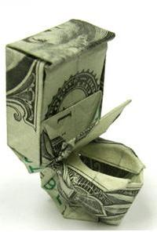

This action, referred to as the Nixon shock, created the situation in which the United States dollar became the sole backing of currencies and a reserve currency for the member states….

FEDERAL RESERVE CHAIRMAN BERNANKE SAYS GOLD STANDARD HAD TO BE ABANDONED

Mirroring Adam Smith’s suggestions in his 1776 mega-document The Wealth of Nations, Ben Bernanke explained in his book The Great Depression that the countries of the world had to abandon the gold standard to “escape the deflationary vortex”.

http://en.wikipedia.org/wiki/Bretton_Woods_system

Here’s Ben Bernanke:

“… [T]he proximate cause of the world depression was a structurally flawed and poorly managed international gold standard…

For a variety of reasons, including among others a desire of the Federal Reserve to curb the US stock market boom, monetary policy in several major countries turned contractionary in the late 1920s—a contraction that was transmitted worldwide by the gold standard.

What was initially a mild deflationary process began to snowball when the banking and currency crises of 1931 instigated an international “scramble for gold”….

As a result, individual countries were able to escape the deflationary vortex only by unilaterally abandoning the gold standard and re-establishing domestic monetary stability, a process that dragged on in a halting and uncoordinated manner until France and the other Gold Bloc countries finally left gold in 1936.” (from “Great Depression” B. Bernanke)….

ALLIED NATIONS TRANSFERRED GOLD TO THE UNITED STATES / BIS

Let’s not forget how the Rothschilds learned their lesson about making huge profits in times of the greatest crisis — namely whether a battered, broken nation was about to be defeated by Napoleon.

The United States found itself in a similar position in World War II. Allied nations were deeply in debt, and ended up transferring their gold to the United States — and secretly putting them on deposit with the BIS — in order to repay their debts.

These countries then became a part of the BIS system, in which central banks traded with other central banks through the use of private individuals who acted as intermediaries — and thus enjoyed the profits.

This was another critical aspect of how the ancient plan for a “New World Order” actually coalesced into reality. These countries did not do this willingly — they were forced to, by powers seemingly beyond their control.

Little could anyone have realized how carefully and deliberately orchestrated this was — unless they were a part of the Great Plan. The Soviet Union did not participate — and soon became the New Bad Guy.

http://en.wikipedia.org/wiki/Bretton_Woods_system

The U.S. dollar was the currency with the most purchasing power and it was the only currency that was backed by gold.

Additionally, all European nations that had been involved in World War II were highly in debt and transferred large amounts of gold into the United States, a fact that contributed to the supremacy of the United States….

Roosevelt and Henry Morgenthau insisted that the Big Four (United States, United Kingdom, the Soviet Union, and China) participate in the Bretton Woods conference in 1944,^{[11]} but their goal was frustrated when the Soviet Union would not join the IMF.

CRITICAL REVELATIONS FROM CITY OF LONDON BANKER DAVID GUYATT

Former City of London banker David Guyatt has done incredible research into this highly secretive plan to confiscate the world’s gold after World War One.

He released his first incredibly detailed book exposing these plots in 2000. By 2002, his knowledge base had considerably grown — and his article “The Spoils of War,” he revealed firsthand knowledge of the group behind the Federal Reserve, and their plans.

As I now have learned from Keenan and Scott, David Guyatt did not have access to all the information. He apparently did not understand that the gold confiscation was truly worldwide, nor that it all ended up going on deposit with the BIS.

Guyatt did the best he could with the information he had — and he focused most strongly on the Japanese confiscation of Asian gold:

http://www.deepblacklies.co.uk/the_spoils_of_war.htm

The story about what really happened to the loot plundered by the Nazis and Japanese during WWII remains one of the best-kept secrets of the last fifty years.

Few outside of the charmed circle of initiated insiders possess any knowledge whatsoever of the true dimensions of what can be described as the biggest cover-up of all time….

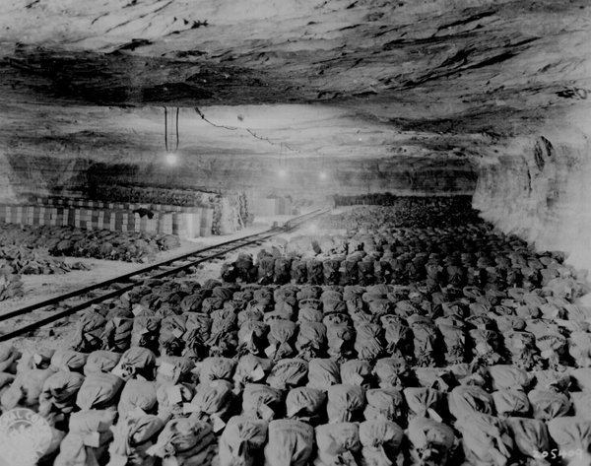
German Reichsbank Underground Gold Storage Vault — Put On Deposit for Bank of International Settlements (BIS) — From Unwanted Publicity Website
By putting the spotlight on Nazi plunder from the very beginning, public attention was diverted away from the industrial scale looting undertaken by Japan’s special plunder teams known as the “Golden Lily.” And it is here that the real story dwells….

Prince Chichibu was the younger brother of Japan’s Emperor Hirohito, and had been named by the Emperor to head the ultra-secret Golden Lily – a secretive group tasked with looting China of its wealth – both government and privately owned hard assets.

Beginning in 1937, with the Rape of Nanking, the plunder teams set to work with a vengeance.

The spoils were far larger than had been imagined. It is believed that 6,000 metric tonnes of gold, plus a bounty of silver and precious gemstones, fell in to the hands of Japan’s imperial treasury as a consequence. [2]

The phenomenal wealth of East and Southeast Asia had accrued over thousands of years — and Japan wanted it all.

Over the next seven years the Orient was wrung dry of its precious metals, solid gold religious artefacts and an unbelievable quantity of gemstones.

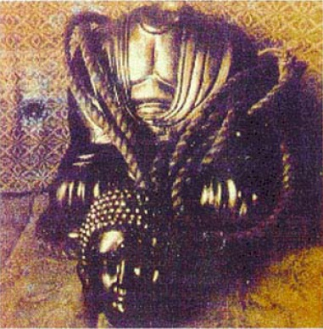

One-Ton Solid Gold Buddha image from Guyatt’s book.
The head unscrewed, revealing a body cavity filled with precious gemstones.

BURIED IN THE PHILIPPINES

As Guyatt’s article goes on — an article that is really just a summary of his impeccably-researched books freely given away on his website — he reveals that the financial value of the confiscated gold was much, much higher than most people would ever believe.

http://www.deepblacklies.co.uk/the_spoils_of_war.htm

Most of this [treasure] was shipped by the Japanese to the Philippines as a collecting point, for onward shipment to Tokyo. However, by 1943 the sea-lanes had been cut by US submarines and the decision was taken to bury the plunder throughout the Philippines….

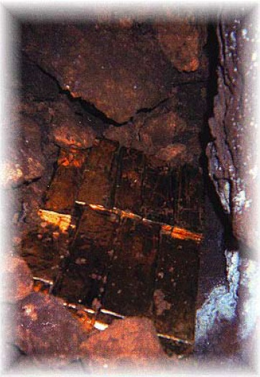

Image of Filipino Buried Gold from Guyatt’s Book

The quantity of gold and other treasures buried was phenomenal. Japanese cartographers made maps of each site and trusted accountants marked them with three digits signifying the Yen values of the gold, diamonds and other assets buried in each.

A site bearing the designation “777” was valued at 777 billion yen. With 1945 exchange rates fluctuating between 3.50 and 4.00 yen to the dollar, just one triple seven site was worth almost US$200 billion – a king’s ransom by any measure.

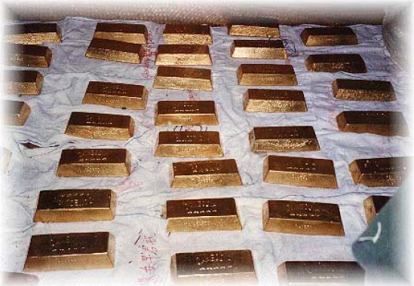

Image of Filipino Buried Gold from Guyatt’s Book

There were many triple seven (“777”) sites as well as triple nine and lesser sites.

Not only were these figures based on 1945 values — when a dollar was really a dollar – but also when the price of gold was $35.00 an ounce.

Today [in 2002,] the price of gold is closer to $300 an ounce. But add to this the fact that in the Philippines alone there were over 170 burial sites, and a picture forms of a wealth so unimaginable that it almost defies belief. [4]

[DW: The price of gold WAS 300 an ounce when David Guyatt published this article in 2002. It is obviously much more than that now. If all this gold becomes publicly acknowledged, the “spot price” of gold will almost certainly plunge.]

IMAGES OF OFF-MARKET THAI GOLD

Not all the gold put on “deposit” with the BIS was buried underground. Some of it was kept in secret storage facilities. Thailand is a great example of a country that did not bury their gold, but chose to keep it above-ground.

Neil Keenan sent me the following images of the Thai gold — which is apparently all registered with the BIS, and not part of the world’s acknowledged, “open” gold supply.
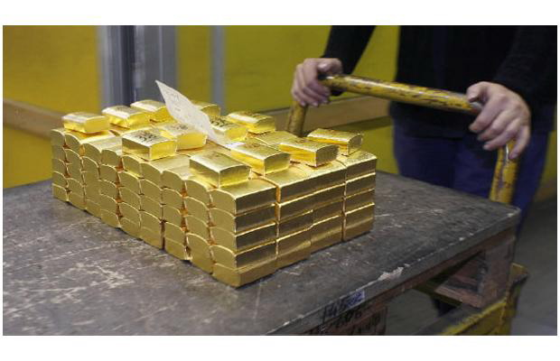

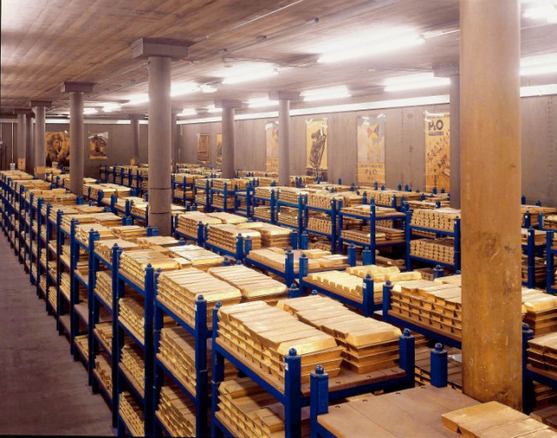
Massive Thailand Gold Storage Warehouse

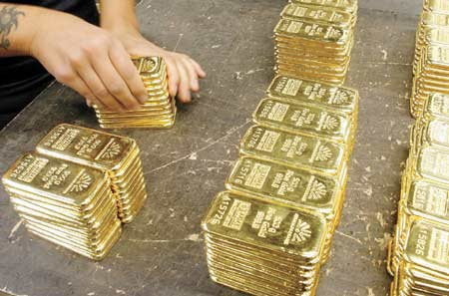
Close-Up View of Thailand Gold Bullion

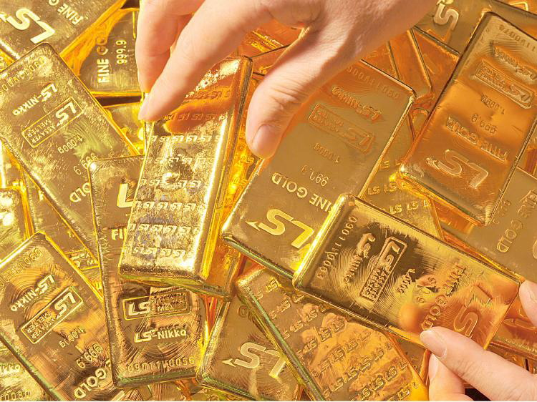
Close-Up of Thailand Gold Bullion Bars, Showing Serial Numbers

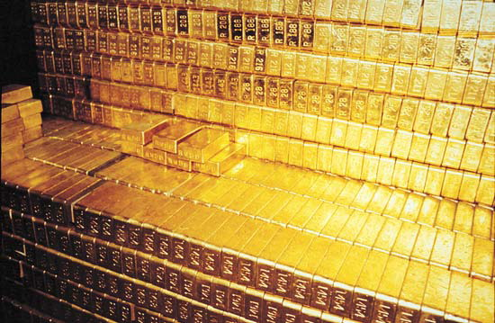
Massive Supply of Thailand Gold Bars

DISINFORMATION DELIVERED IN ONLY FIVE DAYS

Something very curious has happened since we published the above images from within a Thai gold warehouse. It appears that the disinformation engine kicked in immediately.

Sections Five and Six were first posted on Saturday, January 28th. Five days later, on Thursday, February 2nd, the Daily Mail released nearly identical photos — and claimed they were from their own gold depository.

Since then, seemingly innocent readers’ comments have been appearing all over — acting as if this proves the British are telling the truth, and that this one piece of data somehow destroys our vast treasure-trove of evidence.

There were fewer posters on the wall in this picture, yes… but even the camera angle was exactly the same.

http://www.dailymail.co.uk/news/article-2095535/Bank-Englands-glittering-stash-156BN-gold-bars-stored-canteen-London.html

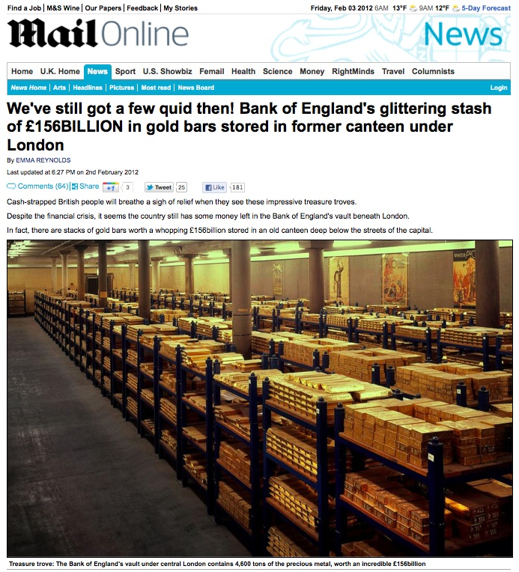

THE EMAIL WAS ORIGINALLY SENT DECEMBER 15TH, 2011
I have deleted my email address and contacts for privacy, but otherwise this is exactly what Neil Keenan sent me on December 15, 2011.
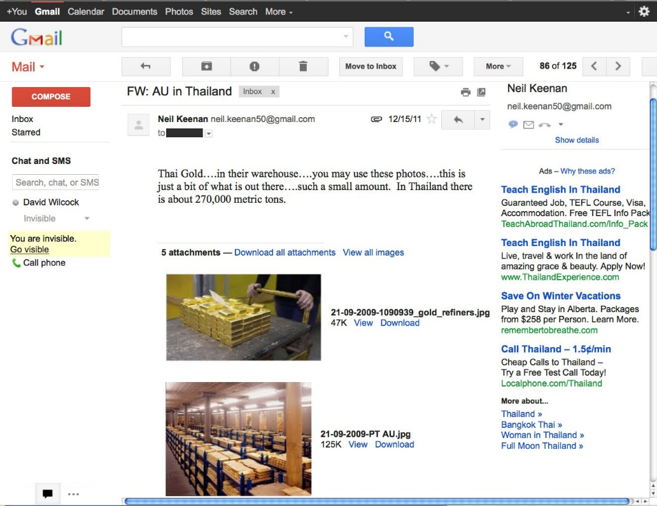

Fox News is now embroiled in an email-hacking conspiracy where celebrities’ emails were hacked in order to provide tips for news stories. Gmail, of course, has absolutely no security — you don’t even have the emails stored on your own machine.

THREE WEEKS LATER…

On January 7, 2012, three weeks after Neil sent me these damning pictures, the Daily Mail published an article that used the exact same camera angle — from within the exact same facility.

In this case, the only difference is there were more posters on the wall.

http://www.dailymail.co.uk/home/moslive/article-2082126/From-river-prospectors-canny-investors-everyones-hunt-gold.html?ITO=1490

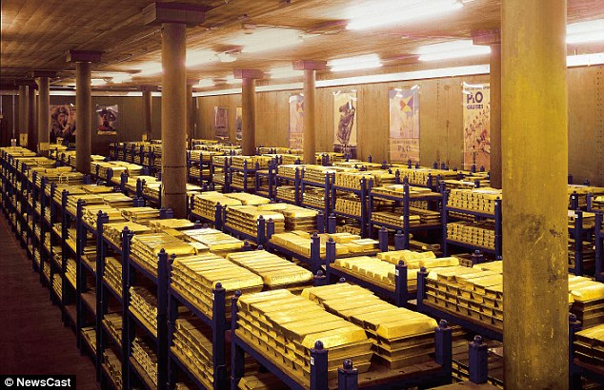

Then, as I said, another article with the same exact camera angle of the same exact facility appeared precisely three weeks later — just five days after I got courageous enough to actually go public with these images.

ALL THE POSTERS ARE FROM THE PENINSULA AND ORIENT CRUISE LINE

Every poster on every wall is an advertisement for the British luxury cruise line Peninsula and Orient, or P&O. This next poster clearly advertises trips to China and Japan. I slightly stretched it in Photoshop to make it easier to see.

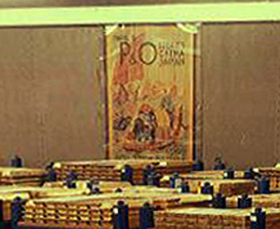

This underground gold storage facility was built with the British in Thailand, back in the 1930s when this all began. The British bankers set it up as a depository for the Bank of International Settlements, or BIS — the international version of the Federal Reserve.

The bankers apparently chose to take a luxury cruise out to Thailand and make it a vacation — rather than flying over, putting them at risk of being shot down on such a sensitive mission.

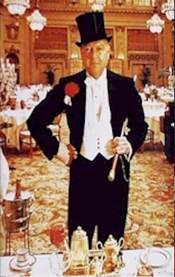

Then, as they left their staterooms and disembarked from the ship, they brought posters with them that were current for the time… namely the 1930s… and hung them up.

THE BEST CRUISE TO THAILAND AVAILABLE… IF NOT THE ONLY

The best cruise line available — and likely the only British cruise line available — was P&O, or Peninsula and Orient.

http://en.wikipedia.org/wiki/P%26O_Cruises

P&O Cruises originates from 1822, with the formation of the Peninsular & Oriental Steam Navigation Company… In 1837, the company won a contract to deliver mail to the Peninsula,^{[2]} with its first mail ship, RMS Don Juan, departing from London on 1 September 1837….

In 1904 the company advertised its first cruise on the 6,000-ton Vectis, a ship specially fitted out for the purpose of carrying 150 first-class passengers. Ten years later the company merged with the British India Steam Navigation Company, leaving the fleet with a total of 197 ships….

A major event in the company’s history took place in December 1918, when P&O purchased 51% of the Orient Steam Navigation Company…

During the 1920s, P&O and Orient Line took delivery of over 20 passenger liners, allowing them to expand their operations once again. Cruises began operating once again in 1925… During 1929, P&O offered 15 cruises, some aboard Viceroy of India, the company’s first turbo-electric ship.

THE POSTERS ARE ALL CORRECT FOR THE 1930s

Thanks to the Internet, we can study all the different eras of P&O Cruises posters, and clearly identify that all of the posters in this facility originated in the 1930s — when all the ‘deposits’ of gold were originally being made.

P&O Cruises – Different Years
http://www.advertisingarchives.co.uk/en/pages/image_map.html?selectedLevels[1]=Magazine%20Advert&selectedLevels[0]=Travel&level=3&search=P+%26+O&page=1

Cruise Line History – P&O Chusan
http://cruiselinehistory.com/?p=4399

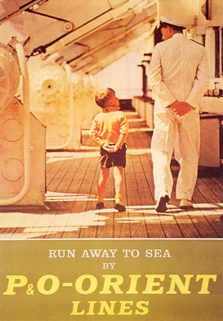

ISN’T IT STRANGE?
Isn’t it strange that on January 7, 2012 — just three weeks after I got the email with these pictures — the Daily Mail would publish an article with almost the exact same image in it?
Isn’t it strange that all the posters on the wall are 1930s-era P&O Cruises posters — even though the posters have been moved around from one Daily Mail article to the next?
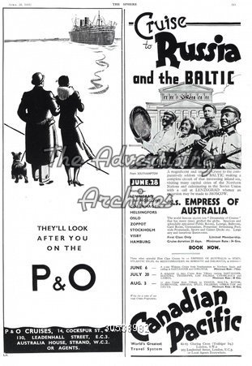
Isn’t it strange that after we first published Section Five, the exact same photograph appeared in yet another Daily Mail article — a mere five days later?
Isn’t it strange that the whole purpose of this new article was to say that this was a British storage facility for gold — with otherwise no ‘story’ to speak of?
Isn’t it strange that every poster in the entire facility would have easily come off of an elite British cruise ship to Thailand in the 1930s — and there are no images of the Queen or any other attempts at decoration whatsoever?

HINTS OF THE INTERNATIONAL ‘DEPOSITS’ AS WELL
Furthermore, in the second Daily Mail article that exposed these pictures, there were some interesting statements at the end.
These statements directly addressed the data we published in this piece about the Bank of International Settlements taking ‘deposits’ from other nations.
http://www.dailymail.co.uk/news/article-2095535/Bank-Englands-glittering-stash-156BN-gold-bars-stored-canteen-London.html
The old-fashioned posters that hang around the room depict sunny climes, luxury cruises and happier times – which may be as welcome a sight as the valuables for many.

Three-foot long keys are needed to unlock to the doors that guard the rooms holding the gold – but sadly not all of it belongs to us.

Some is deposited by foreign governments as well as our own. Different shapes and marks distinguish the varying sources of the wealth.
To me, this is every bit as suspicious as David and Mackie Hutzler dying of gunshot wounds to the head, having their house burned down, and then having the whole thing blamed on David — who was thrilled about the impending defeat of Financial Tyranny.
Even if Neil Keenan and Keith Scott’s contact who sent us these pictures was somehow lying to us — which he definitely does not appear to be — seeing two different articles appear in mainstream media with the exact same picture in such a short time is very suspicious.

THE BLACK EAGLE TRUST

As our excerpt goes on, Guyatt describes how these stolen assets were incorporated into the “Black Eagle Trust” and spread across more than 40 countries — all of whom were signatories of the Bretton Woods agreement.

Again, we’ve now heard from Keenan and Scott that this was all done legally — at least within the hidden charter of the Bank of International Settlements.

http://www.deepblacklies.co.uk/the_spoils_of_war.htm

With the defeat of Japanese forces in the Philippines in 1945, a project of the utmost secrecy was launched to recover the buried Golden Lily plunder.

This project was placed under the day-to-day control of Captain Edward Lansdale and OSS operative Severino Garcia Santa Romana… The CIA would later recruit both officers.

Over the next few years numerous plunder sites were located and the stolen assets recovered. The gold, gemstones and other treasure were deposited in over 170 bank accounts spread across more than forty countries – all of whom were signatories of the 1944 Bretton Woods agreement.

Collectively, the recovered loot came to be known as the Black Eagle Trust or fund.

Even to this day the mere mention of the Black Eagle Fund causes unease, and the entire subject remains cloaked in official secrecy.

For example, during a 1999 discussion on this subject, one highly placed banker familiar with the existence and arrangements of this slush fund cautioned: “if you wish to discuss certain aspects of military program finance on the internet, you may be doing so in contravention of several statutes and regulations, both in the United States and in any NATO-member jurisdiction.”….

According to official figures, the present volume of above ground gold stocks is approximately 142,000 metric tonnes. This, it is claimed, accounts for all the gold mined over six thousand years. [5]

In contrast to these figures, just one of the many “777” Golden Lily sites would have held, using a conservative estimate, upwards of 90,000 metric tonnes. [6]….

TRILATERAL COMMISSION AND “ILLUMINATI”

David Guyatt didn’t know much about the Illuminati when he wrote The Spoils of War in 2002. However, he definitely heard the name from his own insiders.

Specifically, a member of the Trilateral Commission told his wife, on his deathbed, that he had been in a secret society called the Illuminati — and that they had created a fify-year plan to “corner the major part of the world’s gold supply.”

http://www.deepblacklies.co.uk/the_spoils_of_war.htm

…the last word about the involvement of the Trilateral Commission in plundered gold comes from Mr. Goldfinger himself – Severino Garcia Santa Romana.

Prior to his death in 1974, Sta. Romana told his wife that he was a senior member (indeed, he claimed to be the head) of the Trilateral Commission — that he said “controlled world finance.”

He also revealed he was deeply involved with a secret society known as the “Illuminati” which he maintained had set in motion a fifty year plan to “corner the major part of the world’s gold supply.” [41]

It is, of course, impossible to verify this claim.

But it can be no more an outrageous idea than that propounded by Cecil Rhodes for his secret society…

The [British] Minister of Economic Warfare… Lord Selborne… was a member of the top level “circle of initiates” of the secret society formed by South African gold and diamond magnate, Cecil Rhodes – who founded De Beers….

For [these “Illuminati” plans] to succeed, Rhodes wrote in 1891, to his friend W T Stead, would require “…gradually absorbing the wealth of the world…” [42]

Controlling the world’s supply of gold, platinum and diamonds would undoubtedly be one way of achieving this ambition.

THE DOCUMENTS
David Guyatt didn’t just make open-ended claims — he provided leaked documents and photographs to back up what he said.
Some of these documents came from Erick A. San Juan’s book, Marcos Legacy Revisited: Raiders of the Lost Gold. It was published in Makati City, Phillippines, in 1998.
These are just a few of the stunning images you will see when you read “The Secret Gold Treaty”. Notice the Illuminati symbol dominating the top of each document.
In case you can’t read it, the key underlined part of this document says that it provides for “unlimited US-Billion dollars as investment loans” that are backed up by 62,325 metric tons, “or more”, of gold bars held in the Phillippines.
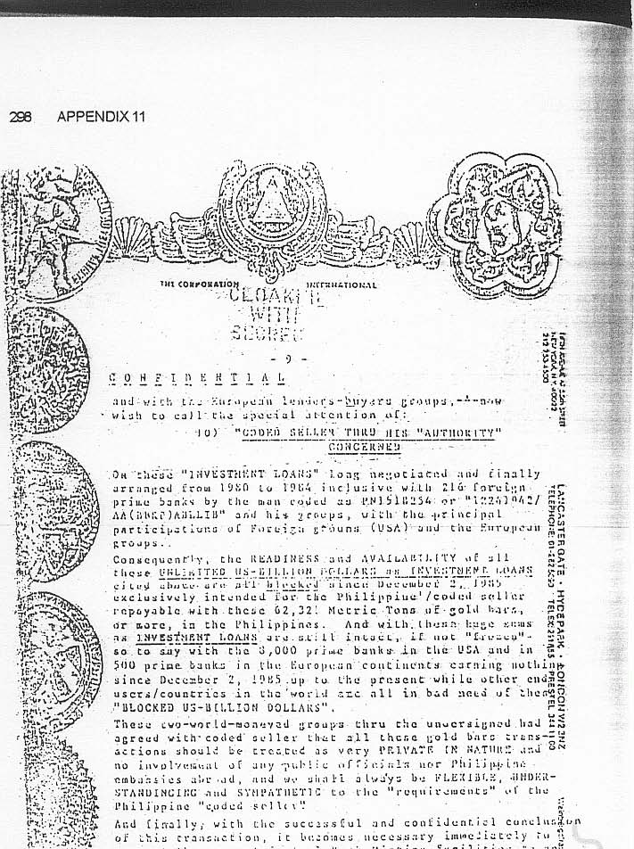

This next document has the best-quality capture of the bizarre seals we see on the above document — including the Illuminati symbol from the obverse side of the Great Seal of the United States.
It is very likely that these seals represent each of the main “banking families” in the Federal Reserve / BIS.
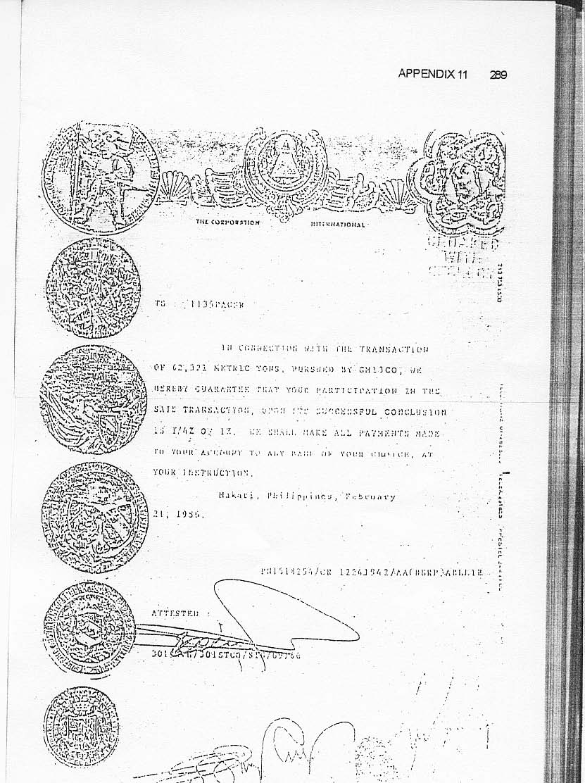

Lastly, this next image gives us the sharpest view of the Great Seal of the United States in its stylized form at the top and center of the document. As we can see, a circular area around the Eye has been cleared away.
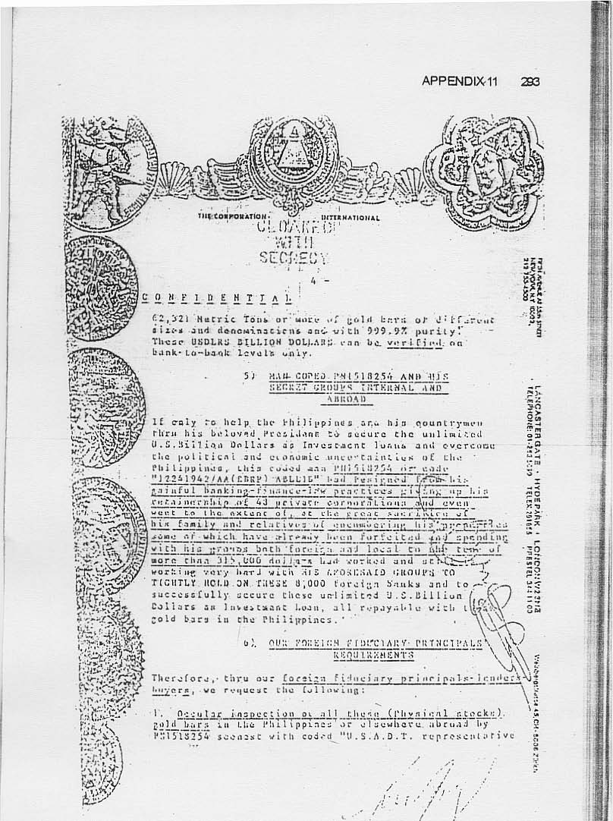

ADDITIONAL ILLUMINATI DOCUMENTS FROM LEO ZAGAMI
I followed Leo Zagami’s career closely when he first went public in 2006 with the Illuminati Confessions website. The content can now all be found at http://www.leozagami.com/confessions/.
I also spoke to Leo once or twice over Skype — and applauded him for his bravery in going public with his story.
Though he is named in the Keenan lawsuit, he is not directly charged. Zagami did numerous radio interviews with Greg Szymanski and also conducted video interviews with Project Camelot and Benjamin Fulford.
Leo’s involvement with Benjamin Fulford ultimately led to a deal that was supposed to help free up the bonds from the former Chinese ruling party, the Kuomintang. These bonds are now at the center of the trillion-dollar lawsuit.
Thanks to a connection faciliated by Leo Zagami, Mr. Daniele Dal Bosco ended up with Neil Keenan’s bonds, which had a face value totaling 144.5 billion dollars.
The Kuomintang had signed over control of these bonds to Neil Keenan in the hopes of getting them freed up — in order to help end Financial Tyranny.
Dal Bosco then stole the bonds. There is no direct evidence that Zagami was involved with this theft, or benefitted from it in any way. It will be interesting to hear his side of things if / when this case goes to trial.
Admittedly, Leo’s thick Italian accent and very fast conversational speed makes it hard for most English-speaking listeners to follow him. The Project Camelot transcripts allow you to follow everything in his interview.

BREAKING AWAY
Zagami has said he represents the younger generation that is ready to break away from the old traditions and start fresh, in a manner that will more directly benefit humanity.
When Zagami’s website first came out, he published photographs of himself with many top Illuminati people. Some of them are still available, while others are broken links that still need to be repaired after the transfer of the site to a new server.
Zagami also released pictures of documents he received as he attained various high-level Illuminati degrees.
This is another rare glimpse at what are very likely real Illuminati documents. We can see that the Illuminati degrees now go well above 33.
This first document lists a 90th degree, 95th degree and 97th degree. The rite itself appears to have been created as of March 8, 1997.
The top of the document seems to feature the Four Beasts of the Apocalypse — flanked by winged beings with cloven hoof feet.
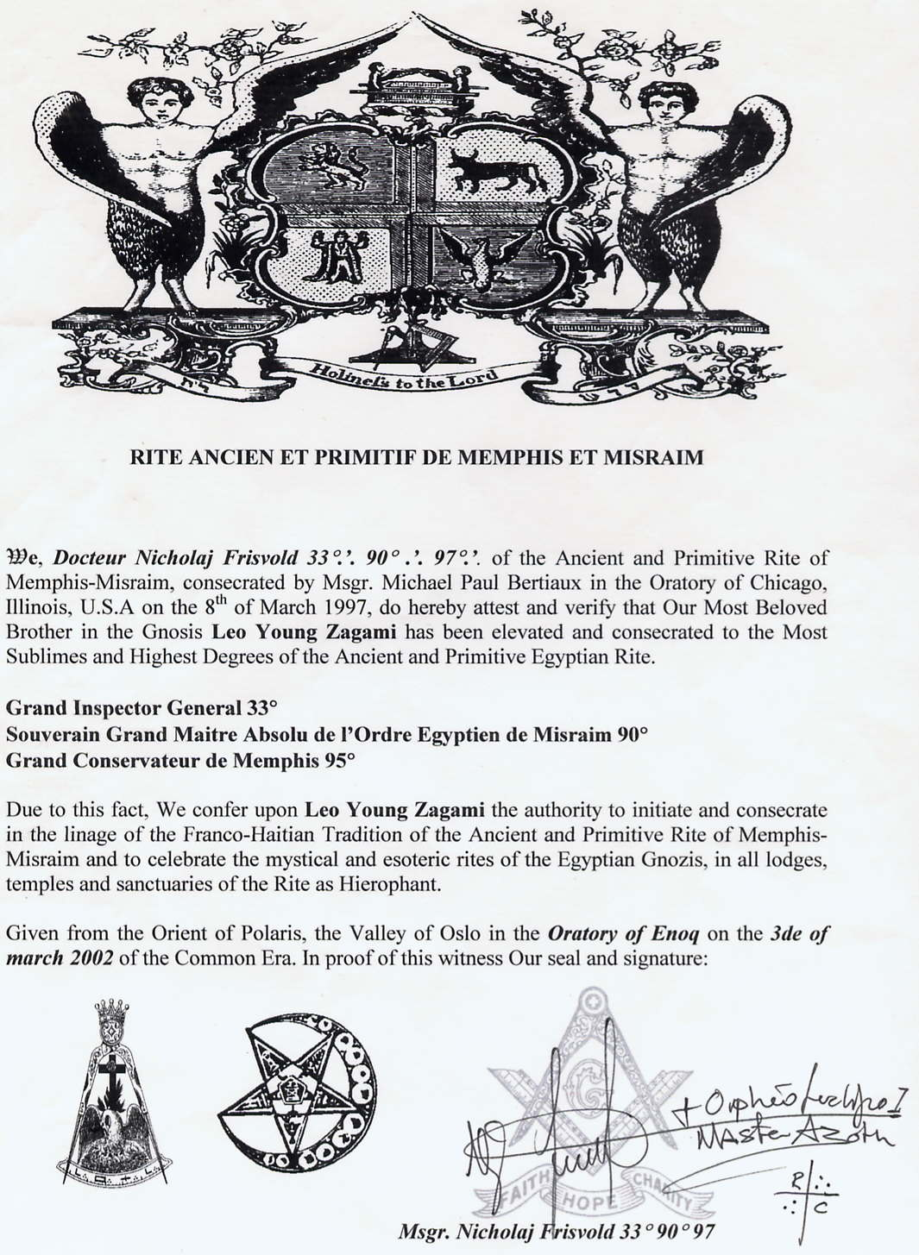

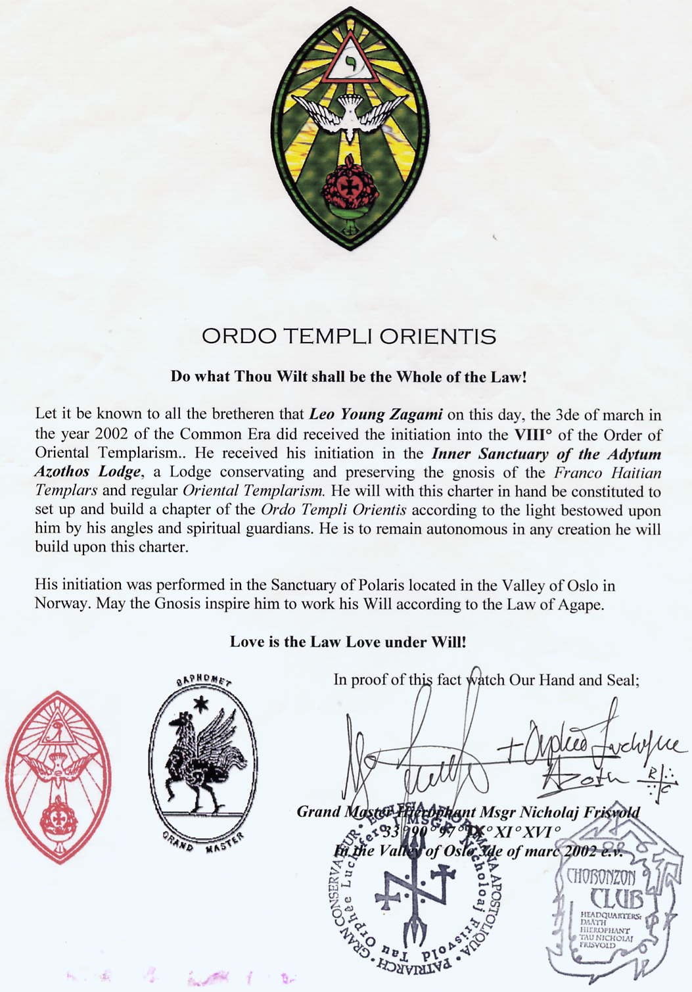
[Notice the phrase “Tau Orphee Luchifero” inside the circular seal. The word “angels” appears to have been deliberately misspelled as “angles” due to the Masonic obsession with geometry.]

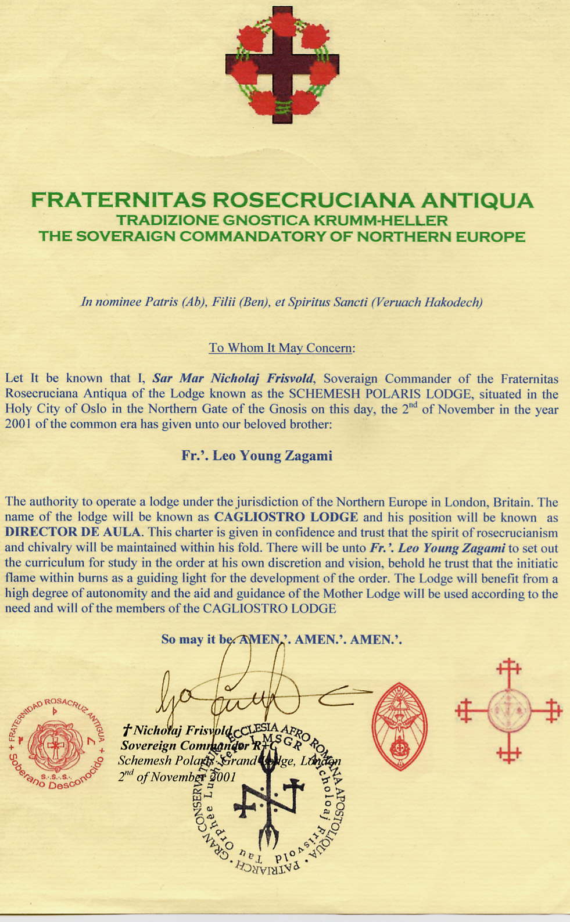

DISTURBING IMAGES FROM WITHIN A RITUAL SITE
One of the very first posts Zagami made on his new website, at the time, also featured this disturbing image of a mosaic made out of human bones nailed to a wall.
These bones may not have been from fake medical skeletons. It is possible that they were obtained from humans who had been sacrificed.
This mosaic appeared directly next to a discussion Leo wrote up about the P2 Masonic Lodge in Italy.
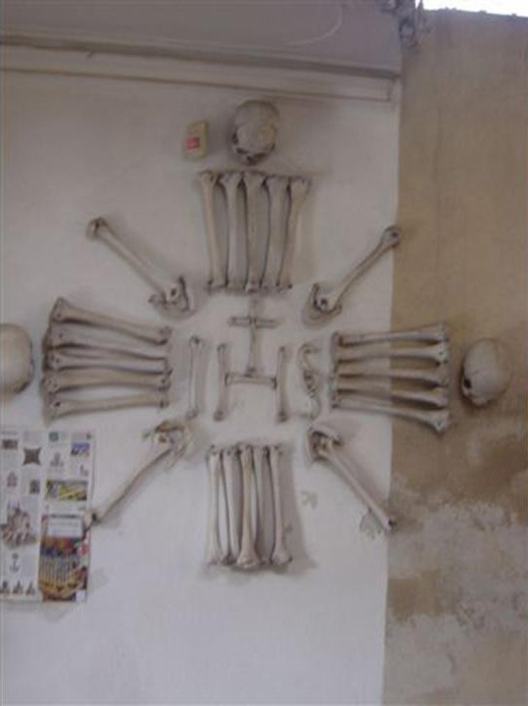

ANOTHER EXAMPLE THAT IS EVEN LARGER
This page features an even larger example of mosaic “bone-work”, fashioned into a crucifix — apparently inside a high-level Illuminati facility. We can see that the bone-work is very elaborate — and continues well outside the frame of the photograph.
It is very important to note that Leo did not announce either of these photographs with any large-scale fanfare. He just randomly tossed them onto his page.
Even if they are made with plastic bones, someone obviously went to a great deal of trouble to make these designs.
If Leo had done this as a “fake,” then why did he only publish this one picture, without even really mentioning it — when clearly there is much more to see outside the visible frame?
I know this is unpleasant to look at, but this is one case where a picture truly is worth a thousand words.
Thick, visible dust has gathered on the tops of the skulls, as we see here. They clearly have been nailed up to the wall for some time.
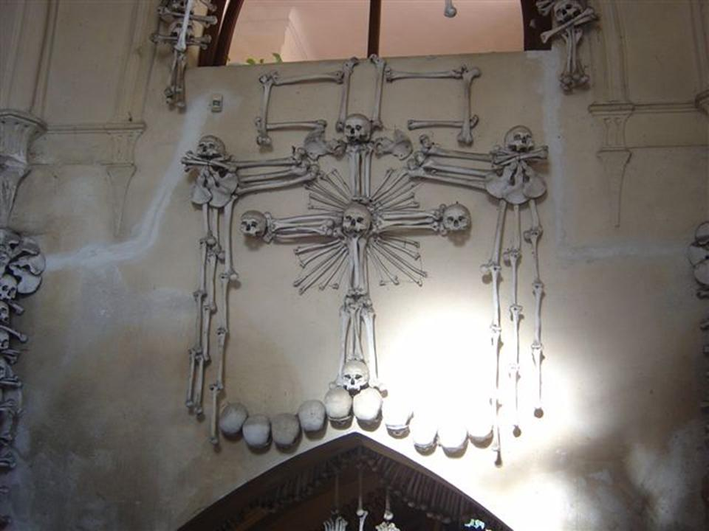

SYMBOL OF THE JESUITS IN BONE
A comment came in on these disturbing images that is worth sharing. The first image, as it turns out, is actually a Jesuit / Christian symbol as well.
Author: Arend Lammertink
Email: [REDACTED]
Comment:
The “image of a mosaic made out of human bones nailed to a wall” has remarkable resemblance to the logo of the Jesuits:



http://en.wikipedia.org/wiki/Society_of_Jesus

The Society of Jesus (Latin: Societas Iesu, S.J., SJ, or SI) is a Catholic male religious order that follows the teachings of the Catholic Church.

The members are called Jesuits, and are also known colloquially as “God’s Marines”[2] and as “The Company,” these being references to founder Ignatius of Loyola’s military background and members’ willingness to accept orders anywhere in the world and live in extreme conditions.

It reads “IHS”, which in public explanation refers to the holy name of Jesus:

http://en.wikipedia.org/wiki/Holy_Name_of_Jesus

In Christianity, the Holy Name of Jesus refers to the theological and devotional use of the name of Jesus. The reverence and affection with which Christians have regarded the Holy Name of Jesus goes back to the earliest days of Christianity.[1]

And you can find this same logo atop the main altar, Church of the Gesù, Rome, for example:

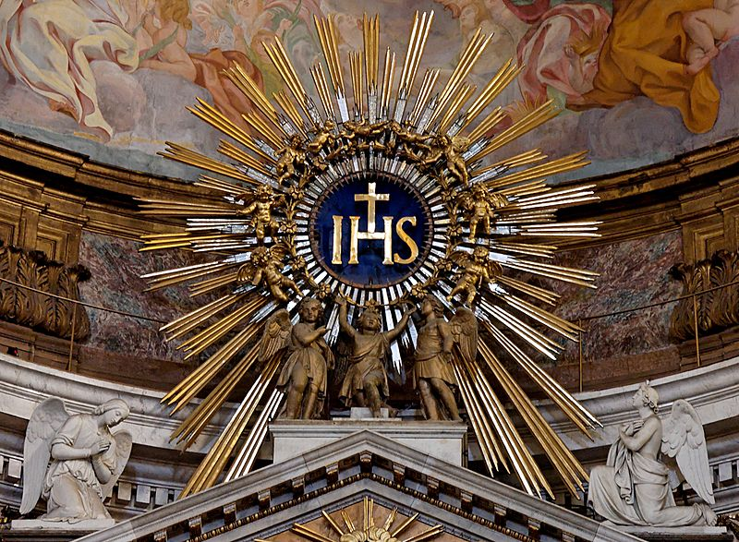

In reality, IHS refers to the Egyptian Gods Isis Horus Seb:

http://www.sabbathcovenant.com/IHS.htm

Pagan Rome worshipped Isis, Horus, and Seb. The round disk wafer IHS symbol of Isis, Horus, Seb, was eaten as food for the soul.

This was integrated into Christianity as The wafer used in the eucharist is round with IHS engraved on it. And this pagan Trinity of Isis, Horus, Seb was represented by IHS which was then made the Christogram for Jesus Christ.

http://www.godlikeproductions.com/forum1/message772711/pg1

Sun worship dominated Egypt. Egyptian priests practiced “transubstantiation”, claiming to be able to transfer the sun god Osiris into a circular wafer.

In rituals prefiguring Catholic Mass, the faithful then ate the “body” of their god to nourish their souls.

The letters IHS on the sun-shaped wafers stood for Isis, Horus, Seb (later, Roman Catholics claimed they were the first three letters of Jesus’ name in Greek)….

At any case, it is clear that the picture with the bones has little to do with “Iesus Hominum Salvator”, that’s for sure…

UPDATE 2/5/12: THESE IMAGES ARE FROM A ROMAN CATHOLIC CHAPEL!

I must admit that finding such gruesome images on an Illuminati whistleblower’s website was quite a shock.

What has now become even more of a shock is that anyone can go to visit this site. It is not secret and not closed to the public — and those are all real human bones.

However, the GREATEST shock is that this is the entrance to a Roman Catholic chapel known as Sedlec Ossuary — in the Czech Republic.

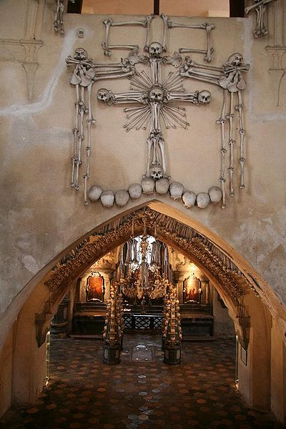

http://en.wikipedia.org/wiki/Sedlec_Ossuary

The Sedlec Ossuary (Czech: kostnice Sedlec) is a small Roman Catholic chapel, located beneath the Cemetery Church of All Saints (Czech: Hřbitovní kostel Všech Svatých) in Sedlec, a suburb of Kutná Hora in the Czech Republic.

The ossuary is estimated to contain the skeletons of between 40,000 and 70,000 people, many of whom have had their bones artistically arranged to form decorations and furnishings for the chapel. The ossuary is among the most visited tourist attractions of the Czech Republic, attracting over 200,000 visitors yearly….

In 1870, František Rint, a woodcarver, was employed by the Schwarzenberg family to put the bone heaps into order. The macabre result of his effort speaks for itself. Four enormous bell-shaped mounds occupy the corners of the chapel.

An enormous chandelier of bones, which contains at least one of every bone in the human body, hangs from the center of the nave with garlands of skulls draping the vault.

Other works include piers and monstrances flanking the altar, a large Schwarzenberg coat-of-arms, and the signature of Rint, also executed in bone, on the wall near the entrance.

COAT OF ARMS HAS 32ND DEGREE MASONIC CROWN IN IT

The Sedlec Ossuary features the Schwarzenberg coat-of-arms, which has a curiously familiar crown on top.

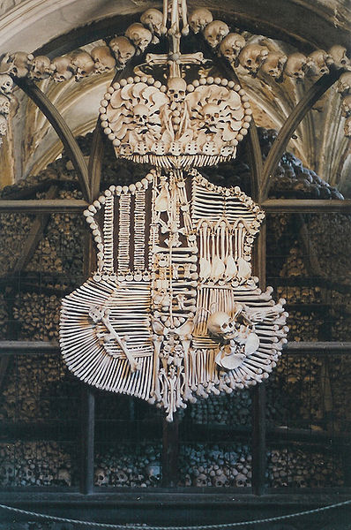

Now look at the top portion of the 32nd-degree Masonic sash.

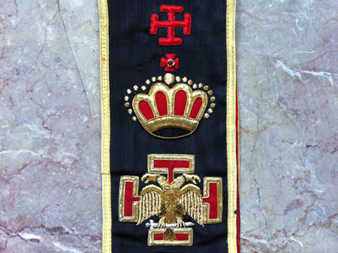

Here is a side-by-side view of the two of them together. There is a remarkable similarity in the design, as you can see.

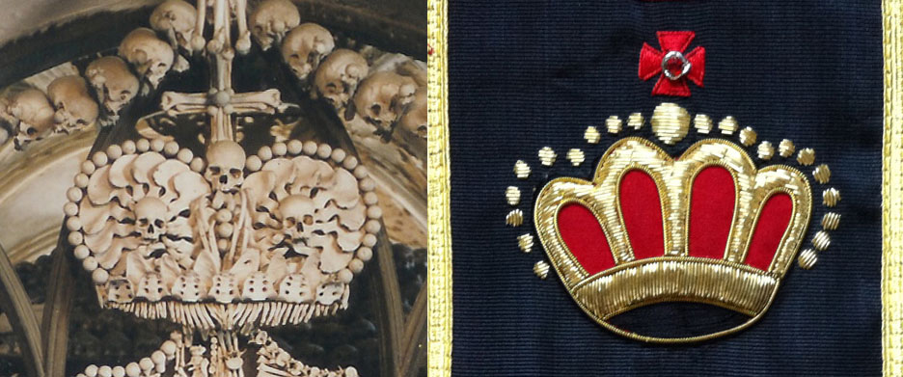

WITH TRUTH COMES FREEDOM

The Sedlec Ossuary is a classic example of the principle of “hiding it out in the open.”

The evidence is overwhelming that the Illuminati really do exist — and are involved in occult ritual magic practices.

Though many of their members strongly disagree with the group and its rigorous control, they have thus far been powerless to escape this living hell.

I look forward to a day where they can come forward and share their experiences — so we can all heal together as a planet.

Directly and indirectly, depending on the situation, I was approached by this group and offered fantastic riches for very little up-front investment.

Now that my life has been threatened, I have nothing to lose by telling you exactly what I was offered — and how it works.

CLICK HERE FOR SECTION SIX: THE ULTIMATE PONZI SCHEME

HOW TO BECOME A MULTI-MILLIONAIRE FOR LESS THAN TEN THOUSAND DOLLARS — IN MONTHS
If you haven’t studied the previous five sections of this stunning investigation, what you are about to read will seem impossible.
You may laugh in disbelief and fire off searing comments — telling me I’m crazy.
Go ahead… but I’m going to tell the truth anyway for those who will listen.
The bonds we have now seen from four different sources are used to underwrite a covert economic system — run by the Federal Reserve and its global equivalent, the Bank of International Settlements or BIS.

This system is backed by massive quantities of gold that were seized from countries all throughout the world, beginning with a secret agreement in 1921 — slightly over seven years after the founding of the Federal Reserve.

World leaders were given worthless bonds — in astronomical denominations — in exchange for massive quantities of gold. They want their gold back — but it is being kept from them with deadly force.

PROFITING FROM THE ‘COVERT’ ECONOMY

An incredibly massive ‘covert’ economy has since been created. Insiders are told this economy is backed by the massive quantities of gold on ‘deposit’ with the BIS.

The dollar values in this covert system are much larger than anything in the open world.

Yet, you can deal in this system, pull profits out of it and use them in the open world.

Could you spend, say, $7,500 dollars and end up with millions of dollars in profits in just a few months?

Yes. Absolutely.

(These programs have apparently now been shut down, according to Fulford and Scott, but a small number of top insiders are apparently still using it.)

Let me make myself clear. This system does exist. More importantly, it is 100-percent LEGAL. The key to whether you can actually get into it and use it is all about who you know.

Due to my public position and the wide variety of contacts I have made with insiders who have access to highly compartmentalized top-secret programs, I was offered several ways in which I could have done this.

Given what we have learned in this investigation, I now consider this to be the Ultimate Ponzi Scheme — custom-made to destroy the legitimate world economy.

NEVER, EVER TALK!

Multiple individuals have explained this system to me, beginning in 2007, and offered to help get me in. Each one of them threatened me to never, ever talk about this, or else government agents would come knocking at my door.

If all these fine gentlemen did was give me a “friendly chat,” I would be quite fortunate.

Nonetheless, Truth and Full Disclosure is now my best protection.

Many groups are standing behind me and protecting me — so that I may reveal all of this publicly, in one place, for the first time.

By writing this, it also paves the way for many, many others to come forward about their involvement with this system, now that none of it is a secret anymore.

There have already been at least four different people who have emailed me with their stories — and I’m sure there will be many more.

I have spoken to others in my field who have had similar financial offers extended to them, including Benjamin Fulford.

I do not have clearance from any of the others to reveal their names at this time.

I DID GIVE IT SERIOUS CONSIDERATION

More than once I have been faced with the question of whether or not to do this. I did give it serious consideration, as the funds could have been used to dramatically assist and expand the work I’m doing in many different ways.

The idea of helping to design humanitarian relief funds appealed to me. I am sure I could create many valuable methods for significantly alleviating human suffering if I had the access.

The rationale I was being asked to consider was that if this system exists, and it is legal, why not get involved to help direct it towards a more positive purpose — such as expanding the outreach of what I can do with my work?

I ultimately saw all of this as a great temptation that I needed to avoid completely.

Those who extended me the lines of credit and who held these accounts in my name could have used this as leverage to damage me very significantly.

I could have started out with a reasonably small investment and ended up being held liable for millions of dollars of debt.

I also could be savagely outed in public as a financial conspirator who had embezzled millions and millions of dollars.

I DON’T WISH TO ATTACK ANYONE

I do not wish to attack, accuse or impugn the entities I will be discussing, as their full contact information is on the Internet.

Let me say again that what they are doing does not violate any laws.

You do not need more than 10-50 thousand dollars to get into this system, depending on how you do it.

What I will reveal is enough for you to potentially get involved in this system if you have the basic starter capital — but again, most of it has apparently now been terminated.

Obviously, I do not recommend trying to do this.

I also want to make it abundantly clear that I will not offer help to anyone who wishes further assistance on how to get involved in this… nor will I even reply to such queries.

I myself have not done it — and have no intention to. We cannot solve Financial Tyranny by joining the very system that allows it to continue.

My work is 100-percent financed by clean, above-board, open-economy public money from people like you, ordering our downloadable products and conference tickets.

Nonetheless, I will show you how this system works.

I will begin by sharing my own personal introduction into this world as a result of my efforts to finance my Hollywood film CONVERGENCE, which is still not funded yet — but we are getting very close to doing it the right way.

MY FIRST EXPOSURE TO THIS SYSTEM
The first time I heard about this system was in 2007. I went to a meeting of movers and shakers from the entertainment industry at a private residence in Malibu, and was particularly impressed by one individual who wanted to start a concert to promote world peace.

I approached this person at the event and let him know who I was, and the film I was working on. We had some written and telephone exchanges after that.

Somehow, I was fortunate enough to have him and his partner invite me to their next meeting with their financier.

The meeting took place at the Casa Del Mar, a posh hotel / restaurant with valet parking on the waterfront of Santa Monica. Everything inside was very high ceilings, Victorian furniture and decor, and affluent-looking people.

The menu was competitively priced with most other restaurants in the area, which surprised me.



I saw Jennifer Garner, the actress, sitting at a neighboring table when I went into the main area to order food. We made eye contact but I did not bother her.

We also saw the CEO of a major Internet corporation arrive with two stunning Asian women in matching bikinis — one white and one yellow — both of whom had the same hair, the same sunglasses and the same gigantic breasts.



This is the closest matching picture I could find, regarding the way they both looked and the bikini style they had on — except for the color, and the fact that they were both wearing sunglasses.

Imagine seeing two women looking this amazing on either arm of this gray haired man — walking proudly through the middle of this posh restaurant!

Well, there I was… but things were about to get even more interesting.

THE FINANCIER ARRIVES

I sat with my new contact and his business partner in the dining area and ordered food. He wanted to be there well in advance of when the financier arrived so we wouldn’t miss him.

Eventually the financier showed up. We paid for the meal and left the dining area, retiring to a table in the far corner of a huge lounge closer to the entrance.

The financier had a blood-red snakeskin leather briefcase and a curious gold necklace in which a crucifix was outlined in gold. The edges of the crucifix had stylized circular “bumps” on them.

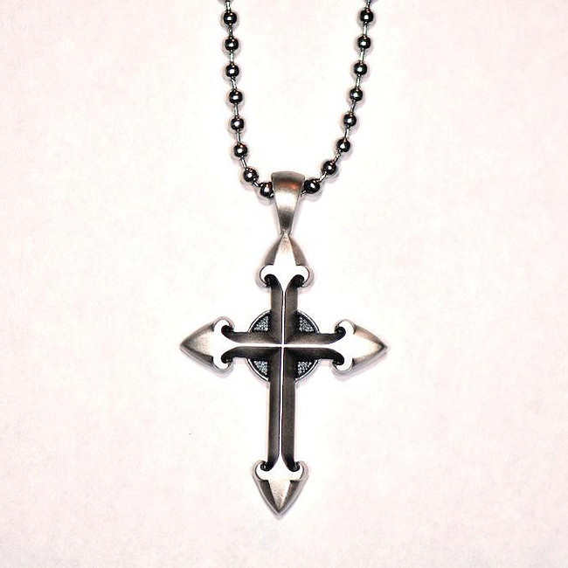

This necklace is about as close as I could find to what the general shape was like.

However, what I saw was just a line of gold that outlined this shape — a cross with circular “bumps” on each edge — without the circular area around the center.

When I commented that this was a Templar cross, he seemed happily surprised — and told me that he was, indeed, a Templar.

Right away I knew I had gotten myself into a very, very interesting situation.

“TRILLIONS AND TRILLIONS AND TRILLIONS AND TRILLIONS AND TRILLIONS OF DOLLARS”

Before long, we got down to talking business.

This was the first time that the financier had explained to these guys how the system really worked. I was very lucky to be there and be able to hear what he said.

Before long, I was asking such intelligent and pointed questions that the other two guys acted like I was the boss.

The financier told us how he first found out about this vast, hidden economic system.

The gist of the story was that a business associate told him money is not at all scarce in the world — if you know the right people.

In fact, his insider told him there were “trillions and trillions and trillions and trillions and trillions” of dollars available. You just have to know where it is and how to access it.

At least two or three different times, he stressed the fact that his insider repeated the word “trillions” five times in a row.

ONLY FROM THE INTEREST — NEVER THE PRINCIPAL

I didn’t understand it at the time, but I was told that any money you get out of this system will only come from interest payments.

You can never touch the principal that is held in your name — for however long it takes to generate the interest.

If you have a film that you want to get made that costs 100M, (you never say the words “million” or “billion” out loud, even on the phone,) a bank will move a certain amount of principal into a separate account for you.

The money stays in this account, in your name, long enough to generate the interest necessary to finance your project.

Depending on the size of the principal, 100M could be generated in less than a month — sometimes only in days.

At the time, the CONVERGENCE budget was hopefully going to be less than 5M — whereas now we’re looking at a larger figure to do it right.

The financier told me it would be “very easy” to generate this kind of money — and almost laughingly dismissed it.

“Why do a film for 5M when you could just as easily do one for 100?”

“Well, we want the film to make a profit,” I answered.

“But you don’t ever have to pay it back!”

He smiled — as if to say, “Do you get it?”

IF YOU PRESENT THE CERTIFICATE, THEY WILL RIP IT UP

The financier told me I would receive a certificate for the principal that would be held in my name.

However, if I went to the issuing bank and handed it to them, wanting to redeem the balance in “my” account, they would rip it up — and I could even be arrested.

Instead, I would let the money rest in the account until the proper amount of interest was generated.

Then, I was told that “a foundation such as one of many Rockefeller entities” would pay me in the form of a grant.

I was told that once I got this money, it was mine. I did not have to pay it back. There would be no further strings. It was that simple.

(Of course, the truth is that nothing is free and nothing is easy.

At the very least, we would have ended up with a “script consultant” who would have steered the message of our film into something that fitted their agenda.)

EVERYTHING CHECKED OUT

Documents were provided from the blood-red snakeskin briefcase that seemed stunningly credible.

The financier said “I’m not supposed to have these” and seemed nervous to show them to us — but I did get to see them and handle them.

I couldn’t help but ask the financier the names of the banking families involved in this.

I went through the laundry list of Illuminati family names as seen in Fritz Springmeier’s books: “Astor, Bundy, Collins, DuPont, Morgan, Rockefeller, Rothschild, Warburg, Van Duyn…”

He was quite surprised and impressed at how much I knew. He confirmed that every single name I mentioned was part of this financial system.

I also asked him if he was familiar with Leo Wanta, a name I’d heard in many articles from Sherman Skolnick.

He again was surprised, and said that this group had worked with Wanta in the past but there had been a falling out.

“DO YOU REALIZE WHAT THIS IS?”

I’ve never been shy. The curiosity was killing me.

So, I took a great risk and started asking the financier more pointed questions.

“Let me ask you this. Have you ever heard of the Illuminati?”

“No,” he answered. “Why?”

“All the names you just mentioned are apparently part of a spiritual group that practices a particular faith.

“And it’s not Christianity.

“It’s based on the teachings of the world’s most ancient mystery schools. Really interesting stuff.”

The man completely and genuinely seemed ignorant of the fact that the people he was working for had any spiritual philosophy.

SVALI CONFIRMS FOUR LEVELS OF SECRECY

Illuminati whistleblower Svali confirmed that there will be about four levels between the real insiders and the “handshake” where the money is transferred.

The people at these lower levels genuinely do not know who they are working for, or what they believe.

In this excerpt she is talking about other types of business, but the same principles always apply.

http://web.archive.org/web/20030808142923/http://www.centrexnews.com/columnists/svali/2000/10/chapter01.html

Drug running: The Illuminati linked up with the Mafia and the Columbians, years ago, to help each other out with bringing drugs into the United States. They also provide couriers for taking drugs and money out of the States.

The Illuminists are generally wealthy businessmen who have 4 layers of people underneath them. The fourth layer down actually has contact with the people in the drug industry.

They never identify themselves as Illuminists; only as people interested in investing, with a guaranteed profit, and are highly secretive….

Banking: The original Illuminists were bankers, and they have highly trained financiers to organize their money, and funnel the above illicit funds into more “respectable” front groups/organizations.

They will also start benevolent charities, community organizations, etc., as fronts, and funnel the money from a broad base into these groups.

The Illuminati particularly pride themselves on their money making and manipulation skills, and their ability to cover their paper trails expertly, through layer after layer.

All banking trails eventually will lead to Belgium, the Illuminati financial center for the world.

They have a lot of financial resources backing their enterprises, which means that in reality they can engage the best lawyers, accountants, etc. to help cover their trail as well.

MORE RECENT INFORMATION

I do not wish to cause harm to any of my contacts, so I am not going to drop hints or go into specifics about how I learned the rest of this information. Nor do I wish to harm the companies running the websites we will be looking at.

The important point is that this information is all entirely provable.

I can talk about this insider world, in which people carry much greater balances than in the open economy, but the best way to make you aware of it is to show you exactly how and where to get involved.

Bear in mind that it is still almost impossible to succeed in this program if you don’t have support from the inside — so I have heard.

Furthermore, the vast majority of people who were doing this “trading” have now been weeded out, and Keith Scott has said the total number is now down to only about 200.

STEP ONE: BUY A SHELF CORPORATION

I want to be clear that there are several different ways to build yourself into this program without spending a tremendous amount of money. However, the purchase of one or more “shelf corporations” appears to be the most popular way.

Put simply, you can buy a company that was created years ago, has filed tax returns and annual statements, and is legally real. You then gain all the benefits of that company.

This can instantaneously transform your credit rating from being in the dumps to being absolutely sterling. Apparently some newly-minted celebrities do this in order to rebuild their credit.

Now that you are the head of an aged corporation, you can then get banks to offer you a line of credit against it — with dollar values much higher than you might imagine.

It is important that the management of the corporation does not appear to have changed hands — otherwise it will be “re-aged” to the time you acquired it, and its credit value will thereby plummet.

The best shelf corporation to buy is an “aged” corporation that has a 10 to 14-year history, as this will insure the largest credit lines. The value decreases when you go over 14 years or under 10.

THE WIKIPEDIA ENTRY ON SHELF CORPORATIONS

http://en.wikipedia.org/wiki/Shelf_corporation

A shelf corporation, shelf company, or aged corporation, is a company or corporation that has had no activity. It was created and left with no activity — metaphorically put on the “shelf” to “age”.

The company can then be sold to a person or group of persons who wish to start a company without going through all the procedures of creating a new one.

Common reasons for buying a shelf corporation include:

* To save the time involved in taking the steps to create a new corporation.
* To gain the opportunity to bid on contracts. Some jurisdictions require that a company be in business for a certain length of time to have this ability.
* To show corporate longevity in order to attract consumers or investors.
* To gain access to corporate credit.

These reasons are open to criticism. Many years ago, it would take months to properly incorporate a business. However, it is now quite easy, at least in Australia, Canada, the United States and Western Europe, to do so.

In fact, it can now be done in as little as a couple of hours in some jurisdictions….

A Reuters report described Wyoming Corporate Services as an example of a vendor of shelf companies, which were literally stored in mailboxes labelled as “corporate suites” in the main room of a 1,700-square-foot (160 m²) brick house a few blocks from the Wyoming State Capitol.

Over 700 companies were available at prices depending on their age, ranging from $5,995 for a six-year-old company to $645 for one recently created.

It is one of scores of similar businesses setting up shop, primarily in Delaware, Wyoming, and Nevada due to regulatory considerations.^{[1]}

One item to be aware of is the re-aging of the shelf corporation. If the credit bureaus learn about the company being under new management, they will list it on their reports, effectively “re-aging” the company.

THE REUTERS REPORTS ON SHELF CORPORATIONS

Reuters has already blown the lid off of this business — it just hasn’t gained any widespread exposure, because hardly anyone knew about this to begin with.

There are two articles to read — A Little House of Secrets on the Great Plains and How Two Shell Companies Duped the Pentagon.

There is also a very fascinating video to watch — U.S. house on the prairie where corporate secrecy thrives — but it cannot be embedded.

IT’S A BOOMING BUSINESS

This first Reuters excerpt reveals how easy it is to buy one of these companies — and conceal your ownership. A “shell” company allows you to hide your identity. Shelf corporations are one type of shell company.

http://www.reuters.com/article/2011/06/28/us-usa-shell-companies-idUSTRE75R20Z20110628

A growing niche in the shell business is shelf corporations.

Like paper-only shells, which enable the secrecy-minded to hide real ownership of assets, shelf companies are set up by firms like Wyoming Corporate Services — then left “on the shelf” to season for years.

They’re then sold later to owners looking for a quick way to secure bank loans, bid on contracts, and project financial stability.

To speed up business activity, shelf corporations can often be purchased with established bank accounts, credit histories and tax returns filed with the Internal Revenue Service.

“They just slot in your names, and you walk away with the company. Presto!” says Daniel E. Karson, executive managing director at investigative firm Kroll Inc. “The purpose is to conceal ownership.”

On its website, Wyoming Corporate Services currently lists more than 700 shelf companies for sale in 37 states. The older they are, the more expensive, like Scotch whisky.

Brookside Management Inc., formed in December 2004, sells for $5,995, while Knotty Management LLC, formed in May, costs just $645. In Delaware, incorporator Harvard Business Services markets First Family LLC, created in May 1997, for $10,000.

“If they’re signing a large contract, they may not want it to look like they’ve just formed a company,” said Brett Melson, director of U.S. sales at Harvard Business Services.

But he added: “Unsavory characters can do a lot of bad things with the companies.”

THE U.S. IS BREAKING THE RULES

This next excerpt shows us how the U.S. has allowed this system to proliferate without any real legal oversight.

http://www.reuters.com/article/2011/06/28/us-usa-shell-companies-idUSTRE75R20Z20110628

The loopholes in U.S. disclosure of bank-account and shell-company ownership have drawn fire.

The U.S. was declared “non-compliant” in four out of 40 categories monitored by the Financial Action Task Force, an international group fighting money laundering and terrorism finance, in a 2006 evaluation report, its most recent.

Two of those ratings relate to scant information collected on the owners of corporations. The task force named Wyoming, Nevada and Delaware as secrecy havens.

Only three states – Alaska, Arizona and Montana – require regular disclosure of corporate shareholders in some form, according to the 2009 report by the National Association of Secretaries of State.

Some lawmakers want tighter rules.

Senator Carl Levin (D-Mich.), chairman of the Senate Homeland Security Committee’s Permanent Subcommittee for Investigations, has introduced the Incorporation Transparency and Law Enforcement Assistance Act each year since 2008.

The bill would require states to obtain and update information about the real owners of companies, and impose civil and criminal sanctions for filing false information.

“Criminals use U.S. shell companies to commit financial fraud, drug trafficking, even terrorist financing, in part because our states don’t require anyone to name the owners of the companies they form,” Levin said in an email to Reuters.

The bill has been beaten back by a coalition of state officials and business groups, citing concerns about the cost of implementing the new law and federal government infringement on state incorporation rights….

Other U.S. agencies raise similar complaints about shells.

The 2006 U.S. Money Laundering Threat Assessment, prepared by 16 federal agencies, devotes a chapter to the ways U.S. shell companies can be attractive vehicles to hide ill-gotten funds.

It includes a chart to show why money launderers might like to create shells in Wyoming, Nevada or Delaware, which offer the highest levels of corporate anonymity.

BILLIONS OF DOLLARS IN SUSPICIOUS TRANSACTIONS

This excerpt shows how huge this business already is — to the tune of billions of dollars — and how little regulation it has.

http://www.reuters.com/article/2011/06/28/us-usa-shell-companies-idUSTRE75R20Z20110628

“In the U.S., (business incorporation) is completely unregulated,” says Jason Sharman, a professor at Griffith University in Nathan, Australia, who is preparing a study for the World Bank on corporate formation worldwide.

“Somalia has slightly higher standards than Wyoming and Nevada.”

An estimated 2 million corporations and limited liability companies are created each year in the U.S., according to Senate investigators.

The Treasury Department has singled out LLCs as particularly vulnerable to being used as shell companies, as they can be owned by anyone and managed anonymously.

Delaware, Nevada and Wyoming had 688,000 LLCs on file in 2009, up from 624,000 in 2007.

Treasury and state banking regulators say banks have flagged billions of dollars in suspicious transactions involving U.S. shell companies in recent years.

DEFRAUDING THE DEPARTMENT OF DEFENSE

This next Reuters investigation focused in on numerous shelf corporations that received juicy government contracts. 90 percent of these contracts were from the Department of Defense.

http://www.reuters.com/article/2011/06/28/us-usa-shell-companies-pentagon-idUSTRE75R21G20110628

(Reuters) – Two companies incorporated at a little house in Cheyenne, Wyoming, won Pentagon contracts after their owner took advantage of the state’s liberal incorporation laws to create the firms using an alias, and then represented them as minority-owned to win favorable treatment as a military supplier.

The firms and their owner were later banned from doing business with the Pentagon for providing knock-off parts.

A Reuters investigation has found that more than 2,000 companies are registered at 2710 Thomes Avenue in Cheyenne, the headquarters for Wyoming Corporate Services, a business incorporation company that specializes in corporate anonymity.

Among the firms incorporated there is a small subset that make their money from government contracts.

A Reuters review of federal contracting databases found nine firms registered at 2710 Thomes Avenue have been awarded 93 contracts worth more than $1.6 million by a half dozen government agencies, including the U.S. Department of Defense, the U.S. Treasury’s Internal Revenue Service, the Centers for Disease Control, and the Department of Veterans Affairs.

More than 90 percent of the contracts were awarded by the Department of Defense.

Again, I also recommend you watch this short video of the investigation to really help all of this sink in and become “real” in your mind.

STEP TWO: OPEN UP A LINE OF CREDIT AGAINST YOUR SHELF CORPORATION

Let’s say that you’ve now gotten your shelf corporation and set yourself up as the owner. You don’t have to disclose this ownership publicly.

The next step is to “monetize the debt” of the corporation — and open up a line of credit against it.

In short, you get money — a large loan — for being the owner of the corporation.

When I decided to be “Brave Enough” to do a search on these terms, I found a website called aged-corporations.com. I want to stress, again, that I am not attacking them and this is all perfectly legal — at least for now.

http://aged-corporations.com/

Welcome to Aged Corporations — where you can invest in your future with the proper set of business tools from credit development, corporations with credit to asset protection methods.

We prefer using Colorado Corporations, Delaware Corporations, Wyoming Corporations and lastly Nevada Corporations or LLC’s — then build credit with real transactions….

A corporation with credit or company with trade lines is the answer for those with personal financial problems, restrictions and negative credit reports.

Also Look at our Private Investor Funding and the SBLC Funding from $1M! These are Highly in Demand in the current financial climate!….

We build a business with verifiable credit backed by actual transactions, invoices and bank statements!

First we use a clean and clear operating entity or shelf corporation or LLC. Next we register this entity with Dunn and Bradstreet.

We then create a bank account and start actual transactions between this developing company and our network of companies.

Credit Applications are sent and credit cards issued and used. Paydex Scores and Composite Scores are developed by Dunn and Bradstreet.

After these steps are complete, we approach lenders for credit….

100-300K IN IMMEDIATE LOANS

Once you’ve purchased your shelf corporation, you can apply for loans. On this page of aged-corporations.com, it discusses how you could quickly acquire 100 to 300K this way.

http://aged-corporations.com/credit-using-your-company.html

However, this is not “the good stuff.”

If you understand the secret world of central bank trading, as I’ve been describing it, you know that these loans are only a stepping stone — to a vastly bigger and tremendously more lucrative fortune.

The next step, in this particular case, is to use shelf corporations to acquire one to eight million dollars of funding in ten to thirty-five days.

Once you secure your millions, you then buy into a “private placement program” or PPP — such as with a “Stand By Letter of Credit,” or SBLC.

WHAT IS A PRIVATE PLACEMENT PROGRAM?

I know that what you are about to read will sound crazy, but I can assure you this is very true.

A “Private Placement Program” is simply an investment opportunity where you get to become one of the “brokers” cutting deals between central banks.

The gains in these programs can be quite spectacular, as Inside Trade LLC spells out here.

http://insidetradellc.com/blog/private-placement-programs-high-yields/

Seemingly every day there are hundreds of more people learning about the private placement business, usually either through online research or word of mouth.

Once an exclusive opportunity which was limited to just a few privileged individuals, the private placement business is now full of thousands of “professional brokers”.

As you would expect, some of them are very successful, but the other 99% are not!….
1 Million: This is the [buy-in] level that most investors lose money, or have less than expected success….

Though there are real programs at 1M, they do NOT trade bank instruments, and offer far lower returns.
MAX POSSIBLE RETURNS: 20% per month

10 Million: At this level, you may be able to find legitimate private placement programs, but your success depends on if the trader will accept such a small file….

At such a small level, it is still very tough to even be placed in a REAL bank instrument trading program.

As you may know, bank instruments are cut in 100M+ increments, and even with a steep discount, you still need over 65M to purchase just one note.

MAX POSSIBLE RETURNS: 10% per week

50 Million: Usually at this level, you can find a trader that will combine your file with another concurrent applicant to meet the minimum needed to purchase a discounted bank instrument.

Though this is possible, it is not guaranteed that you can enter into a program unless you find a REAL trader, who is happy to make an exception for you.

MAX POSSIBLE RETURNS: 20% per week

100 Million: At this level, the trader can purchase instruments with the line of credit that is drawn against the client’s collateral… there is no need to combine the account with another client, since the client’s funds are sufficient to purchase the note alone.

Needless to say, this dramatically increases your potential returns, and opens up opportunities for project funding and humanitarian developments.
MAX POSSIBLE RETURNS: 40% per week

As you may already know, there are many programs out there that may talk the talk, but when it comes to actually paying out, most of them disappear, or change the expected yields at the last minute.

Though yields can be even higher for some opportunities, it is very unlikely that you will find a safe and stable program earning more profit than the numbers listed above.

THINK ABOUT WHAT YOU JUST READ
Imagine that you have 100 Million dollars and you are earning 40 percent per week on this money. You can take those profits and add them to the principal as they come in.

In the first week, you have already made 40 Million dollars. In the second week you make an additional 56 Million dollars — and your total balance is now 196 Million dollars. You’ve already doubled your money in two weeks.

In the third week, you’ve earned an additional 78 Million, 400 thousand dollars. Your balance is now 274 Million, 400 thousand dollars.

By the end of the month, another 109 Million, 760 thousand dollars has materialized. Your total balance is now 384 Million, 160 thousand dollars.

You’ve literally just created $284,160,000 — over 284 million dollars — out of thin air. And that’s just the first month!

If you keep enjoying these gains, your balance will quickly balloon into numbers much greater than any billionaires in the legitimate market. The typical program runs for 40 weeks — and then you can buy your way into another one.

BULLET TRADES
I have had direct sit-down interviews with people and firms who have profited enormously from being involved in Private Placement Programs.

I want to make it clear that this is not a scam — though again, if you get too greedy you will get tossed out.

People’s eyes light up when the term “Bullet Trade” is thrown around. Once I knew what it was, I found I could get quite a reaction just by mentioning the term.

A “Bullet Trade” can be a 2X, 4X, 6X or even a 40X. This means that the value of your entire portfolio either doubles (2X), quadruples (4X), sextuples (6X) or increases by a factor of 40 (40X).

According to Inside Trade LLC, you can’t trust bullet trades. You’ll have to settle for 40 percent gains per week!

http://insidetradellc.com/blog/top-10-red-flags-for-private-placement-programs/

“Bullet Programs”, or Short-term “Leveraged” Programs: Short term or “bullet programs” typically promise extremely high yields, and very rarely work.

Most real private placements last 40 weeks, due to the contractual agreements between the trader and their exit buyers who purchase the medium term notes (MTN)/bank guarantees (BG).

Usually, short term programs claim to “leverage” the funds, and by doing so, “create immensely higher returns”.

THIS IS VERY, VERY COMPLICATED STUFF

You do have to go through a pretty steep “learning curve” to understand how this system works and get involved in it.

If you don’t believe me, just click on this next link and look at all the jargon there is to learn.

http://insidetradellc.com/blog/glossary-of-private-placement-program-terms/

Notice this comment by Gerald Pippen at the bottom of the page. This reveals that many people are being brought into this system and are getting scammed — they are unable to pull any money out.

http://insidetradellc.com/blog/glossary-of-private-placement-program-terms/

Which companies that are participating right now and there is actually a payout? There are a tremendous amount of people out there trying this but have not been paid.

PAYMENTS OUT OF PRIVATE PLACEMENT PROGRAMS

Inside Trade LLC has a very informative page called Steps for Applying to a Private Placement Program.

This excerpt reveals that if you get into a “real” program, the payments come quick and easy.

http://insidetradellc.com/blog/steps-for-applying-to-a-private-placement-program/

(9) Client receives payment of profits weekly or according to the contract
NOTE: Once everything is set up with the banking, it is a very smooth process to get continual profits into your account.

Typically the first payment is made within 10-15 banking days after trading has started, so they can ramp up the account to purchase larger notes.

After the first payment, the client will receive disbursements on a weekly basis, or whatever their contract specifies.

Most clients and brokers would be best served in setting up international bank accounts, or better yet, they can have an account at the bank where the trading is occurring.

This will prevent the need to send external wires through different countries and banking systems. All profits would be internally transferred “ledger to ledger”, and would not attract as much attention.

70 PERCENT FOR “HUMANITARIAN RELIEF”

Various insiders told me you have to allocate 70 percent of the profits towards “humanitarian relief” programs.

However, if this were really true, then there shouldn’t be a single hungry person left on Earth — when in fact the majority still are.

The reality, as I have heard, is that most humanitarian programs are actually money-laundering schemes. However, I also heard that in the last 2-3 years in particular, there has been a major crackdown on these practices.

http://insidetradellc.com/blog/steps-for-applying-to-a-private-placement-program/
(10) Client uses profits to fund projects and retains the rest for personal use

NOTE: Most real private placement programs are intended to fund humanitarian projects in underdeveloped nations.

Typically 60-70% of the program’s profits must go to projects, while the remaining 30-40% is for “administrative use”.

In essence, the 30-40% can be used at the client’s discretion, but you must make sure you are funding projects as well.

The platform does not regulate this, but the FED overseas [sic] all of the companies who have applied and received money in these types of programs.
Once the client completes this 40 week trading process, they can re-enter, but they must have projects to funnel the profits into. Most private placement contracts are for 2 years, and are renewed upon expiration if both parties choose.
In summary, if you understand what we have described above you will know how to proceed with a private placement transaction, and be aware of how to overcome obstacles before they present themselves.

Though there are some programs which follow different steps, this is the basic template for all REAL private placement opportunities above 100M.

In order to get into such a sweet deal — the Private Placement Program or PPP system — you will need a “Stand By Letter of Credit.”

STAND BY LETTER OF CREDIT (SBLC)

Before we go back to aged-corporations.com and see how we can build all this up for as little as $7500 — amounting to micro-fractions of pennies on the dollar — we must first understand what a Stand By Letter of Credit is.

http://insidetradellc.com/blog/what-is-stand-by-letter-of-credit-sblc/

What is a Stand By Letter of Credit (SBLC)?

In the private placement business, the bad joke is, there are more acronyms than there are closed deals….

Since understanding this “lingo” is a key part of conversations in private placement, we thought we’d cover one of the most important terms of all, the “SBLC”.

Until recent years, very few private placement brokers mentioned SBLC’s, or even knew what they were.

This was a time where investors pledged cash or bank instruments for their private placement investments, not “fictional” leased assets.

In today’s private placement world, SBLC’s are all over the scene, popping up like weeds! Unfortunately, they have become popular in bank instrument leasing programs, and are now associated with this “niche” of the industry….
By definition, an SBLC (Stand By Letter of Credit) is a document issued by a bank, guaranteeing payment on behalf of a client.

This is used as a “payment of last resort” if the client fails to fulfill a contractual commitment with a third party.

In all reality, the SBLC is just a piece of paper with a “value” backed by the good credit of the bank, allowing clients to use a “conditional collateral” if needed.

Inside Trade LLC says that the Stand By Letter of Credit “is only important when investors are in the USA.” That’s obviously why I’ve heard of it.

THE NEXT STEP: $1M TO $8M OF FUNDING IN TEN DAYS

Now that you’ve heard the basics of how the game works, and what terms you need to know, let’s go back to aged-corporations.com and see how easy it can be.

Shockingly, you can get a bank to issue you an SBLC for much, much less than its face value.

This money — which could be well over a million dollars — then becomes yours to invest into a Private Placement Program and profit from.

You can take those profits and then “close out your line of credit,” repay whatever guarantees were in place, and then you’re up and running.

There is a LOT of paperwork involved in doing this properly — and if you don’t do it exactly right, you will get nowhere.

The buzzword for doing all your paperwork properly is “due diligence.” This is a term you hear over and over again in these meetings, and everyone loves to use it.

In fact, the emotional response that the words “due diligence” created in these meetings reminded me of hearing fundamentalist Christians saying “Jesus.”

I did my own due diligence and quickly joined the fun by using the same lingo.

ALL THE FORMS YOU NEED ARE ONLINE, READY TO GO

All three forms you need to get started are ready for download: the CIS (Client Information Sheet) Package for SBLC Funding, the Flash Funding Agreement for $50,000 Escrow and the JV (Joint Venture) Agreement for SBLC Funding.

http://aged-corporations.com/1m-8m-funding-in-10-days.html

We now offer Bank Guarantee / SBLC (Stand By Letter of Credit) Funding in 10- 35 Business Days

Amounts range from $1M to $20M and can be used for Forex Trading or Real Estate Flipping and Short Sales!….

50,000 per Million (Fee for $1M) must be placed in an Escrow with Providers Escrow Service. These are hard funds that must move.

New Flash Funding Source will provide $50,000 for 45 Days at $7,500 for this program only.

Must Send Certified Funds to establish flash funding account for the SBLC program….

Upon Approval you must then Bank Wire Funds into Escrow and pay the due diligence and initial administration set up costs of $550 plus $500 per Million in funding applied for ($1M is $1050; $2M is $1550 etc with a cap of $3000).

We will engage contract for funding when we have $20M in Commitments and respective amounts escrowed.

OTHER IMPORTANT POINTS JUMP OUT IN THE CONTRACTS

Certain phrases in the Non-Solicitation Statement within the Client Information Sheet offered at the above link jumped out at me.

http://aged-corporations.com/attachments/article/69/0-CCE-CIS%20APPLICATION-V2.pdf

I herein represent that I am not an informant, nor am I associated with any government agency such as secret service, IRS, FBI, CIA, SEC, banking commission, or any agency whose purpose is to gather information regarding such offering.
I understand that the contemplated transaction is strictly exchanging funds against bank guarantee and is no way relying upon, or relating to the United States security act of 1933, as amended or related regulations, and does not involve the sale of securities.

Further, I hereby declare that you, the provider, have disclosed that you are not a licensed security trader, attorney, bank officer, certified public accountant or financial planner.
Any information, work or service conducted hereunder is that of a private individual and that this is a transaction that is exempt from securities act and not intended for the general public, but “just for my private use only.”

I had already heard that you could not get placed in these programs if you were a “licensed security trader, attorney, bank officer, CPA or financial planner” — and / or if you had anyone like this working for you as a financial advisor.

When I saw this all spelled out in the contract from aged-corporations.com, it was another major clue that everything I had heard was indeed correct.

UP TO 200M IN THIS PROGRAM

In the Client’s JV / Partner Letterhead section, on the page entitled RESOLUTION OF BOARD OF DIRECTORS, the following number pops up — revealing that you can go up to 200M in this program.

http://aged-corporations.com/attachments/article/69/0-CCE-CIS%20APPLICATION-V2.pdf

It is resolved that _______________________, Managing Director and authorized Signatory of the company, to arrange the Lease of Bank Instruments, in the amount up to 200 Million EUR or equivalent US Dollars ($200,000,000 EUR)

DON’T CALL THE BANKS ON THE PHONE

This part of the Escrow Agreement reminded me of what I heard from the original financier I met at the Casa Del Mar restaurant.

As you remember, he told me if you took your account statement of the principal to a bank, they would rip it up and throw you out of there — or worse.

You could not go after the principal, ever — only the interest — and you could never deal with the bank directly.

Obviously, no one in the bank wants there to be a telephone recording of this — only a paper trail that has plausible deniability.

Therefore, don’t bother to call the banks on the phone about your new deal — they’ll deny it ever existed, and cancel the whole thing.

http://aged-corporations.com/attachments/article/69/0-CCE-JV%20AgreementV2.pdf

Any attempt, by any of the parties to this transaction, to communicate with any bank(s) involved in this transaction, by telephone, is strictly prohibited.

All communications must be conducted, on a bank-to-bank basis, or as per the agreed upon and accepted procedures. Any breach of this condition will cause this transaction to be aborted and forfeited.

All notices, requests, demands and other communications under this Agreement shall be in writing and shall be deemed to have been duly given if delivered or mailed, first-class, postage prepaid, to the appropriate party…

IT’S DEFINITELY THE TOP FEDERAL RESERVE / BIS BANKS

If you read the beginning of the Escrow Agreement, you find out that Barclays Bank is directly mentioned — and other “top world banks” are involved as well.

http://aged-corporations.com/attachments/article/69/0-CCE-JV%20AgreementV2.pdf
1. PARTICULARS OF BANK INSTRUMENTS:
ISSUING BANK: BARCLAYS BANK OR ANY TOP WORLD BANK
TYPE: BANK DRAFT, BANK GUARANTEE OR SBLC
CURRENCY: EURO
TERM: ONE YEAR AND ONE DAY
DELIVERY: MT760 SWIFT MESSAGE
SERVICE FEE: $1,000,000 (ONE MILLION US DOLLARS)
FACE VALUE: €100,000,000 (ONE HUNDRED MILLION EURO)
1ST PAYMENT: $1,000,000 (DEPOSITED INTO ESCROW)

MAKE SURE YOU PAY OUT $7500 PER MIL., EVERY 45 DAYS

It isn’t immediately clear that the $7500 dollars per million is also a revolving fee that comes up again every 45 days. That comes out when you read the Flash Funding Agreement for $50,000 Escrow.

If you don’t get paid out by the Private Placement Program as you’ve been promised, in a timely fashion, you could end up owing lots of money that you don’t have.

However, if the PPP doesn’t pay out as promised, you could probably cancel the contract and avoid losing any more money.

http://aged-corporations.com/attachments/article/69/0-CIS-FF-TOWERV2.doc
1. Client shall pay a fee of $7,500 per 45 days for funding an escrow account with $50,000 to be solely used for Commercial Credit Exchange, Inc. SBLC Funding Plan.

2. The leased funds are for the period stated above and can be renewed for two (2) additional times at the same service fee rate.

3. The leased funds that are released for program are considered to be in first position and to be repaid immediately upon funding.

IS IT REAL OR JUST A MASSIVELY ELABORATE SCAM?
Of course, now that I’ve made all of this public, many people will start doing their own research. They will be unable to believe this could possibly be true — and the theft could be so vast.

The documents we revealed from Guyatt’s book already show you how this “deposited” gold is being used to underwrite financial accounts that are so massive as to be theoretically limitless in size.

The incredible amount of “bubble money” that has been created within this system — by the banks themselves — may be responsible for why they needed over 26 Trillion dollars in bailouts to stop a total collapse.

Various insiders told me not to search for any of these financial terms on the Internet.

They also said there was elaborate disinformation about it that was put out on the Internet deliberately — so that if anyone found out about it, they would conclude it was a huge scam.

READ THE “PLANTED DISINFORMATION” FOR YOURSELF

Here is a great example. They actually describe exactly how it works… but then say it is all a fake.

http://www.quatloos.com/prime-bank_HYIP.htm

Ever since Breton Woods and the formation of the International Monetary Fund and World Bank in the late 1940’s, the major banks in the world have engaged in trading programs among themselves, yielding returns ranging from 10% to 100% per month, at little or no risk.

Only these banks, and a few select traders authorized by the Federal Reserve, are allowed to participate in these trading programs, which are principally designed to generate funds for humanitarian and other worthwhile projects.

On occasion, particular traders allow individual investors to participate in these secret trading programs by pooling the individual’s funds with funds from other investors until a certain amount, usually a minimum of $100 million, is accumulated for a trade.

However, these individuals must enter nondisclosure agreements with the traders and agree to contribute half of their profits to a designated charitable cause.

Interested? Your investment advisor never told you about this?

Maybe that’s because all of what you have just read is false.

Nevertheless, thousands of people during the past decade have fallen prey to scams based on similar claims and lost billions of dollars believing they were investing in such mythical trading programs.

A HUMOROUS STATEMENT AT THE END: “DEALING WITH UNCOOPERATIVE VICTIMS”

I particularly enjoyed reading Section VII at the end of this article — claiming that any and all of these “Prime Bank / High-Yield Investment Programs” were completely fake.

http://www.quatloos.com/prime-bank_HYIP.htm

VII. Dealing with uncooperative victims

Unlike victims of some other crimes, victims of prime bank schemes often do not know or want to believe that they have been scammed.

Often fraudsters have told them up front not to believe the government. Some prime bank victim /investors may, at least initially, refuse to cooperate with agents or prosecutors.

Many victim/investors are “true believers,” who have received “interest payments” in a timely fashion and are often talked into “rolling over” or “reinvesting” their principal.

While much of the principal has been secreted away by the fraudster, true believers remain convinced (or want to remained convinced) that the “high yield prime bank market” does exist and that their proverbial ship has come in.

This belief, coupled with the non-disclosure, secret nature of the investment, prevents them from cooperating with the investigation, their reasoning being: “why risk breaching the non-disclosure provision of the contract by talking to the government when I’m getting paid?”

Most investors have been told that the government will deny the existence of the “programs,” and that speaking to an FBI agent or other government agent will jeopardize the success of the secret programs, as well as bar them from any future opportunity to invest in these trading programs.

However, some investors may recognize the Ponzi scheme but want it to continue for just a few more payment periods so they can get their money back.

These investors have little interest in seeing a speedy investigation and would rather be left alone so that they can get their money out before the roof caves in.

Dealing with each of these types of investors can be difficult. However, being forewarned that you may encounter some of them will allow you to plan ahead.

In our experience, a few low-key meetings or phone calls from the agent will allow at least the first two categories of witnesses time to come to grips with reality.

If they remain uncooperative, simply move on and concentrate on counts centered around more helpful witnesses.

IT APPEARS TO BE BOTH

Let me be perfectly clear that there are obviously many different Ponzi schemes that try to lure people in, and make them think they are getting involved in something like this.

However, as I said, I’m also aware of people and groups who have profited ridiculously from these “trading programs” — and met with some of them firsthand in the course of my work.

The problem that a system like this poses, of course, is that it really IS a Ponzi scheme at the end of the day — even the “real” ones.

An account holder may have what appears to be hundreds of billions, if not trillions of dollars in their account.

However, any attempt to pull out large amounts and actually use them — such as to buy a major corporation like Yahoo — would literally collapse the global economy.

That, from what I’ve heard, is the problem. As a result, almost all “traders” have now been shut down and locked out of the system.

INTERESTING COMMENT FROM A FINANCIAL INSIDER

Almost as soon as this part of the investigation went up, a financial insider going by the name Lee wrote in a comment. Lee obviously seems to know what he is talking about. There have been other insiders surfacing now as well.

I am proud of the fact that I didn’t get sucked into this world. I am risking my life to share what I do know, and others obviously know a lot more. All I’m doing is cracking the door open — and showing a paper trail.

Author: Lee
Email: [REDACTED]
Link to content: https://divinecosmos.com/start-here/davids-blog/1023-financial-tyranny

Comment:
Just a few tips to look into~

Edward Falcone did a PPP with a group… 500M invested… still no return of even his principal. Preparing a lawsuit much like Keenan… ok? -see White Hats Report* [DW: #35 is the most recent update at this time and has a lot of info about this.]

Next: Bernie Sanders… you reported this from July off his website.

How about the subsequent report dated October 19, 2011 (GAO report) that does state the obvious conflict(s) of interest of actual names of people who are on the Board of the FRSystem?

[These are] violations indeed that are not allowed by other Central Banks around the world.

Comment: Trades involving SBLC’s into the world of high finance don’t exist anymore.

Maybe they did in ’07 when you spied Jen Garner, but they were very risky snakeoil types of deals which totally disregard the basic tenets of an actual legit trade program.

[These tenets] are compliance, CIS, (vetting of the client,) NDA signed by the investor, source of funds: clean and unencumbered origins… so they can’t be laundered by criminals!!

That part is one reason why these little bitty programs you talk about DON’T exist anymore, because they were scams for the most part. You are right to warn people away from these… hey, $7500 is still too much to lose!

MORE FROM INSIDER “LEE” ON HOW THE GAME IS PLAYED — AND A BIT OF CRITIQUE

It does take a minimum of 100M to play, and that’s small potatoes. 500M is the average, with most playing with 1-5B or more, depending on the licensure cap of the trader working the trades on behalf of the platform.

The mechanics of it does not involve “interest” either, but it would take me longer to explain it or even write about it here.

Trust me… even an international finance degree from the Sorbonne would not teach you the mechanics of this vehicle, which does indeed provide humanitarian aid.

However, I agree it needs much more supervision — even on the corrupted UN groups who follow suit right behind the bad guys at the FRS.

Much more can be done in oversight, so that progress in AID gets actually to the people who it was designed to help.

It’s essentially just an extension of the Marshall Plan to rebuild Europe & Japan after WW11, but then it got off track with the military/industrial complex….

Yes, AU has been manipulated for a long time, and your research has been sterling in this area. The trading part… mmm, not so much….

Section 5-6 didn’t really live up to your best work, David, but I continue to support your awesome, tireless work like Source Field Investigations. That is a masterpiece for sure, IMO~~

Thank you, Lee, for acknowledging the “due diligence” I put into SFI.

ANOTHER INSIDER WHO SPOKE OUT ON DECEMBER 16, 2011

Now is the time to share what Peter, another insider who worked in this system, had to say on December 16, 2011 — back when the preliminary stages of this investigation were published.

Author: Peter
Email: [REDACTED]
Link to content: https://divinecosmos.com/start-here/davids-blog/1023-financial-tyranny

Comment:
Thank you, David, for your courage to bring out the full background of our current, artificially-created slave world… wow.

I must inform you all (although it is dangerous for me and my family to disclose details about the people I worked with, which I will not do for now) that I have been involved and worked with the so-called Secured Investment Programs (better known as HYIP – High Yield Investment Programs).

Back in 1994, I was given the understanding that these programs were good for mankind, since these programs came out after the Bretton Woods Convention, with the purpose (that’s what they said) of rebuilding especially the Baltic countries (Axis countries) after WWII.

For you who have never heard of these programs, these are for high-net-worth individuals Only, requiring a minimum of USD 500 million in cash from the investor/funder. They bear no risk to the funds invested.

The investor is needed, since a bank issuing bank bonds (called MTNs or Medium Term Notes) is not allowed to sell their new issue directly to another bank.

Therefore the funder/investor and his/their account holding the 500 million is needed to take delivery from bank 1 and place with bank 2, so the investor earns the spread/fee for trading or moving the Bond/Note from Primary to Pre-secondary market.

COMMITMENT HOLDERS AND PRETTY DARN GOOD PROFITS

The spreads can range from 5-10% per trade. These trades usually are done Monday to Thursday (from 4-8 trades per week) over a contract period of typically 1 year (these days can be a longer contract of 5 years, i.e.)

Agreements are made with the investor so the majority of the earned profits (20-40% per week or more) are going to so-called humanitarian projects (which I see now is all a lie).

You will ask yourself why banks are selling their bonds/notes way below market price, since you would think that this would create a loss for them, or a very expensive way of borrowing, but that is not the case …

Fractional Bank Lending, where the bank holds the 500 million of the investor’s money, can these days issue debt for between 20 and 100 times the cash on the balance sheet.

These MTNs are issued Off Balance. There comes the Grey screen in the picture — so imagine how much money is there, not recorded for.

I know that some reading this may have sniffed to this kind of business, or maybe even have tried to make it or facilitate such trades — but never have been close enough to a So-called Commitment Holder.

PETER REVEALS HOW DEEP THE RABBIT HOLE GOES

I have been a member of a group which was directly connected to a now-deceased commitment holder who was, let’s say, buddy with a US president — and represented by a Senior Partner in a major US law firm who was the former Secretary of the US Treasury.

I know this business well, and I am so glad that I quit it, since their plan was to get me much deeper involved (they even said they had been watching me for years before contact was made… scary).

Let’s end it here, but if you, David, wish to know more about how these programs work, I will answer these questions (please contact me off this blog then).

I will not disclose the names of these persons I was working with, since the system is breaking down and these programs have only a short life left now (they are being exposed and we all have to survive ;-).

These programs are depending upon strong issuing banks with strong credit ratings, and we all know that the current financial system is in too much debt.

Since this is the backbone of the trades, it is practically over… Thank you God.

Love and light to you all
Peter

THIRD INSIDER “ALEXA” WHO SPOKE OUT ON DECEMBER 31, 2011

Yet another insider, whom I have met in person, sent in the following information on December 31st, 2011. She asked that her name be withheld. I have chosen to call her Alexa.

Now I have a clear conscience. I have shared with you all the most significant intel that these brave whistleblowers have sent me regarding these programs.

Due Diligence!!!

ALEXA’S INTRODUCTION

As per the recent release of photos and information regarding Philippine gold/assets, I provide the following firsthand description — with the offer of further details, should David be interested.

Further to our conversation on the last article you sent (Evidence Corroborating David Wilcock’s Recent Allegations: Philippine Gold on Steve Beckow’s site) please contact David and advise him of the following problems with the photos.

ALEXA’S FIRST POINT — THE BARS ON BECKOW’S SITE ARE NOT PLATINUM

1. Picture 17 – These bars are not platinum, but are Nickel Babbit bars manufactured by ASARCO (American Smelting and Refining Company and other suppliers).

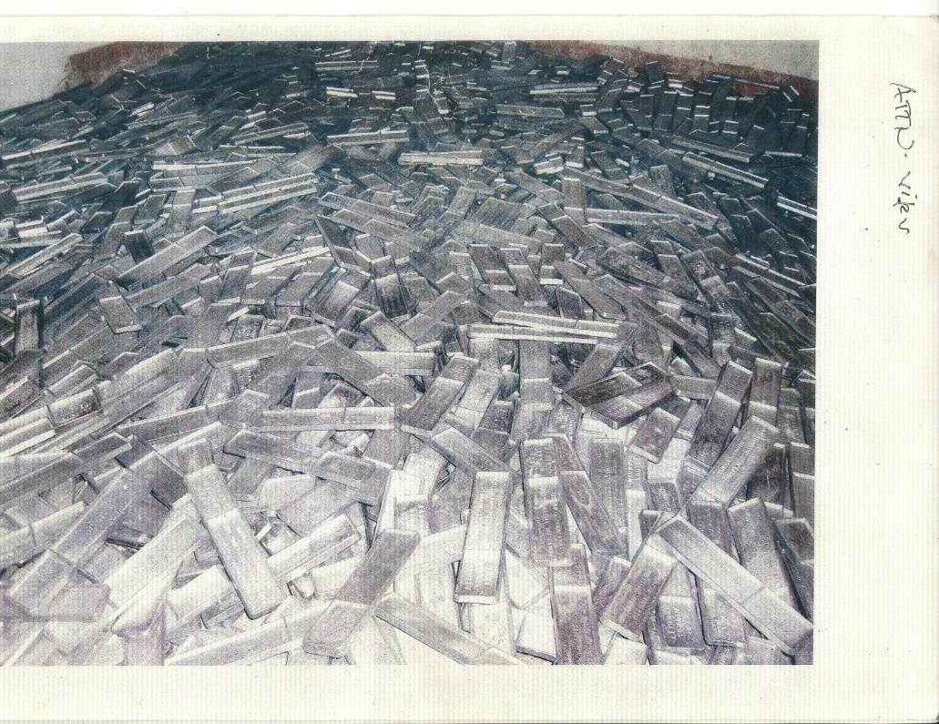

Nickel babbit is primarily lead, with other impurities such as antimony, copper, etc. We have lab-tested a number of samples and they range from 92% to 98% lead.

There are a great number of these bars in the Philippines, and I was given several different stories about them from potential sellers of the material.

The US military had taken a lot of this material into the Philippines, reportedly to make munitions.

Another story was that President Marcos was going to use the lead to shield miniature nuclear reactors, which he planned to use to power remote communities in the Philippines.

There is likely a degree of truth to both of these stories.

The real platinum I have seen in the Philippines is in ball form, each weighing about 8 kilograms. They are few and far between but they are there.

ALEXA’S SECOND POINT: 100,000-DOLLAR BILLS

2. Unnamed Picture of $100,000 Bills – These “Gold Seal” bills are in abundance in the Philippines, and I have seen them on many occasions.

The containers they came in identified them as being from JP Morgan in HOLLAND.

While some are real, there are a lot of fakes as well. I understand that they were used for bank-to-bank transfers.

As to why they are in the Philippines, like the Federal Reserve Notes (FRN’s), Federal Reserve Bonds (FRB’s), Treaty of Versailles boxes (TOV’s), uncut US dollars and other boxes/documents, it is my understanding that some of them were sent to Marcos in payment for borrowing silver, gold and/or gold certificates.

After getting hosed by the banksters, they started to issue certificates against the gold — but kept the gold in “bodegas” (long tunnels used as warehouses) where it could not be kept by the banksters.

The Philippines reportedly also has at least 6 printing presses for printing US Dollars.

They were supplied with the presses, plates, ink, gold dust and other necessary materials, and authorized to print certain amounts of USD. The generals in charge reportedly printed about four times more than authorized.

However, the US did not provide cutting machines, and most of the bills were kept in full sheets on pallets.

ALEXA’S THIRD POINT: OTHER BOND BOXES

3. Other boxes – There are a great number of these boxes, and I have photos of many different types from my 8 years in the Philippines. Some are real, and a great number of them are fake.

It is my understanding that there are at least 4 fake ones (made in the Philippines but authorized by the US) for each real box.

Due to our involvement and relative success in locating these assets, a close personal friend and business partner who is currently living in the Philippines was trained by the US Treasury to identify the various boxes as to their authenticity.

Even the real ones have obvious typo’s in the documents for deniability. (Oh come on, we would not have made a mistake like that!!!)

This is a “gimmick” which reportedly originated in England.

ALEXA’S FOURTH POINT: WELLS FARGO BOXES

4. Wells Fargo – There were a number of these safes/boxes in the Philippines, Hong Kong and elsewhere.

They reportedly came in sets consisting of $25,000,000, $50,000,000 and $75,000,000 boxes.

Many of these boxes have been opened, the contents removed and replaced by newspaper.

Each of the boxes also had up to 20% “deliberately counterfeited” notes in the box.

This enabled the Secret Service to pull some of the fake notes out, point out that they were counterfeits, and confiscate the rest.

Quite a racket!!! And the person that originally had the real money spent a long time in jail.

The boxes could have contained “Silver Certificates”, “Federal Reserve Notes” or “US Banknotes“ (Green Seal, Blue Seal or Red Seal). These were all series of 1934, which was used until at least 1975.

[DW: Keith Scott says 1934-series bonds continue to be printed right up through to the present.]

We have also encountered $25,000,000 boxes of 1928 series. These may have been primarily used for US Military payroll.

There were also large volumes of Trade and Morgan Silver Dollars.

A lot of the coins presented to us were Chinese gambling tokens, likely confiscated by the Japanese and brought to the Philippines before or during WWII.

The tokens were easy to identify, as they weighed about 2/3rds the weight of the real coin.

ALEXA’S FIFTH POINT: JP MORGAN’S BANK IN CEBU

5. “JPMorgan Chase Manhattan & Co opened a Bank here in Cebu”.

An interesting point, and one which I called my friend about.

He has resided in the immediate area for over a year, and was not aware of that bank — but he will check into it.

ALEXA’S SIXTH POINT: KAIN DOH

6. You may want to have David’s contacts check the name Kain Doh in the Philippines, and for bank accounts as applicable.

This is the code name recently assigned to another long time “Canadian” friend still in the Philippines (by an old man who died very recently,) and has reportedly had a number of bank accounts and other responsibilities assigned to him.

Kain Doh’s mother/father were of Spanish Royal blood, related to “Mommy”.

As you know, Mommy’s real name was Enjiluz Rebecca Divinigracia Onate, and she was the real wife of Ferdinand E. Marcos (Imelda being a “show” wife).

It was a marriage arranged by the grandmothers, and took place when Mommy had just turned 13 years of age, and FEM was 12. The marriage took place in the City of Davao in the southern Philippines.

Mommy passed away on April 16, 2008 of pancreatic cancer.

Several weeks before when I had last been in the Philippines, my friend and I spent several days with Mommy in the hospital — and paid many of the hospital bills.

I walked Mommy into the hospital exam when she was diagnosed with cancer, but immediately thereafter I left to catch my flight back home. My friend returned to the Philippines about three weeks later for the funeral.

Kain Doh has been in the Philippines for about 20 years, working with Mommy, has an amazing memory and can provide many details of assets and events — if that would be of any help.

ALEXA’S SEVENTH POINT: HAPPY TO HELP

7. If David or his associates have any questions or comments about any of these matters, you can provide my contact details, and I would be happy to help them in any way possible.

If this goes public, please sign it as “Name intentionally withheld” — as we are still working in this area, and do not wish to have additional problems for any of us.

ANOTHER COMMENTER WITH INFO — SUNDAY, 1/29

Once this section was already posted, another commenter going by “Tiger” added more commentary on this discussion — along with a link to information about “repurchase agreements” or “repos.”

Author: tiger
Email: [REDACTED]
Link to content: https://divinecosmos.com/start-here/davids-blog/1023-financial-tyranny?start=6

Comment:

Aged corporations, stand by letters of credit, tranches have been all over the Internet for years.

If you sign up for a private placement online, chances are it’s a scam. The “legitimate” ones require a personal introduction to the trader’s agent and are truly very, very private.

The money they produce most often comes from the overnight repo market. The returns can be staggering, but only if you can play big from the beginning.

http://wfhummel.net/repos.html

FINANCIAL TYRANNY MUST BE STOPPED

I’ve now given you a good overview of the evidence. I have done my best to draw off of external references, rather than just saying “someone told me this is how it works.”

Other authors have done an amazing job of putting these various pieces together. Original, new insider testimonies have now been shared in our investigation as well.

If you really do your “homework,” you will find that all I’ve done here is dip a teaspoon in the ocean compared to the amount of data that is available. I did present some intriguing new material that most authors miss.

Anyone who doesn’t see the truth for what it is, at this point, is suffering from the cumulative effect of multi-generational brainwashing — through the media, the government and the educational system.

Behind their arrogant, brash, sarcastic, know-it-all skepticism, and scathing Internet character assassinations, THEY ARE SCARED TO DEATH.

How did we get to a point where in the United States — supposedly one of the most affluent countries in the world — the average person has no more than two thousand, one hundred dollars in the bank?

“FAIR” HAS NOTHING TO DO WITH IT

If you or I were to steal this 2,100 dollars from someone — destroying their entire life savings in the process — we would probably get caught… and go to jail for grand larceny.

Yet, when the financial corporations take extravagant 100-to-1 casino bets and fail spectacularly, they get repaid — they are supposedly “Too Big To Fail” — and give themselves lavish bonuses for all the anguish they had to suffer through.

If they had given even ten thousand dollars to each American household — out of the total of $226,000 per family they stole — it would have been an incredible economic stimulus.

It would also be a good way of apologizing and begging for clemency from the public.

Instead, they continue to rely on dinosaur media brainwashing that no one even listens to anymore — while pathetically trying to destroy the Constitution, treat protestors like terrorists with NDAA, and smash all Internet opposition with SOPA and PIPA.

YET ANOTHER STUNNING NEW DEVELOPMENT

Literally just before I was ready to publish this entire investigation, there was yet another stunning new development. It would appear that the Powers that Were, as I like to call them, are now coming right out in the open.

We first broke the story of these “gold bonds” here at Divine Cosmos as of October 31, 2011 — but Fulford had already been talking about it long before then.

I didn’t publish a more in-depth analysis of the situation until December 12, 2011, when I published the first comprehensive investigation into this story — and interviewed Benjamin Fulford.

No actual pictures of the bonds appeared on any website — other than the long-standing Unwanted Publicity — until Steve Beckow published Udo Pelkowski’s images as of December 31, 2011.

I didn’t publish these pictures myself until the first part of this investigation was published on January 13, 2012.

The day before I published what may be the definitive collection of bond images here — including never-before-seen photographs from the Dragon Family — a video was released.

This video starred rap sensation P. Diddy, among others — and it featured countless millions of dollars in gold bonds.

YOU CAN SEE FOR YOURSELF

The video was primarily released by German artist DJ Antoine, and also starred P. Diddy and Timati. It’s called “Dirty Money — I’m On You.”

One verse of the song runs at the beginning of the video with P. Diddy doing the vocals.

Then the song cuts to Hollywood-style suspense music. We see P. Diddy land a black helicopter and meet with Timati, who is there with an attractive blue-eyed Asian woman.

P. Diddy pulls out an Ipad and shows Timati a picture of a 100,000-dollar gold bond — exactly identical to the real ones we pictured in Section Four of this investigation.
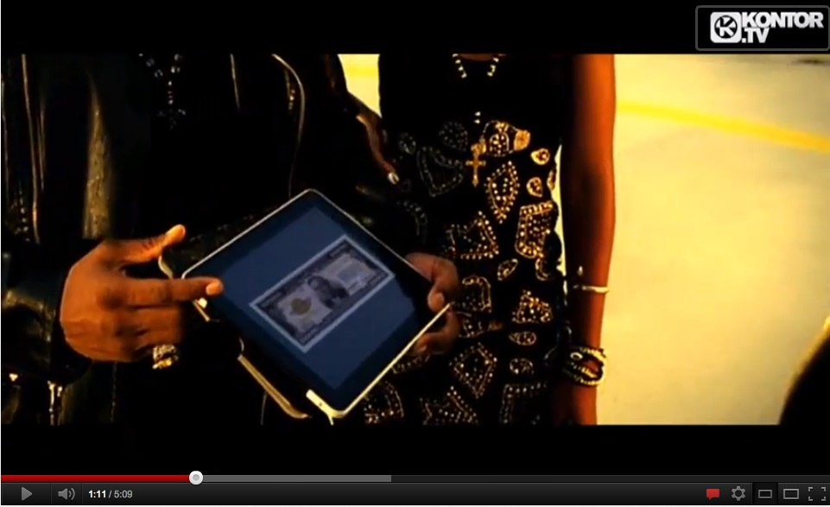

DIDDY: You ever see one of these?

TIMATI: No.

DIDDY: It’s a hundred thousand dollar bill.

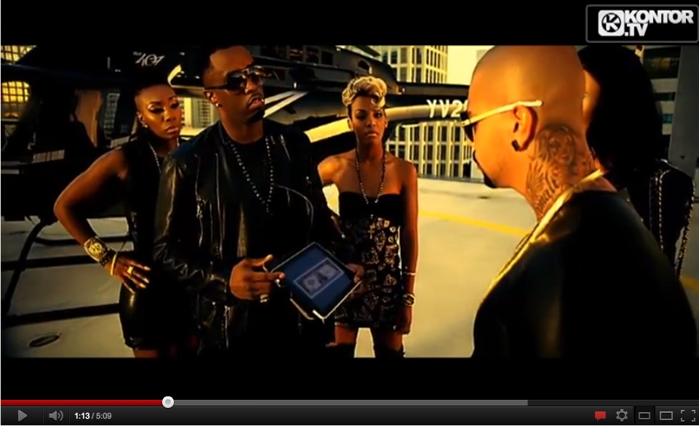

CHASING DOWN THE GOLD BONDS

The woman with Timati reveals that she has seen these bills before. Timati is then sent on a quest to find the missing briefcase in Europe that is stuffed with these gold bonds.

Timati and the woman then arrive at the house of a sweaty billionaire.

P. Diddy’s insider team, led by DJ Antoine behind a futuristic spy-agency console, locates the suitcase once Timati’s crew is inside the house.

Timati pulls the suitcase out of a cement-lined trap door in the house.

Then we see him and the woman outside the house with the suitcase. They hit a detonator and blow up the entire house, killing everyone still inside.

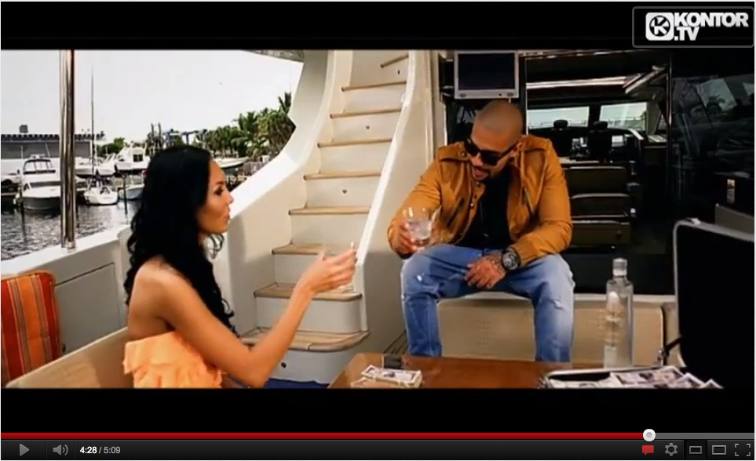

Then we see a series of scenes with Timati and the woman enjoying the rewards.

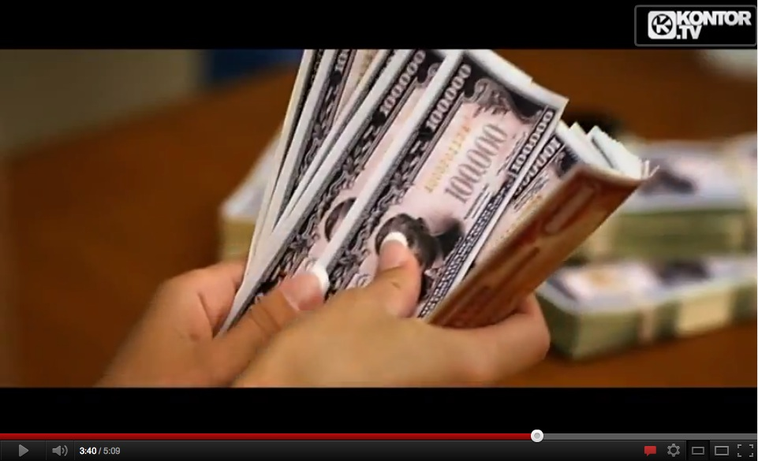

Notice the bottom of the bills in the above image. The color is red and the design is exactly the same as we’ve seen in the real bills.

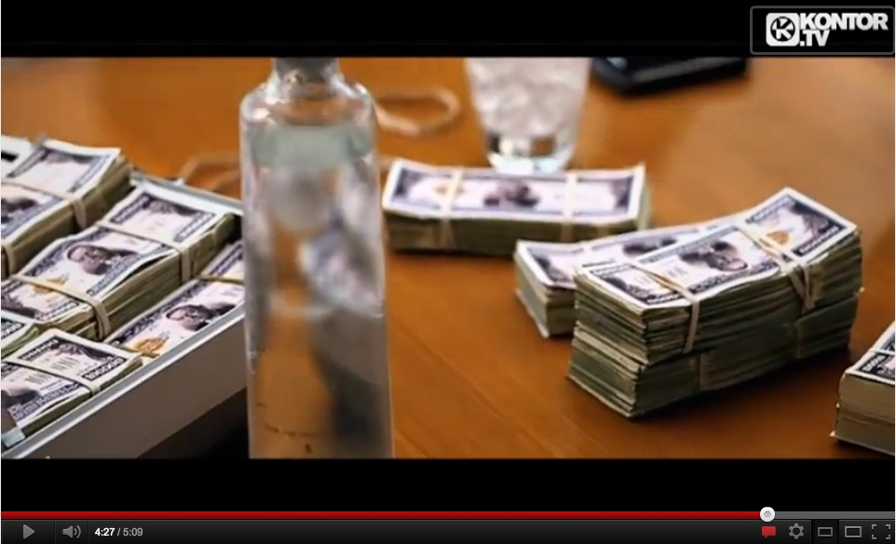

It is patently obvious that, at the very least, these bonds are extremely good fakes — if not actually the real thing — although they do seem too small to be real gold bonds.

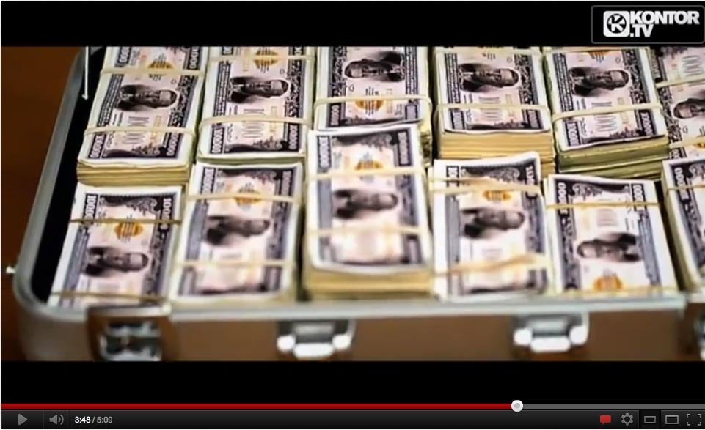

Both sides are exactly as we see them in the images from Udo Pelkowski and others.

In order to help refresh your memory, here is one of the images Pelkowski risked his life to show us — on December 31, 2011.

Getting back to our story, Timati then emerges from the inside of his yacht to discover that the woman, who apparently he was in love with or at least having sex with, had betrayed him.

She waves to him from another ship — with the suitcase in hand.

P. Diddy and DJ Antoine both smile in satisfaction. They betrayed their own ally — after he risked his life to recover the stolen bonds.

All of this sounds very familiar, doesn’t it?

Stolen bonds. Someone attempts to recover them. Then the bonds are stolen back — or so the insiders hope — and the heroes who recovered the bonds end up with nothing.

This is remarkably similar to both the Joseph Riad and Neil Keenan cases we have been discussing.

THE MASS ARRESTS HAVE ALREADY STARTED

It appears that we will soon see mass arrests of many key conspirators in this problem — by a majority faction within the Pentagon.

The majority Pentagon faction is, in turn, backed and supported by an alliance of 122 nations. Many more will undoubtedly join the alliance once action begins to take place.

According to Fulford, over 60 percent of the US military in the Pentagon now supports the overthrow of this cabal. Recently, a new military witness has gone public — providing even more corroborating details.

Much of what he and I discussed must remain off the record. None of us have been given enough detail to cause any damage to the plans if we were interrogated.

However, I do believe these plans are very real, and will succeed. The timing of when this will be done is unknown — but it does appear that it all depends on how quickly things come to a head.

Given what has just happened — right as we were about to publish the final investigation — it seems the arrests have already started.
At the very least, we are seeeing the first phase of the arrests.

AN UNPRECEDENTED HOUSECLEANING

The full event will create an unprecedented housecleaning of the executive, legislative and judicial branches of the US government.

It will also sweep through large corporations, the finance industry, the military and the mainstream media complex — which is largely dominated by a handful of corporations.

The logistics of actually accomplishing this feat are staggering to comprehend.

I fully understand how terrifying this will be to most people — and there will be incredibly powerful disinformation suggesting it will be a “New World Order takeover” once it happens.

However, it appears to have already started as of Saturday, January 28, 2012 — and no one seems to be going into a panic.

FOX NEWS WAS THE FIRST TO BE TARGETED

Fulford has been predicting these mass arrests for over a year. I’ve been promoting this story heavily since October, and I gained a lot more information about the arrests as of early January.

I was even more surprised when a new ex-Navy Seal whistleblower came forward and confirmed everything I had been hearing — putting a public face to what otherwise had been an extremely secretive story.

Despite all of this, I was still shocked to see that the first wave of arrests has already started — before I could even finish publishing this.

http://news.yahoo.com/police-search-news-international-offices-london-arrest-four-110211281.html

LONDON (Reuters) – British police arrested four current and former staff of Rupert Murdoch’s best-selling Sun tabloid plus a policeman on Saturday as part of an investigation into suspected payments by journalists to officers, police and the newspaper’s publisher said.

Police also searched the paper’s London offices at publisher News International, News Corp’s British arm, in a corruption probe linked to a continuing investigation into phone hacking at its now closed News of the World weekly tabloid.

News Corp’s Management and Standards Committee, set up in the wake of the phone hacking scandal, said Saturday’s operation was the result of information it had passed to police….

NAMING NAMES

http://news.yahoo.com/police-search-news-international-offices-london-arrest-four-110211281.html

The arrests included The Sun’s crime editor Mike Sullivan, its head of news Chris Pharo, and former deputy editor Fergus Shanahan, a source familiar with the situation told Reuters.

Also arrested was the paper’s former managing editor Graham Dudman, now a training director at News International, the source said.

Police said a 48-year-old man from north London and two other men from Essex, east of London, aged 48 and 56, were arrested at their homes. The fourth man, aged 42, was arrested after reporting to an east London police station.

A Sun reporter, who asked not to be named, said: “Everyone is a bit shocked, there is disbelief really. But there is a big difference between phone hacking and payments to the police.”….

Thirteen people have now been arrested over allegations that journalists paid police in return for information.

Their detentions are part of Operation Elveden — one of three criminal investigations into news-gathering practices.

Last week, News International settled a string of legal claims after it admitted that people working for the tabloid had hacked in to the private phones of celebrities and others to find stories.

The phone hacking scandal drew attention to the level of political influence held by editors and executives at News International, and other newspapers in Britain.

It embarrassed British politicians for their close ties with newspaper executives and also the police, who repeatedly failed to investigate allegations of illegal phone hacking.

WHY IT HAD TO BE DONE

Now, to close out this section, I want to clearly explain why the “good guys” in the military have been working on this plan for some time now — in the most absolute secrecy.

They were well aware that conventional methods could not be used to conduct this plan. Even the most highly secure computer systems were still at risk.

PENETRATION OF ILLUMINATI INTO MILITARY SECRETS
In one of her reports, Svali revealed that the Illuminati have a big business in buying and selling access codes to military computers.
http://web.archive.org/web/20030808142923/http://www.centrexnews.com/columnists/svali/2000/10/chapter01.html
Buying access codes for military computers: The Illuminati will have people from all strata of civilian life trained to go and make pickups near or on military bases.

A typical person used might be the innocent-looking wife of a military person, a local businessman, or even a college student.

There is a contact inside the base, also a dissociative Illuminist, who brings the information to the outside contact.

Occasionally, the contact person is paid with money, information, or goods.

The military computer codes are changed on random schedules; the Illuminati have at least 5 or 6 contacts on each major base, who alert them when the codes are getting ready to change, on pain of death.

The Illuminists like having access to military computers, because that will gain them entrance to closed files the world over.

No one can keep something this big, and this damaging to national security, a secret. Svali published this intel online, for everyone including top military personnel to see, as of the year 2000.

This is yet another reason why the United States military has been very carefully, very quietly building up to these mass arrests for a long time now.

When you read the Oath of Enlistment, you can see what every new recruit swears to do. This is a sworn oath to God — or whatever universal Creator they may believe in. Even an atheist would at least see it as a sworn oath to the people.

Many high-ranking military personnel have taken this oath very seriously — and intend to carry it out. They have conducted their plans under the most strenuous security protocols, so as to evade detection.

THE OATH OF ENLISTMENT

Every soldier takes a sacred oath, before God and Country, when he or she decides to consecrate his or her life in service to others. It is called the Oath of Enlistment.

http://usmilitary.about.com/od/joiningthemilitary/a/oathofenlist.htm

I, (NAME), do solemnly swear (or affirm) that I will support and defend the Constitution of the United States against all enemies, foreign and domestic;

that I will bear true faith and allegiance to the same; and that I will obey the orders of the President of the United States and the orders of the officers appointed over me, according to regulations and the Uniform Code of Military Justice. So help me God.

Those who administer the oath are rigorously trained to emphasize the first section above all else. The soldier has to have it explained in great detail, and answer multiple questions, in detail, showing they understand it.

http://usmilitary.about.com/od/joiningthemilitary/a/oathofenlist.htm

I, (NAME), do solemnly swear (or affirm) that I will support and defend the Constitution of the United States against all enemies, foreign and domestic; that I will bear true faith and allegiance to the [Constitution of the United States]….

So help me God.

THE OATHKEEPERS

Another brave soldier going by the pseudonym “Bill Wood” has now risked his life — risked everything — to tell us a very controversial, compelling and breathtaking story.

He has gone on camera and given extensive detail. I have since had several long conversations with him — including a three-hour video interview with Project Camelot.

Bill is saying the same thing I’ve been hearing — but has added significant new information to the case.

A growing majority of the Pentagon and United States military does NOT think the Constitution is a useless piece of paper.

They actually RESPECT the Oath they took — to valiantly serve, protect and defend our fathers, mothers, brothers and sisters.

I was since notified that there is an Oathkeepers website you can visit to learn more about them. Obviously there is no public statement about any planned arrests at this point.

REVEALING THE OATHKEEPERS

The very first thing Bill Wood says in the original video is a disclaimer, saying he is developing and marketing a fictional book based on his testimony.

This is standard practice for whistleblowers in order to avoid being killed for speaking out, or sued for any ridiculous claims that could be used to further damage his life.

The very next thing he says after this is as follows.

KC: At this point, we are going to start in the beginning. I’d like you to talk about why you came and contacted me, and what group or groups you, in a certain sense, represent — if you want to use it sort of loosely in that term.

BW: I don’t really have any group that I represent. However, there are many, many people, both former and current military, which have a huge amount of concern over what the members of the military know to be what’s really going on in the Middle East — and places that we are occupying currently outside of this country.

Those concerns have grown more and more throughout the years, and it’s to the point where a lot of these current and former military members speak. The best description of these military members would be “Oathkeepers.”



An Oathkeeper is somebody who focuses primarily on the oath that they took when they joined the service, and not so much what they’re ordered to do — to keep secret, or to tell a secret, as opposed to what is in the best interests of the constitution and the country.

KC: Okay. Let’s say also that there’s a purpose behind this that has to do with the NDAA.

BW: The main purpose for this interview was the enactment of the National Defense Authorization Act. The individuals that I speak with on a regular basis have grown a consensus that this is the end of the erosion of our constitutional rights.

It pretty clearly spells out in a lot of paperwork that America has been declared a war zone, and American citizens are subject to arrest and detainment outside of the constitutional protections of a trial by jury, or the right to an attorney. The right to being charged with a crime even is stripped away in that bill.

I don’t believe most of the American public has been properly informed via the media. So, we’re trying to get the message out, and get some support, in the fact that we cannot continue to allow the progressive erosion of the constitutional rights, and expect to have our rights ever be taken seriously at some point.

STATEMENTS FROM THE OATHKEEPERS WEBSITE

The official Oathkeepers website has a list of ten “Orders We Will Not Obey”. Here is the short summary of those ten points. You can click here for more information.

http://oathkeepers.org/oath/2009/03/03/declaration-of-orders-we-will-not-obey/

1. We will NOT obey orders to disarm the American people.

2. We will NOT obey orders to conduct warrantless searches of the American people.

3. We will NOT obey orders to detain American citizens as “unlawful enemy combatants” or to subject them to military tribunal.

4. We will NOT obey orders to impose martial law or a “state of emergency” on a state.

5. We will NOT obey orders to invade and subjugate any state that asserts its sovereignty.

6. We will NOT obey any order to blockade American cities, thus turning them into giant concentration camps.

7. We will NOT obey any order to force American citizens into any form of detention camps under any pretext.

8. We will NOT obey orders to assist or support the use of any foreign troops on U.S. soil against the American people to “keep the peace” or to “maintain control.”

9. We will NOT obey any orders to confiscate the property of the American people, including food and other essential supplies.

10.We will NOT obey any orders which infringe on the right of the people to free speech, to peaceably assemble, and to petition their government for a redress of grievances.

MORE FROM BILL WOOD LATER IN THE INTERVIEW

This all appears shortly after the one hour and 30-minute mark.

BW: Over time the build-up of what I was seeing, what I was experiencing, what I knew from my previous military experience and what I learned since getting out of the military — it began to build and build and build, until it eventually got to the point where even I couldn’t take it anymore.

And at that point I began looking up information up on the Internet, doing research, information gathering — kind of quote-unquote “building my case”.

Shortly after I began doing that, I was contacted by a group of people that were also doing the exact same thing; [they] were much more aware of who I was and what my experience in the military was — on a Top Secret level.

I was very surprised by that [laughs], but I learned very quickly that there are people out there with a huge amount of information — fighting for the good guys.

KC: So, in essence, you were contacted by a group of, what we call “White Hats”?

BW: I call them Oath Keepers. Essentially, they are the patriots that our government would classify as terrorists [laughs].

KC: But they are ex-military, by and large, and some of them are still in the military?

BW: I would assume a large number are still in the military or in the government – in the FBI, the Secret Service, CIA…

KC: …alphabet agency…

BW: …any alphabet agency. There’s got to be a percentage of people that are seeing the-day-to-day and going: this is wrong — we’ve got to do something!

BILL WAS ‘VETTED’

We continue right where we left off — and hear how Bill Wood was ‘vetted’ to join into this very unique group, which I also have had extensive contact with.

KC: So they contacted you?

BW: Yes, and over the course of a few months, I was vetted.

If you don’t know the meaning of the word, it is a cute term for saying how much you could be trusted [laughs] — how much you would lie, and what you didn’t want to talk about when you figured out that the people on the other side of the vetting process already know all that.

They’re just trying to figure you out and see if all that’s true.

If you respond in exactly the way that you are portrayed in their minds, it’s very encouraging. They knew my deepest, darkest secrets and they knew even more than that.

When I came out with the information I did, I kind of graduated — and got a trusted role in a very compartmentalized world [laughs]….

I WAS “VETTED” AS WELL

I have been “vetted” over the course of years now. I did this by repeatedly not going public with various pieces of classified information I have been given.

If I was explicitly asked not to share something, I did not. In so doing, I have gained and built up trust.

This was a necessary step in order to insure that I could be entrusted with key information that will now help to rescue the fathers, mothers, sons and daughters of the world from Financial Tyranny.

I would never have put this much work into one single investigation had I not been directly asked to — from the highest and most secretive levels of the Oathkeepers.

I wish to thank Bill Wood, and the Oathkeepers, for finally coming in and giving Benjamin Fulford and me both some backup on this mission — when we needed it most, at the time of our greatest personal risk.

Bill wanted me there for the first interview but I was too swamped in this investigation. The Livestream event occurred the following Tuesday night. Bill’s foundation in the original interview allowed us to go much farther in the Livestream event.

THE NDAA ACT IS A DIRECT ATTACK AGAINST THE CONSTITUTION

Remember — the first line of the Oath of Enlistment tells the soldier his responsibility is to the Constitution of the United States of America — regardless of what foreign or domestic enemies may do to threaten it.

That responsibility can include going against direct orders from the highest levels of the unelected and / or occult government.

KC: So you’re working with this group and one of the reasons you came to me was actually because of this [National] Defense Authorization Act?

BW: Yes, that sent shock waves through the community that I’m involved in.

Basically that is the final straw of the complete erosion of Constitutional Rights.

It literally has government giving itself permission to violate the rest of the Constitution and that has a lot of people concerned.

A lot of people would like to see something done about that; it’s my opinion and their opinion that something could be done about that.

Because, quite honestly, we are one false-flag away from enacting all of that legislation that’s just been created.

KC: Right, I would agree with you on that. [snip]

BW: The popular belief is that there is a very, very easy way to prevent that from happening, and to get that information out to the public.

It has been surmised that… if we address the issue directly via our Constitutional Rights, and begin to notify the public in general that this is a problem that needs to be dealt with, [change will occur].

The way it’s been proposed to me — and to a lot of people — is to create a petition that calls for the impeachment of every political person in Congress and the Presidency that enacted this legislation as treasonous.

It is treason to attempt to alter the Constitution through an unconstitutional means.

If you create a law that circumvents the Constitution, you commit treason.

KC: Fair enough.

GAME OVER

While I agree with Bill’s statement about the petition, I have also heard there is a much deeper and more compelling initiative at work.

Therefore I would like to speak directly to the people who are continuing to perpetrate Financial Tyranny.

Guys… This is it. Game Over. You can rape us, beat us, kill us, detain us and silence us, but you cannot stop The Avalanche.

It’s here. It’s real. It’s much bigger than you could ever possibly imagine.

A paper-thin layer of fear is the only thing holding back The Avalanche right now.

You know that. I know that. We’re not stupid. We’re adults. We know what happens in history when this occurs. It’s called a coup.

It’s going to happen no matter what. I have nothing to do with it.

I believe the plan is so comprehensive and brilliant that there is no possible way for you to stop it.

I know you’re scared — but the best thing you can do is STOP LYING.

You still have a chance to give humanity the greatest gift of all time — an end to secrecy — and the most mind-blowing awakening in the planet’s history.

So far you haven’t done this. I’m going to help you finish the job — by telling the rest of the story of Financial Tyranny.

Now no one needs to stick their necks out. It’s already public.

No secrets left for anyone to be threatened for speaking out about. This is it.

THE DRAGON FAMILY LAWSUIT

As we head into Section Seven of this investigation, it’s time to review what we’ve learned about the lawsuit Neil Keenan and Keith Scott have filed on behalf of the Dragon Family / Kuomintang group, formerly the ruling party in China.

This lawsuit will blow open the whole story of the “occult economy” that I have been discussing here. It includes absolutely damning recordings from the defendants — as well as an incredible wealth of supporting evidence.

The Oathkeepers are supporting this lawsuit as one critical element of their greater plan to end Financial Tyranny.

Once we review the story and look at a variety of new data points, we will feature an extensive set of interviews I have conducted with Keenan and Scott — two of the plaintiffs — on many key topics.

This interview series will then conclude with the next volley in their campaign — the world debut of a Cease and Desist order against the people profiting from Financial Tyranny.

CLICK HERE TO CONTINUE TO SECTION SEVEN: THE EVIDENCE IS IRREFUTABLE

FINANCIAL TYRANNY: The Final Sections
Posted by David Wilcock | Feb 9, 2012 | David's Blog | Jump to Comments (1569)
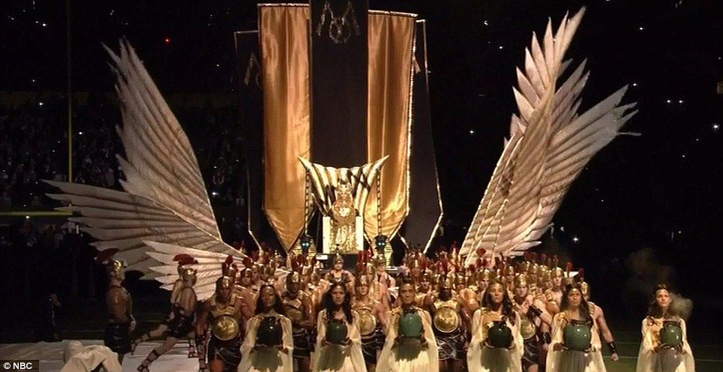
- Part One: FINANCIAL TYRANNY: The Final Sections
- Section Eight: The Interviews
- Section Nine: Closing the Doors -- Cease and Desist
- Section Ten: Comments
- All Pages

UPDATED 2/17! At last — the final four sections of our epic investigation into Financial Tyranny. Get the overview of what we have learned, with stunning new information that paves the way for an end to Financial Tyranny — once and for all.

[Note: You may quote excerpts from this investigation and republish them in your blog, but please do not re-post the entire investigation, as additional updates and ‘tweaks’ may be necessary. Instead, please link your readers back to the original. Thanks!

All updates will be listed at the end of the Comments Section as they come in. Stunning new events are happening on almost a daily basis that show this historic defeat of Financial Tyranny is now imminent.]

SECTION SEVEN: The Evidence is Irrefutable

LET’S REMEMBER THE BIG PICTURE

Before we feature our exclusive interviews with the key players in the lawsuit that could defeat Financial Tyranny, let’s step back and look at the Big Picture.

We now have a compelling storyline of Financial Tyranny, dating back to 1776 with the publishing of Smith’s The Wealth of Nations — and the founding of the Illuminati in Bavaria.

Click here to start from the beginning if you have not already read the first six sections.

We have scientific evidence that a monopoly of 1,318 corporations, headed by the Federal Reserve banks, is now earning 80 percent of the world’s wealth. This ‘core’ is in turn being run by a “super-entity” of 147 corporations, most of which are financial institutions.

The top corporations in the “super-entity” are the Federal Reserve banks — and they created 26 to 29 Trillion dollars in bailouts for their own companies from 2007 to 2010.

The Rothschilds admitted in their own 1962 biography that Mayer Amschel’s five sons “conquered the world more thoroughly, cunningly and lastingly than any Caesar before or Hitler after them.”

Nathan Rothschild destroyed the British economy by making the entire market think Napoleon had defeated them. In one single day of trading, he was able to increase his net wealth by 6500 times — and did what Napoleon could not.

Rothschild conquered Great Britain.

MANY OTHER DATA POINTS TO CONSIDER

We gave links to multiple books full of information — now free to read online — proving there was a government-led uprising against the Illuminati in 1784… and a massive worldwide revolt against Freemasonry beginning after William Morgan’s murder in 1826.

Freemasons openly bragged about controlling the media, the police, the judiciary, the financial system and the government. 45,000 out of 50,000 Masons in the United States — 90 percent — all quit once the scandal broke, and were treated as heroes.

I believe there is abundant evidence that we are right on the threshold of another historical event like this — only of significantly greater magnitude.

We have also thoroughly documented how the global media is in the hands of a very small number of corporations.

We gave compelling evidence that its content is controlled through Operation Mockingbird, which was implemented in the dawning years of the CIA.

DON’T FORGET SVALI

We have explored shockingly detailed and specific testimony from a modern-day Illuminati member, Svali, who risked her life to appear once, and only once, on the radio — and never asked for money.

Svali also generated a tremendous body of written information that is highly informative, although extremely challenging to read. She has since gone into hiding, fearing for her life if she were to speak any further.

Svali’s written information thoroughly agrees with our historical research. It also suggests that the gigantic Eye of Horus painting I found under the Sunnyside Avenue bridge in Scotia, New York was, in fact, a ritual site — just a mile away from a Masonic lodge.

Svali’s testimony also explains the strangest, scariest story from my childhood — where both of my parents witnessed Masonic couples entering the house across the street, without knocking, in the middle of the night, with no lights on outside or inside the house.

The Illuminati is really only a European / American entity — mainly the G5 countries of Germany, France, Britain, Italy and the United States — and in the United States only 1 in 1000 people, or 0.1 percent, are a part of this group.

The attempts they have made to control other countries have been systematically undermined — and a massive 138-nation alliance has now formed against them.

The lawsuit you will hear about in the next section is one of several tools intended to help break through the silence once and for all — and free us from Financial Tyranny.

THE OCCULT ECONOMY

We have now studied the public legal documents of the Bank of International Settlements (BIS) — the global arm of the Federal Reserve. The BIS allegedly began in 1921, but did not fully incorporate until 1929-1930.

The BIS documents openly reveal that they took in “deposits” of gold and treasure from countries all over the world. Central banks were then allowed to trade with each other — using accounts backed by this gold.

These trades are completely free of taxation — and some of the monumental profits they generate are shared with private individuals who are members of the BIS.

The countries who either surrendered their gold willingly or had it stolen from them — such as by Hitler and the Japanese — were given worthless Federal Reserve bonds, in huge denominations, in exchange for their riches.

GEORGETOWN UNIVERSITY PROFESSOR EXPOSES THE BIS

Bill Clinton’s mentor, Georgetown University Professor of History Dr. Carroll Quigley, revealed quite a bit about the BIS in his 1966 book Tragedy and Hope.

http://www.rense.com/general85/tower.htm

In Tragedy and Hope: A History of the World in Our Time (1966), Dr. Carroll Quigley revealed the key role played in global finance by the BIS behind the scenes.

Dr. Quigley was Professor of History at Georgetown University, where he was President Bill Clinton’s mentor. He was also an insider, groomed by the powerful clique he called “the international bankers.”

His credibility is heightened by the fact that he actually espoused their goals. He wrote:

“I know of the operations of this network because I have studied it for twenty years and was permitted for two years, in the early 1960’s, to examine its papers and secret records.

I have no aversion to it or to most of its aims and have, for much of my life, been close to it and to many of its instruments….

[I]n general my chief difference of opinion is that it wishes to remain unknown, and I believe its role in history is significant enough to be known.”

QUIGLEY’S DEFINING STATEMENT ON THE BIS

http://www.rense.com/general85/tower.htm

Quigley wrote of this international banking network:

“[T]he powers of financial capitalism had another far-reaching aim, nothing less than to create a world system of financial control in private hands, able to dominate the political system of each country and the economy of the world as a whole.

This system was to be controlled in a feudalist fashion by the central banks of the world acting in concert, by secret agreements arrived at in frequent private meetings and conferences.

The apex of the system was to be the Bank for International Settlements in Basel, Switzerland, a private bank owned and controlled by the world’s central banks — which were themselves private corporations.” [p.324-325]….

The BIS is now composed of 55 member nations, but the club that meets regularly in Basel is a much smaller group; and even within it, there is a hierarchy.

In a 1983 article in Harper’s Magazine called “Ruling the World of Money,” Edward Jay Epstein wrote that where the real business gets done is in “a sort of inner club made up of the half dozen or so powerful central bankers who find themselves more or less in the same monetary boat” — those from Germany, the United States, Switzerland, Italy, Japan and England.

DON’T INCLUDE JAPAN IN THAT LIST ANYMORE

Japan has since cut off the flow of money to the Federal Reserve / Illuminati bankers. Fulford covered this extensively in Part One of our investigation, published December 12, 2011.

Benjamin Fulford has numerous pieces of evidence that Fukushima was an intentional disaster — a hideous attempt to force Japan to hand over the money.

Fulford published threats from Federal Reserve bankers that they would do this — set off earthquakes that caused a nuclear disaster — several times before it actually happened. This included statements he made on video.

What this horrific act of mass, ritual murder has actually done, however, is create a revolutionary overthrow of Illuminati power and influence in Japan.

This has not yet become public… but it certainly will.

FOUR DIFFERENT WHISTLEBLOWERS CONFIRM

We have now seen four completely different sets of photographs of Federal Reserve bonds from whistleblowers: Neil Keenan, Udo Pelkowski, “Unwanted Publicity” and Joseph Riad. The images are extremely compelling and consistent.

Riad filed a comprehensive lawsuit to reclaim his stolen bonds on December 23, 2011. Keenan filed a comprehensive lawsuit to reclaim his stolen bonds — on behalf of the Kuomintang / Dragon Family — as of November 23, 2011.

Astonishingly, US government agents confirmed to Riad that his bonds were genuine — but then a Homeland Security officer ran off with fifteen billion dollars’ worth of them.

We then saw a big-budget music video, starring P. Diddy, in which a suitcase of 100,000-dollar Federal Reserve gold certificates was stolen by a CIA-type agency. The bonds were identical to the ones our brave whistleblowers revealed.

THE DEADLIEST INFORMATION ON EARTH

We have now conducted a comprehensive examination of what is believed to be the deadliest, most classified and secretive information anyone could possess on Earth — the occult economy built off of this stolen gold.

Nothing I’ve ever encountered in my entire career has been considered as dangerous as this information — even though I spent years gathering testimony from people working in very classified programs.

The insiders who know about this occult economy are much more comfortable talking about almost any other subject — no matter how classified it may be.

David Hutzler and his 8-year-old son Mackie both died of gunshot wounds to the head. Their home was then burned to ashes in an obvious attempt to conceal the evidence. There has been no word about the murder weapon as of yet.

This sent a brutal warning to both Benjamin Fulford, and to me, to abandon this investigation.

Obviously, neither of us acted on these threats — except to become even more dedicated in exposing the truth.

BLATANT ILLUMINATI RITUAL ON THE MOST WATCHED TV PROGRAM OF ALL TIME

Think about the size and scope of what is about to become public knowledge if this story breaks open and becomes mainstream.

Think about how meticulously these plans have been followed — literally for centuries — and how this will be the first time that it has ever been exposed on a global level.

For some in the Order, this exposure will be a tremendous disappointment. However, many other members will be spectacularly relieved — and they are going to need our help and support when this happens.

The Illuminati seem to have responded to this imminent exposure by staging the most dramatic, blatant, in-your-face public ritual during the Super Bowl halftime show on Sunday, February 5th, 2012.

This was the most-watched show in the history of television.

Super Bowl Program Most Watched Ever – 111.3M Viewers

http://hosted.ap.org/dynamic/stories/F/FBN_SUPER_BOWL_RATINGS?SITE=AP&SECTION=HOME&TEMPLATE=DEFAULT&CTIME=2012-02-06-15-59-03

NEW YORK (AP) — For the third consecutive year, the Super Bowl set a record as the most-watched television show in U.S. history.

The Nielsen Co. said Monday that an estimated 111.3 million people watched the New York Giants beat the New England Patriots on Sunday night. That narrowly beat the 111 million who watched Green Bay’s win over Pittsburgh last year….

Madonna has some bragging rights, too. Her halftime show was seen by an estimated 114 million people — a higher average than the game itself – and was the most-watched Super Bowl halftime entertainment show on record, Nielsen said.

I DON’T BELIEVE MADONNA IS “IN ON IT”

Let me say for the record that I do not believe Madonna is a member, nor did she have any knowledge of this plan. I have seen arguments to the contrary, but I am not convinced by them.

Madonna’s efforts to improve the world clearly show that she does not subscribe to a negative, self-serving, tyrannical mindset.

However, in this case she was offered the gig of a lifetime. It involved design concepts that were intended to out-sizzle Lady Gaga, and she obviously went along with it — adding her own input at various points.

The Daily Mail published an article that included pictures of key moments you do not see in the official video version.

Madonna Illuminati Ritual in Super Bowl
http://www.dailymail.co.uk/tvshowbiz/article-2097020/Madonna-Super-Bowl-halftime-2012-Singer-suffers-small-slip-up.html

LET’S LOOK AT SOME PICTURES

The Illuminati believe they are the descendants of extraterrestrial human “Gods” that arrived on earth millennia ago. I have heard this from more than one whistleblower firsthand.

Whether you believe it or not is immaterial. The greater point is that this is what they believe.

Madonna is literally presented as a God in this ritual. It begins with an army of Roman soldiers bringing her out on a huge throne, surrounded with enormous feather-like fans.

The feathers symbolize how these people allegedly arrived here in their “winged discs”. The wings were used as a metaphor to indicate how their discs would fly through the air.

Roman Procession Leading In the Goddess

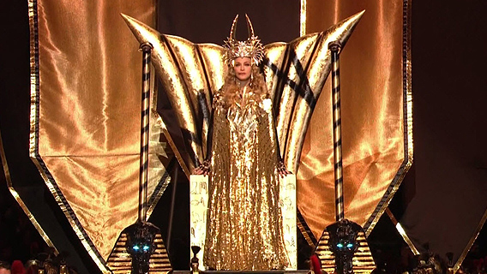

Notice the sinister glowing eyes of the dark sphinxes flanking the throne.

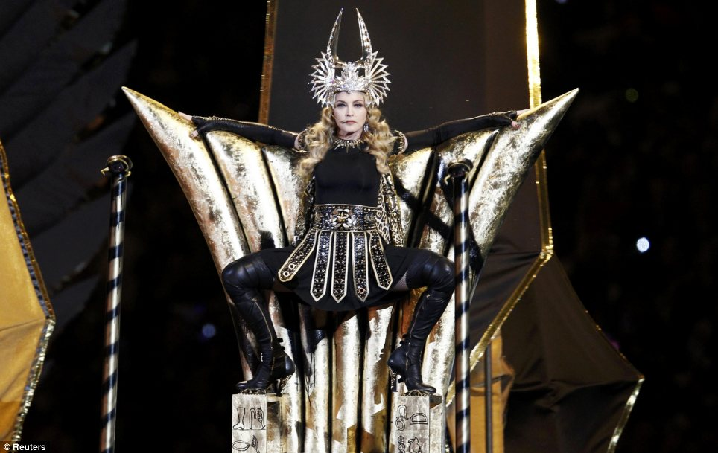

Many people have compared this image to bat-winged god Baphomet.

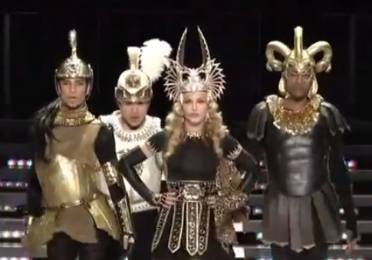

The Roman headdresses of her cohorts include blatant ram’s horns on the right.

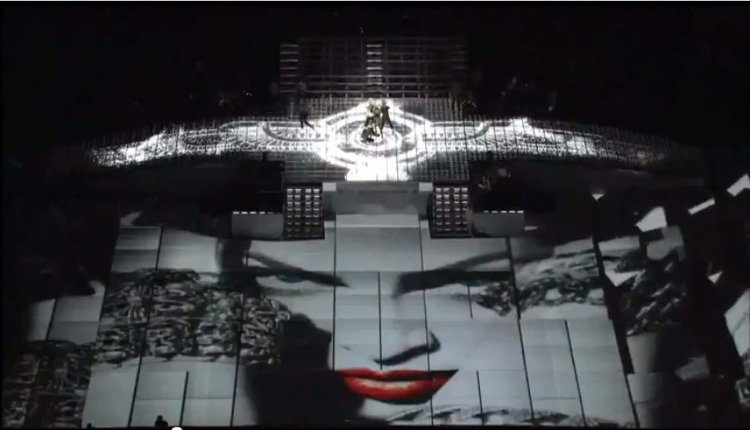

The winged disc is a classic symbol in Egyptian, Babylonian and Sumerian mythology.

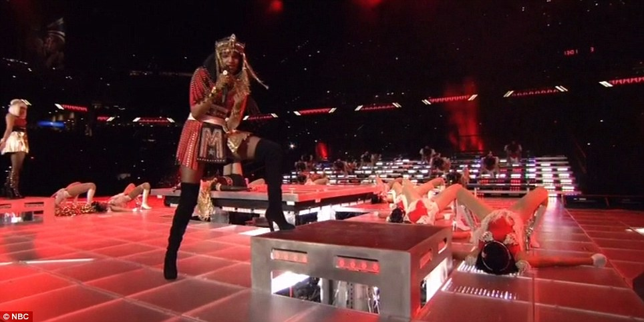

Up-and-coming star MIA gave the middle finger to the cameras while every dancer had their legs provocatively spread.
We were supposed to believe this gesture was an “accident”.

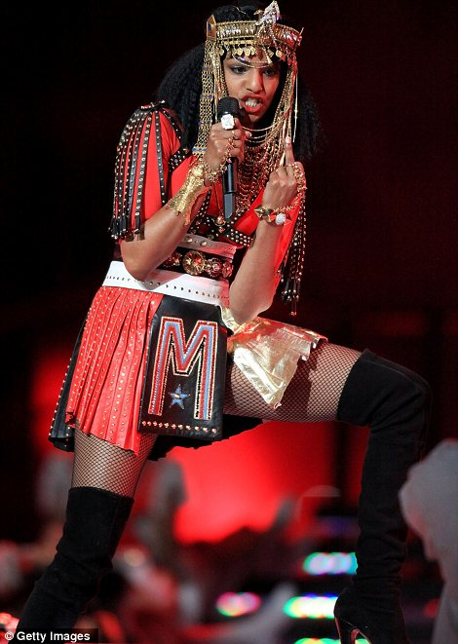

MIA gave the finger as she said the word “shit” at the very end of her rap.
Knowing how well-rehearsed these events are, it does not appear that any of this was unintentional.

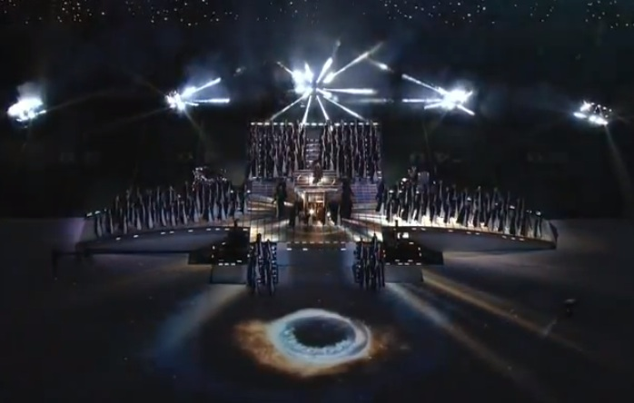

The Eye of Horus appears as a swirling vortex when Madonna sings “I close my eyes” in Like a Prayer.
The lights above the stage reveal the same shape — triangular beams with a central vortex.

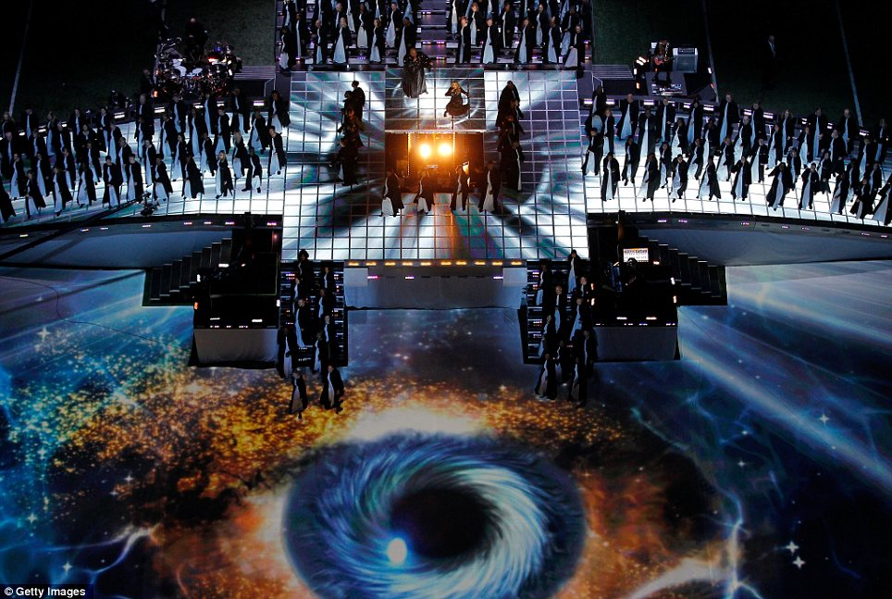

The Eye became fully formed over several seconds as it swirled — and appeared to be made of stars and nebulae.

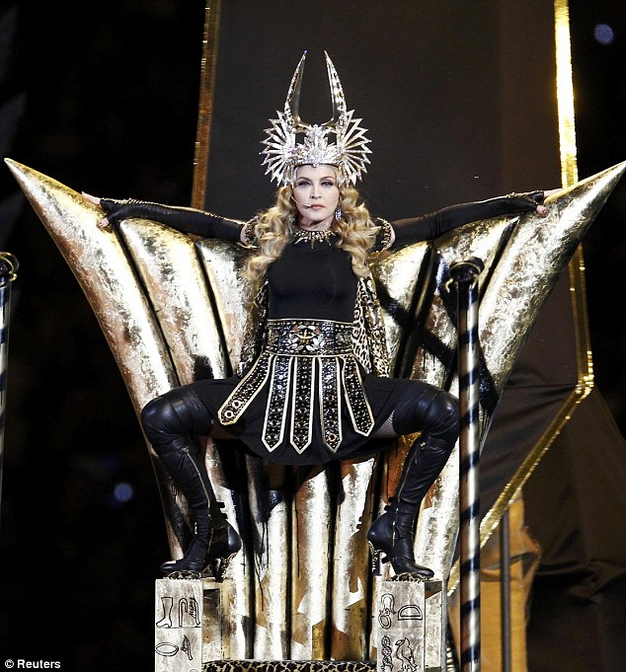

Madonna’s headdress resembles the Sumerian goddess Ishtar. Notice the all-seeing eye on her belt as well.

The following morning, Good Morning America was one of a series of media outlets that referred to Madonna as “the High Priestess of Pop.”

A LAST-DITCH RALLYING CRY

This blatant display of Roman, Egyptian and Illuminati symbolism appears to be a last-ditch rallying cry to their members — as if to say that they still control the world, and are getting ready to formally announce their presence.

The truth is that they have no choice. Ready or not, here we go.

So many people began ‘outing’ the Illuminati symbolism in this show that Daily Mail took the unusual step of closing the comments section within two days of putting it online.

Alex Jones’ Prison Planet was one of a wide number of independent media outlets that wrote about this stunningly blatant display.

http://www.prisonplanet.com/madonna%E2%80%99s-superbowl-halftime-show-a-celebration-of-the-grand-priestess-of-the-music-industry.html

UPDATE MONDAY 2/13: MUCH MORE GROTESQUE RITUAL A WEEK LATER AT THE GRAMMYS

Yet another mass Illuminati ritual — this time seen by almost 40 million people — took place the very next week.

To me, this is an even more blatant sign of how truly desperate they have become.

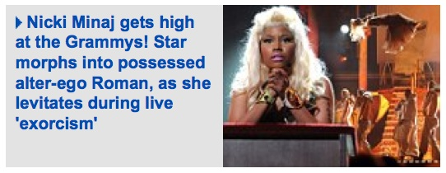

As you can see here, Nicky Minaj appeared in the Super Bowl halftime show.

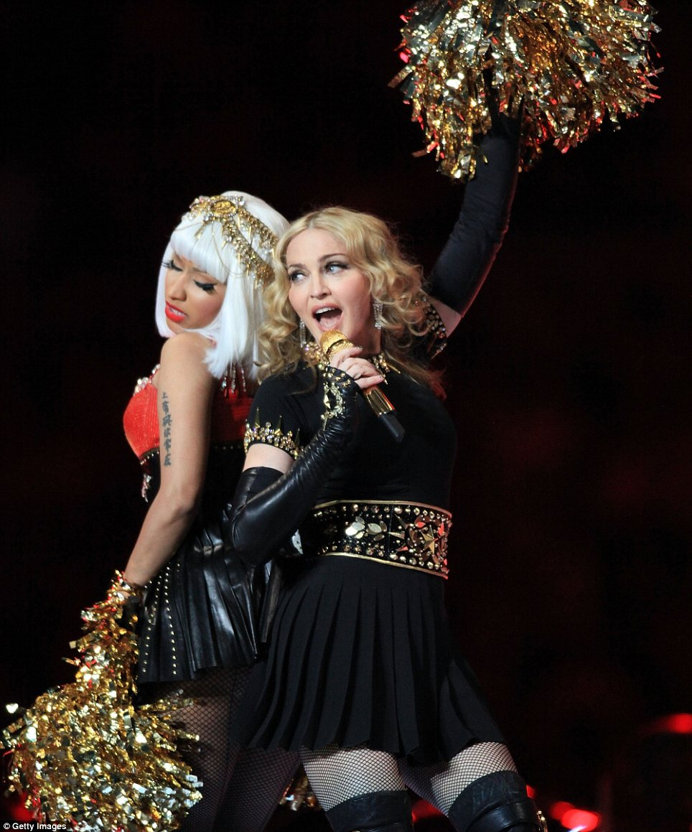

Nicky Minaj also had a short rapping part in the song Give Me All Your Luvin.

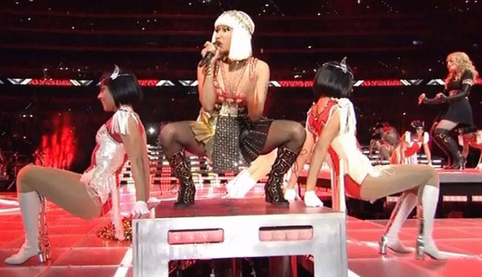

MINAJ WEARS BLOOD-RED MEDUSA COSTUME AND APPEARS WITH ‘POPE’

A week later at the Grammys, Minaj strode in with probably the most outrageous, anti-Christian stunt in the entire history of the awards ceremony — and that was before the performance itself.

She came in wearing a blood-red costume with the Versace logo — which is openly acknowledged to be the face of Medusa, the snake-headed goddess of Greek mythology.

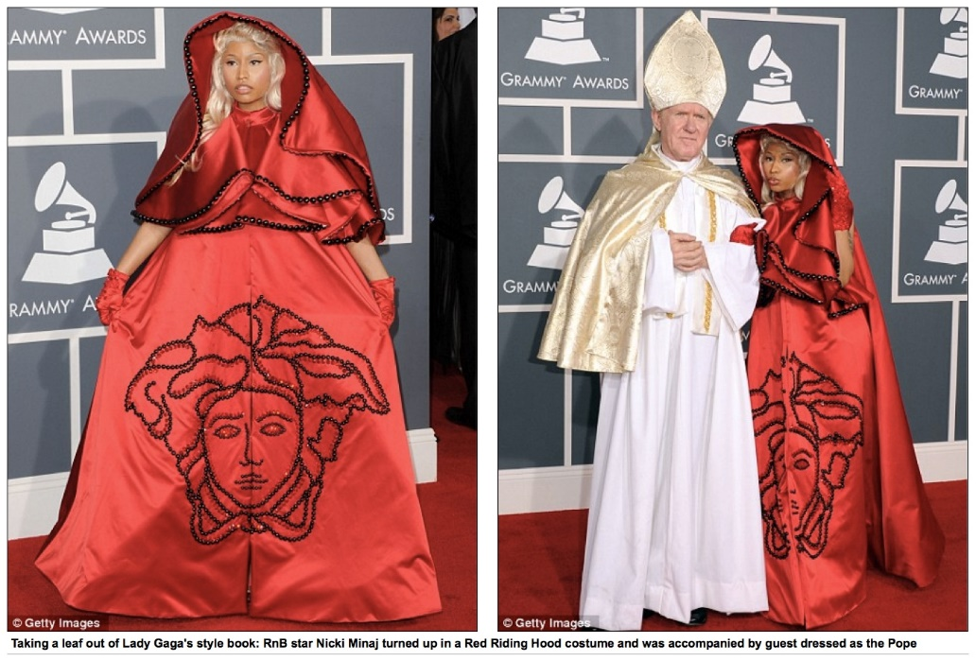

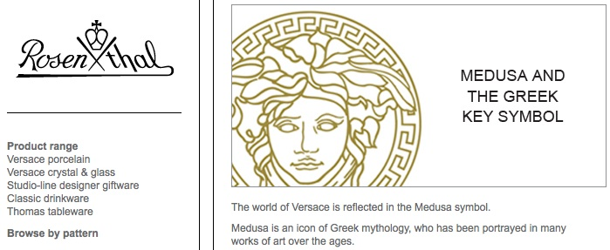

The obvious implications here are that the snake-headed, demonic Medusa has now ‘possessed’ the Pope — and established dominance over him.

SATANIC ELEMENTS IN HER PERFORMANCE

The performance itself was the biggest surprise. It opens with Minaj offering a confessional to the man originally playing the Pope, now apparently just a priest.

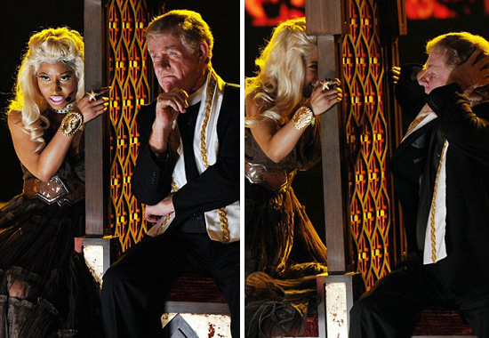

During this confessional she sings “I Feel Pretty” from West Side Story — but in an off-pitch, disjointed way that causes visible agitation to the priest.

The performance then cuts to a pre-recorded clip — in which the priest appears at a house, where a grandmother answers the door.

The very tense music and the grandmother’s demeanor lets us know her ‘son’ is upstairs — and is possessed by a demonic entity.

Once he goes up and confronts her, she acts like she is about to perform oral sex on a stick of pink lipstick — and then suddenly jumps up into the corner of the ceiling, in a move obviously impossible for a normal human being to perform.

THE RITUAL

After this clip ends, we are back on the main stage — wherein the ritual becomes much more blatant.



Minaj is strapped to a coffin-like sacrificial slab — as church windows loom behind her.

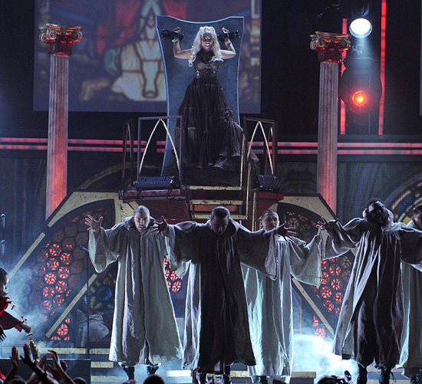

Then, after a verbal cue from Minaj, the windows all abruptly shatter — revealing blood-red skies behind them.

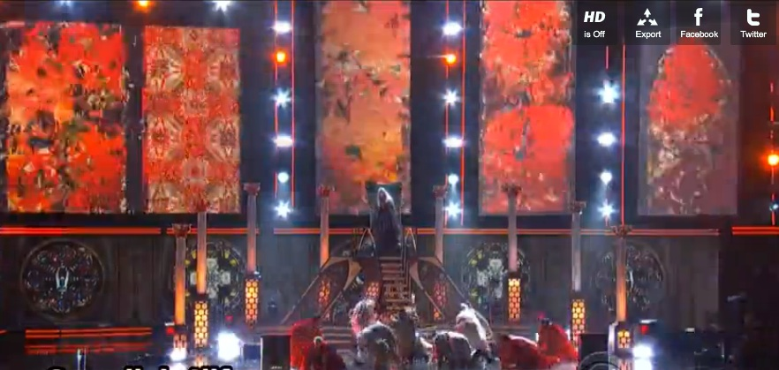

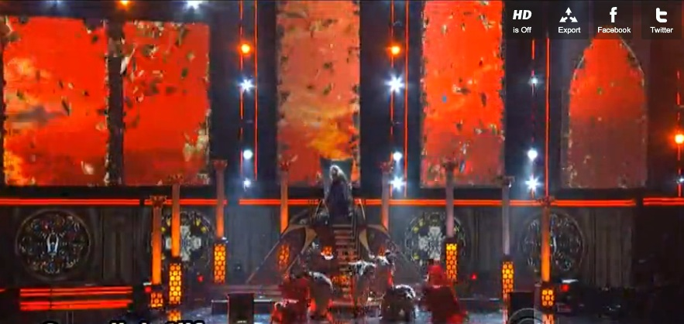

TEMPTATIONS

Once the Church is shattered and the demonic spirit within Minaj is set free, we then see church altar boys seduced by female dancers clad in black leather.

Notice in the first image how the camera angle is set so that a person’s right hand, flashing the sign of the Devil, is maintained within frame for that entire shot.

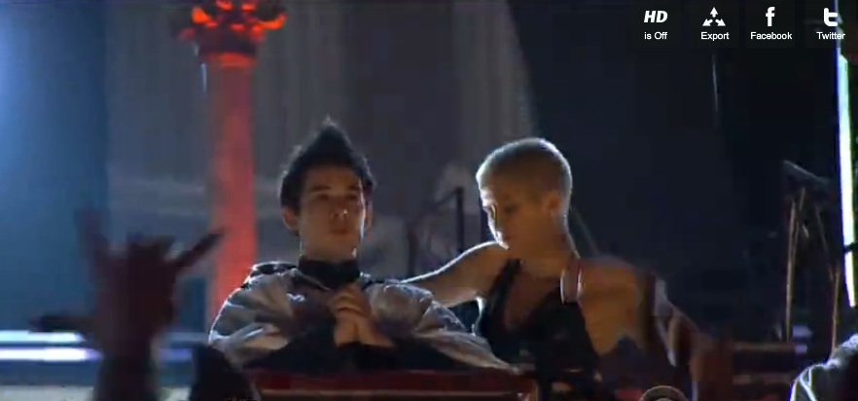

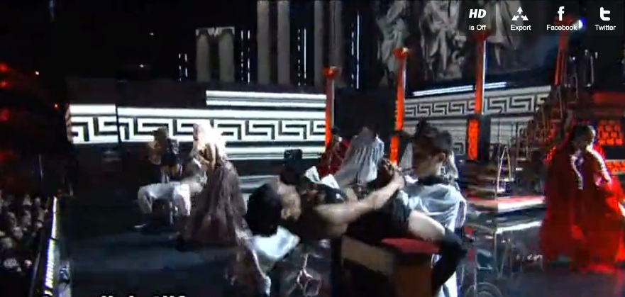

Shortly after the above, we cut back to the same scene — only now the altar boy dressed in white has been killed by the female dancer, and is slumped dead over the altar.

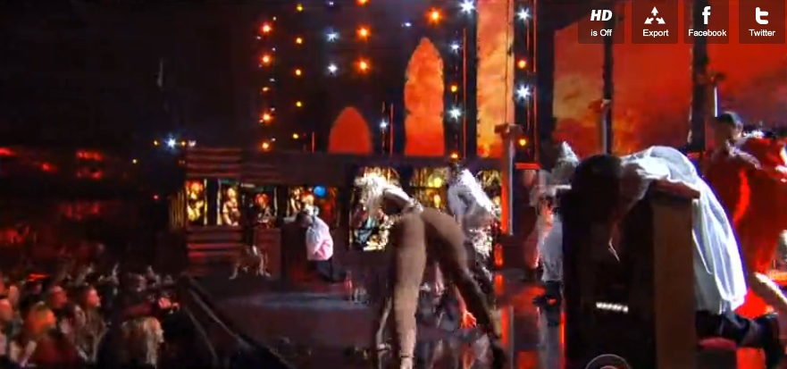

Minaj quickly occupies the altar where the slain boy’s body had just been.

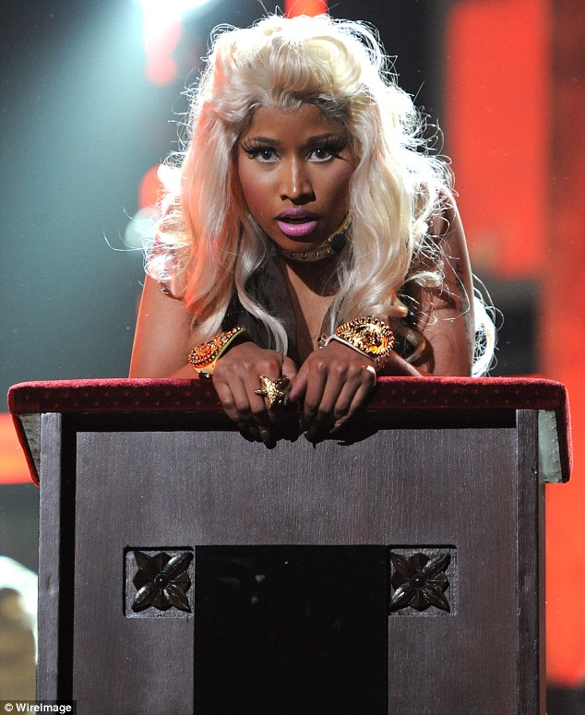

THE PRIEST ENTERS TO TRY TO PERFORM AN EXORCISM

At this point the priest enters to try to perform an exorcism on Minaj.

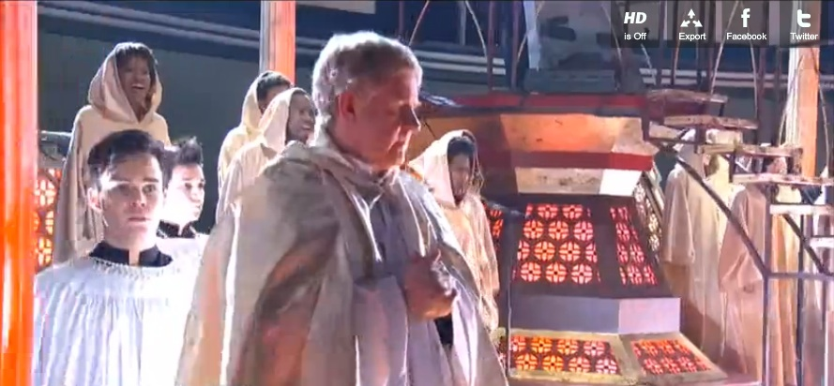

This only causes the ritual to become even more outrageous — complete with blazing fires and Minaj slowly levitating 75 feet above the stage.

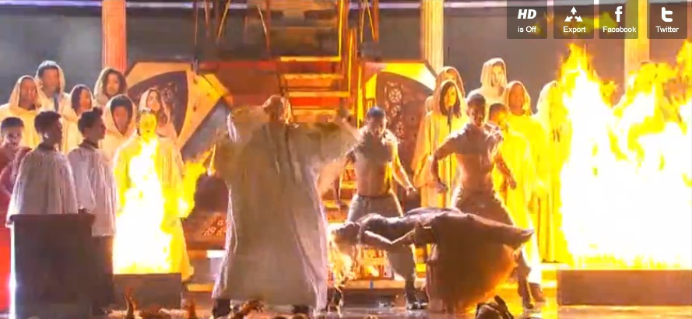

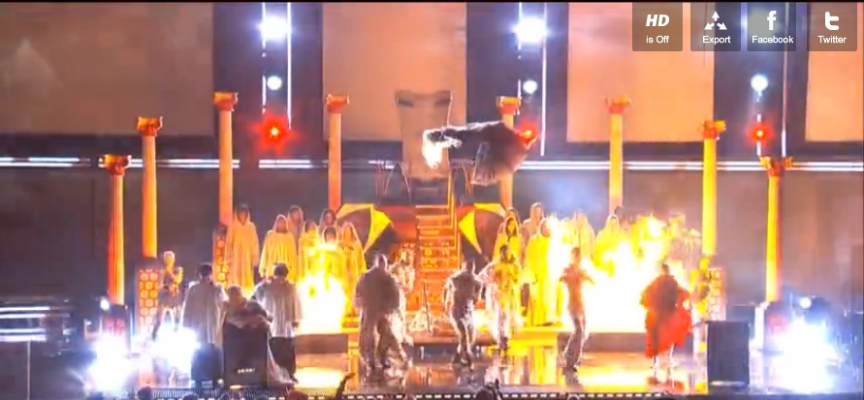

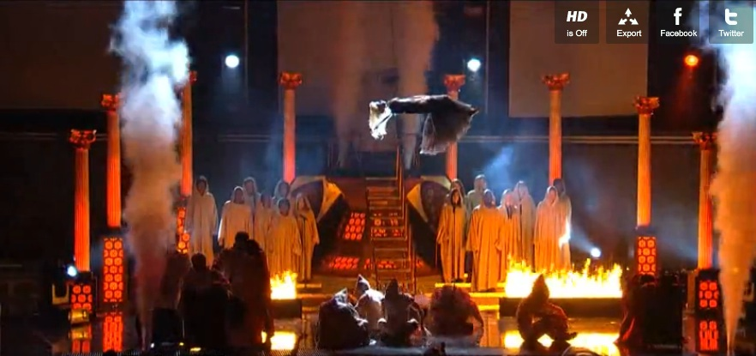

WHAT ABOUT WHITNEY?

Isn’t it strange that Whitney Houston — the biggest pop diva of the 80s other than Madonna — died in the very same hotel where the pre-Grammys parties were taking place?

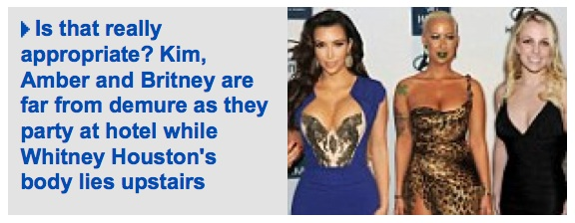

http://www.dailymail.co.uk/tvshowbiz/article-2100026/Kim-Kardashian-Britney-Spears-party-Beverly-Hilton-Hotel-Whitney-Houston-died.html

In Hollywood, they say the show must go on.

And last night not even the death of one of the music industry’s biggest names was enough to halt a pre-Grammy’s party in Hollywood.

Clive Davis decided to press ahead with his annual soiree at the Beverly Hilton Hotel despite the fact his protege Whitney Houston died in the same establishment, mere hours earlier.
The scene could not have been more dramatic or bizarre – as the guests made their red carpet arrival downstairs, Whitney’s body remained upstairs in her fourth-floor suite while the authorities investigated the death scene.

Poignantly Houston – who was found dead in the bathtub – was supposed to appear at the gala and was expected to perform after rehearsing for the show on Thursday with Brady and Monica.

Kim Kardashian, Britney Spears and Amber Rose were among the stars who were arriving on the red carpet while the police investigation carried on upstairs.

The young Hollywood starlets didn’t bother with subdued mourning attire in light of the tragedy and instead turned up in low-cut and very daring dresses.

WHITNEY’S DEATH MASSIVELY BOOSTED GRAMMYS RATINGS

Whitney may or may not have been killed deliberately, but if it was truly an accident, it was remarkably well-timed for Grammys ratings — as it instantly turned into an outlet for everyone to grieve.

2012 Grammy Awards: Huge Ratings!
http://justjared.buzznet.com/2012/02/13/2012-grammy-awards-huge-ratings/

The 2012 Grammy Awards, held last night, was a huge ratings HIT!!

The star-studded music award show delivered massive ratings – over 39.9 million total viewers – which placed it as the second most watched Grammy‘s since 1984! This was the second largest Grammy showing in history.

SONY JACKED UP THE PRICE — AND PROFITS ARE EXPECTED TO SOAR

In a highly controversial move, Sony increased the price of Whitney’s Greatest Hits album by more than 60 percent — immediately after her very opportunely-timed death.

http://www.guardian.co.uk/music/2012/feb/13/whitney-houston-album-price?newsfeed=true

Sony Music under fire after cost of greatest hits set on iTunes rises by more than 60% after singer’s death….

Sony Music has come under fire after it increased the price of a Whitney Houston album on Apple’s iTunes Store hours after the singer was found dead.

The music giant is understood to have lifted the wholesale price of Houston’s greatest hits album, The Ultimate Collection, at about 4am California time on Sunday. This meant that the iTunes retail price of the album automatically increased from £4.99 to £7.99.

Houston’s The Ultimate Collection, originally released in 1997, was the second top-selling album on iTunes on Monday morning. Apple returned the album to its original price late on Sunday.

Music fans described the move as a cynical attempt to capitalise on Houston’s in-demand greatest hits records.

AS TERRIBLE AS IT IS, IT ALL ADDS UP

Whitney’s sudden death generated over 13 million more viewers than the Grammys from the year before, which weighed in at 26.6 million.

Speculations that Whitney Houston was murdered have already begun — as we see here from Nancy Grace, speaking on CNN.

http://www.huffingtonpost.com/2012/02/13/nancy-grace-whitney-houston-underwater_n_1274757.html

Nancy Grace speculated on Monday that someone might have “pushed” Whitney Houston underwater, leading to her death.

The HLN host was speaking to CNN’s Brooke Baldwin about the late music icon, who died suddenly on Saturday. Police said on Monday that she had been found underwater in the bathtub of the hotel room where she was found.

Grace appeared before the police’s press conference. But she seemed to sense that some kind of foul play was afoot. Speaking about the prescription drugs found in Houston’s hotel room, she wondered “who if anyone put it in her system or gave it to her?” Then, she went further.

“I’d like to know who was around her, who, if anyone gave her drugs…and who let her slip, or pushed her, underneath that water?” she said. “Apparently, no signs of force or trauma to the body. Who let Whitney Houston go under her water?”

“Might it have been one person, might it have been multiple people, all excellent questions,” Baldwin said. “Again, we don’t know the cause of her death.”

INSTEAD OF GRIEVING, THEY SAW ONE OF THE MOST BLATANT RITUALS IN TELEVISION HISTORY

Many of the people who tuned into the Grammys expected to be able to grieve Whitney’s loss. Yet, instead they were subjected to a traumatizing satanic ritual.

There were other signs as well — including Dave Grohl, lead singer of the Foo Fighters, wearing an upside-down cross while he was speaking on stage.

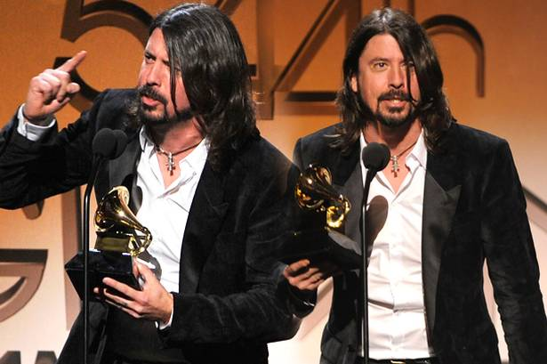

In case you forget, Dave Grohl was originally the drummer in Nirvana — up until the lead singer, Kurt Cobain, shot himself in the head.

We may never know if Whitney was deliberately sacrificed — but these are questions that will only grow stronger as time goes on.

THIS IS NOT THE FIRST TIME THEY’VE “HIDDEN IT OUT IN THE OPEN”

When I visited the UK in 2010, I was stunned by what I saw in the Salisbury Cathedral.

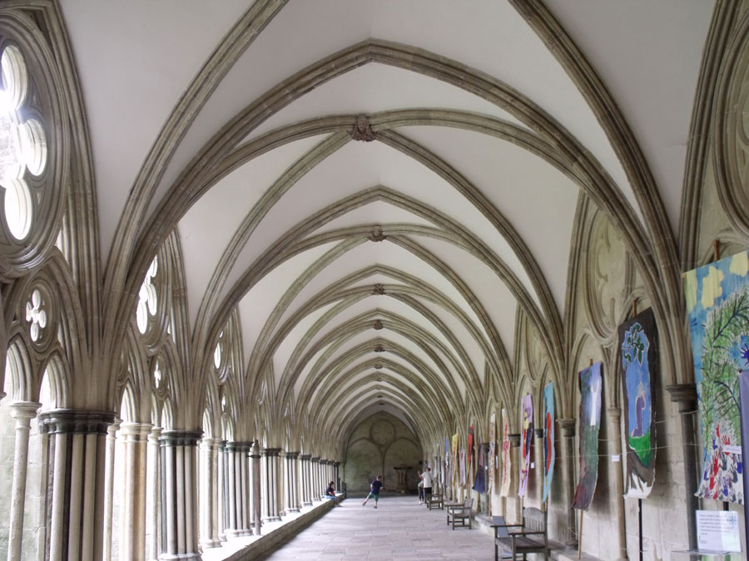

Masonic symbols appeared all over the place inside this cathedral. I didn’t photograph all of them, but people in my tour group were filming as I pointed things out like Templar crosses and a huge doorknob adorned with the Masonic double-headed eagle.

We started to get ominous trouble from the church as I excitedly pointed out Illuminati symbols, with a loud voice, in front of my group as they were filming.

Before long, I was ordered to stop talking as I was “disturbing the service” occurring in one area — even though hardly anyone was there.

I went to go see where this “service” was happening… and an even greater surprise was in store for me.

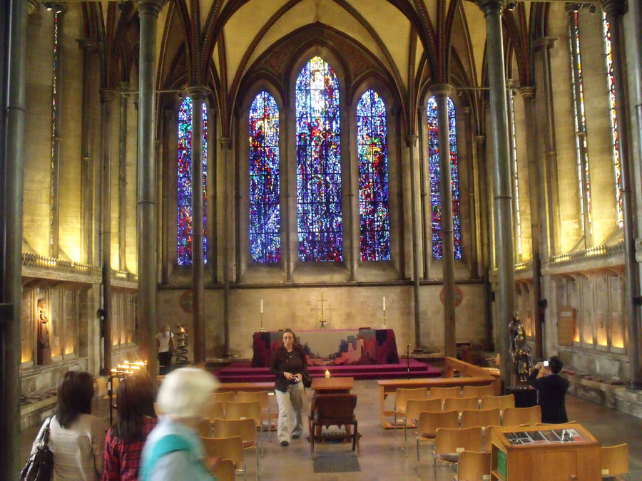

This was the “service” that was taking place. Not one person was even sitting down as I approached this area.

However, I could hardly believe my eyes as I approached the altar. There, in plain sight, was what appeared to be a human-sized black sacrificial slab.

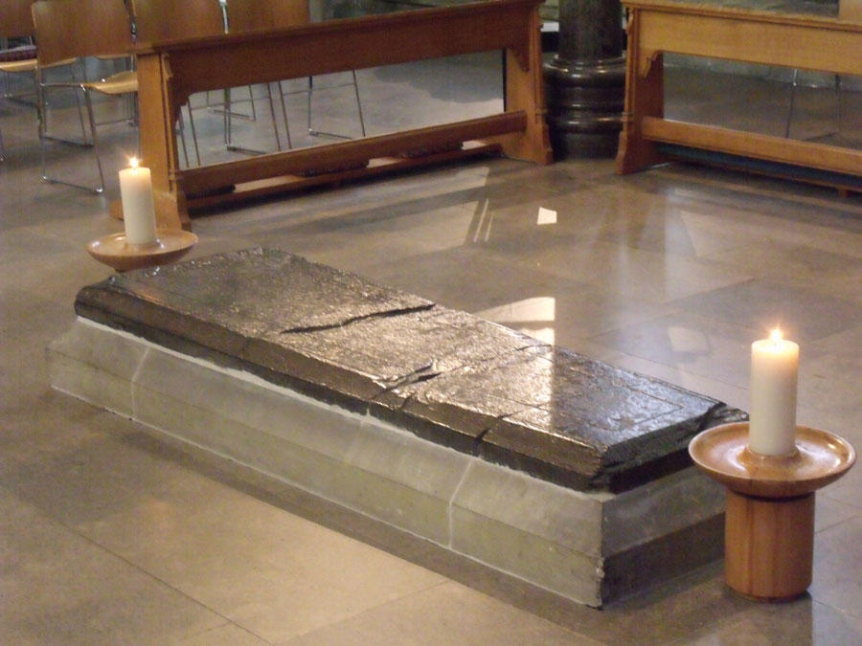

Knowing this was very likely the real thing, I went up and put my hand on the slab. I said a silent prayer for the souls of whomever may have lost their lives in occult rituals on this slab.

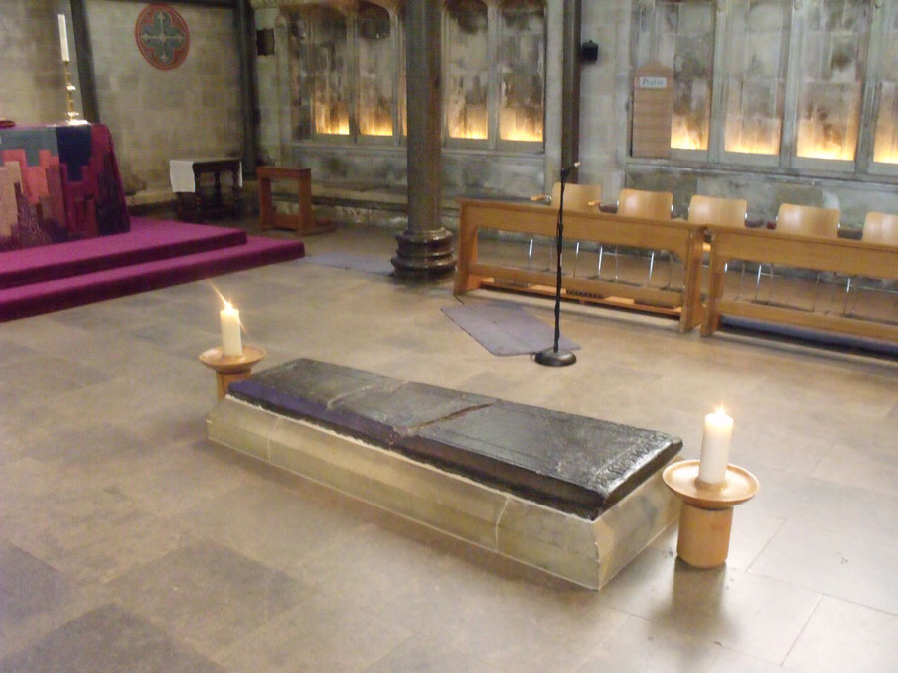

There was a sense of great, oppressive darkness as I touched the slab. I did my best to let it course through me so it could be released, with love.

Svali is on record saying that human sacrifice rituals have been conducted in “black mass” ceremonies that take place in various churches during the night.

Everyone in our group was totally creeped out by this. The cathedral was a veritable grab-bag of Templar crosses, Masonic symbolism and other strange and disturbing regalia.

I’m sure some Illuminati members are thrilled to go through this cathedral and have so many in-your-face symbols on display. And now, they’ve exposed themselves in front of the entire world — in the Super Bowl halftime show.

THEY KNOW THEY HAVE RUN OUT OF TIME

Such an outrageous, totally obvious ritual showcase of Super Bowl symbolism does strongly argue that they know they have run out of time. The truth is about to come out — one way or the other.

Most of their members will be very glad to be free once this happens.

As I have said throughout this entire investigation, fear is what stops people from seeing the obvious. This blatant, global display in the Super Bowl halftime show was a very aggressive, tactical move.

This investigation — and the lawsuit behind it — is one key element that is now forcing this astonishing conspiracy out into the open — so we can finally heal as a planet.

THE ULTIMATE PONZI SCHEME

The Illuminati’s plan calls for the complete destruction of the global economy — at a time of their precise choosing.

They needed a global currency that was backed by nothing but “faith and credit.” Top insiders have told me the word “faith” is very important — and there is a reason why that word always appears first.

The greatest secret of the 20th century was how the gold and treasure of the world was systematically plundered and hidden away… only to be used as collateral for vast, secret bank accounts.

This “gold-backed” occult economy allows for wealthy private individuals to become brokers — who facilitate “trades” between central banks.

UPDATE 2/10: DOCUMENTED, WRITTEN PROOF IN THE NEWSPAPERS

Is there any documented proof that this gold was shipped to the Federal Reserve? After publishing this investigation, I got an anonymous tip — and I acted on it immediately.

David, go to http://news.google.com/newspapers, which is Google’s news archive scans of old newspapers. If you do a search there for China Gold, or similar, you will see a number of articles that talk about shipments — and Chinese gold being held here in the US!!

This correspondent was absolutely correct. I restricted my search to the New York Times, with the keywords “China gold”, and a great wealth of data showed up.

Benjamin Fulford said seven destroyers’ full of Chinese gold — totaling 125,000 metric tons — was shipped to the United States in 1938, to protect it from the Japanese, who were invading China.

Obviously, such a mission would need to be kept absolutely secret from the militant, powerful Japanese, or else they would retaliate. However, someone made a mistake — and one of these secret shipments of Chinese gold actually got intercepted.

It wasn’t a large shipment, relatively speaking, but the important point is that they got caught.

Here’s the link — where I then paid $3.95 to download a copy of the original article:

U.S. Liner Yields to Japan on Cargo – New York Times, October 25, 1938, Page 14
http://select.nytimes.com/gst/abstract.html?res=F50811F63955157A93C7AB178BD95F4C8385F9

Shipment Goes Back to Chase Bank After Japanese Insist Metal is Chinese-Owned….

The Dollar liner President Coolidge unloaded a cargo of gold bars, silver bars and coins collectively worth $2,800,000 last night after Japanese-controlled officials had refused to clear the ship unless she sailed without the shipment.

SEEING IS BELIEVING — 2.5 METRIC TONS OF GOLD TO SHIP FROM CHINA TO FEDERAL RESERVE IN 1938

Gold was at 35 dollars per troy ounce back then. $2,800,000 dollars in gold was 80,000 troy ounces. There are 32,150.746 troy ounces in a metric ton. Therefore, if we don’t count the silver, this one shipment alone would be 2.488 metric tons’ worth of gold.

The article reveals that the shipment was coming to the US from Chiang Kai-Shek. The Japanese were angered by this — and refused to allow the ship to depart until all 2.48 tons of gold were removed.

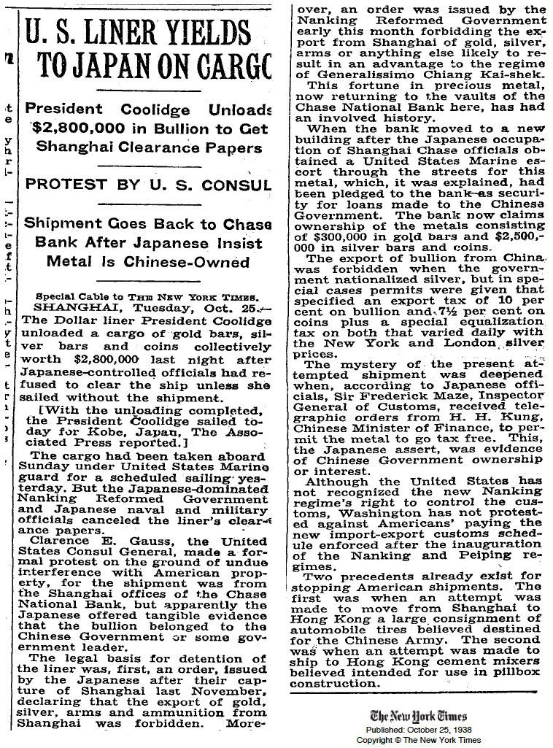

2.488 metric tons is, of course, a very small shipment compared to a total of 125,000 tons — but this was probably a final clean-up mission after the majority of the Kuomintang / Dragon Family gold had already been removed.

That may also have explained why their security was weaker on this shipment of gold bars, coins and silver — thus leading to them being caught.

MANY OTHER NEWSPAPER ARTICLES TELL THE REAL STORY

Throughout this investigation, we have discussed how the Bank for International Settlements took in gold from all over the world, and put it on “deposit” with the Federal Reserve — their main stronghold — in exchange for bonds.

Here are some of the news stories I found that prove it — with hardly any digging. I searched 1938, 1937 and 1934 — the year on most of the Federal Reserve Bonds we’ve been exploring.

The first article you are about to read is from February 19, 1937. Then we begin on April 14, 1934 and move forward chronologically throughout the year: June 8th, September 21st, and December 1st, 1934.

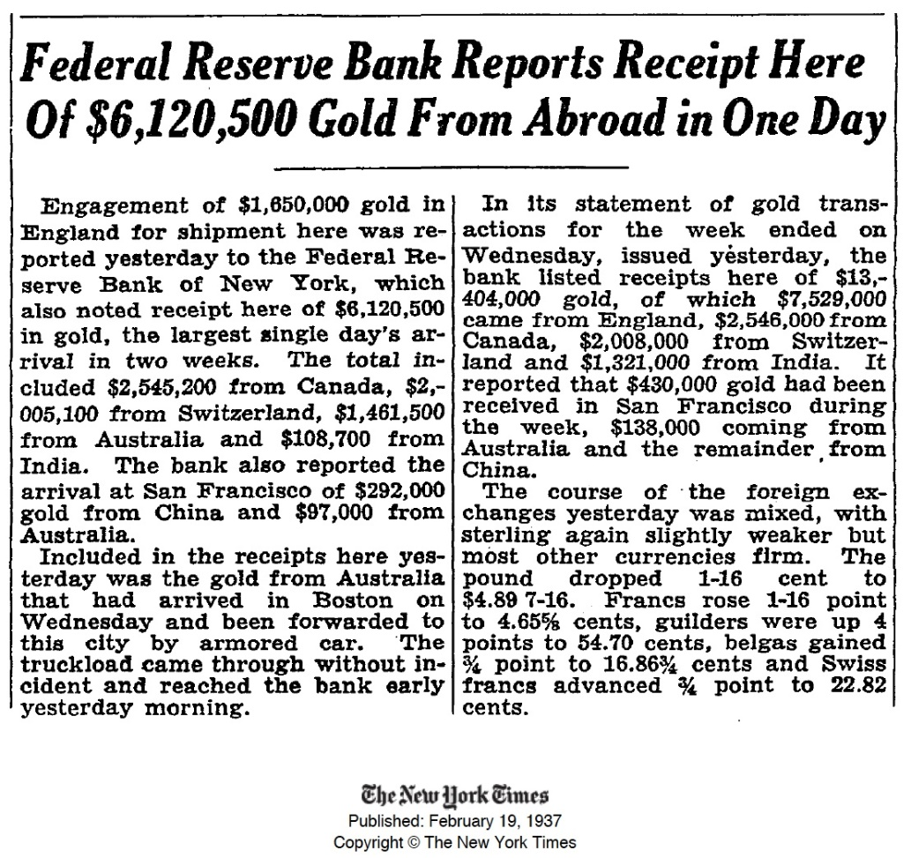

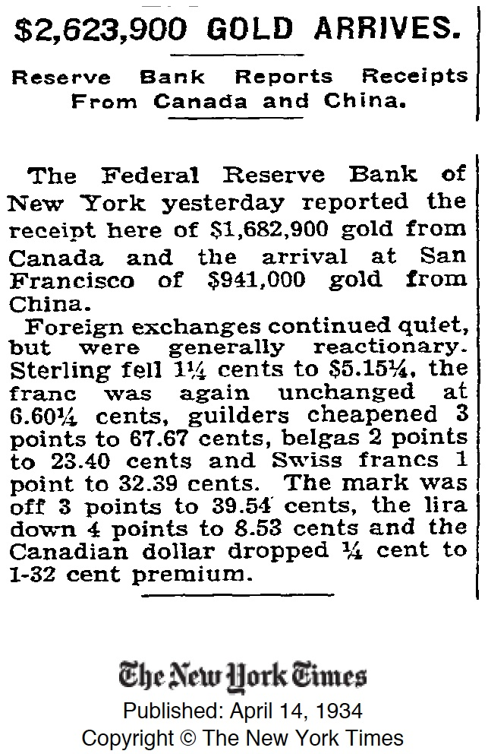

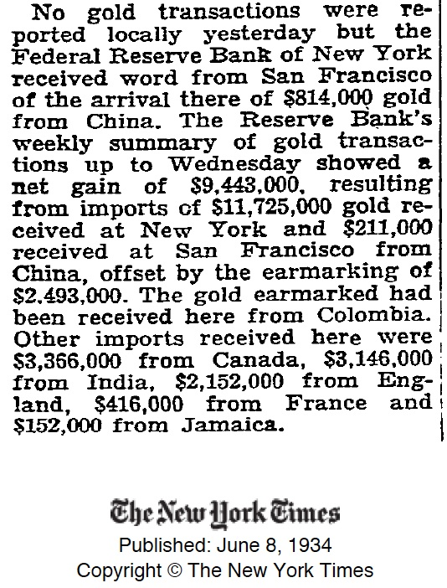

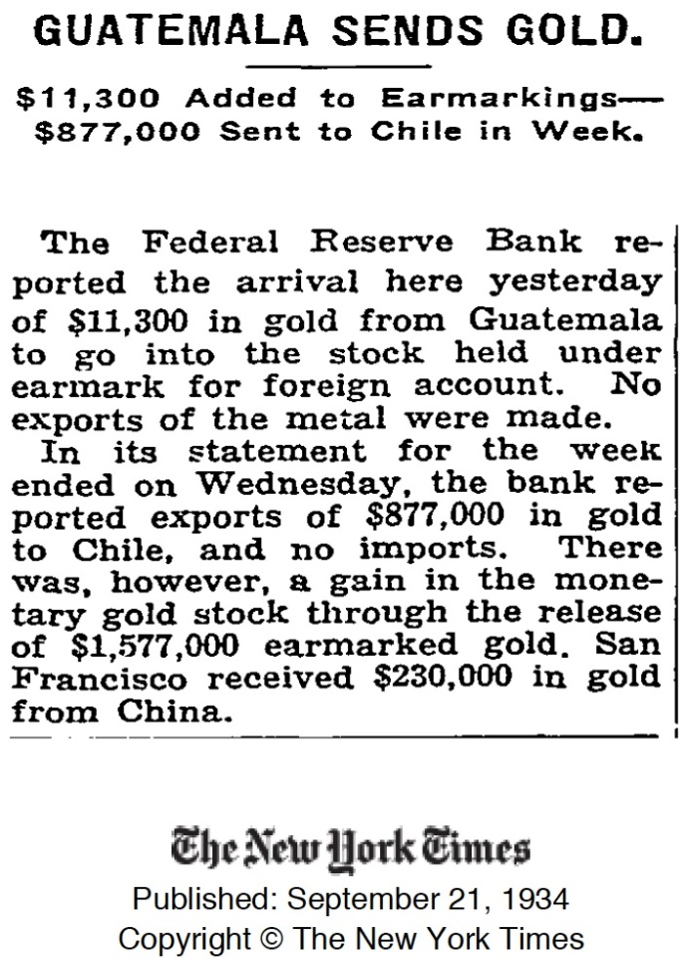

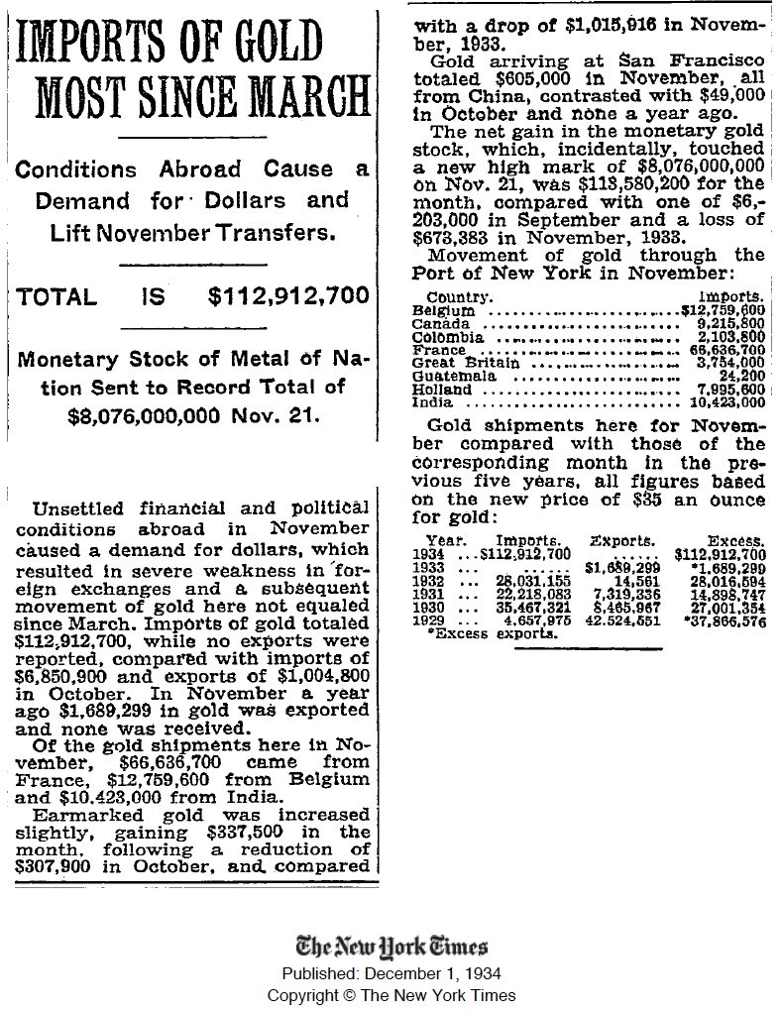

DO THE MATH

The last newspaper article we just read, from December 1, 1934, reveals a total excess of $222 million, 385 thousand and 270 dollars‘ worth of “imported” gold to the US between 1929 — when the BIS was officially founded — and 1934.

At the stated “new price” of $35 an ounce, this adds up to roughly 6,540,743.23 troy ounces, or 203.43 metric tons of gold.

As we can see, this process continued well after 1934. Our first article revealed that $6,120,500 in gold was taken in by the Federal Reserve in a single day — on February 19, 1937.

Chiang Kai-Shek supposedly sent 125,000 metric tons of gold to the US in 1938. This is obviously much higher than the publicly-reported 203.43 metric tons that had been taken in from various countries between 1929 and 1934.

However, let’s not forget that we now have documented proof that secret gold shipments were conducted from China to the US in 1938.

Japan intercepted 2.488 metric tons of gold, bound for the Federal Reserve, on October 24, 1938. It is very likely that many other shipments occurred and were not intercepted — just as we have been told — and Federal Reserve bonds were issued.

The Federal Reserve and BIS put this gold “on deposit” — and after the Bretton Woods agreement in 1944, the “deposited” gold was used to underwrite a secret economy, in which private individuals facilitated trades between central banks.

ENORMOUS PROFITS

The profits created by this occult economy are enormous — and completely non-taxable. Even the “normal” gains at the high end can be as much as 40 percent per week.

The Bretton Woods agreement stipulated that 70 percent of these profits should go to humanitarian relief efforts — but that definitely does not appear to have happened.

I spoke to a new, high-level financial insider recently. When I told him it seemed like the whole purpose of this “occult economy” was to collapse the legitimate economies of the world, he told me I was absolutely correct.

Think about it. The more people pull money out of these enormous accounts and use it in the legitimate economy, the more it destroys the value of legitimate currency.

INSIDERS HAVE STEPPED FORWARD

Now that I have broken the silence and revealed what I know, three new insiders stepped forward to share their stories, in detail, at the end of Section Six — as well as a fourth person who only spoke briefly.

“Lee” chastized me for my lack of knowledge of the occult economy — and confirmed the real game doesn’t begin until you have 500M to invest.

“Peter” revealed that he had a direct connection to one of the “Commitment Holders” — who apparently are also called “Gatekeepers”, as others have informed me.

These “Commitment Holders” are the ones who control which people are allowed into the occult economy.

Peter’s commitment holder was a “buddy of a major US President”, and his commitment holder’s attorney was the former Secretary of the US Treasury.

“Alexa” revealed a variety of intriguing bits of inside information. This included the fact that at least four “fake” bond boxes are made, in the Philippines, for every real box.

Alexa also said that even the real boxes contain up to 20 percent counterfeit bonds. This way, any legitimate bond holder could be arrested at any time — while the Secret Service makes off with the rest.

EVEN MORE INSIDERS ARE COMING FORWARD

Directly after we published Section Six, we were contacted by Carol Adler, the CEO of Dandelion Books, and were given even more information.

On October 31, 2003, Carol published a press release on Rense.com revealing her contact with a CIA insider who provided her with extensive documentation of the occult economy.

The insider was dead before she could ever finish the book he wanted her to write. A vast wealth of supporting documentation was immediately stolen.

Nonetheless, Carol’s press release should sound very familiar by now.

http://www.rense.com/general43/dand.htm

On December 1 [2003], a former CIA contract agent will go on trial in the Southern District Court of New York State, charged with attempting to negotiate a fictitious 100-million dollar note — when in fact documents show it was submitted for due diligence only.

On assignment from July 1995, the accused former CIA contract agent, whose name cannot be disclosed at this time, was instructed to find and recover Morgenthau bonds, Federal Reserve Notes and currencies — and bring back these assets to the US.

He is among several former CIA contract agents who successfully completed their assignment. In doing so, he worked closely with Taiwanese counterparts.

Because of the groundwork done by this former CIA contract agent, several teams are now successfully recovering these assets.

MORE FROM CAROL ADLER’S PRESS RELEASE

As Carol Adler’s press release continues, the similarity with what we have already been discussing becomes nothing short of astonishing.

http://www.rense.com/general43/dand.htm

Many of these bonds and currencies are part of the Morgenthau diaries and are discussed in the book, THE BROTHERHOOD OF MONEY, by Murray Teigh Bloom [BNR Press, 1983].

The value of these assets–“an amount with so many zeros after it, it’s mind-boggling even to consider that much money,” states the former CIA contract agent, “would dissolve America’s debt on all levels of government and abolish the need for a federal income tax.”

“We’re talking about more than enough money to take care of all of this country’s ills: education, social welfare, employment, industry, environment [and] improvement of the quality of life for every US citizen,” states Carol Adler, Dandelion’s CEO and president.

Issued to China and other Asian countries prior to, during and after World War Two up until 1999, the instruments and commodities are worth trillions of dollars in the form of large-denomination Federal Reserve Notes, bonds, gold and platinum currencies and jewels.

Even though the instruments and assets have been tested and approved forensically, the US Government claims either the assets are false or non-existent.

According to the accused former CIA contract agent, the instruments were printed by the US Bureau of Engraving and Printing — and several bank note companies approved by the US President and Treasuries in the US, Canada, England and China.

“It is no longer possible for the US Government to deny either the existence or authenticity of these instruments and assets,” claims the accused former CIA agent. “The volume of these commodities is so great — and too many of them have proven to be authentic.”….

“I am an American patriot. I risked my life for my country, only to discover I was never to have “successfully performed my mission” and come out alive — if the American people ever learned of these assets.”

THE BONDS EVEN AIRED ON NATIONAL TELEVISION
An NBC show entitled American Greed revealed this secret world to the public — including images of the bonds themselves — only to write it off as a “Nigerian email scam for rich people.”
This episode, entitled Suicide is Painless, originally aired on February 3, 2010. It discusses the downfall of Samuel Israel III, who tried to abruptly enter into the world of ‘trading’ as his hedge fund, Bayou Investments, was collapsing.
His plans may well have succeeded had he not been in such a desperate rush to get cash. As I said before, people are occasionally sacrificed to make the system itself appear to be fraudulent.
If you watch a video of it, you can start at the 20-minute mark to hear about Israel’s involvement with the bonds. Each bond in the box had a face value of 100 million dollars. I have transcribed it below.

TRANSCRIPT OF “AMERICAN GREED: SUICIDE IS PAINLESS” — FEBRUARY 3, 2010
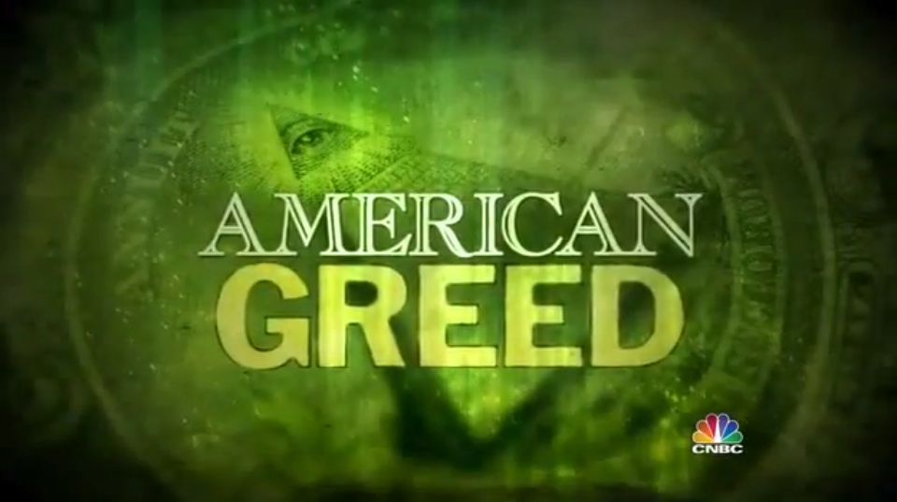

NARRATOR (20:02): As the venture capital investments failed, Israel’s strange saga takes a wild turn as his desperation grows.

At some point in 2004, Sam makes a friend who claims he can solve all of Bayou’s problems – for a slight fee.

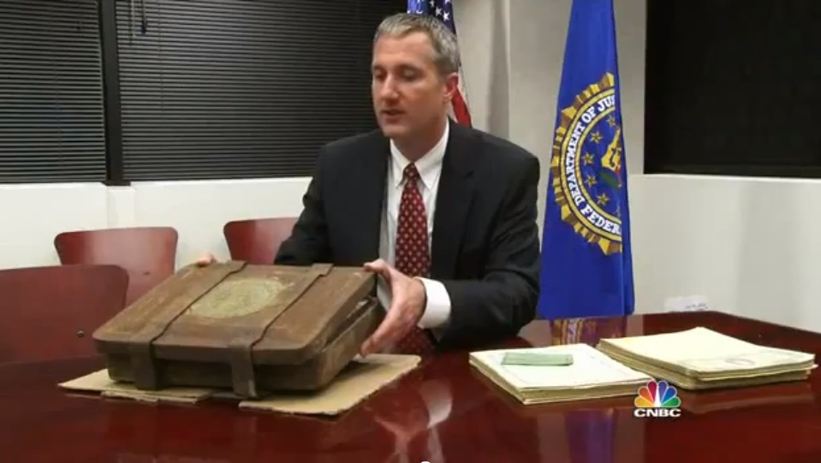

FBI AGENT: This individual was a pretty shadowy figure. He told Sam that he was an ex-CIA officer, he was involved in black operations. A lot of super-secret spook stuff, which Sam just bought hook, line and sinker.

NARRATOR: This man tells Israel about a shadow world of secret government projects – some humanitarian, some “black ops.”

All financed by “Select” or “Prime Banks,” and invite only, to exclusive investors.

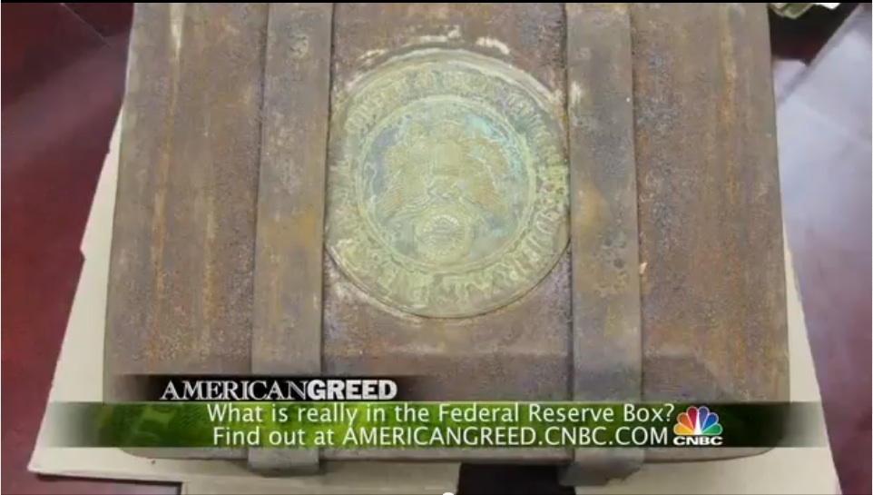

The man sweetens the pot. He tells Israel about a mysterious Federal Reserve box he has that contains unimaginable wealth. Even better than the background story is the incredible rate of return promised Sam.

FBI AGENT: [He said if] you send over a hundred fifty million dollars, you can generate up to 100 percent return within a couple weeks’ time.

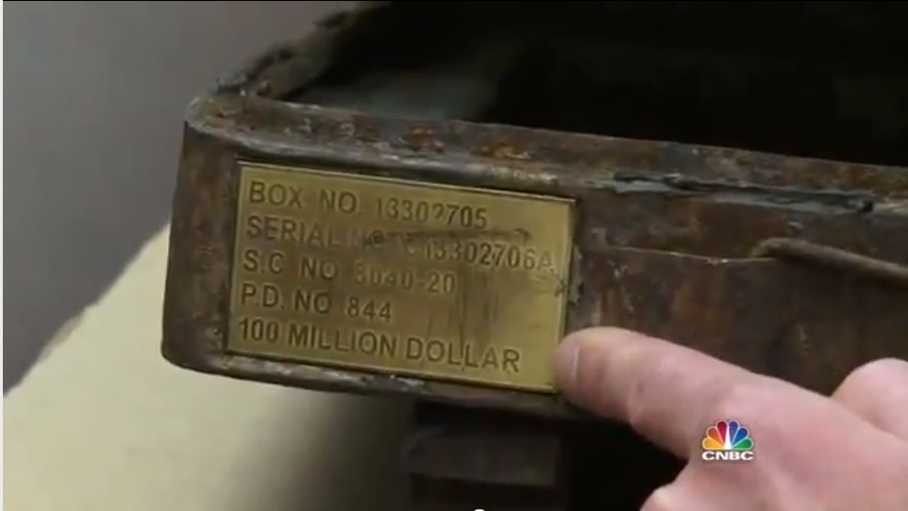

NARRATOR: Israel is essentially singled out for the super rich man’s equivalent of a Nigerian email scam.

Israel pays the man ten million dollars to get him in. In return, he is offered a fascinating bit of collateral.

A so-called Federal Reserve box, supposedly from World War II, that contains over 100 million dollars in Federal Reserve bonds.

[DW: “Over 100 million dollars” is misleading, considering that each individual bond has a face value of 100 million dollars — as you can see in the following pictures.]

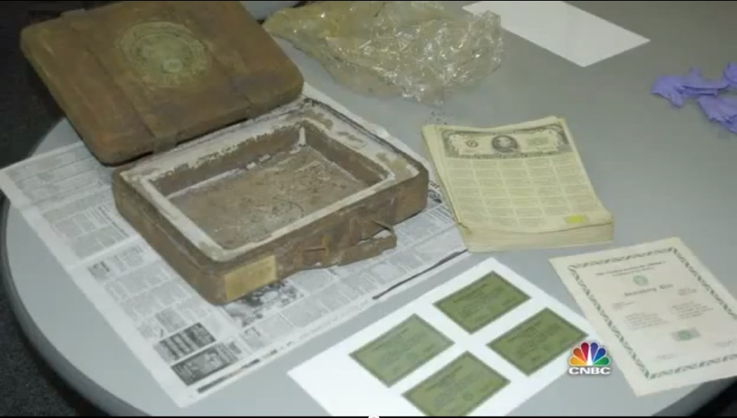

FBI AGENT: This individual told Sam I have this super-secret box. I’m going to give you this thing.

You can’t tell anybody about it. It could destabilize the US economy if you told anybody about it.

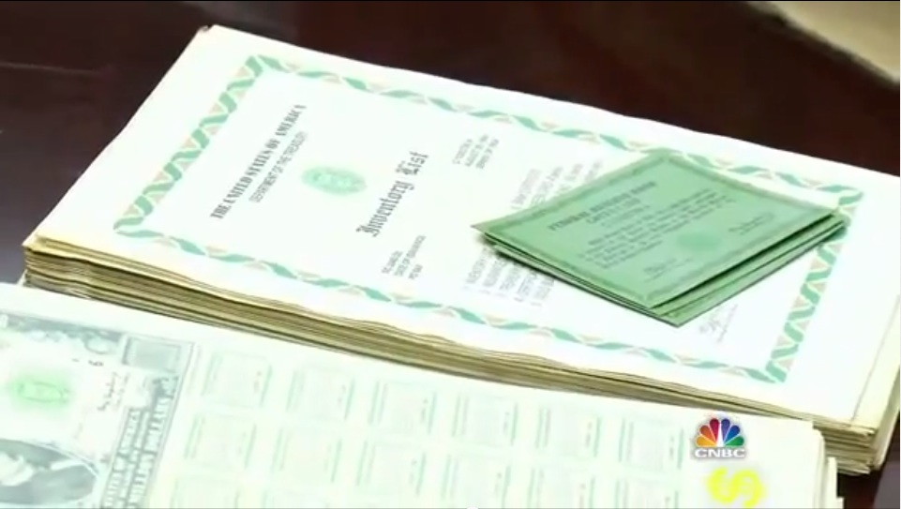

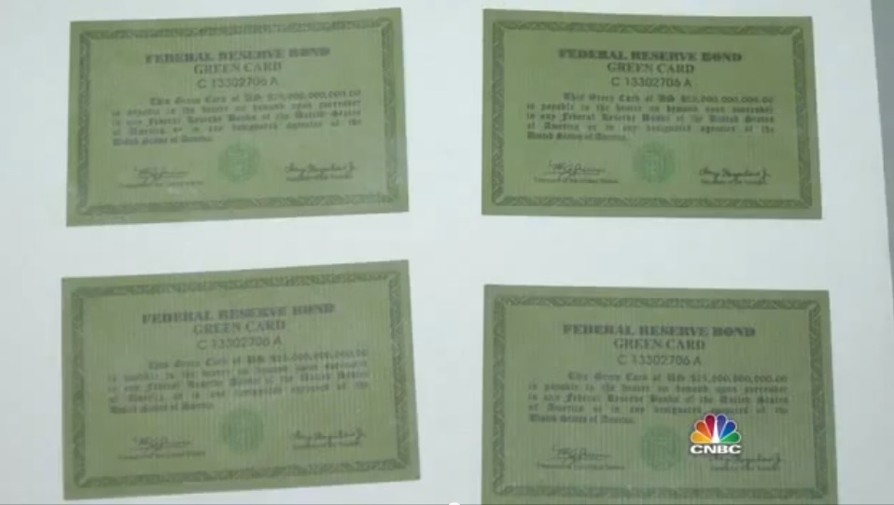

NARRATOR: Of course, it’s too good to be true. The catch? The Federal Reserve issues notes, not bonds.

The box is an elaborate hoax. One FBI agents have heard of, but never seen until now.

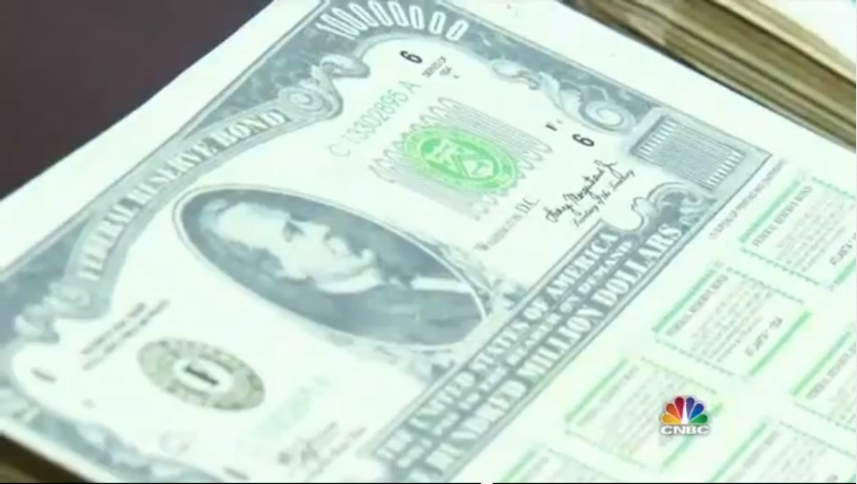

FBI AGENT: So somebody went through a lot of work to create this fraudulent box to steal ten million dollars from Mr. Israel.

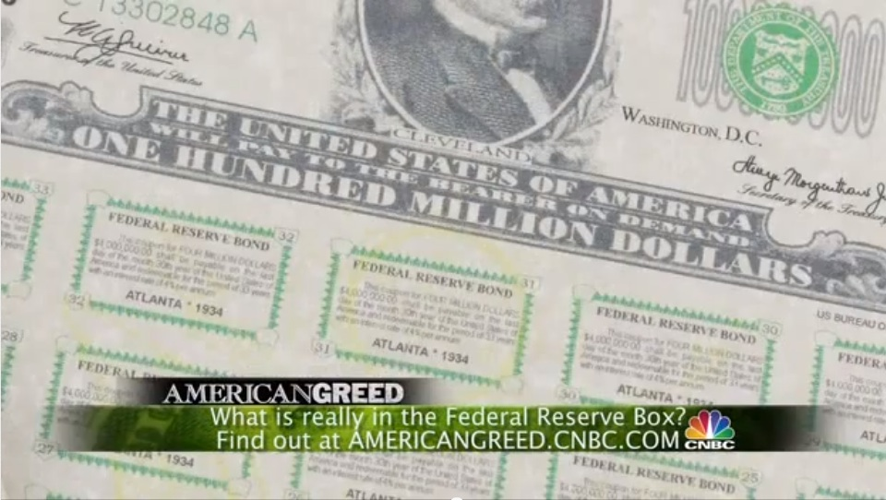

NARRATOR: The scam Israel falls for is well known to federal investigators. They are called prime bank frauds or high-yield investment frauds.

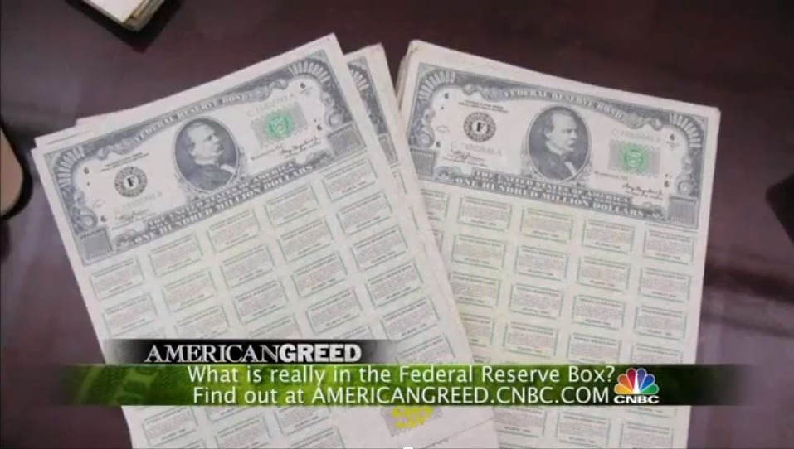

HIDE IT OUT IN THE OPEN

By showing these bonds on national television and labeling it as a “scam” and a “hoax,” the controlled media took damage-control steps in the event that any of this scandal ever became public.

In April 2009, the Dragon Family — i.e. the former ruling party of China known as the Kuomintang, run by Chiang Kai-Shek in the 1930s — issued two sets of bonds, hoping to free up some of their seized assets.

One set ended up seized in Chiasso, Italy. The other was given to Daniele Dal Bosco by Neil Keenan and was stolen — thus forming the basis of our investigation.

Another incident occurred in Spain less than two months later, on June 1, 2009 — involving an even larger quantity of bonds. In this case, it was rigorously covered up by the media outside of Spain.

It appears that the Illuminati-controlled media was deeply concerned that if two of these stories got publicity at the same time, people might start asking too many questions.

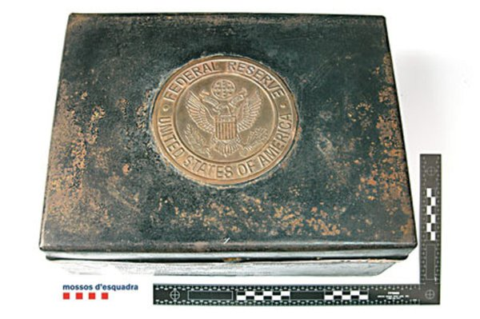

If each and every legal case involving Federal Reserve bonds is nothing more than a hoax, why would there be so much secrecy around this Spanish event — and others like it?

UNWANTED PUBLICITY ON THE SPAIN BOND SEIZURES

This is just a very small summary of all the information there is to read about this intriguing case on Unwanted Publicity — the very site that David Hutzler sent me to, a week before he and his 8-year-old son died of gunshot wounds to the head.

Spain Seizure of 1.64 Trillion in 1934 Federal Reserve Bonds
http://upintelligence.multiply.com/reviews/item/28?&item_id=28&view:replies=reverse&show_interstitial=1&u=%2Freviews%2Fitem
USA, Washington, D.C. – October 14, 2010 – Combining criminal intrinsic and face values of what federal law enforcement authorities seized in Spain, [they] should have stopped counting at $1,664,082,000,000 trillion U.S. dollars (that-is: $1,664 billion) by June 2009….

[This was something] ‘only local news reports’ identified as an investigation that actually began beforehand during March 2009 — when federal law enforcement investigators began “Operation Morgenthaus.”….

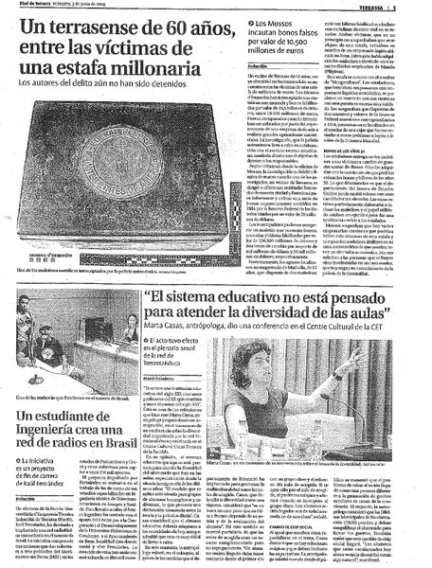
The Spain news report details were ‘extremely convoluted’ with a ‘wide spectrum of information disparities.’

Plus, the U.S. mainstream media news blackout of the Spain seizures of U.S. Federal Reserve Bank Federal Reserve Notes and more (face value of more than $1.6 trillion)… went un-noticed by the rest of the world public….

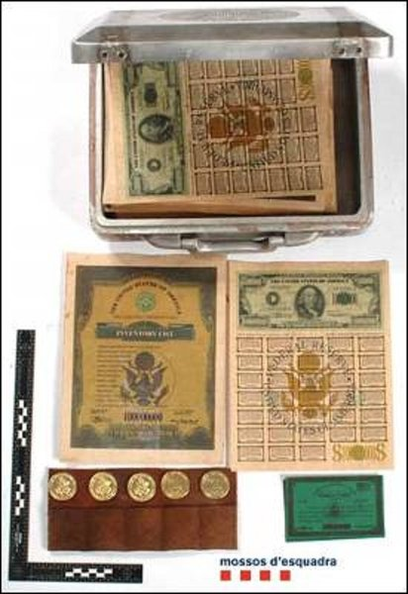

Why was the Chiasso, Italy news story carried by ‘all major world news wire services’ in addition to so many world television news program broadcasts?
Why was the Spain news story hushed by ‘world news’?
Did U.S. government embedded reporters around the world have anything to do with this?

ANOTHER MAJOR BONDS CASE IN 2003
Another case involving 2.5 trillion dollars’ worth of Federal Reserve bonds broke into mainstream media in 2003 — involving a wealthy man named Graham Halksworth and a former Yugoslavian spy named Michael Slamaj.
This next article appeared in the UK Independent on October 28, 2003. It has since disappeared from their website — but the original ‘teaser page’ can still be viewed on Archive.org.
The only reason I found it is I did a keyword search on Jeff Rense’s website. This was one of very few articles that popped up once I began looking for words like “Morgenthau bonds.”
http://www.rense.com/general43/whow.htm

Deep in the vaults of a London bank lay 22 cases stamped with the American golden eagle. They were crammed with US Treasury bonds whose face value was so high that if anyone tried to cash them it would virtually bankrupt the US government.

An extraordinary story was attached to them. In 1934, the Chinese Nationalist leader Chiang Kai-Shek was facing a twin threat — from the invading Japanese and from the Communist rebels of Mao Tse-tung.

For safekeeping, [Chiang Kai-Shek’s] supporters sent 125,000 tons of Chinese gold to America and, in a covert deal with the president Franklin D Roosevelt, were given US bonds in return.

The sum was so large that it led to the creation of Fort Knox and paved the way for America to abandon the gold standard….

THE PLOT THICKENS

This UK Independent article sounds very familiar — it is the basis of the Dragon Family lawsuit that started this investigation. The lawsuit, remember, is backed by physical proof of key conspirators discussing the truth of this gold exchange.

As we continue studying this case, we find out that Graham Halksworth sent two men to a bank, with 25 million dollars’ worth of these bonds, hoping to use them as collateral — to open up a line of credit.

http://www.rense.com/general43/whow.htm

Two years ago, two men — a Korean living in Japan and a Canadian — walked into the Imperial Bank of Commerce’s main branch in downtown Toronto and tried to cash $25m (£15m) of US Treasury bonds.

With the bonds, they offered a certificate of authentication bearing Halksworth’s signature. What the eagle-eyed Mountie spotted was that the letter “s” was missing from the word “dollars” on the bond….

The idea was not to try to cash the bonds: it was to offer them to financial institutions, along with the authentication documents, and the indication that the US government backed the documents with gold, to secure a line of credit.

But the attempt to cash them subjected the whole scheme to close scrutiny. It was not long before the police were knocking on Halksworth’s door.

HALKSWORTH EXPLAINS THE DELIBERATE MISTAKES

As our excerpt continues, Halksworth shared what he knows about how this system works with the Canadian mounted police.

http://www.rense.com/general43/whow.htm

Even then the old hand was unfazed. Deliberate mistakes were often made in such bonds as a security device; ask the CIA, he said.

But some bonds had so many mistakes on them it looked like a child had printed them, the police said; exactly, he replied, as if that proved his point….

But there were some pieces of evidence to which Halksworth had no answer. He and Slamaj, the man who had ostensibly received the bonds from the Mindanao tribesmen, claimed that Chiang Kai-Shek had given the Americans 125,000 tons of gold in the 1940s.

[DW: The Independent probably got this detail wrong — as most of these shipments occurred in the 1930s.]

But police inquiries on the London Bullion Market revealed that the cumulative total of all the gold mined in recorded history was only 63,500 tons by 1950.

Even more damning, the documents contained zip codes which the US postal service introduced only in 1963 – and a Treasury Seal which was too modern. Furthermore, analysis showed that some of bonds had been produced on an inkjet printer….

REMEMBER WHAT ‘ALEXA’ SAID

These particular bonds may have been hoaxes — but maybe not. Keith Scott has told us that as the price of gold rises, more bonds are issued to cover the difference. This would explain the zip codes and the newer Treasury seal.

Our whistleblower ‘Alexa’, whom I have met and spoken with in person, confirmed that obviously fake bonds are included in every ‘real’ box — so that anyone trying to cash them can be arrested.

Probably the single best way to make a ‘fake’ bond is to use an inkjet printer. It would look almost exactly the same, but the colors would run once you got it wet.

That may be what happened here.

TELEVISION COVERAGE OF THE HALKSWORTH / SLAMAJ CASE

The Halksworth / Slamaj story did appear in a few other places as well — including a Scottish newspaper and a UK television documentary produced by Journeyman Pictures.

This documentary openly revealed how “CIA records show that there was indeed a secret mission to remove gold from China” — as you can read in this transcript.

Journeyman Pictures UK Television Documentary: Who Wants to Be a Trillionaire?
http://journeyman.tv/?lid=12192&tmpl=transcript

Halksworth told police an extraordinary story.

He reckoned the bonds were printed by the American Secret Service in the 1930’s.

They were in exchange for the gold of this man, Chinese Nationalist leader Chiang Kai Shek, to protect it from Mao’s communists….

Like all good conspiracy theories this one has an element of truth.

CIA records show that there was indeed a secret mission to remove gold from China.

DRAMATIC CONFIRMATION FROM A NOTTINGHAM UNIVERSITY PROFESSOR

On September 20, 2003, The Scotsman revealed that Nottingham University Professor Richard Aldrich discovered that the CIA did, in fact, extract gold reserves from China. The article is still online as we publish this section.
Professor Aldrich’s research proved that large quantities of gold were removed — at least as of 1948 — but there is plenty of other evidence that the process had started well before then.

Let’s not forget that Halksworth said the bonds were printed in the 1930s in the previous link — in exchange for 125,000 tons of gold from Chiang Kai-Shek.

http://www.scotsman.com/news/international/naive_scam_or_secret_cia_counterfeits_1_665329

A HAUL of $2.5 trillion dollars worth of United States Federal Reserve notes, dated 1934, bearing the signature of Franklin Delano Roosevelt, packed in sealed tins, some said to be protected by canisters of poisonous gas, does require explanation….

Slamaj claimed the vast haul was recovered from the wreckage of a B29 bomber that crashed on the Filipino island of Mindanao in 1948.

Professor Richard Aldrich, of Nottingham University and the co-editor of the journal Intelligence and National Security, was hired to investigate the claim — and his findings suggest it is plausible enough for Slamaj to have believed it in good faith.

As Chairman Mao’s forces advanced through China in 1948, says Prof Aldrich, Britain and the US dreaded the prospect that one of the world’s largest stocks of gold — worth $83 billion at current prices — would fall into communist hands.

So it was decided to extract the gold reserves from China before the communists could seize them.

The CIA provided the means for this bullion-rescue mission. Flying in B29 bombers decked out in the livery of its proprietary civilian airline, Civil Air Transport (CAT), it flew numerous missions to move huge shipments of gold from mainland China.

ALDRICH EXPLAINS WHY THE BONDS WERE ISSUED

As we continue with this surprising story in The Scotsman, Professor Aldrich offers his opinion for why Federal Reserve bonds were printed in exchange for the gold.

Although Professor Aldrich apparently did not have enough of a security clearance to know the truth, as the co-editor of the Intelligence and National Security journal, he seemed to have gotten quite close.

http://www.scotsman.com/news/international/naive_scam_or_secret_cia_counterfeits_1_665329

Where might Federal Reserve notes have fitted into the operation? Prof Aldrich explains that they may have been used “for persuading managers of major banks in the interior of China to part with their vast stocks of gold”.

Printing Federal Reserve notes to a value much greater than that of the gold they were intended to replace could have been an operational necessity. The US almost certainly had no intention of honouring them anyway.

In fact, suggests Prof Aldrich, the monetary instruments obtained by Slamaj may be intricate forgeries, but if they are, it is possible that the CIA manufactured them….

Slamaj is preparing to appeal. He remains adamant that he truly believed the notes were authentic.

If that is the case, Prof Aldrich suspects the CIA expected them to disappear into civil-war China and that their re-emergence has threatened to lift the lid on still-classified aspects of economic warfare.

He says: “I cannot prove these FRNs were part of the operation to extract gold from China. But there is absolutely no doubt that such an operation took place.

JEFF RENSE MAKES A STATEMENT

Jeff Rense mirrored the above Scotsman piece on his website as well as another mainstream article that has since disappeared from the Net, but originally appeared on uk-fraud.info.

The mirrored UK Fraud article ominously ends with the Orwellian statement, “If you are presented with documents of this nature, the US Secret Service at the US Embassy would be delighted to hear about it — and will assist in any way that they can.”

Jeff’s statement reveals that he had heard these stories enough times to believe there was a grain of truth in them — but he had no further information at the time.

http://www.rense.com/general41/lost.htm

There have, over the years, been a number of attempts by various individuals and groups to redeem some of these Treasury notes (real or hoaxed)… with alleged values of $20 million to $100 million dollars US… for cash at banks and other financial institutions around the world.

As far as is known, all efforts to collect have failed… the banks and institutions have been told, it is suggested, that under NO circumstances are they to cash the notes.

As one might imagine, the US Treasury is more than a little concerned about the potential of a couple trillion in legitimate Treasury notes floating around or getting into the hands of adversaries.

We have received reports that the Treasury has conducted secret talks with a few of the note holders and has made offers to redeem them for a small percentage (1-10%) of their face value.

The Treasury clearly wants these notes turned in and removed from ‘circulation’… but will not pay full face value for obvious reasons.

If anyone has anything further — of substance — on this story, please let us know. –ed

COMING FORWARD

Jeff Rense published this request for more information on September 20, 2003. Five weeks later, Carol Adler’s article appeared on Rense’s site. Let’s again review what it said.

http://www.rense.com/general43/dand.htm

On December 1 [2003], a former CIA contract agent will go on trial in the Southern District Court of New York State, charged with attempting to negotiate a fictitious 100-million dollar note — when in fact documents show it was submitted for due diligence only.

On assignment from July 1995, the accused former CIA contract agent, whose name cannot be disclosed at this time, was instructed to find and recover Morgenthau bonds, Federal Reserve Notes and currencies — and bring back these assets to the US.

He is among several former CIA contract agents who successfully completed their assignment.

Here is part of what Carol Adler wrote me in the letter she sent, featuring the above press release about this case.
I had visited Philadelphia to meet with a marketing person — and also to discuss a book that one of his associates wanted me to ghostwrite. The associate was a former contract CIA agent… you’ll read about him in the press release.
I met this man, who visited the office with a “suitcase.” [DW: Here she is talking about a Federal Reserve bond box.] My eyes dropped to the floor when we met in a back office and he opened the suitcase.
The end of the story isn’t pretty. Before he died, he begged me to contact the NY Times and disclose the story. It was too late. “They” took all of his documents, etc.

A REVIEW OF THE SEAGRAVES’ GOLD WARRIORS
Sterling and Peggy Seagrave based much of their stunning research on David Guyatt’s pioneering work — causing Guyatt to feel he had not received enough credit.

Nonetheless, at this point it is worth reading a few quotes from Phil Shannon’s review of the Seagraves’ 2003 classic, Gold Warriors: America’s Secret Recovery of Yamashita’s Gold — on the Green Left website.

http://www.greenleft.org.au/node/30468

In June 1945, with US tanks less than 30 kilometres away, General Yamashita, head of the Japanese occupying army in the Philippines, knew the war was lost.

He held a farewell party in Luzon province for 175 Japanese chief engineers, in one of the 175 underground tunnel complexes the engineers had constructed.

At midnight, with the sake and patriotic singing in full flow, Yamashita (with two of Emperor Hirohito’s princes) slipped out and detonated dynamite at the tunnel’s entrance.

Buried 70 metres underground, the engineers had only the mute company of row upon row of gold bars, looted by the Japanese army from the territories it had conquered in Asia….

LAUNDERING THE ACCOUNTS

As Phil Shannon’s review continues, we find out what happened with the looted gold next — according to Guyatt and the Seagraves’ research.

http://www.greenleft.org.au/node/30468

US President Harry Truman set up a secret, high-level government team to launder the stolen assets into 176 bank accounts in 42 countries. In charge was US war secretary Henry Stimson.

The Japanese militarist regime’s looting of Asia had been systematic and vast. Government treasuries, banks, factories, homes and art galleries had been raided with ruthless efficiency, exemplified by the meticulous attention paid to hammering the teeth of corpses to extract gold fillings….

US President Bill Clinton continued his predecessors’ secrecy surrounding Yamashita’s gold. He allowed the CIA to remove Golden Lily documents from declassified US records on the war in Asia, to avoid embarrassment for Washington.

According to the Seagraves, two weeks into George Bush junior’s presidency, two US Navy ships and navy commandos were dispatched to the Philippines to recover more gold — to replenish US gold reserves.

Swiss banks remain some of the major repositories and beneficiaries of the loot stolen by Japanese regime (and the Nazis). They cashed in on Switzerland’s neutrality during the war.

One Swiss bank holds more than $190 billion (bigger than Microsoft’s Bill Gates’ net worth) in a covert US government account, the Seagraves report.

US BANKS AND “BLACK GOLD”

As Shannon’s review goes on, we learn about the intended purposes of the “black gold” that was laundered by US banks.

http://www.greenleft.org.au/node/30468

US banks also have had their fingers deep in the golden pie, including the Chase Manhattan Bank, the Bank of America, Wells Fargo Bank and Citibank.

Just as Swiss banks have denied for decades that they were sitting on, and turning a huge profit from, gold stolen from Holocaust victims, so US banks clammed up about Yamashita’s gold, hoping to wait out the death of potential claimants….

“Black gold” was secretly put to work by all US presidents to “interfere in the political life of sovereign nations, to buy elections, to undercut the rule of law, to control the media, to carry out assassinations, in short to impose America’s will”, write the Seagraves.

It was used by the CIA to manipulate post-war elections in Italy, Greece and Japan, to fund the dictator Diem in South Vietnam, to spread anti-communist propaganda during the Cold War, and to reinforce the treasuries of Washington’s anti-communist allies.

BANK OF ENGLAND REFUSES TO ANSWER QUESTIONS ABOUT GOLD TRANSACTIONS
Even in the aftermath of a Freedom of Information request, the Bank of England completely refused to reveal anything about their own “gold transactions” — many of which have remained secret, just as in the US.
This data was revealed by GATA — the Gold Anti-Trust Action Committee — on November 3, 2011.
http://gata.org/node/10635
Denying a recent freedom-of-information request from a citizen of the United Kingdom, the Bank of England has insisted on secrecy for its swapping and leasing of gold from the national reserves.

Replying on October 24 to GATA supporter James Bern, who sought a more precise accounting of the British gold reserves, Bank of England spokeswoman Jackie Keating wrote that the gold swap and leasing information is “market sensitive” and its disclosure “would allow enquirers to find out what gold transactions have been taking place.”

This, the bank’s spokesman wrote, would impair the interests of both the British government and the bank’s “private customers,” to whom the bank “owes a duty of confidentiality.”

The statement thus confirms that the Bank of England is surreptitiously active in the gold market on behalf of both the British government and the bank’s “private customers” — and that the interest of British citizens in knowing how their government is meddling in supposedly free markets is quite secondary….

The Bank of England’s reply to Bern has been posted at GATA’s Internet site here:
http://www.gata.org/files/BankOfEngland-GoldSwaps&Leases-10-24-2011.pdf

FIVE MAJOR US BANKS ABOUT TO GO INTO ‘UNDECLARED’ DEFAULT
Obviously, the 26 trillion dollars in secret Federal Reserve bailouts shows that this occult economy is not working anymore. The rest of the world, outside the key G5 countries, has systematically cut them off.
As a result, the banks are going into freefall — and we can expect major changes very soon. This next article gives us a good sense of what is coming.
Notice that this will be an undeclared default. It is not clear how much longer they can prop it up — but probably not by much.
Impending Undeclared Default of 5 Major Banks — January 30, 2012
http://www.jsmineset.com/2012/01/30/the-impending-undeclared-default-of-5-major-us-banks/

The following interview with Ellis Martin of www.EllisMartinReport.com covers in detail the impending undeclared default of 5 major US banks this week by the International Swaps and Derivatives Association.

This even has the potential to cause a second financial crisis that would require significant financial intervention.

If you have time to spare, listen to this interview. If you don’t have time to spare, listen to it anyway.

BLOOMBERG ARTICLE REVEALS MULTIPLE, IMMINENT TROUBLES FOR BIG BANKS

You can read more about these imminent bank defaults in a comprehensive Bloomberg article that just emerged as of February 6th, 2012.

Included in the list are Bank of America, JP Morgan, UBS and Goldman Sachs. The incredibly dastardly subprime mortgage loan scandal — causing massive waves of home foreclosures — is also reaching a head.

Multiple High-Profile Cases Against Banks
http://www.bloomberg.com/news/2012-02-06/bofa-jpmorgan-ubs-foreclosure-deal-goldman-in-court-news.html

DROP IN THE BALTIC DRY INDEX ALSO SUGGESTS MAJOR CHANGES ARE AHEAD

On January 30, 2012, Alt Market described how the plummeting volume of international shipping, as measured in the Baltic Dry Index, suggests that major economic changes are very near.

Drop in Trade Signals Collapse is Near
http://www.alt-market.com/articles/540-baltic-dry-index-signals-renewed-market-collapse

Much has been said about the Baltic Dry Index over the course of the last four years, especially in light of the credit crisis and the effects it has had on the frequency of global shipping.

Importing and exporting has never been quite the same since 2008, and this change is made most obvious through one of the few statistical measures left in the world that is not subject to direct manipulation by international corporate interests; the BDI.

Today, the BDI is on the verge of making headlines once again, being that it is plummeting like a wingless 747 into the swampy mire of what I believe will soon be historical lows….

SHARP CORRELATIONS BETWEEN BDI AND IMMINENT FUTURE ECONOMIC MOVES

As our Alt Market article goes on, we see how neatly the changes in the Baltic Dry Index have predicted imminent market moves.

http://www.alt-market.com/articles/540-baltic-dry-index-signals-renewed-market-collapse

Introduced in 1985, the Baltic Dry Index first and foremost is a measure of the global shipping rates of dry bulk goods, mostly consisting of vital raw materials used in the creation of other products.

However, it is also a measure of demand for said materials in comparison to previous months and years. This is where we get into the predictive nature of the BDI…

From 2001 to 2002, a similar sharp collapse in the BDI preceded a progressive drop in the Dow of around 4000 points, ending in a highly suspect (Fed engineered) illegitimate recovery.

In 2008, the index fell to near record lows once again, just before the derivatives and credit crisis hit stocks full force.

To imply that the BDI is not a useful measure of future economic trends seems like an astonishingly ignorant proposition when one examines its very predictable behavior just before major financial downturns.…

CANADA IS RISING UP AGAINST FINANCIAL TYRANNY

Another amazing sign of progress is Canada’s sudden legal uprising against Financial Tyranny. This press release was published on Jeff Rense’s site as of December 19, 2011.

http://www.rense.com/general95/centbank.htm

COURT CHALLENGE
Bank of Canada and Minister of Finance, Defendants

PRESS RELEASE
Toronto, ON., Canada- 19/12/2011

Two Canadians and a Canadian economic think tank confront the global financial powers in the Canadian federal court.

The Canadians plead for declarations that would restore the use of the bank of Canada for the benefit of Canadians — and remove it from the control of international private entities, whose interests and directives are placed above the interest of Canadians — and the primacy of the constitution of Canada.

MORE INFORMATION ON THE CANADA LAWSUIT

As we read more about the Canada lawsuit, we begin to see how significant it really is.

http://www.rense.com/general95/centbank.htm

Canadian constitutional lawyer, Rocco Galati, on behalf of Canadians William Krehm, and Ann Emmett, and COMER (Committee for Monetary and Economic Reform) on December 12th, 2011 filed an action in Federal Court, to restore the use of the Bank of Canada to its original purpose, by exercising its public statutory duty and responsibility….

The Plaintiffs state that since 1974 there has been a gradual but sure slide into the reality that the Bank of Canada and Canada’s monetary and financial policy are dictated by private foreign banks and financial interests contrary to the Bank of Canada Act.

The Plaintiffs state that the Bank of International Settlements (BIS), the Financial Stability Forum (FSF) and the International Monetary Fund (IMF) were all created with the cognizant intent of keeping poorer nations in their place….

[This] has now expanded to all nations, in that these financial institutions largely succeed in over-riding governments and constitutional orders in countries such as Canada — over which they exert financial control.

The Plaintiffs state that the meetings of the BIS and Financial Stability Board (FSB) (successor of FSF), their minutes, their discussions and deliberations are secret and not available nor accountable to Parliament, the executive, nor the Canadian public — notwithstanding that the Bank of Canada policies directly emanate from these meetings.

These organizations are essentially private, foreign entities controlling Canada’s banking system and socio-economic policies.

TROUBLE FOR FOX NEWS EXTENDING INTO THE UNITED STATES AS WELL

Earlier we described how the sudden arrests in Fox News phone-hacking scandal has given us a preliminary glimpse of what may become a much larger series of mass arrests — likely this year.

Now, on February 7th, 2012, just as we are preparing to publish the final version of this investigation, we find out that this Fox News scandal may extend into the US as well.

US Authorities Looking Into Murdoch Foreign Payments
http://www.reuters.com/article/2012/02/07/us-usa-murdoch-investigation-idUSTRE81616620120207

(Reuters) – U.S. authorities are stepping up investigations, including an FBI criminal inquiry, into possible violations by employees of Rupert Murdoch’s media empire of a U.S. law banning corrupt payments to foreign officials such as police, law enforcement and corporate sources said….

The FBI is conducting an investigation into possible criminal violations by Murdoch employees of the U.S. Foreign Corrupt Practices Act (FCPA), a law intended to curb payment of bribes by U.S. companies to foreign officials, a U.S. law enforcement official said….

If it is found to have violated the FCPA, Murdoch’s News Corp, which has its headquarters in New York, could be fined up to $2 million and barred from U.S. government contracts….

Individuals who participated in the bribery could face fines of up to $100,000 and a jail sentence of five years.

THE DRAGON FAMILY / NEIL KEENAN / KEITH SCOTT INTERVIEWS

As you can see, there is a tremendous amount of evidence that the world’s gold was seized, bonds were issued, and a vast occult economy has been formed — using them as collateral.

A variety of initiatives are surfacing that could break this all open. One of them, which apparently has the direct support of the “good guys” in the Pentagon as well as a 138-nation alliance, is the Dragon Family lawsuit.

As we head into the next section, we will explore this lawsuit and its full ramifications — with original, firsthand interviews with the principals in this case.

If the rumors we are hearing are true, this lawsuit could be one of the most important keys in defeating Financial Tyranny.

CONTINUE TO SECTION EIGHT: THE INTERVIEWS

THE EVIDENCE IS OVERWHELMING

In this investigation, we have now inspected seven completely different sets of photographs of Federal Reserve bonds: Neil Keenan, Udo Pelkowski, “Unwanted Publicity,” Joseph Riad, the P. Diddy music video, the American Greed television show, and the 1.64 trillion-dollar Spanish bond case.

These bonds were all part of a comprehensive plan, dating back to at least 1776 with the foundation of the Illuminati in Bavaria, to seize the world’s gold — and exchange it for bonds — so that no gold-backed currency could threaten Financial Tyranny.

In Section Seven, Georgetown University professor Dr. Caroll Quigley spoke quite frankly and unapologetically about the Bank for International Settlements’ (BIS) desire to “create a world system of financial control in private hands, able to dominate the political system of each country and the economy of the world as a whole.

“This system was to be controlled in a feudalist fashion by the central banks of the world acting in concert, by secret agreements arrived at in frequent private meetings and conferences.”

On Sunday, February 5th, 2012, the Super Bowl halftime show featured a blatant Illuminati ritual, witnessed by 114 million people — the largest event in the history of television. We then saw a disturbing coffin-shaped black “sacrificial slab” in Salisbury Cathedral.

Carol Adler told us how she was going to publish the story of a CIA agent whose job was to recover these Federal Reserve bonds overseas — only to have him suddenly die before she could go public. All his explosive documentation was stolen.

ALDRICH’S CONFIRMATION OF “BLACK GOLD”

The 2.5 trillion-dollar Halksworth and Slamaj bonds case from 2003 brought forth Nottingham University Professor Richard Aldrich, whose research confirmed the CIA did indeed remove gold from China — to protect it from the Communists.

Professor Aldrich concluded the bonds may have been used “for persuading managers of major banks in the interior of China to part with their vast stocks of gold.”

Furthermore, Aldrich concluded that “[the Federal Reserve bonds’] re-emergence has threatened to lift the lid on still-classified aspects of economic warfare.”

In Phil Shannon’s review of the Seagraves’ Gold Warriors, we found out that this “Black Gold” was secretly put to work by all US presidents.

Its purpose was “to interfere in the political life of sovereign nations, to buy elections, to undercut the rule of law, to control the media, to carry out assassinations, in short to impose America’s will.”

EVERYTHING IS COMING TO A HEAD… RAPIDLY

On November 3, 2011, we saw the Bank of England flatly refuse GATA’s Freedom of Information request about gold swaps — saying it would disturb the confidentiality of their “private customers.”

On January 30, 2012, Ellis Martin revealed that five major US banks are about to go into an impending, “undeclared” default. This “has the potential to cause a second financial crisis that would require significant financial intervention.”

On February 6th, 2012, Bloomberg News revealed that multiple financial institutions are reaching a critical mass for imminent failure. This includes Bank of America, JP Morgan, UBS, Goldman Sachs — and the entire subprime loan home foreclosure scandal.

On January 30, 2012, Alt Market revealed that the Baltic Dry Index — one of the only true indicators of the economy — is sending out the same signals it has before the last two serious market upheavals — after 9/11 in 2001, and the “Lehman shock” of 2008.

On December 19th, 2011, a prominent Canadian lawsuit appeared — with the goal of freeing Canada from the BIS, in order to reclaim their central banking system from Financial Tyranny.

On February 7th, 2012, a comprehensive FBI investigation was announced that suggests the Fox News phone-hacking scandal may be sweeping its way into the US — signaling a major blowback against mainstream media control.

EVEN MORE BOND PICTURES

In addition to the seven different sources’ worth of bond images we’ve now surveyed, Neil Keenan sent me even more private, firsthand bond pictures as I was completing this investigation. Have a look.

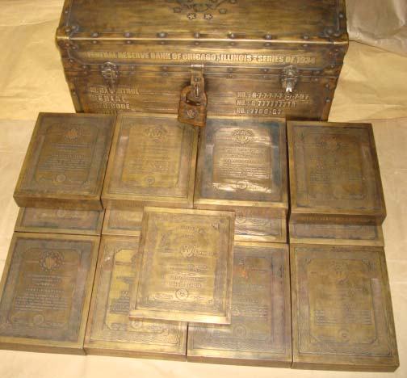

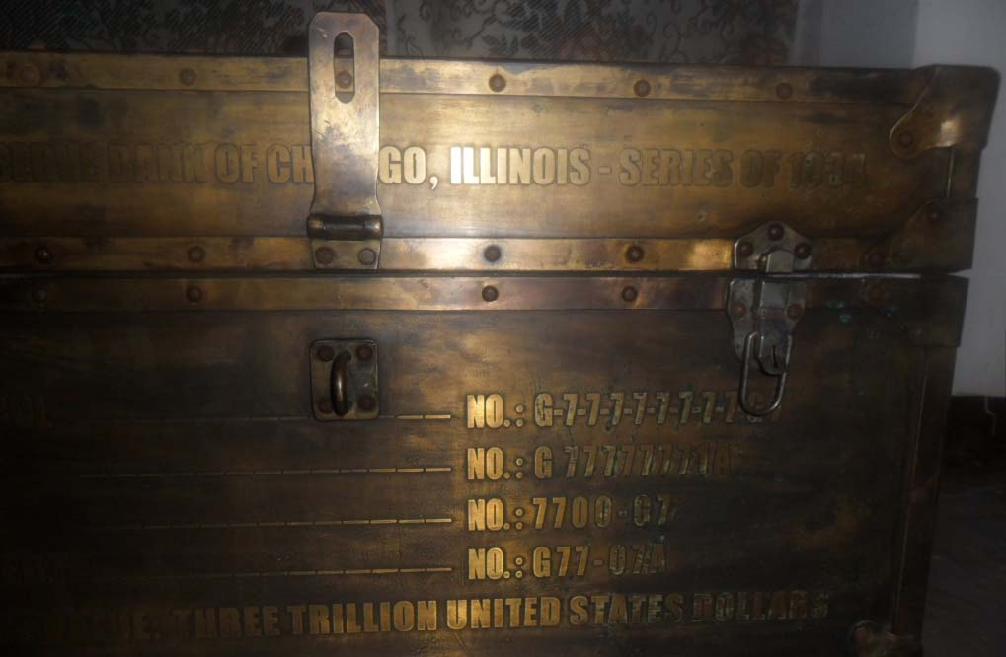

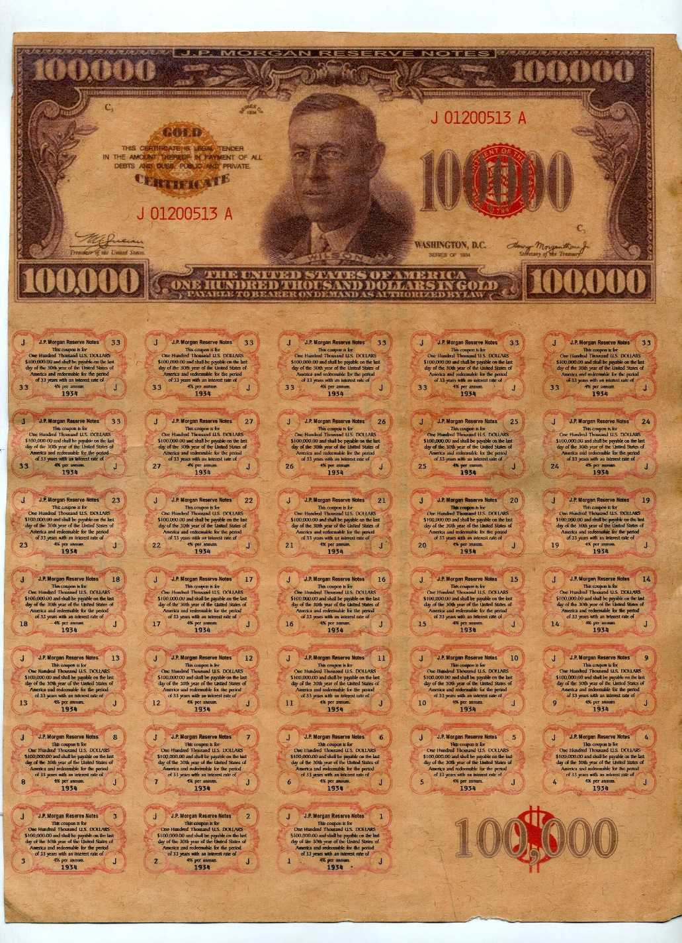

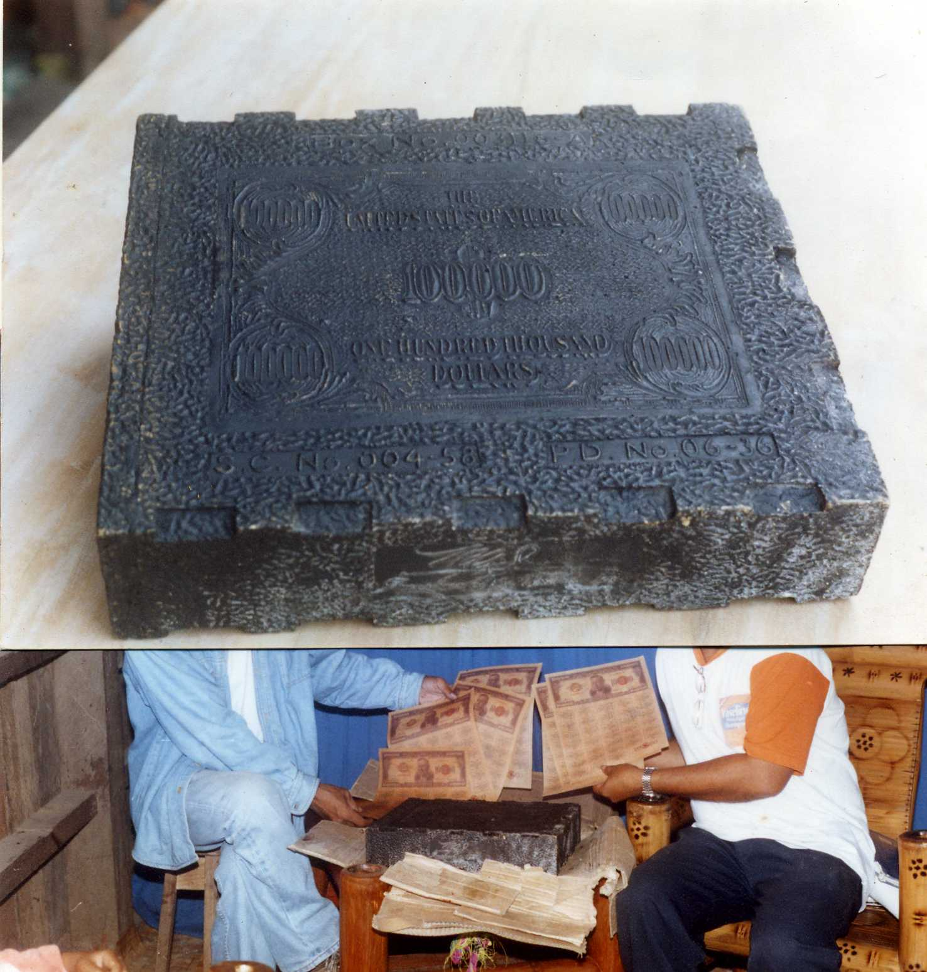

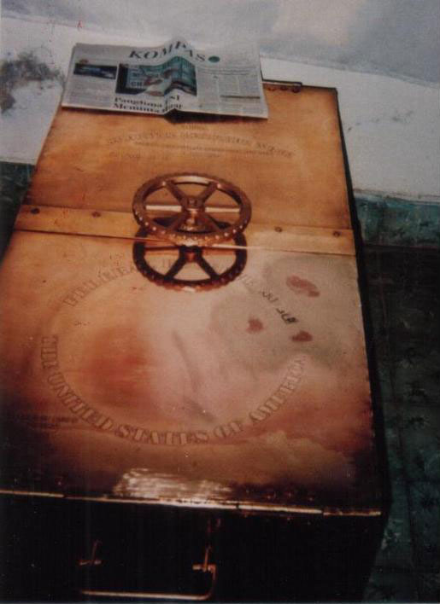

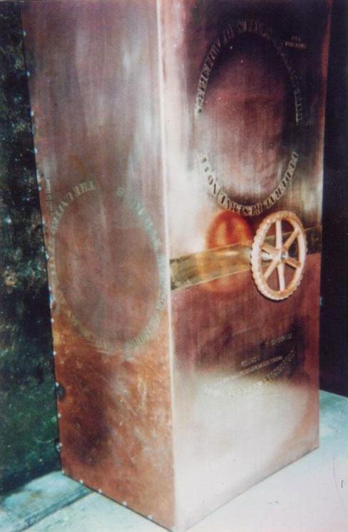

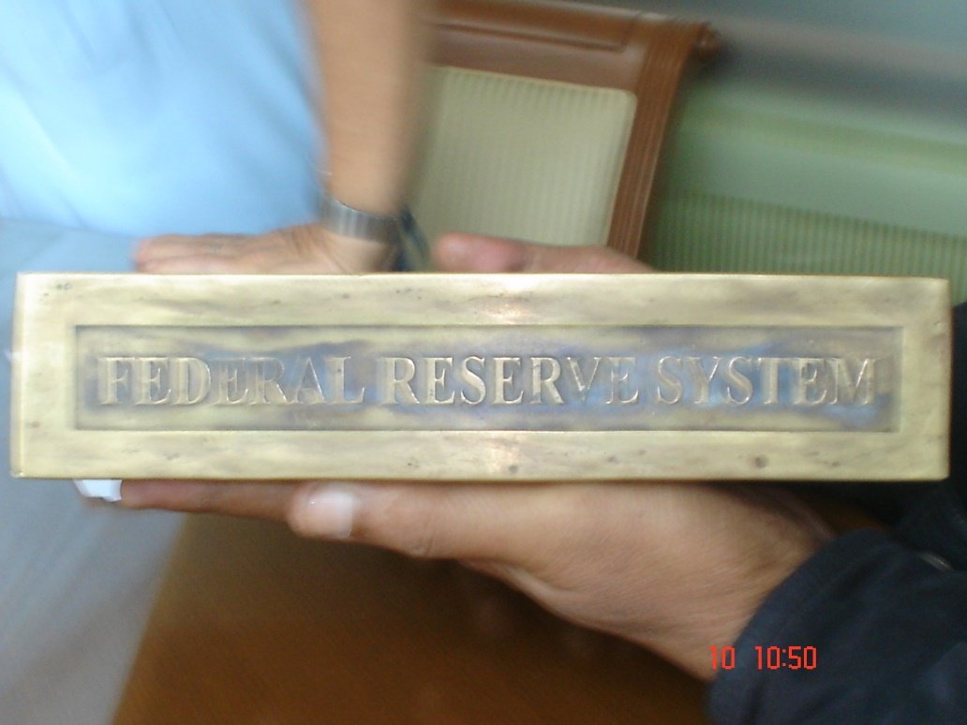

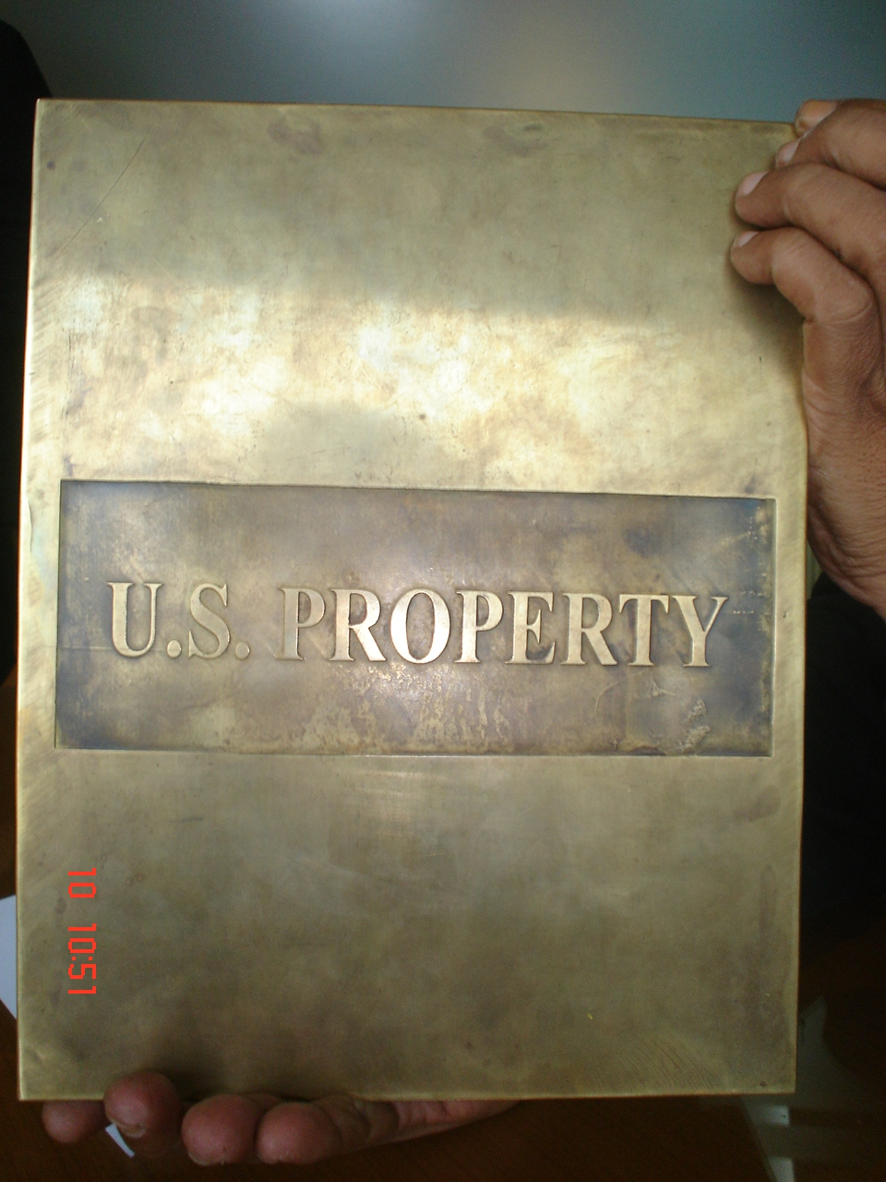

THE LAWSUITS

Joseph Riad filed a comprehensive lawsuit to reclaim his stolen bonds on December 23, 2011.

Astonishingly, US government agents confirmed to Riad that his bonds were genuine — but then a Homeland Security officer ran off with fifteen billion dollars’ worth of them.

Keenan filed a comprehensive lawsuit to reclaim his stolen bonds — on behalf of the Kuomintang / Dragon Family — as of November 23, 2011. And this is where our story concludes.

You can get your copy of the lawsuit from this link — saved locally on our website for your protection and privacy.

https://divinecosmos.com/media/Keenan_complaint_11-23-2011_SDNY.pdf

THE DRAGON FAMILY LAWSUIT

On January 18, 2012, Dr. Michael Salla was one of the first, other than Benjamin Fulford, Courthouse News Service and our website, to write a good summary of the Dragon Family / Keenan case.

http://exopolitics.org/Study-Paper-13.htm

A mysterious trillion-dollar lawsuit, filed on November 23, 2011 in the U.S. District Court for the Southern District of New York, claims that 145.5 billion dollars worth of gold was secretly given to the U.S. government in the mid-1930s — by the then-Nationalist government of China — for safekeeping.[1]

The lawsuit claims that 1934 U.S. Federal Reserve notes were issued to the Chinese government, and the gold transferred to the Federal Reserve Bank.[2]

It is claimed that a total sum of almost one trillion dollars, representing both the principal and accumulated interest of the 1934 Federal Reserve notes, was fraudulently taken from the plaintiff, Neil Keenan, an agent for the owners — a mysterious Asian entity called “The Dragon Family.”

THE CHIASSO INCIDENT

Here, Salla explains how two different sets of bonds were released — and how this factors into our story.

http://exopolitics.org/Study-Paper-13.htm

What makes the lawsuit worth paying attention to is that involves the unresolved June 2009 “Chiasso incident,” where two Japanese citizens were caught on a train in Italy near the Swiss border town of Chiasso — while traveling with 134.5 billion dollars in US Federal Reserve notes, bonds and other financial instruments.[3]

The “Chiasso incident” involves a separate but complementary set of high-denomination US Federal Reserve notes that have a similar origin, history and ownership.

The U.S. District Court lawsuit supports claims by David Guyatt, author of The Secret Gold Treaty, that missing World War II era national gold reserves have been intentionally kept out of public circulation (“black gold”).

Furthermore, the lawsuit reveals a coordinated international effort to launder, trade and defraud owners or investors of bonds and other financial instruments issued against the “black gold”.

A VERY IMPRESSIVE LIST OF DEFENDANTS

We wrote about this case in some detail in Part One of this investigation, on December 12, 2011.

The list of defendants is very impressive: the Italian Republic, the Italian Financial Police, Italy’s Prime Minister Silvio Berlusconi, the World Economic Forum, Ban Ki-Moon (the head of the UN), and the United Nations itself.

I kicked off Part One of this investigation by interviewing Benjamin Fulford, who had been telegraphing the release of this lawsuit for over a year before it arrived.

The reason I was so interested is Fulford said this lawsuit had backing from the “good guys” in the Pentagon, who are now the majority — and who want to use this lawsuit to help legally defeat Financial Tyranny.

They want to have full, open, public justification for doing so. I have done my very best to help pave the way for them to complete this process… and begin the mass arrests.

A SHOCKING, WORLD-TRANSFORMING DISCLOSURE

This event may well be the most shocking and significant moment in human history once it actually happens. It will pave the way for Disclosure of many, many hidden truths.

I do believe the Pentagon, and the 138 nations backing them, are doing their job — by responding to the collective will of the people.

For freedom.

Once I read the Keenan lawsuit, I could see it was highly complex — but a few minor things, such as quoting from Wikipedia to obtain a description of the Davos World Economic Forum, caused me to question its legitimacy.

I was contacted by Neil Keenan and later Keith Scott in an effort to clear up the misunderstandings. They provided me with an incredible amount of documentation, including photographs, to legitimize the story.

Among other things, Keenan asked me to share the following quote with you, as it is very revealing.

ON HIS DEATHBED WILSON STATED:

“I am a most unhappy man. I have unwittingly ruined my country.

A great industrial nation is controlled by its system of credit. Our system of credit is concentrated. The growth of the nation, therefore, and all our activities are in the hands of a few men.
We have come to be one of the worst ruled, one of the most completely controlled and dominated governments in the civilized world.

No longer a government by free opinion, no longer a government by conviction and the vote of the majority, but a government by the opinion and duress of a small group of dominant men.”

By: Woodrow Wilson
(1856-1924) 28th US President
Date: 1916

Source: Attributed. In reference to signing the Federal Reserve Act in 1913. Most likely a compilation of 2 quotes from his book The New Freedom, 1916.

INDONESIAN PRESIDENT SOEKARNO

If you want to understand the history behind this lawsuit, it is important to know who owned the historical rights to the Asian gold that was forcibly seized and put “on deposit” with the BIS.

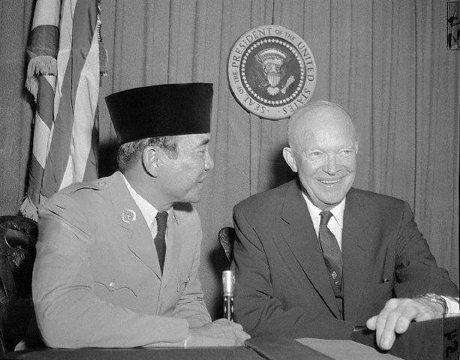

The Asian countries received Federal Reserve bonds in exchange for their gold. Indonesian President Soekarno was put in charge of this fund — as their main signatory.

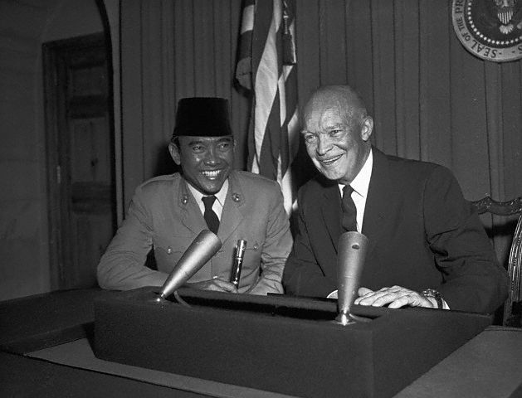

Technically, Soekarno was supposed to be responsible for where this money would go, and how it would be spent.

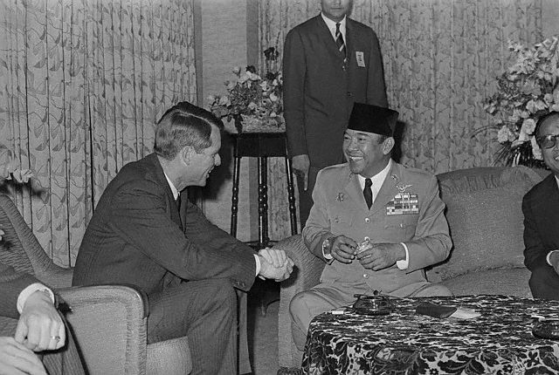

Soekarno was quite a popular international figure in his day — though his memory has been largely lost in the sands of time, likely due to media suppression.

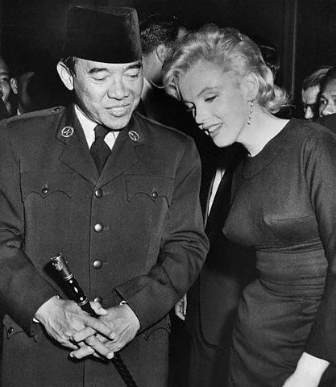

THE GREEN HILTON AGREEMENT

As the years rolled by, Soekarno realized that the promises of the Federal Reserve and the BIS… promises for a peaceful world, rebuilt by humanitarian projects financed by the gold on “deposit”… had not been kept.

In 1963, Soekarno recalled the gold from the BIS and created a new deal with President John F. Kennedy that came to be called the Green Hilton Memorial Agreement.

This article was sent to me by Neil Keenan as an excellent overview of what happened.

The Green Hilton Agreement
http://lisnosetiawan.blogspot.com/2008/11/green-hilton-agreement-geneva-1963.html

In 1963, the gold that had been entrusted to the care of President Soekarno was recalled by the Nations — to underpin the issuance of further US Dollars, in order to further facilitate international trade.

Under this Agreement, Soekarno (as the International Trustee Holder of the Gold) began the process of repositioning the gold, which had earlier been entrusted to the care of the Indonesian People, back into the banking system — to create a fractional backing for the US Dollar.

Initially this was managed under the arbitration of the Tripartite Gold Commission in The Hague — as per the decisions of the International Community, through their Government representatives at the Innsbruck/Schweitzer Conference… and its later revisions.

Under the agreement signed between President Soekarno and President John Kennedy, the control of these assets would cede automatically to the US upon the fall from power of President Soekarno. This occurred in 1967.

EXECUTIVE ORDER 11110 — AND THE AFTERMATH

As our excerpt continues, we learn about Executive Order 11110 — which may very well have been the final straw that led to John F. Kennedy’s open, public assassination.

http://lisnosetiawan.blogspot.com/2008/11/green-hilton-agreement-geneva-1963.html

The potential of this agreement led to Executive Order 11110, issued July 1963, which would have provided the Department of the Treasury with the power to issue United States Dollars. [This, of course, would destroy the Federal Reserve.]

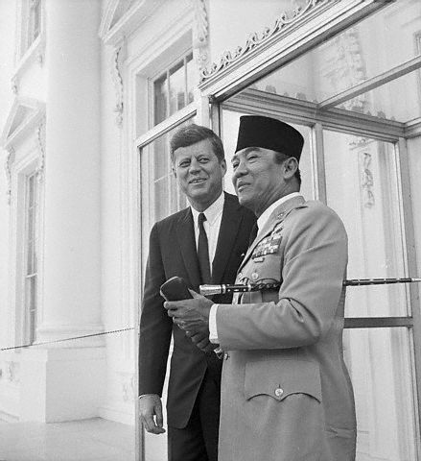

Within two weeks after signing the Green Hilton Agreement, which would have then enabled consolidation of EO 11110, Kennedy was assassinated… With the death of Kennedy, the authority granted to the Treasury was never taken up….

The assets were placed into the International Collateral Combined Accounts that form the Global Debt Facility.

While an apparently innocuous document to read, in its proper and full interpretation, The Green Hilton Agreement is one of the most profound agreements made between Presidents of any two countries within the twentieth century — and most probably, in the history of the world.

[This is] particularly so, as this agreement was made between a President of the United States and the Trustee of the hidden, but combined wealth of the world.

These assets are not the property of the United States, but centralized assets under the authority of a centralized system — to be used as independently deemed to be for the better benefit of the World.

138 NATIONS HAVE AGREED TO SET UP A NEW SYSTEM IN THE MONACO ACCORDS

In Part One of this investigation, published December 12, 2011, the former Forbes Magazine Asia-Pacific bureau chief Benjamin Fulford discussed how this long-standing issue has finally reached a tipping-point with the 57-nation alliance that met in Monaco.

This alliance has since swelled to 117, 122 and now 138 nations in the ensuing months. It encompasses almost all of the biggest countries in the world outside the G5 Western elites — namely the US, UK, Italy, Germany and France.

Together, they have joined forces to combat Financial Tyranny — and this lawsuit is a very important part of the process.

https://divinecosmos.com/start-here/davids-blog/995-lawsuit-end-tyranny

BF: We need an open discussion involving lots of people. That discussion is going to take place at the forum of 117 nations, the Monaco Accords, who have agreed to set up a new financial system.

We need to get the G5 nations and their satellite countries to participate in these discussions, so we can as quickly as possible come up with new global structures to replace the corrupt and rotten UN, World Bank, BIS and IMF with something more representative of the people on Earth.

I don’t mean a global government. I mean a common set of rules for the planet we all share, the air we all breathe and the oceans we all use. Not some centralized New World Order control grid. All right?

DW: Absolutely!

MY INTERVIEW WITH NEIL KEENAN AND KEITH SCOTT

After I interviewed Fulford and gave a detailed but flawed critique of the lawsuit, Neil Keenan and Keith Scott contacted me. I wanted to get to the bottom of the story. I had many questions. I have not censored any of their answers.

I found their answers fascinating, and it dramatically increased my understanding of the underlying issues. This also serves as their first public presentation of written statements since the release of the lawsuit itself.

WHAT ARE YOUR CREDENTIALS?

WILCOCK: Can you explain why Soekarno’s nephew put you in charge of recovering a trillion dollars’ worth of stolen assets? [Note: The matured value of the bonds stolen by Daniele Dal Bosco in the lawsuit total a trillion dollars.]

What are your credentials?

KEENAN: My credentials in this matter, David, are simple. I am pursuing the theft of bonds entrusted to me by the Dragon Family.

Edy Seno of the Soekarno Trust has signed the Soekarno Trust over to us, because he believes we just might have success in recovering what rightfully belongs to them as well.

Edy Seno is a friend of Keith Scott’s and his friends. As you may know, the trusteeship of these assets was not easy to get – not at all.

Dr. Edy Seno did not put me in charge of recovering a trillion dollars in assets. Those assets were entrusted to me by the Dragon Family, and I had an obligation to maintain control over them — not to lose them.

The trillion dollars had nothing to do with Dr. Seno, who is in charge of the Soekarno Trust. The Soekarno Trust was turned over to Keith Scott, myself and one other (best to leave him be for the time being).

WHY WAS THIS TURNED OVER TO YOU?

KEENAN: Why was it turned over to us? Dr. Seno is not getting any younger, and he has not been well.

Seno has been the heir holder of said collateral accounts, as President Soekarno’s Will emphasizes, for many years — and has nary seen one cent for the Indonesian People.

He is tired, and realizes that what is owed his people will never be accomplished without litigating. His dreams of developing Indonesia are disappearing as he grows older — and he wants to see this within his lifetime.

He continually receives quarterlies from UBS, substantiating the accounts and what is owed the Trust — but despite having the credentials of holding the Trust, there has not been one payment made.

Soekarno M1, as appointed by the Nations of the World, never received one cent. Why? Because of the looting taking place by the Western World!

It began right from the outset and continues on to this very day. The very same people have created our financial crisis.

This is a man-made crisis, and they are going out of their way to create the world in their image.They believe they are the chosen ones!

EVERYONE COMPETING FOR THE FUNDS

KEENAN: They cannot deny the fact that Dr. Seno is the heir of this trust, as stated in the documents and even the UBS statements — but they will not give the Indonesians one cent.

They attempted to circumvent Dr. Seno and Soekarno’s Trust by going direct to the Indonesian Government — with the hopes that they could find a way to eliminate the need for that Trust. This was a task impossible to do.

The Dupont family from Montreal was most recently there with some very powerful people, trying to convince the Suhartos to give them the Codes — but they did not get anything.

The very reason Seno turned to us is because we are very persistent in our quests to have returned what belongs to the Dragon Family.

KEITH SCOTT CAME FORWARD TO HELP — AND EXPOSED THE “BLACK SCREENS”

KEENAN: For this reason, and the fact that people very close to Keith Scott advised him that we could help him, Keith did listen — and came forward to help. He did not hesitate in his attempt to better Indonesia’s lot.

This is how we gained copies of the Book of Codes and Maklumat/Ledgers etc… the secret codes to the Black Screens that the Federal Reserve and BIS use to print money out of thin air.

These books and Codes are currently in several places throughout the world — and will be opened up if need be.

They are not only for trading purposes to verify certain financial instruments, but they are also the best form of security for everyone involved.

Should these books be opened, the Black Screens will follow — and there will be a long line of very powerful people heading to jail.

WE WANT TO GET EVERYTHING STRAIGHTENED OUT

KEENAN: Our goal is not to put people in jail. We just want to get things straightened out, so that the accounts can and will work properly for everyone — not just the chosen few, who have stolen from the accounts for far too many years now.

The IMF, the World Bank, the BIS and the many federal banks, Sarkozy, Blair, the Bushes and many others have continually used them illegally.

The Books and Codes will reveal the outright thefts that have taken place throughout the past with the accounts, and expose the thieves — but our real reason for needing it was to authenticate the stolen bonds.

COULD WE PROVE THAT THE BONDS ARE AUTHENTIC?

KEENAN: I heard so much about how they would defend themselves by claiming the bonds were not real, so I had to work at proving them wrong. I delved into a world that I never even knew existed.

I felt like Alice falling into Wonderland — when in fact, initially I was concerned about what a collateral account was. I had no idea! Thank god for Scott, who eventually gave me the knowledge I have today of them.

If we could not prove ourselves that the bonds were authentic, then where would we be?

We had received much information from various groups that they were real, but we did not have anything from the FEDS stating as such (FRB).

If they stood fast and did not help us, then we would be lost — and the theft would be complete.

We had no choice but to dig deeper and deeper, which brought us further and further into this big dark financial hole.

It was not scary — it was confusing. How do we justify the bonds?

WE HAVE SENT THEM OUT FOR SAFE KEEPING

KEENAN: Many have been after these books because they expose the World’s Global Accounts, but in fact they do much more than this.

Now we have them. I sent them out for safe keeping in 6 different directions throughout the West, and Scott sent them out throughout the East.

Should anything happen to anyone involved in this case, I repeat — and this includes you, David, or Ben Fulford — arrangements are in place for these books to be opened… and the Black Screens to follow.

At that point, a long line of very powerful people will be heading to jail – as I said before.

Again, it is not our quest to put people in jail, but to just get things straightened out — so that the accounts can and will work properly.

We will use them only if we need to authenticate the Bonds. We have much documentation that the bonds are good, but we are not taking any chances.

THIS BECAME BIGGER THAN HE EVER IMAGINED

KEENAN: We, Attorney Mulligan, Scott, and others have continuously seen that the FEDs will pull the rug out willingly from underneath you if you give them a chance. Despite the fact I am comfortable with the FEDs involvement in this, one can just never be too safe.

We entered into an agreement providing we would continue on with our battle to have the stolen financial instruments returned to us – and we will fight for what is owed to the Soekarno Trust as well.

This was never the initial intent, but following in Alice’s footsteps, I went from door to door. I found that the entire world was illegally being used by certain groups using the accounts controlled by the Soekarno Trust.

This then became bigger than I ever imagined. It was a James Bond thriller, David — and the only James Bond I know lives in California. It seems as though he is the straw that stirs many drinks worldwide.

Dr. Seno entrusted us with the Accounts — seeing, as he said, that it was the first time in his lifetime he saw anyone take a stand.

Thank God Keith Scott was able to work this out with his dear Asian friends. The books and the Black Screen and even the Green Hilton Agreement clearly authenticate the stolen bonds.

HAVE YOU SEEN ANY OF THE GOLD YOURSELF?
WILCOCK: Have you personally seen any of the “off-market” Asian gold Fulford and others refer to, and can confirm that it actually exists?

KEENAN: My Associate Keith has seen it. It is not off-market but on ledger — it is just that people do not know about it.

I will send you a photograph of one of the warehouses. It is in Thailand.

The bunkers and boats and tunnels do exist, and Al Gore’s nephew Bruce is there at this moment trying to work it. People think they are not registered, but they are. It is all part of the Global Accounts and registered.

Even the gold in the hills in the Philippines is registered. The Japanese registered everything. It is all in the Garuda Green Hilton Agreement.

IF YOU WIN THE LAWSUIT, WHAT DO YOU INTEND TO DO WITH THE SETTLEMENT?
WILCOCK: What do you intend to do with this settlement, should you actually be paid as the signatory for the Kuomintang / Dragon Family?

KEENAN: There is no settlement at this time, and no reason to think so until it actually happens — but I do have contractual obligations which I cannot reveal to anyone.

I can only speak for myself, and what I will do with what I receive — and that is to develop Free Energy and New Technologies.

This goal had been established even before the bonds were stolen.

DANIEL DAL BOSCO TRIED TO STEAL THE BONDS

KEENAN: As a matter of fact, the actual thief Daniel Dal Bosco was there with me at the factory where these technologies were being developed.

He has since tried to circumvent us there with his cronies as well — attempting to get them to work with him with the Free Energy.

My friends know all about Mr. Dal Bosco, so his calls to people such as Mr. Santi and others fall on deaf ears.

He has ruined himself, as far as I can tell — and his statement that he only took the bonds so they could be returned to their rightful owners does not fly, seeing the rightful owners are the Dragon Family.

Dal Bosco and the OITC/David Sale and Ray Dam attempted to unsuccessfully place them in a Trade in May 2010.

This is beside the 100 Million USD they offered to me to go away (this was to be split with Dal Bosco).

HAS YOUR ATTORNEY SEEN PROOF THAT THIS IS A CREDIBLE LAWSUIT?

WILCOCK: Has your attorney William Mulligan been shown bonafide, undeniable proof that this is a credible lawsuit? Can you describe any of it for us in generic terms?

KEENAN: William Mulligan is one of the best attorneys in the United States, and comes from a long line of professional litigators.

He might not be out there on the front pages of the papers, but then again he is not a Khazar [Illuminati]. The papers keep feeding their own but never ours.

You may not have heard of him, but this does not mean he hasn’t been out there — quietly going about his winning ways.

In my eyes, he has earned the nickname Wild Bill, seeing he comes out with guns blazing — just the way I like it.

On the other side, I have seen him passionately deal with people. He is one of the few that can deal with a case like this.

Now that he took the leap into this Wonderland of financing as I did, he often pissed me off — but he made sure that everything was backed by evidence and fact before putting his name on the complaint.

WHAT TOOK SO LONG?

KEENAN: The waiting made me insane, and this is what took us so long — but in the end it was the right thing to do.

So many people asked when is it going to get filed? I had no idea. Everytime we got closer it seems we got further. New information was coming in often, and would not match up with what we already had.

So it would be back to the drawing board. Everything had to match up — and we had to have the evidence to back up everything we claimed.

It took a lot longer than I wished, but I had no choice if I was going to continue pursuing this. I can imagine that so many hoped that I would let it go.

TELL US MORE ABOUT BILL MULLIGAN

KEENAN: The firm itself has been around for more than 100 years (I believe) and has been instrumental in much development in NY.

Bill’s father is a good example of his pedigree: Dean of Fordham Law School and Federal Judge in the Southern District of NY. He comes from a good long line of litigators and professionals.

His assistant Justin is also no slouch, and he continually checked things out to make sure we did not stray from our course.

I read where attorneys stated this cannot be a civil suit, seeing too much has been given away too quickly.

Are they sure it cannot be a civil suit — and that we give what we have given away as part of a strategy?

What if it is all we have, and we are shooting the mother lode?

Or, in essence, attorney Bill Mulligan may be just that much sharper than they could ever conceive of him being.

He is a clever man. Do you believe an intelligent man would not keep the best for last? Decisions, decisions!!!!

It was great to have Bill screaming at me to stay online and not to run amok after the bad guys. which I always did. It was Bill who understood what had to be done, and how to do it.

Keith Scott also worked many, many hours attempting to get this right. He was in a world different than mine, which contained treasure troves of information – like the actual buried Treasures. It was a world of darkness unbeknownst to the average person like me.

HOW LONG DID IT TAKE YOU TO PREPARE THIS LEGAL DOCUMENT?
WILCOCK: Approximately how many hours or days did it take for your team to prepare this vast, 111-page legal document?

KEENAN: I spent 20 hours per day since June 2010 until it was filed. I looked under every rock, hoping to find something. Not one moment of it was easy.

When Dr. Seno gave us the rights to the Soekarno Trust on November 6, 2011, along with the Books, I could finally sit back and rest once I saw it confirmed the bonds. 18 or 19 months of constant pursuit finally came to an end.

The only problem was that to confirm the bonds, we must open the books and the Screens. When we do this, all hell just may break loose – as it will reveal the names and entries of those who illegally used the accounts.

Bill Mulligan worked so many hours, I cannot begin to tell you.

We thought we were getting close to filing the complaint on numerous occasions, only to find out that we had more information that contradicted what we had. We had to go back and do it over again and again and again.

HOW MANY DRAFTS?

KEENAN: I think Bill said he did 18 Drafts of the complaint before finally feeling comfortable enough to put his name on it.

You must understand that this is not just a complaint, as some have said – this is a VERY well-thought-out complaint, and there is a method to our madness. Bill is that clever!!!!

When we could not see any more to gain, and knew that we could authenticate all of it if necessary – (this ties into the Garuda Green Hilton Agreements as well) — this was when Bill filed it.

Keith Scott pushed this over the hill with his assistance. It is not possible that anyone out there understands the collateral accounts such as he does.

Keith has such an innate feeling for banking and numbers, and seems to have this magical twist that makes things work. Without Scott, there would be no Indonesia. It was he who once again brought to me what was needed to make this ready to file.

It seems like it took forever, and I took to sleeping on the sofa — not wanting to wake my wife up at all times of the morning. It was horrible, and I never want to do it again.

This all has to end sometime — or end and be reborn the proper way.

CAN’T THE DEFENDANTS JUST “MAKE IT GO AWAY?”

WILCOCK: Can’t the defendants just “make it go away” thanks to corrupt judges, media blackout, and / or the lack of proper jurisprudence to appropriately handle such a vast, international scandal?

KEENAN: I am sure lots of things can happen, but usually Federal Judges are very proud of who they are and what they do.

My belief is that this case is a Judge’s Legacy. Understandably, one would think they have the clout to do this — but it only takes one good judge to make this happen. They are not all corrupt.

As for a media blackout, isn’t this what is happening now?

Without Benjamin Fulford’s help, I never would have been able to pump these guys for information.

HOW DID BENJAMIN FULFORD PARTICIPATE?

KEENAN: Benjamin even participated personally. As he stated, he wanted to know himself what was going on.

He directly investigated the case by speaking with Dal Bosco.

He even flew to Italy to meet with the P2 Masonic Lodge — only to find that the Italian Financial Police told him the bonds are real, but were stolen from me.

Then they tried to kill Benjamin by poisoning him. Thank God he got out of there in time.

THE RUMOR MILL NEWS CONNECTION

KEENAN: Even Hobie at RMN (Rumor Mill News) gave me a big hand in this. I see I was not alone — and I could not have gotten this filed without everyone’s contributions.

It was on RMN where Sale made his admission of guilt.

I acted foolishly, on a continuous basis, to get him furious. The man kept responding, so I kept pushing. Finally he blew up and let it all out — to show me he had one-bettered me.

At this point I went into silence. I had him. There was no need for more discovery — he had just admitted his guilt.

THOUSANDS OF TRILLIONS

KEENAN: Speaking of Benjamin, with all due respect it must be noted that 371 Trillion is not the entire amount contained within the collateral accounts. Not even close. It is Thousands of Trillions!

I’m sure Keith Scott would say the same thing.

GIANCARLO BRUNO OFFERED 100 MILLION DOLLARS — NOT UN SECRETARY GENERAL BAN KI-MOON

KEENAN: Also, UN Secretary General Ban Ki Moon never offered me 100 Million Dollars, as Fulford had accidentally stated.

The person whose name I have is Dal Bosco’s buddy Giancarlo Bruno, from the World Economic Forum — as mentioned in the lawsuit.

Bruno is another person whom I have never spoken to, but many others have.

THE BOOK OF CODES IS AVAILABLE, BUT HAS NOT BEEN SEEN BY WILCOCK OR FULFORD

KEENAN: On the Power of Attorney from Indonesia, there are three names: Scott’s, mine and one other who requests not to be named for safety purposes.

Other than the people we have sent the Book of Codes to, there are no others who have them from us.

I think Benjamin got into trouble by claiming he has them, when in fact he has a couple of pages similar to what you have, David.

The Books are in good hands, and if we need them, they will be available.

IF THE BONDS WERE NOT STOLEN, NONE OF THIS WOULD HAVE HAPPENED

KEENAN: All this happened because of Dal Bosco, Sale, Dam and the OITC — the Office of International Treasury Control, which helped manage the Collateral Accounts with no official UN charter — though they do claim to have one.

It is they who are responsible for having put so many people on edge. If they had not stolen the bonds, this never would have happened.

They opened the doors, knowing that they were throwing others in harm’s way — but they frivolously continued without thinking of the repercussions. It was never my plan for any of this to happen.

Finally, if the case is ever dismissed, there are many options. I doubt this will ever happen, seeing the importance of this to the US….

IS THE MAINSTREAM MEDIA CULPABLE IF THEY DON’T PICK UP THIS STORY?
WILCOCK: Is the mainstream media equally culpable if they fail to report on this, now that it is a confirmed legal complaint, filed with Judge Holwell in the Southern District Court of New York as 11-civ-8500?

KEENAN: I leave this answer to you, David. You know better than I that it is possible that those who run the Banking Cabal will go to work, and can even suppress the ink that prints the news or paper as well.

They have their hands in everything. They literally control the world.

However, my belief is that the media will finally pick it up — and begin to enlighten the people as to just what is happening all around, and not just this case. Again, we only need one to begin.

There are publishers with Principles, who do not want to see the world collapse at the hands of few.

When they do start printing the actual truth, I believe a change will take place. Until then, it is just a matter of getting things properly into place — including this lawsuit.

Expect this to take a slow turn – as we are exposing much of what they consider sacred. Remember — they control the media industry itself. Look at what just happened with the Super Bowl halftime show.

DO YOU HAVE ANY KNOWLEDGE OF THE MONACO ACCORDS?

WILCOCK: Do you have any direct knowledge of the Monaco Accords, an alleged meeting of 57 nations off the coast of Monaco referred to extensively by Fulford, and how those discussions factor into this puzzle?

KEENAN: This is a later matter for discussion — not particularly for the lawsuit. It is up to 138 nations now!

What I can state is that once you hear their names out loud, you will realize it is an awakening from a long long sleep.

We have all been punished enough — but remember, in the land of the blind, the one-eyed man is king.

THE REAL KEY IS WHAT HAPPENED IN CHIASSO

KEENAN: The real key here is what happened in Chiasso — and the effects that this has caused.

Yamaguchi and Watanabe were detained with the 134.5 billion dollars in bonds at Chiasso, Italy. The Italians then used the Chiasso detention of Yamaguchi and Watanabe to steal these bonds/notes.

There is no mention in any of their databases of such an arrest, complaint or judicial decision — but there is an Italian named Alessandro Santi, who received 16 months’ probation.

Yamaguchi and Watanabe each received 3 year sentences — in absentia.

The head of the Financial Police checked all 3 databases and found nothing. He is also the Liaison from Italy to Interpol, so no secret files either.

There is nothing there — so you tell me what happened. Why are sentences delivered when there is no case?

This is one hell of a story — and it exposes Italy. This is where the bonds entrusted to me also ended up, and where they are now.

Read the complaint we filed about Chiasso, and you can get into the details of what happened.

THE BRETTON WOODS AGREEMENT

KEENAN: The Bretton Woods Agreement was the creation of a fiat currency system — and the methods of management and control over the world of banking.

It created the International Monetary Fund and the Bank for Reconstruction — now known as the World Bank.

Bretton Woods has nothing to do with the assets, but is the creation of the banking system that existed from 1945 and lasted until the 1970’s.

At this time, the concept of banks stealing from national treasuries was promoted through a process known as securitization.

THE GREEN HILTON AGREEMENT

KEENAN: The Green Hilton Memorial Agreement in Geneva was an agreement between President John F. Kennedy and the assigned owner-controller of the International Collateral Combined Accounts, President Soekarno of Indonesia — over assets being transferred to the United States.

The process of Agreement began in 1961, and proceeded through to Agreement by 1963.

After the death of President Kennedy, President Lyndon Johnson amended EO11110, and unilaterally transferred the assignment to the Federal Reserve.

Under this agreement, vast amounts of gold were assigned to the control of the United States of America on the fall of President Soekarno.

The agreement was not effected till 1967, when Soekarno fell from power.

That amount of gold was then vastly increased to include all the gold and gold value assets under the Combined Garuda Hilton Memorial Agreement in Jakarta.

This Agreement listed all the precious metal assets assigned into the banking system through Union Bank of Switzerland in 1972 — and all counter-assets in US Dollars.

WHAT ABOUT THE COMMITTEE OF 300 DOCUMENT?

WILCOCK: One of many documents you sent me is from the Committee of 300, entitled an Identical Code Termination Certificate. President Ferdinand Marcos is named in the document as a holder of “Gold, Silver, Platinum and Other Precious Items.”

The document reveals that this gold is being held in “mountainous and undersea areas of the Philippine Islands” and the position is “immovable and restricted”.

The document also says the financial intention is for “Humanitarian and National Development Program.” The Depository Institution is listed as “All Financial Institutions of the Committee of 300,” and the official Location is listed as “Top Secret and Worldwide.”

KEENAN: David, the person you need to speak with about the gold is Keith. I am sending him a copy of this communication, so he knows you need his help here.

You must know that Queen Elizabeth is the Head of the Committee of 300 — and they believe it is their duty to control the World! What a bunch of hogwash, eh?

She cannot even run England — and in Rothschild’s City of London, she has to get permission to enter — and must walk 6 feet behind the Mayor.

This one square mile within London is the banking headquarters of the Rothschild Empire. They make the rules and break the rules — and as far as they are concerned, there is nothing you can do about it.

NEIL KEENAN’S WRITTEN INVITATION TO KEITH

KEENAN: Keith, you are the most brilliant person when it comes to the Philippines and the collateral accounts, etc. You know more than anyone I know, and David Wilcock wishes to do a complete paper.

Would you please explain the 900,000,000,000,000 and many more zeros to him? Help him get things right.

David, you need to have people like Keith with you when it relates to Gold or Banking. He knows it inside and out. Keith is my dear friend. He is the one who helped me put together the lawsuit regarding gold and banking, etc.

They tried to kill him as well — but I will let him tell you about it.

As I write this, Ray Dam has said he is going to kill Keith before Xmas — and me, I am going to have an early coffin.

Good old Keith also got suckered in by Ray Dam, seeing Keith once worked at the OITC. Again I will let him tell you about it. Anyway, their loss is everyone else’s gain, because Keith is doing a whale of a job.

Keith, help David — he needs to get things right, and so far no one has really given him the meat to go with the potatoes. You know all about my case, and also what happened everywhere else.

Good Luck with your article, David. Keith is the man you need to answer all your final questions. He is in Vietnam right now, so it is 4 in the morning my time right now there.

Figure out your timing, and good luck when you get together. He is a treasure trove of knowledge about this stuff, and has been involved in it, I believe, for 25 years.

KEITH SCOTT: THE WORLD’S GOLD WAS CONFISCATED IN THE 1920s, 1930s AND 40s

KEITH SCOTT: Dear David,
The Gold of the United States was surrendered to the Federal Reserve in 1934. The gold of all nations was surrendered to their central banks — and through them to the Federal Reserve.

The world’s gold disappeared through the second world war. The institutional gold of governments that had been handed in by citizens, and the gold that had been withheld privately, were both located and forcibly taken by armies.

Those who failed to comply with the law were marked for capture. Their wealth was confiscated – and after this, they were executed. This was to prevent massive reparation claims through legal redress.

CAN WE PROVE THAT SEVEN BATTLESHIPS TRANSFERRED CHINESE GOLD TO THE US IN 1938?

WILCOCK: Is there ANY way we can prove, with public records that are available online, that these seven battleships transferred Dragon Family gold to the US for safe keeping in 1938, as Fulford said? This seems to be a critical part of the story.

In the interview Fulford said it should have been out in the news at the time it happened.

When I’ve tried searching for it online, I can prove that things reached a head with Japan raiding China in 1938, but so far the only things about this gold shipment that come up are links to Fulford talking about it.
SCOTT: No. It is absolutely irrelevant. What can be shown is the gold in the system from the records of UBS (Union Bank of Switzerland) – but publishing these would be considered illegal, as they endanger National Interests.

It takes many years to even begin to understand these accounts.

GOVERNMENTS AND SOVEREIGNS WERE FACED WITH TWO TERRIBLE EVILS IN 1921
SCOTT: I feel there are other issues derived from this that are more important than a historical reconstruction of the gold accounts. Much of that is best left hidden, for it is wrong for us to make judgments on the options faced by Governments and Sovereigns in 1921.

They were faced with the potentials of two terrible evils. No matter how you look at it, they made decisions that even to them would have been terrible — but in my mind, they made the right choices, as the alternative was far too terrible to even contemplate.
What we can be very critical of is how a system, created for the better benefit of the world, could be hijacked by evil people with a most evil plan.

This occurred off the back of the NSA 5412 Committee, who were charged by Richard Nixon with finding ways to steal these assets.
There is so much it would take an enormous book to provide the full story.

CAN YOU TELL US MORE ABOUT THIS MEETING IN 1921?

WILCOCK: I do understand the greater context you are speaking of here — regarding that the real key is simply demonstrating the vast Asian gold hoard is real.

I will continue looking for ways to validate the 1938 shipments, as Fulford says they should be in newspapers from the time.
The date of 1921 is unfamiliar. If there is anything you are at liberty to reveal there, that may prove helpful.
The only reason I asked you about these gold shipments is Fulford said they played a key role in the T-dollar bonds issue that broke this lawsuit.

THEY DECIDED TO ELIMINATE THE GOLD STANDARD WORLDWIDE

SCOTT: David, type “Hirohito 1921 London” into Google.
This was fundamentally the most important meeting Hirohito ever attended. From London England, he went on to France, Belgium, Holland, Germany, Italy and Yugoslavia.

At this meeting, they considered the ramifications of the Versailles Treaty — and the eventual consequences of that Treaty.

It became apparent to all of them that the gold standard was the real precursor of the First World War.

The gold standard had to be eliminated — and the financial system had to change.

THERE WOULD BE ENDLESS WAR

SCOTT: As per their understanding of the Jekyll Island Agreement, if the global financial system was not changed, the disparity of wealth between rich nations and poor nations would expand exponentially.

That would condemn the world to war endlessly.

And worse, through World War I, mankind had had demonstrated the capacity of technology to destroy human life on a scale never seen before.

Thus, they understood the world was on the edge of human self-destruction.
Belgium, Italy, France, Japan, Great Britain and Germany, together with a group of American banks that owned the Federal Reserve, worked toward the creation of the Bank for International Settlements.

They also decided to centralize global assets — and allow all nations equitable access. This was followed by further meetings and agreements until the system was implemented.

HOW DID YOU GET INVOLVED WITH NEIL KEENAN’S CASE?
SCOTT: To explain my involvement with Neil Keenan’s case, I was contacted by Keenan initially through Fiji – after he called them regarding what occurred there in 2006.

The Fijians contacted me to let me know they had been contacted by Keenan. They then advised Keenan to contact me, which he did.

I advised him that the bonds were the property of the Dragon Family – no question about that. The Collateral Accounts could not hold both the asset and the counter assets: it cannot hold the asset on deposit and the obligation against the asset.
I spoke to Ray Dam several times since learning of this debacle, and he denied all knowledge of it. He told me he knew that bonds were available through David Sale, and he intended to place them into trade.

I told him that in my opinion he needed to clear it up and get the bonds back to Keenan, or this thing would blow up in his face — and would do immense damage.

He simply said “I am not involved, and I do not know anything about it.” I no longer believe any of this to be true. I believe he knew, and he lied to me whenever I raised the matter with him.

WHEN DID YOU BEGIN HELPING KEENAN?

SCOTT: I began to co-operate with Keenan when I realized that this court case could bring about an opening of the Collateral Accounts.

If we manage to get them open, we will be able to expose the revolving frauds committed by banks, and the extraordinary extent of the cost to the general public.

What I liked even more was the fact that I was able to convey this to Neil.

Together, using this case as a stepping-stone, Neil and I (mostly Neil, who is a brilliant strategist,) have planned to clean the entire system out — and force changes that would otherwise be impossible.

DO YOU BELIEVE THE UNITED STATES TOOK GOLD FROM THE KUOMINTANG IN 1938?

WILCOCK: Guys, this is fantastic stuff.

The biggest question I have right now is whether Fulford is even on the right track. Keith, do you consider that the United States did take gold from the Kuomintang dynasty on seven battleships in 1938? Is this the source of the 134.5 billion in bonds?

SCOTT: I have no knowledge of that, though it does sound right, because at that time the Japanese had already occupied Manchuria.

The need to have that gold away from where it could fall into the hands of the Japanese would have been high in the minds of the Chinese.

They certainly did take gold from China, but whether it was in seven battleships is not known to me.

Yes, that is the source of the bonds. Much of the physical gold is in China, some in Harbin and other lots in Guanghou and Yunnan. This is all book-entered into the global system.

To their great credit, the Chinese Government honor the old agreements, and keep this gold secure for the benefit of the Global Financial system. People can criticize China on many things, but in this case they have been very honorable.

FULFORD’S FOCUS IS THE ELIMINATION OF THE ROTHSCHILD AND ROCKEFELLER FACTIONS
WILCOCK: I’m not sure if Fulford understands all of this yet, as I’ve never heard him talk about a lot of the stuff you are saying, but it’s coming together for me. Now I’m trying to get more specific.

SCOTT: I think Ben has a different focus and he also has his own agenda, where history becomes less important and the imperative is the changing of the entire economic and geopolitical system.

His focus is the elimination of the underlying power of the Rothschild / Rockefeller / Bush faction.

WHAT WAS THE REAL PURPOSE OF THE GREEN HILTON AGREEMENT?
WILCOCK: The Book of Maklumat shows a total of 900 quintillion dollars in gold assets, based on the value of gold in 1963 dollars.

Was the Green Memorial really just an attempt by Soekarno and Kennedy to break the back of the Federal Reserve and divert the use of this 900Q in assets to something outside the control of the existing system — given that Soekarno had signatory control over the assets?

SCOTT: The Green Hilton Agreement was not just an attempt – it was the changing the matrix of the global financial system.

Originally, Kennedy intended to get rid of the Federal Reserve, and the Green Hilton Agreement would have done that – as the underlying assets and accounts of the Federal Reserve would have moved to the Treasury.

It was a plan that could not work. It would have created a US Dollar that would have been the only pre-eminent gold-backed currency.

This would have been dangerous, and would have undone the entire purpose of the creation of the central system. It would have led to war.

Johnson amended EO11110, and transferred the gold to the Fedsystem. The US Dollar became the world currency backed by the assets.

DID THE UNITED STATES TAKE GOLD INTO CUSTODY IN 1938?
WILCOCK: Did the United States actually take gold into custody in 1938, or are the bonds in this suit simply part of the overall equity being held in the Global Collateral Accounts?

SCOTT: Not the United States. The Federal Reserve did, via the Treasury. Remember, at that time it was illegal to hold bullion gold outside of the Federal Reserve System.
WILCOCK: It’s a lot to piece together, but I do thank you. It will probably have to be done in sections.

I have many questions and I need to get something out now, so I will probably start with the Fulford interview.

SCOTT: I can see you are a serious researcher, thus it is a pleasure to help.

CAN YOU GIVE US YOUR OPINION ON DAVID GUYATT AND HIS DATA?

WILCOCK: Keith, could you vouch for the accuracy of the following data? That would be my next question. David Guyatt’s research seems to be very central to everything we are discussing and I want your take on it.

About David Guyatt
http://www.deepblacklies.co.uk/about.htm
GUYATT: Following a twenty eight year career in investment banking (Member AIBD) based in the City of London, David’s last position was Associate Director & Treasurer of the Forfaiting division of a major international bank.

Aged 56 years, he is married with three children, and pursues a career writing in a variety of mediums as well as researching and producing factual material on a wide range of associated subjects….

SCOTT: Guyatt was credible in many things, but never really knew the history behind the system — and therefore he only wrote about what he could see.

DAVID GUYATT’S ARTICLE “THE SECRET GOLD TREATY” — AND SCOTT’S COMMENTS

The Secret Gold Treaty
http://www.deepblacklies.co.uk/secret_gold_treaty.htm
GUYATT: Yet, the world of money holds many more and darker mysteries still. The most startling of these is that the official figures revealing how much gold exists are fabricated.

This, it seems, is because it has been determined that there are two sorts of gold. The “white” gold of the West is mined in small quantities, and is used as the basis for official purposes.

The “black” gold of the Orient is not official, and so cannot be allowed to exist on the books at all.

Such are the massive quantities of black gold in existence that had this singular fact ever been publicly disclosed, the price of gold across the world would have plunged to the depths — and remained there forever more.

SCOTT: True. The total amount of gold recorded in the market is around 120,000 tons. The total of gold in the system (as per the records from UBS) is more than Two Million tons.

TWO MARKETS FOR GOLD
GUYATT: This has given rise to two distinct markets for gold. There are official markets that are quoted in the financial press and which appear to be open and above board (but, as we have seen, are not).

Then there is the black market. Like gold itself the black market has a long and grimy history. Of this, no period is grimier than the Second World War.

SCOTT: There is no market for black gold, as this is held irrevocably within a single system — and underpins the currencies of the world through the use of SDR’s (Special Drawing Rights.)

The system was originally devised to be equitable to all Nations, but via Khazarian control of the central banking system, the original system has been totally perverted to serve the interests of the owners of the Central Banks. (All Khazars.)

This is where everything has gone wrong.

THE STRIPPING OF CHINA’S WEALTH
GUYATT: Beginning in 1935, Japan set about stripping China of its wealth. This “rape” was extended, with the outbreak of WWII, to include a total of twelve Asian nations.

The haul gathered by the Japanese plunder teams was simply beyond belief — gold in quantities never dreamt of.

This was black gold, long hoarded by the Chinese. Also stolen were large quantities of silver, platinum, gemstones and irreplaceable religious artefacts, some made from solid gold and, in some instances, embedded with precious stones.

SCOTT: Japanese in Asia… Germans in Europe. This was planned in 1921. It was essential.

The world needed to move to a Fiat currency system, as under a gold standard the divide between poor countries and developed countries would only become greater and greater.

The solution was to centralize the wealth, by whatever means necessary, and remove any risk to sustaining that centralization.

Thus, private assets became public assets, and all claims against those assets was eliminated. This not only occurred in Asia, but also in Europe — and the gold was centralized through WWII.

LOTS OF BURIED TREASURE
GUYATT: Much of this was buried in the Philippines between 1943 and 1945. Altogether, there were 172 Imperial Japanese burial sites stuffed full of plunder.

One site, designated as a triple seven (“777”), held gold and other plunder valued by Japanese accountants at 777 billion yen. At prevailing 1945 exchange rates, this equated to 200 billion US dollars.

Included was an oil barrel packed full of loose diamonds, totalling 150,000 carats. There were dozens of Japanese “triple seven” sites dotted around the Philippines.

There were also many “triple nine” troves, too, and a long list of smaller ones. Indonesia also held many equally impressive Japanese treasure troves.

In the Philippines, Ferdinand Marcos was one of those who set about recovering some of this war loot as soon as the Japanese had left….
SCOTT: All registered through the BIS. Japan was a founding nation of the BIS.

Marcos, like Hirohito, was a servant of the system.

Santa Romana was an interrogating officer for the OSS. Santa Romana, as I have been told, is also the actual father of Imelda Marcos.

There is a striking facial similarity, therefore I think it is so.

It also explains why Marcos was induced to marry Imelda. One of the most powerful forces behind Marcos being elected as President of the Philippines was Santa Romana, who at that time worked for the CIA.

Marcos was married to Virginia Reyes, a very beautiful actress, and had four children with her when he married Imelda. Marcos had another three children with Reyes.

GUYATT’S ARTICLE “THE SECRET STORY OF WWII JAPANESE & NAZI GOLD” — AND SCOTT’S COMMENTS

The Secret Story of WWII Japanese & Nazi Gold (2002)
http://www.deepblacklies.co.uk/the_spoils_of_war.htm
GUYATT: The story about what really happened to the loot plundered by the Nazis and Japanese during WWII remains one of the best-kept secrets of the last fifty years.

Few outside of the charmed circle of initiated insiders possess any knowledge whatsoever of the true dimensions of what can be described as the biggest cover-up of all time.

SCOTT: Totally true.

GUYATT: But it is not just public awareness of what exactly “happened” to this plunder in the post war years that is the cause of supreme unease amongst the powers that be.

SCOTT: It is not what the public think it is.

GUYATT: It is the sheer magnitude of treasure forcibly confiscated by the Axis powers that causes trepidation.

SCOTT: Why? It had to happen, there was no choice in that.

GUYATT: Were the actual dollar numbers involved to be revealed, it would lay bare an even more sensitive secret — one that has endured for a hundred or more years.

SCOTT: The failure to tie the pieces together is the real problem. We cannot blame the Axis forces, as this was part of an agreed plan made by all Nations that had to be executed by the Axis forces.

Hirohito and the Germans rounded up all the loose gold out there that could threaten the fiat currency system, and centralized it into the global system.

A fiat currency system could not co-exist with a gold standard system. Impossible.

That meant the gold had to disappear into a single system.

That allows currencies to appear to be fiat, while the underwriting was in fact gold-backed on an equitable basis.

This was seen as being good for trade, and good for securing the world against destructive wars. Short-term sacrifices had to be made in pursuit of long term goals of peace and security.

GUYATT: A decades-long propaganda campaign had served to focus public attention on the gold stolen from governments — known as monetary gold — as a means of eclipsing from public view far larger amounts of privately held gold that was also stolen.

SCOTT: Not stolen. It was nationalized and centralized.

People were given the opportunity to surrender their gold bullion and coin gold. It was made illegal to own them. Many decided not to surrender their gold, and paid for that decision with their lives so there would be no possible right of claim for reparations.

While gold remained freely available, systems would have been devised, no matter how illegal, to maintain a gold-backed system.

Fiat currencies and gold-backed currencies cannot co-exist, which is why Kennedy was killed. The Germans cleaned out Europe and the Japanese did the same in Asia. The gold and other metals they took ended up in the central banking system.

GUYATT: The heavy cloak of disinformation and double-talk had still another layer.

By putting the spotlight on Nazi plunder from the very beginning, public attention was diverted away from the industrial scale looting undertaken by Japan’s special plunder teams known as the “Golden Lily.”

And it is here that the real story dwells….

SCOTT: Not at all. The amounts of gold and treasure handed in by the Germans was also huge, and the gold surrendered by the Allies who sent their gold to the Philippines, Netherlands or to Singapore was truly vast.

The concept that the Chinese provided all this gold is just total nonsense. A lot came from them, and the amount looted, vast though it is, pales into insignificance when compared to the amounts that were surrendered.

If you consider that even the Templar Knights gold, which had been hidden at Languedoc in France, was recovered and delivered into this system. This includes gold that came from as far back as King Solomon. That was gathered up by the Gestapo, transferred to Argentina and then eventually transferred to Philippines.

GUYATT: The quantity of gold and other treasures buried was phenomenal. Japanese cartographers made maps of each site, and trusted accountants marked them with three digits — signifying the Yen values of the gold, diamonds and other assets buried in each.

SCOTT: The amount buried was indeed phenomenal.

More to the point, every country in the world contributed their gold into this same system, including countries such as Australia, New Zealand, Canada, Great Britain, all European nations, Russia, France, India, China and Japan.

Anything that could have been used to support a gold standard was swept up.

GUYATT: A site bearing the designation “777” was valued at 777 billion yen. With 1945 exchange rates fluctuating between 3.50 and 4.00 yen to the dollar, just one triple seven site was worth almost US$200 billion — a king’s ransom by any measure.

There were many triple seven (“777” ) sites as well as triple nine and lesser sites.

SCOTT: The value was never the issue. The complete sweeping up of anything that could be used to support a gold standard currency was the real point.

GUYATT: Not only were these figures based on 1945 values — when a dollar was really a dollar — but also when the price of gold was $35.00 an ounce.

Today the price of gold is closer to $300 an ounce. But add to this the fact that in the Philippines alone there were over 170 burial sites, and a picture forms of a wealth so unimaginable that it almost defies belief.[i] [4]

SCOTT: 170 sites is merely a part of it. It is not only buried in the Philippines and Indonesia, but also in China, Laos, Thailand, Burma, Cambodia and Malaysia.

GUYATT: With the defeat of Japanese forces in the Philippines in 1945, a project of the utmost secrecy was launched to recover the buried Golden Lily plunder.

This project was placed under the day-to-day control of Captain Edward Lansdale and OSS operative Severino Garcia Santa Romana…. The CIA would later recruit both officers.

SCOTT: Partially true. Lansdale headed the establishment of the Central accounts in actual structure. This brought about the creation of the International Collateral Combined Accounts under the control of Soekarno.

GUYATT: Over the next few years, numerous plunder sites were located and the stolen assets recovered.

The gold, gemstones and other treasure were deposited in over 170 bank accounts spread across more than forty countries — all of whom were signatories of the 1944 Bretton Woods agreement.

Collectively, the recovered loot came to be known as the Black Eagle Trust or fund.

SCOTT: All the main treasure sites were registered into the international system by the Japanese long before Lansdale ever came along.

GUYATT: Even to this day, the mere mention of the Black Eagle Fund causes unease, and the entire subject remains cloaked in official secrecy.

For example, during a 1999 discussion on this subject, one highly placed banker familiar with the existence and arrangements of this slush fund cautioned:

“If you wish to discuss certain aspects of military program finance on the internet, you may be doing so in contravention of several statutes and regulations — both in the United States and in any NATO-member jurisdiction.”

A RARE LIE

GUYATT: According to official figures, the present volume of above ground gold stocks is approximately 142,000 metric tonnes. This, it is claimed, accounts for all the gold mined over six thousand years.[ii] [5]

In contrast to these figures, just one of the many “777” Golden Lily sites would have held, using a conservative estimate, upwards of 90,000 metric tonnes.[iii] [6]….

SCOTT: There is more than two million tons in total.

GUYATT: The key to understanding the secrecy that embraces this story is that much — probably most — of the gold that was plundered by Japan and Germany was already “black” gold that didn’t officially exist.

Consequently, when the United States re-plundered this metal, it did so in complete secrecy.

Not only was there the fear of crippling the price of gold — and the world economy with it — were it discovered that monumental quantities of gold existed, in addition to official stocks, but also the use to which [the gold] was to be put demanded secrecy as well.

SCOTT: True.

GUYATT: How can fabulous volumes of gold exist when all the world’s bankers and economists continue to tell us that this metal is so rare? The answer is as prosaic as it is damning.
SCOTT: Because that is what they have been taught, it is what they know and the scoff at the possibility of it being otherwise.

Those at the very top know better, but never speak because they are held to silence by their own criminal conduct.

GUYATT: Mining industry sources reveal that as much as 30% of annual production of gold is quietly filtered into the “private market” and does not, therefore, impact on the official figures.

In years past, off-market sales by the mining industry have been reported to be as high as 80%.

The reasons for selling into the private market are varied, but the central one is the avoidance of tax.

In addition, as we have already noted, gold production in the former Soviet Union — the world’s second largest producer after South Africa — and that of China and Southeast Asia have never been included in official gold mining statistics….

SCOTT: True.

GUYATT: The total quantity of gold buried in the Philippines during WWII has been reported to be over 1 million tonnes – or roughly 90% of the worlds “actual” gold stock.[iv] [33]

During the course of a seven-year investigation into the subject, this writer has accumulated information from a variety of sources suggesting this is indeed, a more accurate figure. In other words, official statistics represent a modest 10% of reality….

SCOTT: 10% is not all that far from the truth.

GUYATT: Since its inception in 1954 (the same year that the London gold market reopened following its closure in 1939) Bilderberg has had a large German representation over the years….

SCOTT: The Bilderbergers are post war Nazis. They have combined with British, European, American nazi counterparts, and are working toward a One World Government.

Their control in banking and access to the accounts are the cornerstone to the possible realization of this insane dream.

GUYATT: The Trilateral Commission — which can be said to be the Bilderberg group dressed in another frock (membership critically includes Japan’s elite) – has been deeply involved in black gold, according to several accounts.

Prior to the ousting of Ferdinand Marcos as president of the Philippines, representatives of the Trilateral Commission tried to persuade him to turn over 63,000 metric tonnes of gold to them.

Marcos didn’t like the terms presented and refused. A few days later his reign as President came to an abrupt end.[v] [40]

SCOTT: True.

GUYATT: But the last word about the involvement of the Trilateral Commission in plundered gold comes from Mr. Goldfinger himself — Severino Garcia Santa Romana.

Prior to his death in 1974, Sta. Romana told his wife that he was a senior member (indeed, he claimed to be the head) of the Trilateral Commission that he said “controlled world finance.”

He also revealed he was deeply involved with a secret society known as the “Illuminati”, which he maintained had set in motion a fifty-year plan to “corner the major part of the worlds gold supply.” [vi] [41]

SCOTT: He was caught up being among such luminaries. All true.

EXCERPTS FROM GUYATT’S ARTICLE “HIROHITO’S GOLD” — WITH KEITH SCOTT’S COMMENTS

Hirohito’s Gold
http://www.deepblacklies.co.uk/hirohitos_gold.htm
GUYATT: Operating under the command of a Royal prince of the Imperial household, a highly secret unit was tasked with the methodical plunder of Southeast Asia.

The project was called “Golden Lily” – named after a poem written by Emperor Hirohito.

The unit plundered such profoundly large quantities of loot from China and Southeast Asia that, following the end of the war, the west determined to keep its activities secret.

A mixture of fear, greed, an impending cold war and a vast complex of international corruption sat behind this decision.
SCOTT: Not completely true. Direct command for dealing with the treasure was Lt. General Sigenori Kuroda.

Chichibu was like an accountant for the Emperor. Hirohito had committed to deliver the gold and repository information to the central system in the BIS. He did exactly that.

GUYATT: Cynically forgotten were the horrific deaths of Allied POW’s who were forced to build complex tunnel systems and other underground depositories and then buried alive with the loot.

One reason, perhaps, why history will record this as one of the most explosive stories of World War Two ever to be told….

SCOTT: Thousands of Filipinos and Japanese were also killed.

I remember opening a tunnel at Camalaniugan in Northern Luzon where bunkers had been built off the tunnel. I ordered the workers to remove everything but hard rock.

We found sand, about five feet across and two feet deep full of blood — and it ran for several hundred meters. The stench and gas from it, even after forty years, were terrible.

When I asked Kuroda what happened, he told me that everyone who worked on the tunnel had been killed in there, so their spirits would guard what they had given their lives for.

At the entrance to the tunnel we also found blood. I was told that would have been from the engineer, his wife and children, who were beheaded there. Kuroda then killed the soldier who killed them.

GUYATT: In January 1944, when it became clear that the Allies would win the war, Privy Seal Kido called a meeting of Japan’s leading investment bankers to advise the throne on how best to preserve the wealth of the imperial family.

SCOTT: True, but it relates to treasure used to create the funds that rebuilt Japan into the modern industrial state it became. That had been pre-agreed prior to the war. In fact, it was the keeping of the agreement Hirohito made in 1921.

GUYATT: The authors go on to reveal that in addition to large foreign investments and shareholdings, the emperor’s large portfolio of gold, silver and platinum was “held under various covers in the vaults of banks in Switzerland, Sweden, the Vatican, Portugal, Argentina, Spain, Britain and the United States.”

SCOTT: It was not the Emperor’s personal portfolio, but gold he placed into the system – and which the system used to maintain the agreements they made with Hirohito.

GUYATT: The bullion that could not be laundered in time was trucked to a vast underground imperial “bunker” where it was stashed in secret.

SCOTT: Nothing to do with laundering, rather it was a matter of re-introducing.

GUYATT: This was at Nagano, north of Tokyo, a backwater town artfully developed by Tsutsumi Yoshiaki in time for the 1998 Winter Olympics.

Tsutsumi, as head of Japan’s Olympic Committee, had earlier courted Juan Antonio Samaranch, chairman of the International Olympic Committee. This would later lead to sensational press stories that huge bribes had changed hands.

SCOTT: I do not know about the bribes. Not my business.
GUYATT: The Nagoya bullion bunker was only one of numerous treasure sites where loot from all over Asia was buried before the war’s end. On the Philippines alone, there were 172 locations used to stash booty plundered by the imperial Golden Lily treasure teams.

SCOTT: Much more.

GUYATT: The authors reproduce one of Prince Chichibu’s burial maps showing a complex tunnel system dug by POW’s under the army base at Teresa, near Rizal, southeast of Manilla.

SCOTT: Amazing place. There is a fully equipped field hospital there within the mountain.

GUYATT: Here, bullion, platinum, diamonds and valuable religious artefacts — including a golden Buddha figurine weighing one tonne — and collectively valued by Golden Lily accountants at $190 billion — were buried together with live Allied POW’s that had been forced to dig the tunnels.
SCOTT: Filipinos, POW’s and Japanese were all killed around these sites.

GUYATT: Part of the Teresa site was later recovered by Philippine President Ferdinand Marcos – lending real weight to tales of “Marcos gold” that have been treated more as fantasy than fact by the international media….
SCOTT: True. Marcos tried to steal quite a bit. But it was already recorded in the system, and the only one who missed out was Marcos.
GUYATT: The sheer quantity and value of plunder gathered by the Golden Lily was mind-numbing. The whole of Asia under Japanese control had been combed for treasure. Most of it was shipped to Prince Chichibu’s headquarters in the Philippines….
SCOTT: Not true. Only a very small part of it went to Manila. Chichibu was like an accountant on a job site.

The real key person who knew where everything was put was Sigenori Kuroda, as he was in charge of burying the gold. Not Yamashita. Not Chichibu. Chichibu was responsible to get the records back to Hirohito.

GUYATT: There was no intention on the part of the OSS/CIA to return any of the plunder to the rightful owners.

Instead, Santa Romana set up numerous front companies to launder the gold bullion secretly recovered. In all, OSS/CIA gold bullion was secretly deposited in a total of 176 bank accounts located in 42 countries….

SCOTT: Not true. The plunder was placed into the central system, and still belongs to the countries it was stolen from.

The 176 bank accounts is about right. 46 Countries sounds about right.

The gold was irrevocably placed into the Central System, and the depositor Trustees (who act as owners) were provided counter assets to operate their treasuries in the form of 1934 series Federal Reserve Notes.
GUYATT: The twice-looted gold became “the basis of the CIA’s ‘off the books’ operational funds during the immediate postwar years, to create a worldwide anti-communist network.”

To ensure loyalty to the cause, the CIA distributed Gold Bullion Certificates to influential and well-known people throughout the world.

The authors hold documents showing that “one of the big gold bullion accounts set up by Santa Romana was in the name of General Douglas MacArthur.”

Other documents indicate that gold bullion worth $100 million was placed in an account in the name of Herbert Hoover, former President of the United States.

SCOTT: True. But all that was before the Collective Agreement made between Kennedy and Soekarno. That formerly centralized the system.

GUYATT’S ARTICLE “THE ELECTRONIC BLACK MARKET” AND SCOTT’S COMMENTS

http://www.deepblacklies.co.uk/the_electronic_black_market.htm
GUYATT: An offer posted in March this year on the international trade board hosted by Thaipost.com (http://www.thaipost.com) was hocking “1.8 million ounces of unprocessed gold in 12 kilo bars.”

This originated from a seller in Ecuador who offered the gold at a 7% discount to the “Second London Gold Fix” due to the impurity of the bars and because they bore no refiners mark or “chop.”

Clearly, this gold was straight out of a mine and destined for a buyer who cared little if local tax or other laws were breached in the process.

SCOTT: Wrong. This was gold from the system held in Thailand. It has been on offer for a very long time and a lot of people have been badly burned trying to buy this gold.

The Thais will provide an axport certificate and approve it for lifting, but this is a scam. Wherever you take it, you will be met by law enforcement who will confiscate the gold.

GUYATT: This deal is an exception, however. It is far more common for gold to be offered or bid on the basis of Good London Delivery.

SCOTT: Most mines send their gold direct to refineries and sell it through the refineries, who log the money onto the miners’ accounts.

GUYATT: This specifies the bar size, minimum required purity and an acceptable hallmark. While London Delivery remains the bar of choice for many, the preferred destination is Switzerland, and in particular, the free trade zone located at Kloten airport.

Hidden beneath the airport runway well-guarded vaults house large stocks of bullion for a diverse range of customers.
One of the most notorious black market gold dealers in the world, the late President Marcos of the Philippines, rented space at Kloten to store some of his plundered gold. By depositing the metal at the airport’s free zone, he avoided registering it with Swiss customs, thus also keeping it hidden from prying eyes closer to home.
SCOTT: Not true. While the gold delivered to Kloten by Pedro (Peter) Laurel was originally stored there, it was immediately entered into the system. It never belonged to Laurel or to Marcos. It always belonged to the system.
GUYATT: Marcos, however, preferred to avoid keeping all his golden eggs in one basket and therefore stashed bullion in banks vaults all over the world. Documents given to this writer in confidence purport to identify 57 banks in 33 countries where Marcos gold was deposited.

Verifying the accuracy of such gold deposits is often fraught with danger. . A copy fax message dated 1994, noted that a Swiss lawyer who had undertaken to “probe” a sensitive gold deposit once belonging to Marcos, was now “missing, presumed dead.”

SCOTT: A number of Swiss lawyers have been killed over the years. Marcos, like Hirohito and Soekarno, deposited system gold into the system for the benefit of the system.

SEAGRAVE’S ARTICLES GIVE ADDITIONAL DETAIL

The Japanese Golden Lily (Seagrave — Additional Details)
http://gold.greyfalcon.us/gold10.html
The Black Eagle Trust
http://gold.greyfalcon.us/gold11.html
SEAGRAVE: The immense wealth of the Japanese war loot is confirmed in a 1950 report prepared by MacArthur’s headquarters. An excerpt appears below:
SCOTT: True.

SEAGRAVE: Japanese owned gold and silver–property that was acquired by Japan under duress, wrongful acts of confiscation, dispossession or spoliation–property found in Japan and identified as having been located in an Allied country and removed to Japan by fraud or coercion by the Japanese or their agents–great hoards of gold, silver, precious stones, foreign postage stamps, engraving plates–precious metals and diamonds stockpiles owned or controlled by the Japanese–30,000 carats of diamonds in one stash, and a single find of 52.5 pounds of hoarded platinum —
SCOTT: Mac Arthur never knew the inside workings of the system. There was no need for him to know. He knew a lot about what was going on, as did the Keenan Fund that was set up to fund the hiding of the truth and to protect Hirohito.

[Note: The Keenan Fund is not related to Neil Keenan in any way.]

SEAGRAVE: One of the spectacular tasks of the occupation dealt with collecting and putting under guard the great hoards of gold, silver, precious stones, foreign postage stamps, engraving plates, and all currency not legal in Japan.

Even though the bulk of this wealth was collected and placed under Untied States military custody by Japanese officials, undeclared caches of these treasures were known to exist.

FINAL QUESTIONS BETWEEN WILCOCK AND SCOTT

WILCOCK: Keith, I do have one big set of questions / statements that I realize I didn’t already ask you, all that being said.

If I gather what you’ve told me correctly, it would seem that the international community realized that precious metals, held as collateral for national economies, was a negative. It would restrict economic growth to whatever the net value of those assets were and could therefore cause massive inflation.

SCOTT: If a specific item such as gold is used as the basis of currency, the rich keep acquiring the gold and the poor keep selling it. It is a ludicrous and antiquated system, and it cannot be sustained.

Prior to WWI, gold in Europe and America was predominantly owned by Jews. (I am not being derogative here, just stating history). Nothing wrong with that.

However, one must understand them as a distinct culture living within the realms of other cultures.

In pre-World War I Europe, most of the gold was owned by private families who moved their gold from country to country for various reasons.

Gold being the base and the basis of currency issue, it meant Nations had no control over their own economies.

This is why we cannot return to the gold standard.

FIAT CURRENCY

SCOTT: Fiat currencies may appear to be debt-backed, but that debt would be backed by assets of value.

For example, when a mortgage is entered into, the bank issues new money (a fiat) against the signature of the Mortgage Note Maker — but there is a real asset behind it, which is the property purchased via the mortgage note.

The fiat is then guaranteed by the underwritten cash value of the property. And so, the money created has value — as long as the new money (the fiat) and the value of the property are both book-entered in the treasury.

This gives you X100 (the fiat) minus Y100 (the underwriting offset for the property), which on balance gives XY=0.

When you book-enter X100 as the Fiat but then fail to register Y100, you have a balance of X100 negative balance — and the bank has Y100 positive balance.

The problem now is the discharge on the negative balance Y cannot be met, because the X position (now privatized) seizes the discharge.

This expands the profit scope of private position X and decimates the public position Y, which continues to be sustained only by the third party collateral accounts. This occurs only because the collateral accounts are being misused.

DOES FIAT CURRENCY IDEALLY ALLOW FOR ECONOMIC GROWTH TO OCCUR AT ITS OWN PACE?

WILCOCK: If I understand you correctly, the ideal of creating a fiat currency was to create a more peaceful planet where people weren’t fighting over gold — and money could be issued in accordance with the amount of economic growth taking place.

Ideally, the amount of money issued would be proportional to the amount of new wealth generated in the form of commodities, services and labor — including property.

SCOTT: Correct. It worked well for a few years, and then along came securitization.

Instead of registering property in the National Treasury and making payment to Treasury Direct, the banks simply securitized the mortgage, billed it against the Treasury in their ledgers, packaged the security through Freddie Mac or Fannie Mae or Sallie Mae etc, referenced the underwriting against the global accounts (by just mirroring the accounts and without authorization,) and then sold it as AAA paper.

So what they did was charge the cost to the Treasury, which is the public side, and then took the mortgage repayments as profit on the private side. They did this by failing to register the Mortgage Note which they entered against the Treasury. This is a breach of Charter.

People are losing their homes as banks foreclose on them. This is in fact outright theft. The bank is not the end holder of the Mortgage Note, they are the escrow holder only and therefore they are not a party in interest.

The Bank is just being a common thief, they lie and cheat their way through what they arranged as an administrative procedure. I will provide you the information on how to fight a foreclosure. This is information everyone should have:

https://divinecosmos.com/media/KEITH_SCOTT_GETTING_BACK_TO_BASICS.pdf

DID THEY SEE IT AS A NECESSARY EVIL?

WILCOCK: I gather that the international community saw this massive confiscation of worldwide gold supplies as a necessary evil in order to stop much greater humanitarian crises from occurring down the road.

That could explain how leaders who didn’t otherwise embrace the Hegelian dialectic / genocidal mindset would be OK with creating the atrocities necessary to accomplish this task. Is this correct as you see it?

SCOTT: In 1921, when the agreement was made between the nations, they understood that equity was the key essential for a peaceful world.

They had just seen a world war fought, won and lost – and it changed nothing, other than the World now had some thirty million less people in it.

At the end of World War II, Hirohito told MacArthur that he regretted the war as being so essential. Only those of us who know what the centralizing of this wealth was all about understand his sadness.

WHAT PERCENTAGE OF THESE FUNDS WAS SUPPOSED TO BE DELEGATED FOR HUMANITARIAN RELIEF?

WILCOCK: Bretton Woods called for something like 75 percent of the fiat money generated to be allocated for humanitarian relief causes. That amount has more recently gone up to 80-85 percent, if I remember what I was told correctly.

SCOTT: Wealth generates wealth. That is a basic fundamental. Debt generates debt, which is the other side of the coin.

This is what forfaiting (pre-purchase of debt) is all about, as it is the recycling system.

The structure actually requires 65% of the money to be used on projects of humanitarian benefit. It became totally perverted through the years of George Bush Snr., Clinton and George Bush Jnr.

Today the entire system is totally corrupted, with the powerful robbing everyone.
WILCOCK: I was also told that various humanitarian funds became money-laundering operations — even though those involved in the trading programs were already enjoying ludicrously fantastic, almost unimaginable profits.

SCOTT: As above.

IS THE SEC CRACKING DOWN ON THIS?
WILCOCK: Furthermore, I’ve heard that the SEC has been heavily cracking down on those who were abusing the system, particularly in the last two years.

This is why new people are being invited in at lower entry levels. The system needs people to hold these positions in order to function, as currently designed, and many have been quietly weeded out.

SCOTT: Traders who do not operate the system correctly are as guilty as anyone. Most are only interested in churning paper, and have no regard to who takes profits or what happens to those profits.

People who work in the financial system must have a better moral compass, and if they do not make sure money is being directed properly, they should be shut down.

HAVE THE TRADING PROGRAMS BEEN SHUT DOWN? WHO IS STILL USING THEM?
WILCOCK: Fulford has said that the trading programs have recently been shut down. If this is actually what happened, how has it affected the international economic system? Is this why the Euro has gone into free-fall collapse, in part?

SCOTT: Around 200 top people are still using it.

The reason the Euro has gone into collapse is the same reason why the Dollar has gone down.

The difference is that the Dollar has a safety net (i.e. the collateral accounts,) and the Euro has no safety net — just the dream.

The Euro’s days are numbered.

WHY HAVE ANY BULLION IN CENTRAL BANKS IF IT’S NOT A GOLD STANDARD?
WILCOCK: Getting back to the central question, if 90 percent of the world’s gold was taken off-market, why allow there to be the appearance of gold bullion in central banks in Europe and America?

Doesn’t this defeat the whole purpose of confiscating all the gold?

SCOTT: Normalcy. It appears normal to people. Investors like to think there is some form of safety net. The amounts in these banks is actually small — insufficient to run an economy.

DID THESE COUNTRIES HAVE ENOUGH MILITARY POWER TO COUNTER ANY THREAT?
WILCOCK: Was the degree of military power possessed by these countries deemed sufficient to counter any perceived threat that this gold might have?

SCOTT: Countries in general have a knowledge of the agreements, thus the military issue never really arises.

China, for example, has vast amounts of gold, but never touches it — so therefore their economic stability is never threatened.

HOW COULD THIS TWO MILLION TONS OF GOLD HAVE ANY EFFECT ON THE ECONOMY?
WILCOCK: OK… then, let’s talk about these global collateral accounts. From the documents you’ve shown me, there is roughly 2 million tons of gold in total.

How could this much larger illicit economy have any relevance or impact upon the mainstream financial world and the goods and services of the world?

SCOTT: It is the underlying value for a fiat system.

For a debt to be of value, it requires two things: the promise of the debtor, and the surety of his promise. Those two things confirm actual value to the debt.

Secondly, where there is a secured debt, unless the bank has registered that at the Treasury, then the fiat is non-applicable.

By that, I mean there is no underwriting.

Banks say they underwrite debt, but if the banker understood what he was doing and did his due diligence right through, he would find the underwriting is a mirage of smoke and mirrors.

This is because the debt is applied against mirrored accounts, and has no value — because the debt was never registered through the Treasury.

LET’S SAY YOU HAVE 753 TRILLION DOLLARS…
WILCOCK: Put bluntly, let’s say someone has a series of well-aged insider accounts that have ballooned to 753 trillion dollars, given how quickly entire balances can double in value for those who get really into trading.

That’s over 12 times more than the combined GDP of every country in the world.

SCOTT: Yes, and it is the underlying value of all currency when it is accessed through the National Treasury.

Banks do not do that anymore, because they make money from securitizing and selling the debt.

CAN YOU DRAW THIS EQUITY OUT OF THE SYSTEM?
WILCOCK: Let’s say that person wants to release some of that equity and cash out.

Doesn’t it become extremely detrimental to the system if people start pulling out a few hundred billion here, a few hundred billion there, and attempting to convert it into assets they can use in the mainstream world — such as to buy out some big giant like Yahoo, for example?

SCOTT: That is why you cannot draw it out of the system. It always remains there to underwrite the value behind the debt fiat.

THE TARP BAILOUTS SUGGEST THIS BECAME IRRELEVANT
WILCOCK: The TARP funds, and the relish with which they were absorbed, suggests that this money did indeed get to the point where it lacked all relevance.

Money from within the open, public system was needed, or else nothing would do.

The banks and institutions post-2008 seemed to quite desperately embrace the TARP bailouts.

SCOTT: They had no choice — and still, the central system does not force banks to comply with their Charters as public institutions. It is either intentional or extremely ignorant.

DO WE ULTIMATELY NEED A FIAT-BASED CURRENCY SYSTEM?
WILCOCK: However, just playing devil’s advocate here, do we ultimately need a fiat-based currency system? Was there indeed wisdom in the move to confiscate all these gold holdings?

Fulford’s utopian visions aside, would it actually damage the world to repatriate all this treasure and let people know about it?

SCOTT: Yes, but value on the fiat must be registered with the treasury – for that in turn puts value in the currency.

HOW DO YOU SEE THINGS WORKING OUT FAVORABLY?
WILCOCK: How do you personally see things working out favorably?

SCOTT: Difficult to say. The Irish have taught Europe a good lesson on what happens when the Fiat system is abused.

It has consequences when people are aware that a debt is actually a credit extension of the note maker.

Europe will have little chance of collecting on the debts of Greece, Portugal, Spain and probably Italy.

This is because they entered the debt against the note maker without completing the conversion process, which is the registration of the debt within the Treasury.

DID SOEKARNO AND KENNEDY CREATE AN ALTERNATIVE SYSTEM DUE TO THE ABUSES?
WILCOCK: Clearly it seems the system has been massively abused. Would you agree that this is why Soekarno and Kennedy began moving to create an alternative system in the 1960s?

SCOTT: Yes, they both realized that the system was entirely corrupt.

WOULDN’T THIS LAWSUIT BRING THIS GOLD BACK ON THE MARKET?
WILCOCK: You have indicated that this system would have caused suffering and atrocities by putting the US in disproportionate control of hard assets.

However, is this not what your lawsuit would be doing — repatriating assets and bringing them on-market, reducing gold to at least 10 percent of its current market value, if not closer to 2 percent?

SCOTT: We have no intention of repatriating the assets, and I would warn anyone against thinking this way.

Such a thing has too much danger for the world. What must happen is that the basic system be retained and operated correctly.

IF THERE IS A MASSIVE GOLD DEFLATION, WHO BENEFITS?
WILCOCK: If everyone who has bought gold to protect their assets, almost with religious fervor, goes through this massive gold deflation, cui bono?

Where does all the equity they had parked in those assets actually end up going at the end of the day, once gold becomes a pretty but fairly cheap metal?

SCOTT: The gold in the accounts should never be brought onto the market.

Gold is currently a blown-up balloon that is an inch from the end of pin. That is without the Global Accounts gold.

The gold should remain where it is, but be publicly managed by an independent public institution — barred from trading or engaging in any business.

DO YOU AGREE WITH THE IDEA OF A COMMODITY-BACKED CURRENCY?
WILCOCK: Do you agree with the idea of a commodity-based currency, in which dollars are issued against assets stored in a warehouse such as wheat, corn, steel, copper, et cetera?

SCOTT: I am a great believer in this concept.

Why just stop at commodities? Why not use all value in society as a nation’s worth for currency issue?

HOW DO YOU THINK WE CAN RE-DESIGN THE SYSTEM?
WILCOCK: What are your personal feelings about how best to re-design an economic system that benefits humanity and the Earth in the most genuine way possible?

(I personally do not see the need to reduce population, however we do have the technology to migrate off-planet — and that will obviously be necessary if people want to have the comforts of the Western world on a larger-scale basis.)

SCOTT: Economics are fundamentally very simple. I drafted a short paper on this and will add it.

Fundamentally, it is really a simpler vision of the Bretton Woods plan — with a clean management.

The simplicity of it is scary, and it is a little arbitrary, but much less so than the current system that nobody understands.

One of the main issues is transparency.

People can believe in what they can see, rather than believe what the market leaders are telling them — which is usually just a ruse to allow the financial system to cheat them.

DO YOU THINK THEY SHOULD ALL BE PUT ON TRIAL?
WILCOCK: How do you see this system unfolding and unraveling in the real world? Do you agree with the idea of a Nuremberg / South African truth and reconciliation committee?

SCOTT: No. Simply expose them and then take their money away.
WILCOCK: Will there not be a tidal wave of people attempting to locate and pillage these gold holdings as soon as this goes public?

SCOTT: No.

WILCOCK: How do you plan on addressing the criminal elements of our society once they become aware of the amount of plunder that is potentially available?

SCOTT: There is no chance to plunder if a new system is established correctly.

HOW DO YOU PROTECT THE ASSETS IN A MASSIVE UPHEAVAL?

WILCOCK: If the enforcing arm of the groups protecting these accounts is crippled by a massive international upheaval, how do you protect those assets?

SCOTT: It will remain in the system. All that will change is the management structure.

WILCOCK: Is it even possible to protect those assets?

SCOTT: Yes, too easy. The system was structured with certain weaknesses. All we need to do is tighten it up.
WILCOCK: Do you think the average person will ever be able to understand why these actions were originally taken and deemed necessary, or will most people become furious and take to the streets?

Will the top people involved be able to have a fair trial, or will they most likely be executed by angry mobs?

SCOTT: I would not blame people who have been cheated out of their homes taking revenge. This is bound to happen in many cases.

Yes, I can see angry mobs literally hanging bankers off whatever they can find. However, this is not our intention — and it can be avoided.

HOW DO WE AVOID GOING THROUGH SUFFERING IN THIS TRANSITION?
WILCOCK: How do we avoid going through profound economic suffering in the midst of this transition?

Will all legitimate monies in all legitimate banks be protected as this happens, by some sort of international consensus via an emergency stimulus program?

SCOTT: America does not have to go through any period more painful than now. (I will attach part of a plan I sent to various authorities who can be trusted in America.)

The solution to the so-called debt problem can be eliminated almost overnight.

In the attachment you will need to go down a little, as the first part is the same as some of the information you already have.
WILCOCK: If the toxicity is pulled out of the system, shouldn’t the average person have much greater ease and comfort in life than at present? It certainly doesn’t seem right that so many people are in such adverse poverty.

SCOTT: Absolutely. Prosperity will greatly increase once the stealing stops. Specifically, there will be 100 Trillion dollars a year that can be devoted to improving the planet and its people’s welfare.
WILCOCK: Are you trying to tell humanity that there is a need to continue using fiat currency, albeit in a more regulated and transparent fashion? Does the global collateral accounts of gold have any relevance in this new system?

SCOTT: A fiat currency, yes… but it must be booked with equivalent asset value.

CONTINUE TO SECTION NINE: CLOSING THE DOORS — CEASE AND DESIST

CLOSING THE DOORS

DAVID WILCOCK: As we were nearing the end of this incredible process, I had an additional dialogue with Neil Keenan that he ended up entitling “Closing the Doors” — as follows.

NEIL KEENAN: After months of hard work, you have constructed a masterpiece. For this everyone thanks you.

Call it a classic in the making, if you wish, but this will be the mantle everyone reaches for when writing about such a difficult subject as the collateral accounts.

You have mastered the impossible — and this is no less then a Work of ART.

DW: I thank you, Neil. I have worked for months to produce Financial Tyranny. It has been quite an extraordinary burden: it nearly ruined my health and my sleep, it got me death threats, and I’m very glad to have finally finished.

TELL US MORE ABOUT IT

DW: Just as it was all coming together, you wanted to make this new announcement – Closing the Doors. Can you tell us a little more about it?

NK: To be perfectly honest, we wanted to issue it before the New Year, which is the right time to end things – but, after the fantastic response you had from the first article, we felt it was better to wait until this third and most revealing piece – really now a full-length book — was published.

As you know, when the first issue was done, the Monaco Group had 117 countries supporting our plan of specific action — but now there are 138 nations involved.

All are concerned, as they know certain people are trying to sell gold and utilize financial instruments that do not belong to them.

They are aware that they need to clean up the banking system as soon possible. The conspirators need to be stopped in their tracks. And NOW!!

WHAT DOES THE CEASE AND DESIST NOTICE DO?

DW: You have asked me to publish a Cease and Desist Notice at the end of this investigation. What does this notice do?

NK: It acts as a provisional notice, informing everyone who is not entitled to touch those Accounts that they must leave them alone, or be responsible for the consequences.

(This includes the BIS, who are hand-in-hand in all the thefts taking place to date.)

We have mentioned specific people and institutions who are already among the worst offenders.

The fact is, the entire system is operating illegally, outside the trust provisions — and we must serve notice.

As we act as Settlors for the Trust, we need the Beneficiaries (which are the Governments) to help us reset the operating conditions of the Trust.

HOW DO WE STOP FINANCIAL TYRANNY FROM REPEATING?

DW: Couldn’t these governments go corrupt if they gain control of these accounts? How is it going to be set up? Who makes the decisions? How do we stop Financial Tyranny from occurring all over again?

NK: Just as with the initial trust established between 1961 and 1971, the rules of ownership are that the assets shall be privately held.

This allows for an administration body and an independent arbitration panel at the top level to manage the Trust.

All Governments will be allowed to apply for support to build and develop their own economies.

Good sense requires that no singular country, or any group of countries, will be allowed control over these assets.

WHAT EXACTLY DO YOU MEAN BY “CLOSING THE DOORS?”

DW: When you say “closing the doors”, what do you mean?

NK: The collateral accounts have been illegally used for years — and not one thing has been done to stop it.

The inmates have actually taken over the asylum — and we have done nothing, nothing at all, to put an end to it.

We, our group, were just entrusted with the Rights to the Soekarno Trust, and we will clean it up from top to bottom — with the proper help.

There are many individuals and groups who continually make claims against these accounts — from the Philippines, the US, the UK and all other nations. It goes a lot deeper than just those mentioned in our Cease and Desist order.

They now have to realize that just because they have some papers in their hands, these accounts are not theirs to plunder.

There is a process — and if you abuse that process, you will go to jail.

THE BICKERING IS NOW OVER

NK: The bickering over the accounts is finished as of this C & D.

There will be some fights coming forth, but this time someone will fight back — and expose them.

They have been stealing too long — destroying not only the US but Europe, Asia and everywhere else. Many have cowered in their corners, despite the fact that only a small number of people have taken over the financial world.

I am ashamed to think that humans can act so cowardly, but this is a fear that has been manipulated for hundreds of years now.

THEY HAVE BEEN MASTERFUL — BUT NO ONE WANTS TO FOLLOW THEM

NK: Despite all this, one must not say that the Rothschild family, for example, has been anything less than masterful in enacting their plans.

We may not like them, but they really were ingenious — waiting and waiting for the right time to come forth, knowing they would never even see it in their own lifetimes.

However, they came out much too early. No one wants a Luciferian New World Order – not even their own members. We are all wired to crave freedom – even to die for it.

The technologies they have suppressed make any and all of their arguments about “overpopulation” irrelevant.

We are more than capable of migrating off-planet. Let’s be honest – the real issue here is that this is the severest case of racism, hatred and intolerance ever seen on Earth.

FAKE MEDIA, FAKE ANGER

NK: Our money has been spent on a fake media, creating fake anger and fake divisions between countries.

Some of these countries were created by these same people. They just drew borders wherever it suited their best interests, insuring these territories would have constant civil wars and internal unrest.

MASS HUMAN SACRIFICES

NK: Then they spend the majority of all our money – we, as a collective species – in acts of mass ritual human sacrifice that they call “wars.”

These “wars” are staged. They are not real. The cabal finances both sides. They profit. They win no matter which side comes out victorious. “Order out of Chaos.”

It can all be stopped — but we need to wake up first. That is what is finally happening.

WHAT ABOUT PEOPLE VISITING THE BIS AND TRYING TO USE THE SOEKARNO ACCOUNTS?

DW: I have heard that many people visit the BIS (Bank for International Settlements) with the hopes of using these Soekarno accounts. Do you know anything about this?

NK: I do, yes. Our group had someone placed outside the BIS (Basel) monitoring a situation just this past week. They came back with the fact that a Sovereign Nation we are familiar with is trying to get the BIS to assist them in using the accounts.

One of our yet-to-be-named partners acted as the eyes, in this case, and Keith was our internal control on this operation.

They do understand that the Soekarno Trust is the sole authorization of said instruments. And yet, despite this, they still try to work directly and behind the backs of the Trust.

Our observers saw them enter the BIS early in the day, and exit the BIS late at night.

Something is going on there. We know who they are — and it must be stopped immediately.

LAGARDE SAYS THE IMF WILL NO LONGER PARTICIPATE IN MONEY LAUNDERING

NK: A further note to make is that Christine Lagarde, Chief of the IMF, has already made it clear that the IMF, a FED creation, will no longer launder the FED’s money.

This is, in effect, her telling the Cabals that their day in the sun is over with.

Some strong hints of this made it into the media, as you see here in her statement from January 23, 2012:

http://www.bbc.co.uk/news/business-16689211

In a BBC interview, Ms Lagarde said now was the time to act in order to avoid a 1930s-style depression.

She said: “Looking at it from this perspective, 2012 must be a year of healing. But as Hippocrates put it long ago: ‘Healing is a matter of time, but it is sometimes also a matter of opportunity.’

“And today, it has to be an opportunity of our own making. Otherwise, we could easily slide into a 1930s moment.

“A moment where trust and co-operation break down and countries turn inward. A moment, ultimately, leading to a downward spiral that could engulf the entire world.”….

However, she added that there was still a chance of a resolution to the crisis.

She said: “I remain ever hopeful. I believe we can avoid such a scenario and I say this for a simple reason: we know what must be done.

“Although the economic outlook remains deeply worrisome, there is a way out. Now the world must find the political will, the collective will, to do what it knows must be done.”

HOW CAN YOU STOP THEM?

DW: How can you stop these nations and the BIS from continuing to steal such massive amounts of money?

NK: You punch them in the mouth before they eat you up! No… just joking. (Am I?)

It has been going on for a long time, David. The sole reason it continues is because all Central Banks, with the exception of two, are controlled by the FEDS.

The BIS is also a private institution controlled by the FEDS, who are in turn controlled by six major commercial banks.

This is all FED, and has nothing to do with the Soekarno Trust — other than the fact that they illegally have placed people into positions without the proper procedure. This, in turn, has allowed everyone to steal what does not belong to them.

It has created many problems. Look at the IMF, which is also an extension of the FED. Now Christine Lagarde wants nothing to do with this laundering of money, as she calls it.

What money? They are just mirroring the accounts, and illegally creating money from smoke and mirrors.

IT’S ALL A VERY ELABORATE CON JOB

NK: The entire European Union has been bailed out by these smoke-and-mirror schemes, which in the end game means no money actually ever exchanges hands.

There is no debt to any of these Nations. The EC has been conning them. The Irish scared the living hell out of them by simply requesting to see where the money came from.

They cannot show this, because all the money came from smoke and mirrors.

Therefore, as we now know this is accurate, how can they illegally appoint anyone such as Monti to any Sovereign Nation position? Yes, appoint!!!

He is formerly from Goldman Sachs (one of the Fed Owners) and is ready to sell his own country down the tube by agreeing to pay for loans that were mere book entries — but must be paid for in real money.

WHO IS DOING THIS?

NK: If you do not pay back this money that never existed, they will take your high-ranking political posts, your energy rights, your water rights, et cetera. Remember the 147 Super corporations owned by these FED-associated companies?

And who is doing this? A couple of rankled old men who used to work behind the Iron Curtain — and still believe in Global Domination.

This is why we must stop it, David. Once we do this, it ends their silly little game — and puts Europe back on an equal footing.

The European Union is best described as “fascism on steroids”. Here you have a group of appointed dictators, who are dictating to elected Governments.

It is the beginning of global corporate Governance, and should be thrown in the dustbin of history as one great experimental folly.

Out with the Old and in with the New, so to say — but they want Out with the Old and In with the Old.

Forget it. Time for a change. This is not 1995 all over again. Oz has been exposed as an old man!!!

WHAT ABOUT THE MONACO GROUP?

DW: What about the Monaco Group? Any news on this front?

NK: From what I know, this group will come into action in the very near future.

There is supposed to be another group with 130 nations, but this is nonsense — so I do not want to waste any of our time addressing it.

They are copycat pretenders, nothing more.

The Soekarno Trust is the top of the mountain, and everything rains down from there. That spoils many a parade, doesn’t it?

WHAT DO YOU SAY TO THE PEOPLE WHO WILL NEVER BELIEVE ANYTHING POSITIVE?

DW: Many people are so weary of reading about this vast international conspiracy that they will never believe anything positive — even once it actually happens.

What can you say to them? Do you really think you can close the doors on Financial Tyranny?

NK: They will be closed – and will not be opened again.

The Foundation to be established will make efforts to compensate those that have been stolen from — and even set up a legal department to go after those who have illegally used the instruments.

The Foundation will keep their eyes on things — along with those who have the legal monitoring and management rights.

In order for certain banks to continue, they must tow the line — and allow themselves to be rigorously audited and cleaned out.

We also will have our own people within the private sector of each Bank to keep an eye on things. No more secrets. No more hiding. Truly transparent auditing.

THE BANKS CANNOT BE TRUSTED

NK: As we have all learned from experience, the Banks cannot be trusted.

We will have our own group of Professionals overseeing the entire operation, whether the Banks like it or not. Their stealing must be stopped. No more back-room deals.

Do not take “Closing the Doors” literally, David. We are just beginning to free humanity from Financial Tyranny. We are closing their doors, not ours.

We have to take time to heal after what they have put us and the world through.

DO YOU WANT TO RUN THE TRUST?

DW: Let’s just be clear on this one point. Are you saying that you want to be the ones to run the Trust?

NK: No. The intention is to place highly qualified people in charge of the Trust.

We need people who are qualified to make the decisions that need to be made. They need proper advisors.

We would hope to see highly qualified and strong, ethical people, with a clean history, who can make the decisions that need to be made.

We will remain as Settlors of the Trust. We should have no part in controlling it — rather we will act with the Beneficiaries if the Trust gets offline.

HOW DO YOU SEE THIS EVOLVING?

DW: How do you see this all evolving as we head into the future?

NK: In the future? Wow, you have me living forever!

I am not one of those elders who live hundreds of years. I am still relatively young, but this was never my life’s work. It just seemed to happen, develop and grasp me, and not let me go. So much had to be done – and no one was doing it.

Once this is all set up — and I cannot speak for our group — but once it is set up, I personally plan on getting on my horse and riding off into the sunset.

WHAT DO YOU WANT TO DO NEXT?

NK: There are many things to do. One of the things I will be doing almost immediately is to activate our Free Energy initiatives.

Everything is all set to go right now. We just need the security to move forward without our people being killed.

Numerous nations are already requesting it, and every nation will demand it once they know it is real. This is the end of the OIL & GAS era the Cabal had us choking on.

THIS ALL BEGAN WITH A THEFT

NK: What I cannot seem to get over is that this all began with Daniele Dal Bosco, an Italian Citizen stealing bonds that were entrusted to me by the Dragon Family.

From there he led me to David Sale, Ray Dam and the OITC, which really when you do your homework is actually a non-entity and fraud.

From there, he took me on an adventure inside the Masons. This is something he now personally realizes he should never have done, but he did it anyway.

He exposed people such as Leo Zagami and those that work with him to me – and to many others. I would think he is in danger now as a result of doing this.

Without Dal Bosco, David Sale and Ray Dam, we would know absolutely nothing. Maybe we should thank them for exposing the evil and corrupt organizations that have taken over our planet.

We now have found out that Dal Bosco has not renewed his Italian Passport. He cannot be found, although he is presumed to be in Italy or France.

Of course, the Italians will hide him or bury him, seeing he created this mess.

On the other hand, Sale left Thailand in a hurry — seeing another organization did their checking on him, only to find out there is no United Nations diplomatic immunity. It was all a lie. They will cuff him shortly.

HAS ANYONE STEPPED UP TO HELP YOU?

DW: Has anyone other than your own group stepped up and assisted you during this final period of closing the accounts and re-designing the regulations that will run them?

NK: David, if I did not know any better, I would say you must have some insider information… Hahaha…

I must thank Professor Dr. Drs. Seno Edy Soekanto (Jakarta), for his patience and tenacity to carry out the content of Soekarno’s testament.

He has gone through extreme difficulties over the past decades with so many different groups and organizations attempting to steal what was never theirs to begin with.

Even today, they are all attempting to split up what actually belongs to the Global depositors in the BIS in Switzerland.

Hopefully Dr. Seno will finally realize the development of a new Indonesia.

WHO ELSE?

NK: I thank Nelu, our representative in Indonesia, for all the legwork and hard work he has put into getting others to believe — not only in what we are doing, but in Indonesia itself.

We also have some retired Indonesian Generals, who have for a very long time desired to release the funds owed to President Soekarno and the Soekarno Trust.

THE INDONESIA CONNECTION

NK: These funds must be released, returned and utilized in the Humanitarian Projects that were originally designated for Indonesia.

John F. Kennedy was killed for trying to create a deal with Indonesia that would have allowed these funds to transform our world.

If Indonesia continues to step up, as they have started to do, the World can jump on their backs – and together, we can bring everyone to a vastly safer and better place.

Indonesia has sat still for 50-60 years, waiting for the corrupt Western Cabal — the very same Cabal that is destroying America and the World today — to release the funds promised to M1 President Soekarno of Indonesia.

The Cabal will never release those funds, seeing they are intent on destroying the world as we know it. Nonetheless, Indonesia’s day is still coming!!

THANK YOU, NEIL!

DW: Thank you very much, Neil. I wish you well.

NK: You are welcome, David. It is we who should thank you — for putting so much of your time and effort, as an unpaid volunteer, into something you initially never really believed in – and risking your life to help us, and help the planet.

You now understand that in this world of ours today, there really is a BOOGEYMAN….

Now you, the reader, can understand how we feel. Once enough of us reach this point, there is no way even the Boogeyman can beat us.

Click on the following link. This is us… United!!!

http://vimeo.com/moogaloop.swf?clip_id=2539741

UPDATE FRIDAY 2/10: DR. SENO HAS BEEN THREATENED
NK: I have been told that because of our issuance of the C & D in the Financial Tyranny report, Dr. Edy Seno has been threatened by someone only identified as the Cabal.

It was not just one call, but many that have concerned Dr. Seno.

Although anyone has the right to be frightened when their lives are threatened, I would like to make it perfectly clear to the Cabal at this time that Dr. Seno has signed over all rights to the Accounts — in an Agreement signed on the 6th of November 2011.

It does not matter who calls and threatens Dr. Seno, seeing he has no legal control over the Accounts any longer. If they wish to make calls and threaten people, then they should call me.

But save your calls, because I will most likely put the phone down and let you speak to no one in particular — and let you blab for 30 or 40 minutes while I’m in the other room, running up your phone bill.

So, in essence what I am telling you is that we do not care about threats, because the actual threat is in the opening of the books.

So, if some fool decides to just play with us, that fool might actually find himself facing such people as the Cabal — explaining why he did such a foolish thing, and was the one responsible for why our associates had to open the books.

I have since learned that the phone call did not come from the Bush Cabal, as I had heard, but from some unnamed person. Despite this, it is important for everyone to understand that Edy Seno has finally divested himself of this obligation — in accordance with the aforementioned agreement.

Regards
Neil Keenan

THE CEASE AND DESIST NOTICE

DW: And now, here is the Cease and Desist notice as it was sent to me.

Preface To Cease and Desist.

On November 11, 1961, the President of the United States has agreed and attested that:

Ownership of the Assets committed under terms of agreement between President John F. Kennedy of the United States and President Soekarno of Indonesia on November 10, 1961, and further committed under the Collective Agreement, when signed on March 1, 1971, then based on the certificates issued by UBS (Union Bank of Switzerland), is private ownership.

Therefore, as signed and witnessed, as ratified and confirmed, the ownership shall pass unbroken to the successor as named in Family or otherwise mentioned.

Recognized for legal access, control and authority in breach of the Treaty, the Heir and Successor named — and/or those he shall appoint and/or designate — shall control as ownership change of the ownership name of the ownership receipt is illegal and improper, according to the law. So said they all, Geneva, November 11, 1961.

We, the undersigned Trustees, appointed by the Heir with Full Power of Attorney, state and declare that the Trust and Treaty were violated on January 20, 1995 by illegal appointment of Heir of ownership — an impostor never mentioned in the Treaty.

We further state that the terms of Agreement have never been honestly and properly managed as agreed.

Rather, the assets have been used for the perpetration of fraud, and the violation of sovereign rights of many contributing countries through discriminatory access, and the violation by other sovereign nations and Heads of State of these accounts that were centralized for the betterment of the world with equitable access guaranteed to all contributors, and never to be used as the casino fund of bankers, be they Central Banks or Commercial Banks.

We re-state and re-declare the ownership of all assets within the Trust still stand owned as Private Assets of the true Heir, according to Treaty and Law is as stated.

All sovereign countries are guaranteed their just rights, ONLY when the Treaty of the Trust is maintained. The Trust of Ownership to heir is herewith confirmed — and all claim to the contrary is denied.

No national Sovereign shall access or use these accounts. No Central or Commercial Bank or other Institution shall directly access or use these accounts.

No national leader shall directly access or use these accounts. No Government shall directly access or use these accounts without following due procedure.

Due procedure for access shall be via the Ministry of Finance of any nation who shall apply to the designated Arbiters and Administrators as appointed by those who have signed hereinafter.

Date: January 5, 2012.

To whom it concerns:

By virtue of the Collective Agreement between Garuda Memorial Hilton Indonesia with Green Memorial Hilton Geneva, and Certificate of Guarantee, UBS Certificate of Geneva, it was agreed and understood that the ownership of the hereinafter stated precious metal, with legal receipt and consistence with current law, that each of the mentioned persons who signed thereon within the time period (1961-1972), and those attending and not signing thereon, it was agreed to protect and understand the ownership of all the funds and assets saved in Union Bank of Switzerland and stipulated hereinafter.

All of them are saved within a code and receipt, as had consistence with shipping and ownership receipt of Union Bank of Switzerland, then, according to the receipt of personal ownership and was agreed who could represent that ownership, these being;

1. Ownership of Name, Mr. SOEKARNO, (Grantor) Position I., thereafter his designated heir;

2. Ownership of Name, Mr. KIYAI HADJI DJAWAHIR, (Grantee) Position II., thereafter his heir son;

3. Ownership of Name, Mr. SENO EDY SOEKANTO, (Heir Son from Grantee), Last Holder Family Heritance Guarantee of Signatory, Ownership, Position III. (organizedunder the ‘SOEKARNO TRUST’).

Be it known by all men:

* that Prof Dr. Drs. SENO EDY SOEKANTO, Heir Son from Grantee, PATN, 101371/ Position III., according to the attached Agreement transferred all his rights and entitlements arising from the FAMILY HERITANCE GUARANTEE — and organized under the ‘SOEKARNO TRUST’– to Mr. Keith Francis SCOTT, together with Mr. Neil Francis KEENAN, and together with a THIRD INDIVIDUAL who requests to remain anonymous, hereinafter referred to as: “the undersigned”;

* that on this Fifth day of January 2012, the undersigned issue the claim of title and ownership as agreed, that the undersigned deny and repudiate any allegation of the lapse thereof and hold their claim above legal repudiation or denial. It is confirmed that there has been consistent claim and recognition of claim by Bank in law and deed from 1972 and thereafter till this day;

* that the claim of Ownership to all the precious metals, monies and other value mentioned hereinafter are hereby Re-Affirmed and Re-Confirmed inviolate and hereinafter set forth;

* further, the undersigned claim the Terms of the Trust implicitly agreed between the signatories of said Agreement have been in continuous default all unpaid fees, levies, interest, and other costs as well as all rights assured under said Collective Agreement due to breach of Treaty and Agreement which the undersigned herewith declares null and void due to failure to perform by the Assignee(s);

* for reason of preventing continuing abuse, theft, fraud, malfeasance and failure to account against the rights and purposes of the beneficiaries (The Nations of the World) of the assets held by the FAMILY HERITANCE GUARANTEE -and organized under the ‘SOEKARNO TRUST’- in trust for the Nations.

The undersigned therefore issue this Cease and Desist Order which is to serve as legal notification to the following Parties whom the undersigned deem to have acted in Bad Faith, who may not use, or allow use of, or claim title, or have right or control of all and or any assets, or derivatives thereof, in the attached list of funds and assets, Marked “Annex A” until they provide proof of just account and stewardship to the undersigned — and until and unless the undersigned issue, on a case by case, transaction by transaction basis, a certificate of allowance for the use thereof, such allowance to be given in writing under their hands only in response to a request by a Government Ministry of Finance.

This Cease and Desist Order is issued and effective from this 5th Day of January 2012 to all Parties specifically nominated and stated below:

* ACKERMANN, Josef / DEUTSCHE BANK
* BAN Ki-MOON, Secretary-General United Nations
* BANK FOR INTERNATIONAL SETTLEMENTS (BIS)
* BARCLAYS GROUP, London and Worldwide.
* BAROSSO, José Manuel D., President of the European Commission
* BERLUSCONI, Sylvio, former Prime Minister of Italy
* BERNANKE, Ben S., Chairman of the Board of Governors of the Federal Reserve
* BLAIR, Tony A.C.L., former Prime Minister of the United Kingdom
* BLANKFEIN, Lloyd C. / GOLDMAN SACHS
* BUSH Sr., George H.W., 41st President of the United States of America
* BUSH Jr., George W., 43rd President of the United States of America
* CAMERON, David W.D., Prime Minister of the United Kingdom
* CLINTON, Hillary D.R., United States Secretary of State
* CREDIT SUISSE (CS)
* DAVIGNON, Étienne F.J., former vice-president European Commission
* DIMON, James / JP MORGAN
* DRAGHI, Mario, President of the European Central Bank (/ex-GOLDMAN SACHS)
* EMANUEL, Rahm I., Mayor of Chicago
* FEDERAL RESERVE SYSTEM and all CENTRAL BANKS
* GEITHNER, Timothy F., United States Secretary of the Treasury
* GREENSPAN, Alan, 13th Chairman of the Board of Governors of the Federal Reserve
* HSBC GROUP
* INTERNATIONAL MONETARY FUND (IMF)
* KISSINGER, Henry A.
* MONTI, Mario, Prime Minister of Italy (/ex-GOLDMAN SACHS)
* NETANYAHU, Benjamin “Bibi”, Prime Minister of Israel
* PAPADEMOS, Lucas, Prime Minister of Greece (/ex-GOLDMAN SACHS)
* PAULSON, Henry “Hank” M., former United States Secretary of the Treasury (74th)
* QUEEN ELIZABETH II. / HOUSE of WINDSOR, The United Kingdom & Commonwealth
* QUEEN BEATRIX / HUIS van ORANJE, The Netherlands
* ROCKEFELLER, David Sr.
* ROCKEFELLER, John “Jay” D. IV
* ROMNEY, W. Mitt
* ROMPUY van, Herman A., President of the European Council
* ROTHSCHILD de, Evelyn R.A.
* ROTHSCHILD de, David M.
* RUBIN, Robert E., former United States Secretary of the Treasury (70th)
* SARKOZY, Nicolas, President French Republic
* SOROS, George
* SUMMERS, Lawrence “Larry” H., former Director of the National Economic Council (USA)
* UNION BANK OF SWITZERLAND (UBS)
* UNITED NATIONS
* WOOTTON, David, Lord Mayor CITY OF LONDON
* WORLD BANK (International Bank for Reconstruction and Development)

* ALL GOVERNMENT offices in the United States, Germany, Great Britain, Italy, The Netherlands, Belgium, France and Japan;

* ALL Commercial and Central BANKS at any location in the world, especially those with a registered office or branch in Switzerland, Hong Kong, Singapore, United States, Germany, Great Britain, Italy, The Netherlands, Belgium, France, Indonesia, Philippines, Japan;

* ALL PERSONS, CORPORATIONS or other LEGAL ENTITIES attempting to use these accounts without the expressed written permission of the undersigned.

Remedy may be obtained by way of providing true account of the accounts set forth in “Annex A” hereto attached — and/or obtaining the specific approval of the undersigned.

Signed : January 5, 2012

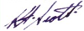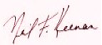
………………………… …………………………
Keith Francis SCOTT Neil Francis KEENAN

A:
List of funds and assets:

XXXXXXXXXXXXXXXXXXXXXXXXXXXXXXXXXXXXXXXXXXXXXXXXXXXXXXXXXXXXXXX
Reference: Family Guarantee Heritance.
(His Heir Son from Grantee),
Last Holder, Signatory, Ownership, PATN, 101371 / Position III.

For the Gold of Certificate Guarantee, Platinum of Certificate Guarantee, and Obligation of Certificate Guarantee, All the writing in the Black Book registered.

Guarantee Secret Code No. 754008979933/GIS/441.
FC – 719098 – Union Bank of Switzerland – GTF – 91 – NVS

Reference Code No. M550–7825-9096- M5307-8259-069.34200313.

Statement Code No.
VFT/2006747711/NG/4100001109/CFT/3218867571/CFT.6540078688

Heritance Code, No.
0067/D/4515/LM/45/A/00045/INDONESIA/0437756/DC/000045/A/00001

LAST HOLDER CODE, No.
BR/274809/CH/48092/INDNESIA/4860/CH/4809/TS/780982
XXXXXXXXXXXXXXXXXXXXXXXXXXXXXXXXXXXXXXXXXXXXXXXXXXXXXXXXXXXXXXX

CONTINUE TO SECTION TEN: COMMENTS

COMMENTS SECTION

I wanted to close out this investigation by sharing a few excerpts from Benjamin Fulford’s two most recent updates.

I have found many occasions where Fulford independently heard the same things my own insiders were saying.

Despite widespread disinformation, it is an established fact that Fulford said, in advance, that the Cabal was planning on creating an artificial earthquake in Japan that would trigger off nuclear reactors.

This tragic threat came true — and in other reports I have tracked this story. Fulford hasn’t been right about everything, particularly the dates, but I do believe that in time he will be vindicated on many points.

I thank Ben for breaking this story to the public in the first place — so it seems fitting to close with these latest inspiring updates from his paid journal.

FULFORD ON JANUARY 31, 2012

http://benjaminfulford.net/2012/01/31/out-of-the-box-negotiations-are-proceeding-at-the-highest-level/

The reason that many of the top Federal Reserve Board crime syndicate crooks have not been arrested yet is that the old system needs to be kept going with string and wire and duct-tape until final preparations for a radically new system are completed.

For example, an Asian proposal now being negotiated calls for 10 million yen or about US$125,000 to be budgeted for each and every individual human being on earth.

The Pentagon is also making similar radical proposals for a complete change of how humans interact with each other and with nature.

The big conclusion being reached at the highest level is that the old financial system in the West was an illusion used by a secret cabal to keep us enslaved.

We are now about to become truly free in ways that will exceed most people’s most optimistic expectations. However, there will be some hard work at first before this becomes true….

The Pentagon, for its part, has reached an agreement to merge with the Chinese and Russian Military to form a global peace-keeping force, according to a high ranking agency source.

There has also been an agreement to break up many of the large corporations controlled by the Khazarian Satanic Cabal.

Microsoft was specifically mentioned as a company that was about to go Kaput. The major corporate media corporations will also be broken up. Many other top 100 corporations will be broken up into as many as 20 smaller units, according to this source.

The cabalists in charge of the G5 countries are also going to be excluded from the new financial system. If necessary, the Pentagon will round up both the Illuminati and the Nazis, in order to make sure they cause no more trouble.

In the US there is also going to be a detailed study of what happened over the past 100 years since the Federal Reserve Board took over — and a lot of stolen funds are going to be returned to their rightful owners.

SECOND FULFORD EXCERPT: THE TAKEDOWN IS PROGRESSING SMOOTHLY

http://benjaminfulford.net/2012/02/07/the-takedown-of-the-satanic-cabal-is-proceeding-smoothly

Despite widespread pessimism on the part of many truth seekers about the situation in the G5 terrorist states, behind the scenes the satanic cabalists in control of the Western central banks are in a state of extreme fear.

One reason is that US Defense Secretary Leon Panetta told a White Dragon Society representative last week that the Pentagon and the US agencies were in no mood to let off the cabalists with a truth and reconciliation committee.

“We have been watching these guys for a long time,” he said. The conclusion reached was that Federal Reserve Board needs to be dismantled — and the cabalists jailed.

The 65% drop in the Baltic Dry Index (the price of shipping) this year is one visible sign of the dismantling.

This is related to a growing global boycott of the G5 terrorist states as seen in the growing number of countries refusing to use US dollars or Euros for trade.

Another sign was the stoppage on February 3rd of the Federal Reserve Board owned Clearing House Interbank Payments System. Under the surface, much more radical events are being planned.

[The] complete revamping of all the institutions set up after World War 2, including the BIS, the World Bank, the IMF, the International Court of Justice and the UN will mean the wholesale removal of agents for the Satan-worshipping Zionists who have been in control of these institutions from behind the scenes….

Once the Khazarian Satanic cabal is removed from power, there will be so much money and so many investment opportunities that all areas will experience a boom.

For example, the old plan to turn the Philippines into a fully modern nation with large nature preserves is being dusted off. There will be similar development projects taking place all over the world — so no area is going to feel left out or left behind.

A MESSAGE FROM A CLOSE FRIEND OF DAVID HUTZLER

WILCOCK: We received the following letter from someone who only wishes to be known as L*M***. We now have tracked down a blog post David made just hours before he died.

There isn’t the slightest hint of suicidal ideation in this post — quite to the contrary.

I have known Davie Hutzler since 1982 when I bought a business from him. We spoke many times over the years, except for the last 10 years, because I was just so busy with building homes — which is what I have done for a living since around 1999.
That business tanked, as you are well aware, due to the bubble busting on that industry. I have often thought about stopping by to see Davie, but never took the time, which I now regret.
I do know that the man I knew 10 years ago loved his son, and I just cannot see him doing what they say he did. David was always cash poor because he was always putting his money in other things, Businesses, land, gold, silver, and recently Iraqi Dinars.
He was also way too open about this. I believe he was either killed for the precious metals he kept around the home or there was another underlying reason.
The police never released all the details, and I sure as heck would love to know what they know… or what they think they know.
I read where he had made a comment to someone (maybe you) that he would have some kind of information about something which was posted on a site called Turf Wars: http://turfwarsapp.com/forum/43/topic/98670923/
(MKUltra 4 weeks ago
David Hutzler January 5, 2012 11:46 pm
There is secret stuff going on but the (**************) is almost there …(***********)everything seems to be in place…
government reset like fullford said is planned
west va got in today ..
going to get more details soon .
hutz

This was written the night before he died, which was the next morning according to the newspaper. Someone phoned in the fire report around 8 something in the morning.

Maybe his outward political views caused his death. Since his death I have googled his name and came up with several sites that he frequented and see he was opinionated in his views politically.

Who knows why he is dead… but I do know that he would not take his own life or that of his child. He just was not that kind of man. That man was kind, caring, giving, shared everything he had, and had a religious faith/belief.

Police have closed the case, and in my opinion the dumb asses really didn’t care as they have drawn their assumption… and so they walk away thinking they’re “Dick Tracy” the great crime solvers.

I believe Davie was murdered, plain and simple. There is more to this than what is being revealed, in my opinion.

I only hope someone brags or something, because I would love to see his name cleared — and the perpetrators brought to justice.

Thanks for reading.

